A learning from home pack

For learners in years 7–8

Theme: Sustainability

Context 1: Environmental Sustainability

Context 2: Cultural Sustainability

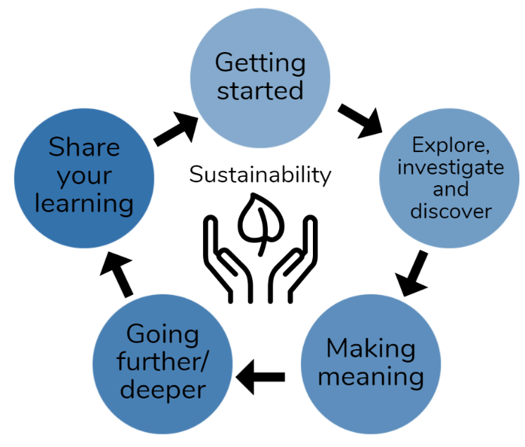
Layout of the resource
This pack is filled with learning activities that can be used at school or at home. All activities are framed around the theme of sustainability | toitū
Suggestions are provided for starting the day with a karakia (see p. 7), check in with the teacher, and setting up the learning environment. You can replace these with how you want your learner to start their day.
The activities follow an inquiry learning model (figure 1) exploring one theme through two contexts. Each day the learner will work through one part of the model culminating with sharing their learning on days five and ten.
Figure 1 Inquiry learning model

Realities
You know your learners and have a good understanding of their learning situations. Many learners will be sharing space and materials. Some may have access to the internet and devices, and others may not. Learners will also have varying levels of adult support. This pack contains a mix of activities using materials found in most homes. Some activities will need support while others can be managed independently.

Resources
The pack uses books from the School Journal and Figure it Out series. You might want to send these home with the learner, along with an exercise book, pencils, crayons, or felts, and some craft materials (glue, scissors, construction paper). Learners can bring their notebook back to class to share. All images have been sourced with permissions for use in this pack. If your learners do not have reliable access to the internet, here are the resources to print and send home to create a paper-based pack.

Resources to print
- https://nzmaths.co.nz/sites/default/files/2020-05/FindTheSpot.pdf
- https://nzmaths.co.nz/sites/default/files/FindtheSpotCM.pdf
- Map of your school
- https://nzmaths.co.nz/sites/default/files/ClassifiyingResources.pdf
- https://www.un.org/sites/un2.un.org/files/actnow_action_guide_2021.pdf
- https://sites.unicef.org/disabilities/files/AliFindsAWay-digital.pdf
- https://www.un.org/sustainabledevelopment/wp-content/uploads/2018/01/10_Why-It-Matters-2020.pdf
- https://nzmaths.co.nz/resource/where-earth-0
- https://instructionalseries.tki.org.nz/Instructional-Series/Connected/Connected-2019-Level-4-Seeing-Beyond/Maths-Craft
- https://www.ohchr.org/sites/default/files/Documents/Issues/MDGs/Post2015/SDG_HR_Table.pdf
- https://www.sciencelearn.org.nz/resources/185-rongoa-maori
- https://static.sciencelearn.org.nz/documents/files/000/000/063/original/Using_rongo%C4%81_M%C4%81ori.docx?1528155914
- https://nzmaths.co.nz/resource/voyage-hawaiki
- https://nzmaths.co.nz/sites/default/files/HawaikiMapCM.pdf
- https://hpe.tki.org.nz/assets/healthpe/Uploads/Oho/Downloads-My-culture-in-my-place-of-learning/Oho-My-culture-in-my-place-of-learning-sheet.pdf
- https://hpe.tki.org.nz/assets/healthpe/Uploads/Oho/Downloads-Oho/Oho-cards-Printable.zip
- https://docs.google.com/presentation/d/1S4h2OL5qb-E_WXH492eOZR7fsXr90KhTjbLgy2b4QnE/present?slide=id.p
- https://www.sciencelearn.org.nz/resources/2897-fake-facts

Resources to send home
- https://instructionalseries.tki.org.nz/Instructional-Series/Connected/Connected-2019-Level-4-Seeing-Beyond/The-Global-Positioning-System
- https://instructionalseries.tki.org.nz/Instructional-Series/School-Journal/School-Journal-Level-4-June-2018/Climate-Change-Our-Biggest-Challenge
- https://instructionalseries.tki.org.nz/Instructional-Series/School-Journal/School-Journal-Level-4-November-2017/The-Moa
- https://instructionalseries.tki.org.nz/Instructional-Series/Connected/Connected-2016-Level-4-Getting-the-Message/What-Now-for-the-Rena
- https://instructionalseries.tki.org.nz/Instructional-Series/School-Journal/School-Journal-Level-4-November-2019/Chinese-New-Zealanders
- https://instructionalseries.tki.org.nz/Instructional-Series/School-Journal-Story-Library/Te-Tiriti-o-Waitangi
- https://instructionalseries.tki.org.nz/Instructional-Series/Connected/Connected-2019-Level-4-Seeing-Beyond
- https://instructionalseries.tki.org.nz/Instructional-Series/Connected/Connected-2015-level-3-Fact-or-Fiction/The-Science-of-Rongoa

Setting up the learning environment
Encourage whānau to support learners to set up a space for learning at home. Learners might like to design their own space as a separate learning activity. Some materials they may need could include pen, pencils, paper, a notebook, colouring pencils, glue, scissors, and a device to access the internet.
Many of the suggested activities and experiences include the optional use of online resources which can be accessed and viewed using a Smartphone.

Overview of the learning in this pack
The theme of sustainability | toitū will be explored through two contexts.
- Days 1–5 look at this idea through the context of environmental sustainability.
- Days 6–10 look at this idea through the context of cultural sustainability.
Learners will explore, investigate, discover, and make meaning as they go through each task. There are times where they look a little deeper into the topic. Some of the tasks may be independent hands-on tasks while some may involve connecting and sharing with others.
Day 1 | Day 2 | Day 3 | Day 4 | Day 5
Launching our learning with exploration of the Sustainability Development Goals. | Start from where your feet are standing.  How do you decide what to do? Let’s explore! | Making meaning:  Environmental issues are both global and local. | People adopt different roles in response to community challenges. Discover how one person can start a movement – going deeper. | Share your plans to educate family/ whānau and friends on “Taking Action for the planet”.
Day 6 | Day 7 | Day 8 | Day 9 | Day 10
Launching our learning with concepts of human rights and inequality | Exploring the significance of our founding document Te Tiriti o Waitangi and the importance of addressing historical injustices. | Making meaning: Sustainable Development Goals are interconnected. | People claim ownership of places, resources, and environments, which leads to the disputes over the rights to them. | Share your learning about cultural sustainability through art and gamification.

Daily timetable
Below is a possible daily timetable. We have allocated 30 minutes for each activity; your learner may take more or less time than this for an activity. We suggest your learner takes the time they need to complete an activity. This may mean they choose which activities they will complete for the day, rather than complete them all.
At the start of each day the learner will draw up their timetable for learning. You can adjust the timing to suit the other activities that might be happening the day, such as Zooming with the class/teacher.
Time | Activity
9:00 am | Starting the day
9:30 am | Activity 1
10:00 am | Break
10:30 am | Activity 2
11:00 am | Fitness break
11:30 am | Activity 3
12:00 pm | Lunch time
1:00 pm | Activity 4
1:30 pm | Reflection time
2:00 pm | End of the school day

Daily fitness – Choose something each day
Please ensure that your learner includes fitness in their daily timetable. If possible, it would be great to do the fitness activity with your learner or have them complete it with others. Below are activities to choose from – or you can make up your own ideas!
Tama Tū, Tama Ora; Tama Noho, Tama Mate.
Through physical activity we thrive. Through inactivity we languish.
Your learner may prefer to go for a walk or run around your house. They could time themselves for fun! Maybe they’d like to go for a bike ride? Play a game with whānau? Have a boogie to a favourite song? Or do some yoga? It is up to you just get active!
Please note you can change or modify the exercises (in addition to those suggested) if you are not able to do the ones we have suggested, get creative and change it up
Clean your room
This is an exercise that will make everyone in your whānau happy – even you!
Turn it into a game, work out how long you think it will take and see if you can beat your time. Divide your room into quadrants and set a time limit for each section and see if you can beat your time. Keep a chart to see how long it takes you each day.
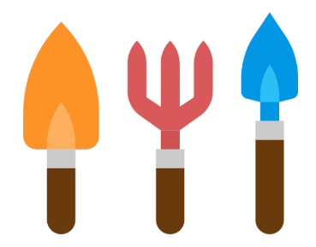
Get into the garden
It takes a lot of work to keep the garden nice and tidy, and it is a good way to get some exercise outside. Ask your whānau what work needs to be done that you can help with. You could do some weeding, rake up leaves, or tidy up any toys and equipment.
1 to 8 ball game
Find a ball and a wall to bounce it against. Try to make it all the way through from 1 to 8 doing each action the number of times indicated without dropping the ball. You can make up your own actions.
1 – throw the ball at the wall and catch it
2 – throw the ball at the wall and let it bounce once then catch (x2)
3 – bounce the ball on the floor, off the wall, one bounce and catch it (x3)
4 – bounce the ball on the floor, off the wall, and catch it (x4)
5 – bounce the ball under your leg and off the wall and catch it with a bounce (x3)
6 – bounce the ball under your leg and off the wall and catch it without a bounce (x4)
7 – throw the ball at the wall, spin around, and catch it with a bounce (x5)
8 – throw the ball at the wall, spin around, and catch it without a bounce (x 6)
Start again from the beginning if you miss the ball!
Online option
Les Mills Born to move workout https://www.youtube.com/watch?v=0skunYNQdhI

Daily wellbeing – Choose something each day
These activities are good to do at the beginning and end of the day but can be done anytime. They can help you get ready for learning, calm your mind and body, and can help you to reflect on your learning:
Wellbeing checklist
Have you:
- Drunk lots of water? Do you have a water bottle with you? Staying hydrated is very important.
- Taken mini breaks to stretch and walk around? Keep your brain alert and your heart pumping.
- Stopped to think of something you are grateful for?
- Connected with someone to have a chat, kōrero?
- Planned time to do your favourite activity?
- Planned my fitness activity for today?
- Got healthy snacks ready for the day? Healthy food for a healthy body and mind!
- Made your bed? Tidied your workspace/bedroom?
- Been outside? Even for a brief walk? You need vitamin D and fresh air!
- Paid it forward? Have you done something nice for someone else?
Future focus
Write a letter to your future self ...
OR
Write 5 pieces of advice for your tomorrow you...
Powerful people
List 10 things you love about your best friend / important person in your life. Read it to them OR take a picture of this page and share it with them. It will make their day, and you will feel good too.
Write a poem using (some of) these words:
together gratitude hope love I can world support special unique

Fresh air
Ask an adult if you can go for a walk together. Fresh air and exercise really help to improve your mood! Use the time to talk to them about things that may be worrying you, what you are excited about, and what you are looking forward to.

Starting each day
Notes for teachers and whānau:
Starting the same way each day helps create a structure for your learner. Your school might have your own way to do this, for example starting the day together as a class on Zoom. In this pack we provide a karakia to settle into the day. Saying the karakia with your learner a few times will help them be able to do this more independently tomorrow and beyond. As part of the start of the day and setting up the learning environment, help your learner look through the activities suggested for that day and choose a fitness and wellbeing activity. They could fill out their daily timetable and think of other activities they might like to do, like reading.
Remind your learner of when and how to check in with the teacher/you.

Karakia
Here is a karakia to welcome in the day.
Karakia mō te Ata https://www.youtube.com/watch?v=3em_pulEjT0
Kia hora te Marino  Kia whakapapa pounamu te moana  Hei huarahi mā tātou i te rangi nei  Aroha atu aroha mai  Tātou ia tātou katoa  Hui e taiki e! | May peace be widespread.  May the sea be like greenstone; a pathway for all of us this day.  Let us show respect for each other, for one another.  Bind us all together.

Planning my day
- Have you chosen which activities you will do today and in which order?
- Remember to choose a fitness activity (see p. 5)
- Have you chosen a wellbeing activity? (see p. 6)
- Have you done a ‘Wellbeing check-in'?
  - How are you feeling today?
  - How do you feel about your readiness to learn this morning?
  - What do you need extra assistance with today? Who could you get to help you? What strategies could you use to help make your learning more effective?
  - What would you like to do as a quiet time activity to end your day?
- Remember to do your Reflection at the end of the day (see p. 8)

Ending each day
Please ensure your learner does this at the end of each day.
Reflection can be challenging for all learners, but it can also provide them with rich opportunities to think about how their learning is progressing. Use the questions below as prompts to encourage your learner to think about what they have learned so far and help them to plan out their next steps. If you have concerns with their learning or find that your learner is needing more help, contact their teacher for more support.

I am learning to: reflect on my learning, my day and myself
What do I need?
- A notebook or online doc that you can use each day for your reflection activity. We will call this your “reflective journal”
- Materials for your quiet time activity
Option 1: Reflections about my learning
Take time to think about how you are feeling after today’s learning. Reflect on 2 or 3 of the following prompts in your reflective journal.
- What did you enjoy most about today?
- What is one thing you feel you learnt today?
- What is one strategy that helped you with your learning?
- Is there anything you need extra help with? Who can you ask to help?
- Is there anything you want to catch up on tomorrow?
Option 2: Reflections about my day
Choose 2 or 3 questions to respond to in your reflective journal:
- What is something kind you did for someone else today?
- What made you laugh today?
- What is something that frustrated you today?
- What is something you wish you had done differently today?
- On a scale of 1–10, with 10 being the best day ever, how does today rate? Why?
- Were you able to finish all of your work today? Why or why not?
Option 3: Reflections about myself
Choose 2 or 3 questions to respond to in your reflective journal:
- What are your greatest strengths?
- If you could live anywhere in the world, where would it be? Why?
- Who do you talk to when you have a problem? How do they help?
- What do you like to do for fun?
- If you could have one wish, what would it be?
- What are you grateful for?
- What do you like about yourself?

Remember to finish with a wellbeing activity and/or your chosen quiet time activity.

Context 1: Environmental Sustainability

In the first five days we will investigate the theme of sustainability by looking at how we understand and work towards environmental sustainability.

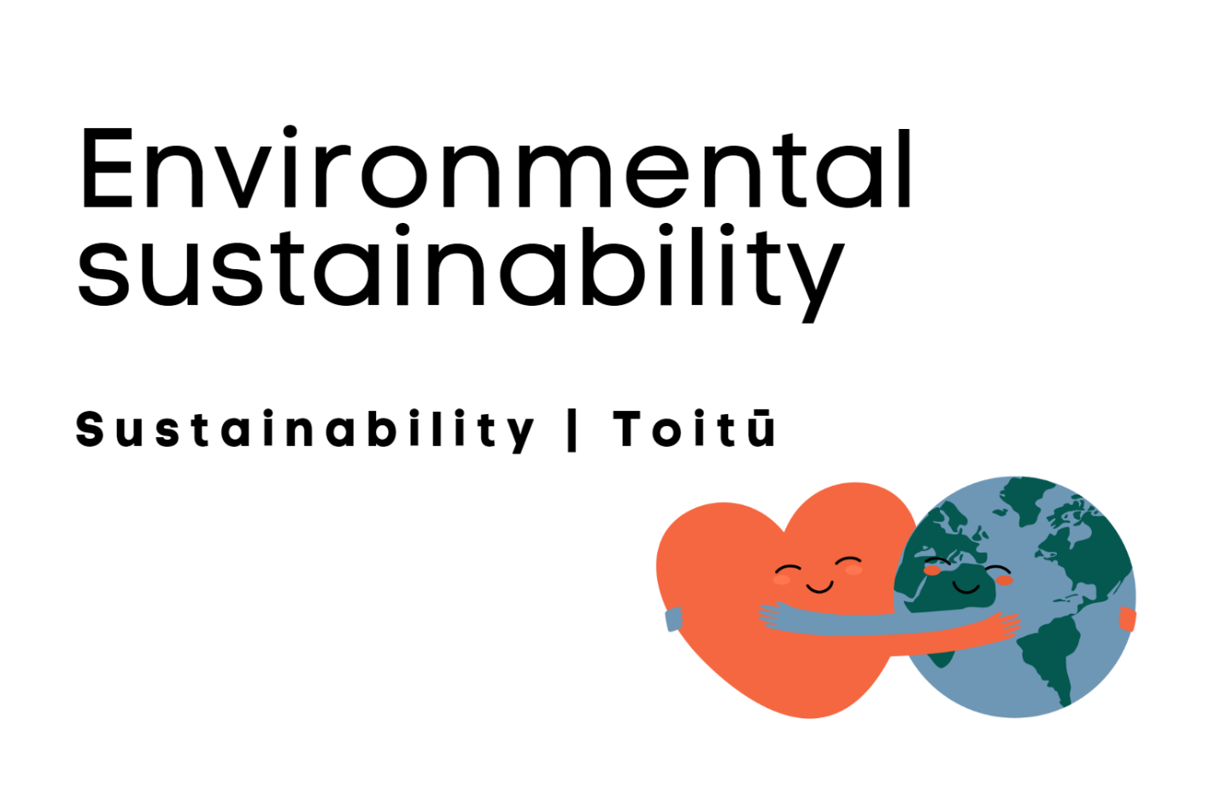

Day 1 activity 1: The world’s largest lesson
Notes for teachers and whānau
Learners will explore the concept of sustainability through the United Nation’s Sustainable Development Goals project. ‘The World’s Largest Lesson’ is a project to be achieved by 2030. This activity supports learners to explore the Sustainable Development Goals, what they are and why we need them using the learning area of Literacy/writing. Note that our Inquiry focus for today is “getting started” which includes generating questions, activating prior knowledge, and introducing the theme.

I am learning to: write a paragraph with supporting detail to describe what the Sustainable Development Goals are, and why we need them.
What do I need?
- 30 minutes
- Optional digital: The World’s Largest lesson https://www.youtube.com/watch?v=ry_9SU0eq9M
Remember to start your day right (see p. 7).

Instructions
New Zealand is one of 193 countries that belong to the United Nations – a global organisation which promotes peace and equitable living for humanity. In 2015 the United Nations established a global project, identifying 17 Sustainable Development Goals, (the SDGs), to address: global inequality, extreme poverty, and respect for our planet. This project requires your help and involvement. Your first task is to understand what the Sustainable Development Goals are, why we need them and why they matter to you, your family, and your community.

Your task:
Task 1 – View The World’s Largest Lesson or read the video transcript
Imagine you are travelling in space looking for intelligent life. You’ve spotted millions of planets with no life at all. And then you see it. Earth! A tiny island in space. It looks like a spec of water, rock, and soil and a thin veil of air that we can breathe.
There might be life out there in space but here on Earth it is everywhere – on the land, in the water, in the air, plants, insects, birds, fish, and every type of living creature. And people, billions of people like you and me. In most ways we’re just like the rest of life on Earth. We start from tiny seeds and with the right conditions we grow and mature. To do that we all need the same basic things – fresh water, clean air, and healthy food. The good news is that Earth has enough for all of us. The bad news is we’ve got some serious problems in our way. The first is climate change. The way we are living on Earth now is damaging the very things we need to live. The fuels we burn are choking the atmosphere with gases we can’t breathe. We are running out of clean drinking water. And all of this is changing the weather.
The second problem is inequality. Some people on Earth have far more than they need, and most people don’t have nearly enough. Many live in terrible poverty. Millions of people are unable to get medicines or healthcare that could stop them from getting sick or cure them if they do. In some places children complain about having to go to school. In others, millions of children can’t go to school at all. Is that fair?
The thing is, we are causing these problems, so we can fix them too, if we work together and get creative. If you think about it, all living things have superpowers. Birds can fly, we can’t. Dogs can smell things we can’t. Plants absorb gas that we can’t breathe and turn it into air that we can. But human beings have a power that other creatures don’t. We are the most creative creatures ever. Our heads are full of ideas, and we are great at making things too. And with that power we have already changed the world over and over and solved thousands of problems. And now we can do it again.
The good news is we have a plan that can only succeed with your help. There is one organisation that represents the people of 193 countries, and it is entirely dedicated to keeping us peaceful and working together – the United Nations. They have just announced the Global Goals for Sustainable development. These are 17 goals to protect the planet against climate change and make the world safer, fairer, and more just for everyone. We have to achieve these goals by 2030. The great thing about a plan is that we can check how we are going as we go along. 2030 isn’t too far away so we need to start right now. There is a lot we can do if we work together and get really creative. We can start by making these goals famous and tell everyone. Then, and this is the exciting bit, see if there is something practical you can do to actually help. If we don’t waste food, water, or electricity, that would help protect the planet. If we all stick up for people who aren’t being treated properly and respect each other’s human rights that would make a big difference too.
There are 17 goals so lots of different ways that you can help. We need new ideas and ways of doing things. We all depend on the Earth to live. We only have one planet. If we take care of it and each other and share what we produce fairly and sustainably, everything we need is right here. Someday we might find intelligent life on other planets, in the meantime let’s see how intelligent we can make it down here for all of us.
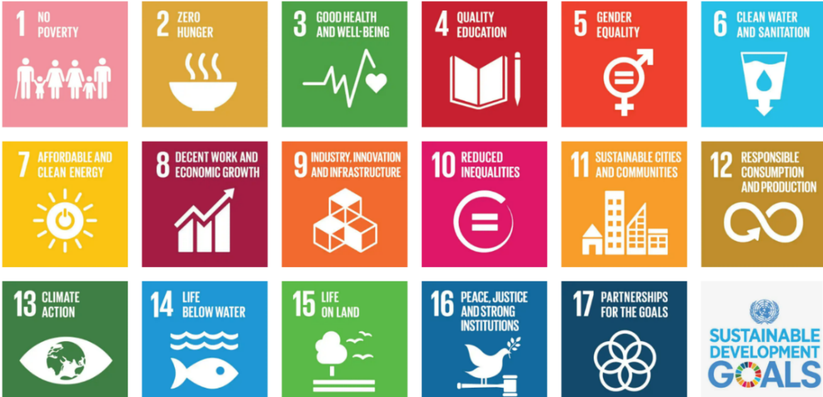

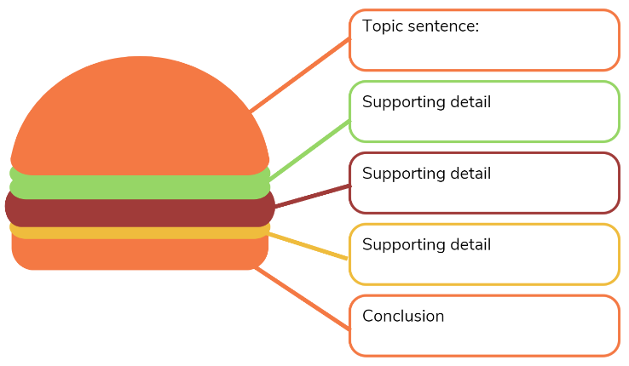
Task 2 – Write a descriptive paragraph explaining with detail what the SDGs are, why we need them and why they matter, to inform your friends and family about them.
Use the ‘Hamburger Paragraph’ Graphic Organiser to organise your ideas and write the paragraph in your home learning book.

Day 1 activity 2: Is my lifestyle sustainable, how do I know?
Notes for teachers and whānau
This activity encourages learners to consider their own lifestyle and the concept of sustainability. They would benefit from a conversation with you about your thoughts.

I am learning to: think critically about my lifestyle and sustainability.
What do I need?
- 30 minutes

Instructions
This activity requires you to think deeply and critically about your lifestyle and its sustainability. Grab your workbook, someone to talk to, and your curious mind.

Your task:
Task 1 – Copy this chart into your workbook and complete the first two columns:
What I KNOW about sustainability | What I WANT to know about sustainability
Task 2 – Talk with an adult about this quote, or ask what sustainability means to them.
“Sustainability is an economic state where the demands placed on the environment by people and commerce can be met without reducing the capacity of the environment to provide for future generations. It can also be expressed in the simple terms of an economic golden rule for the restorative economy: leave the world better than you found it, take no more than you need, try not to harm life or not of the environment, make amends if you do.” Paul Hawkin’s, Ecology of Commerce.
Read how some children have described what sustainability means to them:
- Something that lasts for a long time – maybe forever
- Like a circle – it goes around, and all is re-used
- Taking care of the planet and its creatures
- Something that is good for everyone
- Sharing what we have with others and not taking more than our share
- Thinking about what you need rather than taking what you want
- Making the world a better place for the future
- Making rules we can all follow
- Taking care of the air, water, land, and those who live there
- One thing leads to another, then another. Let’s make the chain good.
- Sustainability is not just cleaning up your own room – it’s about keeping tidy an even bigger room that belongs to everyone!
Examine the Ecological Footprint Measures image:

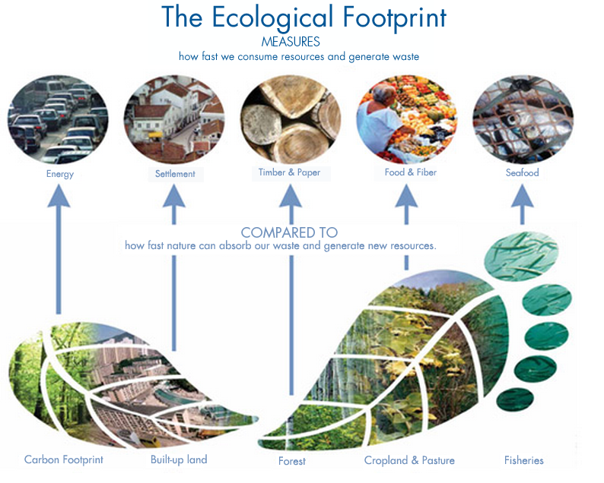
Source: Global Footprint Network, www.footprintnetwork.org
Task 3 – Think about the following questions and record your responses in your book.
- Do you think YOUR life is sustainable?
- How can you tell if your life is sustainable?
- How can we compare lifestyles?
- How would you compare your lifestyle to a student in another country?

Task 4 – Complete the last two columns in your chart. Record what you have learned in this session, and brainstorm some actions you can take to learn more.
Add more to the ‘what I want to know’ column if you now have more questions.
What I KNOW about sustainability | What I WANT to know about sustainability | What I LEARNED | HOW I can learn more

Day 1 activities 3 & 4: My world in 2030
Notes for teachers and whānau
Learners are invited to visualise a city/ urban or rural landscape of the future (2030) that has achieved or not achieved the 2030 Sustainable Development Goals. There is an opportunity to take this activity much further if the learner is interested. Part one asks them to visualise and sketch the world of the future. The extension invites them to construct a paper city model and take photos of the city and/ or create a stop motion video clip featuring the cityscape, using an APP downloaded to a mobile phone. Learners would benefit from support from an adult if taking on the extension activity.

I am learning to: use drawing skills of perspective, shading, and colour to visualise a cityscape of the future
What do I need?
- 60 minutes
- Home Learning Book or paper, pencils, coloured pencils
- Optional digital: Paper city – An urban story https://www.youtube.com/watch?v=-Bqx2BuFjik or read the transcript.
For extension activity:
- craft materials: paper, cardboard, glue, sticky tape, a photo camera, time, basic photo, and video software (often already part of your mobile phone bundle) and your creative ideas.

Instructions
You are invited to visualise and draw the world in 2030 with coloured pencils to create two images. One image will show what your environment (where you currently live: city/town/rural) would look like if the 2030 goals are achieved. The second drawing will show what your environment would look like if the 2030 goals are not achieved.

Your task:
Task 1 – Watch Paper city – An urban story or read the transcript.
Transcript
Cities generate over 75% of the world’s wealth. This attracts a lot of people looking for a better future. But more people need more housing. Lack of affordable housing means that living in slums is often the only alternative. There is now an increased need for basic services. These services are often expensive and don’t work well. The consequence – diseases and epidemics become the norm. People need to earn a living. If they can’t find regular jobs in their city, they will look for money somewhere else. As economies boom so do illegal activities.
Many cities currently follow traditional urban planning with strict zoning. Residential over here, industries over there, commercial in the middle, more residential suburbs all around. The result is urban sprawl. Cities get wide and wide means that people need to travel longer distances, mostly by car. This results in huge jams and slows down not only traffic but also a city’s economy.

Cities are big polluters. They count for as much as 70% of greenhouse gas emissions, the main cause of climate change. As a result natural disasters and storms test the resilience of our cities more than ever. Loss of lives, destroyed property, and economic downturn are a global problem.
In the face of all this, cities need to rethink themselves. Cities need to have a wholistic all-inclusive approach to their development to accommodate more people and provide equal opportunities for all. So what is a city that works? Well planned cities increase their job numbers by 15% by being well planned. Cities need to:
- get their street grid right with sufficient intersections to ease traffic flow, enhance access and interconnect the city.
- embrace mixed land use, become more compact, blending residences, offices, shops, and amenities. This cuts the need for long commutes.
- get their social mix right promoting neighbourhoods with a variety of housing types for all budgets.
- look beyond this providing the right incentives for the economic sector to strive and focusing on providing jobs for the urban poor. Slums need to be upgraded and connected to the city not only in terms of mobility but also socially to create a strong overall social tissue and foster inclusivity, universal access to basic services is paramount.
- provide enough land for public spaces, at least 30% of their footprint. Public spaces are vital for social exchange. They are spaces for leisure, fitness, and culture, and where citizens interact.
- free themselves from the dominance of cars by setting up attractive affordable public transport systems and promoting non-motorised mobility such as walking and cycling. This will not only reduce congestion but also help to curb pollution.
- become greener to help alleviate the effects of climate change and provide a clean environment for their citizens.
- become resilient to the increasing adverse effects of climate change.
All this makes for a happy city.
Task 2 – Visualise and draw with coloured pencils, two drawings:
- What your environment (where you currently live: city/town/rural) would look like if the 2030 goals are achieved
- What your environment (where you currently live: city/town/rural) would look like if the 2030 goals are not achieved
Label parts of your pictures that you want the viewer to think deeply about.

Extension activity:
Create a stop motion video of your current environment transforming into your vision of the future city. To do this you will need to build your environment using craft materials and take photos of each stage of the transformation into the future city.
You can find ‘how to’ videos about stop motion on YouTube to help you.
Remember to do your end of day reflection and wellbeing activities (see p. 6&8).

Day 2 activity 1: Reading – GPS
Notes for teachers and whānau
The main literacy demands of today’s text lie in interpreting and understanding abstract technical information and vocabulary. Learners will think about how digital devices impact humans and society and that the devices and their impact change over time. Technology will play an increasing role in meeting the challenges of the global SDGs. Note our Inquiry focus is “explore, investigate, and discover” which includes choosing and evaluating information, and thinking critically.

I am learning to: make meaning of a complex text by identifying and understanding main and supporting ideas and the links between them.
What do I need?
- 30 minutes
- Look in your pack for a copy of The Global Positioning System https://instructionalseries.tki.org.nz/Instructional-Series/Connected/Connected-2019-Level-4-Seeing-Beyond/The-Global-Positioning-System
Remember to start your day right (see p. 7).

Instructions
Before you start this reading and thinking activity, it’s important to understand the term ‘impact’. Start with this quote:
An impact is an effect. It might be positive or negative. My television impacts on my life because it’s a great source of entertainment and information. But it can have a negative effect when I watch too much and don’t do other interesting or important things. I wonder what the impacts of GPS might be?

Your task:
- First skim read the School Journal article “The Global Positioning System”.
- Think about how you might answer the author’s questions. Now read the text.
Task 1 – Record your thinking and ideas as you read the text in a Plusses, Minuses and Implications (PMI) chart.
Positive | Negative | Interesting
Task 2 – List topic specific vocabulary as you read. Notice that the vocabulary belongs to at least two groups: mathematical terms and technological terms.
Technological terms | What I think this means | What I now know it means | Example
Mathematical terms | What I think this means | What I now know it means | Example
Task 3 – Review your PMI chart:
- Try explaining GPS to someone in your home. Do you still have questions?
- Would you call the impact of GPS on our lives positive or negative?
- Are there things you would like to know more about?

Day 2 activity 2: Scientists are everyday people
Notes for teachers and whānau
Learners are invited to consider careers in science by understanding that scientists are everyday people. Using the case study of a young New Zealander who campaigned for improvement to our marine environments, learners may find the inspiration needed to take up the call for action with SDG 14 Life Under Water or one of the other SDGs.

I am learning about the skills and attitudes required to become a scientist.
What do I need?
- 30 minutes
- Young ocean explorers https://www.sciencelearn.org.nz/resources/1531-young-ocean-explorers-introduction
- Working as an ecologist https://www.sciencelearn.org.nz/resources/1529-scientists-are-real-people
- Becoming a marine scientist https://www.sciencelearn.org.nz/videos/35-becoming-a-marine-scientist
- Optional: see if your school has a copy of the book: Love our Ocean

Instructions
Today we focus on Sustainable Development Goal 14 Life Below Water. Kiwi Riley Hathaway became an ‘everyday scientist’ by observing the ocean environments she loved and asking questions about the health and sustainability of life under the water. In this activity we are going to consider the attributes and skills a young scientist needs and how everyday people can become scientists.
“You don’t really look like a marine scientist. You kinda look like a surfer.” Riley Hathaway when meeting marine ecologist Dr Tim Haggitt.

Your task:
Task 1 – Read the text or watch the videos
First we are introduced to teenager Riley Hathaway who is making a difference through educating people about sustainability and our ocean life.
https://www.sciencelearn.org.nz/resources/1531-young-ocean-explorers-introduction
Young Ocean Explorers (text adapted from Science Learning Hub)
Riley Hathaway is serious about looking after the ocean. With a dad who loves the water, she was exposed to marine life from an early age. When she was at school, she made a video about sea turtles accidentally eating floating plastic. The video was such a hit with her fellow students, it inspired her to make a 10 episode video series with her dad, Steve, called Young Ocean Explorers. They have also made an interactive website for students and teachers to use.
Riley and Steve have also written a book Love our Ocean which was sent to every school in New Zealand.

View the video or read the transcript of Working as an ecologist
https://www.sciencelearn.org.nz/resources/1529-scientists-are-real-people
Transcript – Working as an ecologist
Ecology is the study of plants and animals and their interaction with the environment. As ecologists we are interested in how animals or plants respond to changes in the environment and also how the environment influences the plants and animals.
I used to go fishing with my dad, loved being out at sea. So I guess from a very young age I knew that I wanted to do something in marine environments. It’s the creativity side of it – you get to think up research ideas and then it is the challenge of developing a study that is the best way to answer those questions. There are several different components to the work. You are doing research in the field and the laboratory, and you are working as an advisor with students. There is no way that you can be an expert in everything when you are working on different species and systems so you collaborate with people who have the expertise in a particular field or area of knowledge. So we work with people who have a strong chemistry background and to help us interpret the data. We work with people who work on sediment changes on a microscale, so looking at changes on a mm scale to try and interpret some of the processes that we are measuring. And I also work with people who come from a biogeochemistry background to try and understand the geological components of these changes through time.
View the video or read the transcript of Becoming a Marine Scientist
https://www.sciencelearn.org.nz/videos/35-becoming-a-marine-scientist
I always had a fascination with biology. I like the outdoors; I like scuba diving and I got more interested in how things work and just loved animals. My job has taken me all around the world – down to the Antarctic and up into the Tropics. It is a big adventure. You look at the Discovery Channel and you see people doing this sort of thing, but you can do it yourself if you really want to. There are lots of opportunities to visit marine labs all around the world and visit exotic places and look at really interesting species.
The weirdest place I have been to, would have to be diving in the Antarctic because you are diving under sea ice and it’s very clear water. Even on the sea floor there is ice. The water is so cold there is ice everywhere. I remember the first time I went diving there we were sitting in a dive hut, and I was looking down this whole they had drilled, and it was pitch black and I thought, “there’s no way I’m going in there!” But we went diving down there and once I hit the sea floor there were starfish and sea urchins and I felt at home again, there were animals with which I was familiar.
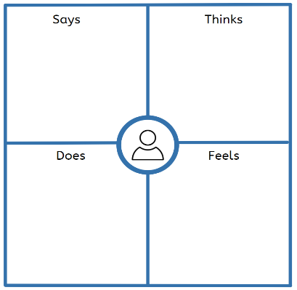
Task 2 – Empathy map graphic organiser
- Think about the skills that everyday scientists need.
- What kind of scientist would you be? What problems would you like to help solve for the world?
- Copy the empathy map in your book and take notes about the type of scientist you might like to become.
Digital opportunities:
- Watch: Young Ocean Explorers: Using kids to connect with Kids https://www.youtube.com/watch?v=UzA_CTkn7vk
- Visit Young Ocean Explorers site where you will find a collection of over 100 videos and choose an assignment to do https://www.youngoceanexplorers.com/

Day 2 activity 3: Start with where your feet are standing
Notes for teachers and whānau
Today’s activities build on the introduction to the SDGs and thinking about what a future city or town might look like in 2030. Learners explore issues in their environment that affect them personally and explore how they can have a positive impact. Note that our Inquiry focus for today is "making meaning" which includes analysing data, organising, and sorting information, summarising, synthesising, making connections/conclusions, building deeper understandings, and thinking critically.

I am learning to: think about how cities might look in the future, and how we can help to shape their creation
What do I need?
- 30 minutes
- Optional digital: The World’s Largest Lesson part 3 https://vimeo.com/266852848

Instructions
Today’s activity asks you to start right where you are, in your town or city. Well-designed cities can increase our overall sustainability.
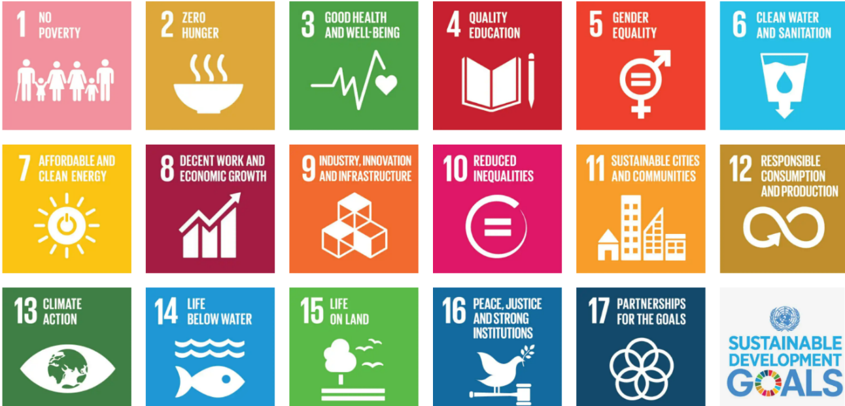

Your task:
View video The World’s Largest Lesson Part 3 (4 min 40 secs.) or read the transcript.
Transcript
There is a lot you can do to help get the goals done if you get creative. But getting started can be hard. Especially when problems can seem enormous from where you are standing. The best place you can start is where you are standing with the person you know best – you.
Lots of things you do in your life have an effect on the goals – from what you buy, to what you eat, to how you treat other people. Even one little change will make a difference. So how do you decide what to do? First spend a bit of time asking yourself questions. What do you care about? What is really important to you? Start a list of things you care about and think about what you could change in your life to help improve them.
Maybe you:
- love sea life or having clean water for you and your friends to swim in – so if you refuse to use a plastic water bottle, straw, or bag, you will stop them making their way into the sea when you throw them away.
- care about getting a good education in a school that feels safe – so if you make sure you treat everyone with kindness and respect their rights then others will follow your lead, and everyone will feel happy and ready to learn.
Or maybe it is something completely different. Tell people what you are going to do and maybe they will do the same. Suddenly it’s a movement! Then go out into your community with the global goals in mind and discover how it could be better. Look around you and ask people what they think. Talk to lots of different people so you get a range of answers. Sometimes the quietest voices have the best ideas. And don’t jump to conclusions or leap to your first idea. Thinking more makes your best ideas even better. Work with friends and family as some things are hard to do alone and it’s nice to have a team.
- Could your local park do with a clean-up, could you get some friends together to tackle it?
- Are there people where you live who are hungry – could you organise a food drive?
- Are there places that you and your friends avoid because you don’t feel safe. How could you work together to change that?
Or maybe it is something different. Do your research and work it out. Imagine what it would be like when it is done. Work backwards and think about all the changes that are needed. You will find some things work and somethings don’t, but it is good to keep trying. Once you have achieved something locally you will feel confident about thinking even bigger.
The people in charge of running your country have a lot of decisions to make so it is important that we don’t let them forget about the goals. If you show them how much you care they will work harder to make them happen. Whether it is the environment, health, schools, or almost any issue you are passionate about there is a goal and someone in the government who should look after it. And don’t forget businesses either. They have people in charge of sustainability too. Ask them what they are doing, tell them what you are doing. Maybe you can work together? You could even ask to meet them and start getting things done. And don’t stop there. Let the United Nations know that you care about the goals. It will help them to get all the countries in the world to work together more. The best way to make sure they pay attention is if you tell them how you got started and what you and your friends have achieved. You will be giving them a real-life story to tell, and stories can be really persuasive.
Now you know what you need to do– take a deep breath, jump in, and show how much you care.
Task 1 – Identify an issue you care about
- Decide on an issue that you care about, and which affects your life and the lives of those in your wider community. Write this as a title in your workbook.
- Identify which of the SDGs would help improve or solve the issue you care about? Write this under your title.
Copy and complete the problem and solution chart below into your workbook.
What is the problem?
What are the effects?
What are the causes?
What are the solutions?
Task 2 – Visualise the result
Sketch your sustainable city or town or make amendments to your previous sketch.

Day 2 activity 4: Find the spot
Notes for teachers and whānau
Learners connect prior learning about GPS to traditional navigation methods and locate spots on an illustration using compass bearings. Learners will benefit from support on how to use a protractor on a map. Students often get confused by the two competing scales on a protractor and have trouble using a protractor that goes only to 180 degrees to measure angles that are greater than this. (You may like to show them a circular protractor if you have one available.)

I am learning to: use compass bearings to describe positions
What do I need?
- 30 minutes
- Graph paper, ruler, and protractor
- Look in your pack for the Figure it Out Find the Spot activity https://nzmaths.co.nz/sites/default/files/2020-05/FindTheSpot.pdf
- Map of your school grounds (optional)

Instructions
Read these tips to help you complete the activity:
- bearings are always measured clockwise from north.
- bearings are always written as 3-digit numbers.
- Q1 is best done using back bearings. If we know the bearing of B from A, the back bearing gives us the bearing of A from B. To find the back bearing:
- add 180º to the bearing if it is less than 180º (for example, the back bearing of 081º is 81 + 180 = 261º )
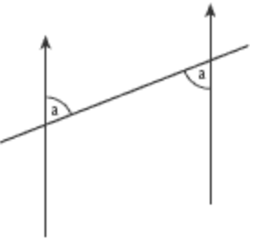
- subtract 180º from the bearing if it is greater than 180º (for example, the back bearing of 308º is 308 - 180 = 128º).
Back bearings make use of the fact that alternate angles are equal. Alternate angles are formed whenever a line cuts across a pair of parallel lines, as in this diagram.

Your task:
Complete the Figure it Out Find the Spot activity. Locate particular spots on an illustration using compass bearings. Then make up your own sets of clues, based on locations around their own school grounds if you have a map available.
Extra extension (optional)
You could investigate:
- the difference between true north and magnetic north
- the technologies used for modern navigation
- the history of navigation
- why the inventions of the chronometer and the sextant were so important.
Share your learning about navigation providing an overview of the history of navigation to the benefits of the modern GPS system with a family member.
Remember to do your end of day reflection and wellbeing activities (see p. 6 & 8).

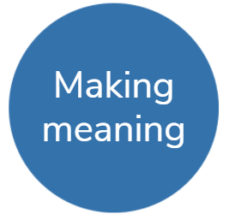
Day 3 activity 1: Environmental threats and disasters can happen where I live
Notes for teachers and whānau
Today’s activity invites the students to learn more about the multiple issues that affect our New Zealand marine environments. They will explore one of the issues and how as an individual they might raise awareness and take action. Learners will be considering how both short term and long-term responses to an environmental issue might happen. Note that our Inquiry focus for today is "making meaning" which includes analysing data, organising, and sorting information, summarising, synthesising, making connections/conclusions, building deeper understandings, and thinking critically.

I am learning to: explain short term and long-term responses that might help limit environmental damage
What do I need?
- 30 minutes
- Optional digital:
Threats facing our oceans https://www.doc.govt.nz/nature/habitats/marine/threats-facing-our-oceans/
Plastic bottle found in stomach of emaciated albatross https://www.doc.govt.nz/news/media-releases/2020-media-releases/plastic-bottle-found-in-stomach-of-emaciated-albatross/
Remember to start your day right (see p. 7).

Instructions
You will be aware of environmental threats to the oceans surrounding New Zealand and may already have thought about one you would like to learn more about. This activity invites you to dive deeply into researching information about the Rena Disaster or the one issue or threat to oceans you select to create a cause-and-effect flow chart.

Your task:
Task 1 – Research threats to our oceans
Watch Rapid response to the Rena or read the transcript
https://www.sciencelearn.org.nz/videos/609-rapid-response-to-the-rena
Transcript
At 2.20 am on the 5th of October 2011, the cargo vessel Rena ran aground on Astrolabe reef off the Port of Tauranga. It began to leak oil. Bay of Plenty Polytechnic and the University of Waikato formed a marine rapid response team to survey the biology of the local reefs.
It is vital to establish baseline reef health before any oil affects the marine life. You need to know the health of the marine life before the oil reaches it to be able to make comparisons to observations made at a later date. This will help determine whether the oil has had an effect on marine life. Dive sites are selected for the surveying, and the scientists prepare for the first dive. Dry suits worn over their clothes will keep them warm and dry in the cold water. In addition to the usual diving equipment, the divers also need equipment for the surveying. Notes are written underwater with pencils on special waterproof paper attached to their dive slates. They use quadrats (or sampling squares) and cameras to record the different habitats. A blue and white dive flag marks the site.
At specified depths, the scientists take photos of the plants and animals inside the bright orange quadrats. They record the size and abundance of key species, such as sea urchins and kelp. At each depth within a site, five repeat photos are taken to measure the variability, and fingers are held up to record the number of the replicate. These ‘before’ photos will later be compared to ‘after’ photos to record any differences. The scientists also use dive computers to measure depth and time elapsed under water. Video transects also provide a useful and rapid record of the variety and components of particular habitats. Samples are collected for analysis, including the lamina of the seaweeds, some large sponges, and other colourful invertebrates.
The dive lasts about 45 minutes, and soon it’s back to the boat where the scientists give general descriptions of the site and process the collected samples. This involves labelling them and snap freezing them in dry ice. Then it’s off to the next site.
It is important to sample a wide spread of sites in the Bay of Plenty that might soon be affected by oil from the Rena. GPS coordinates are used to locate each of the sites. Dive times and depths are closely monitored for each diver on their computers to make sure the divers are safe to carry on working.
The divers work together as a team to record and identify the key species. At the sites, they see a range of seaweeds, spiky sea urchins, gorgonian fan trees and white-fringed anemones. The seafloor is packed with interesting invertebrate life. More photo quadrats and video are taken, and then it’s back to the boat. A small brown seaweed is identified before being snap frozen for analysis. It’s important to keep good notes of the sites and what has been found.
Back in the water for the third dive, and they have the company of a curious fur seal. This is a much shallower site, and the waves move the divers around, making it more difficult to count and measure sea life.
The wind has come up so it’s a bumpy ride home, but they are soon in the calm water of Tauranga Harbour. Time to unload all the equipment and catalogue all the photo quadrats and video transects. Back at the lab, the samples will be put in a special minus 80-degree freezer.
With the leaking oil reaching the shore, a clean-up begins – this involves beach clean-up crews and volunteers manually picking up the oil and putting it into plastic bags. Using machines is quicker but pushes the oil deeper into the sand, making it harder to retrieve. The oil from the Rena was also found stuck onto the rocks around Mount Maunganui at high-tide level. It was very sticky, and it was important to use protective gloves, disposable covers on shoes and overalls to stop spreading the oil further. The work was slow, hot, and difficult. Follow-up underwater surveys are being carried out by divers from the marine rapid response team to establish the impacts of the oil and recovery times for key species.
Digital option – Research another threat that face our oceans.
Research the threat, using sites like https://www.sciencelearn.org.nz/topics/oceans
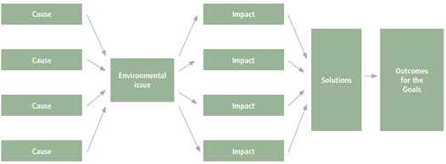
Draw and complete a flow chart about the causes of the environmental threat, the impacts, possible solutions and outcomes from actions taken.

Responding to Rena © Copyright. Science Learning Hub, The University of Waikato. http://sciencelearn.org.nz
Response | Possible solutions | Consequences
Birds covered in oil | Catch and bring birds to a centre so they can be cleaned. | May stress birds further but could result in saving birds including endangered species.
 | Leave the situation to nature. | Depletion of bird populations in the area. May result in fewer birds of endangered species e.g. dotterels.
Oil spilling into the ocean | Spray oil with dispersants using boats. | Rough seas may make it difficult for boats to get close enough. Wind could blow dispersants away from target area. Dispersants could harm marine life, particularly benthic organisms.
 | Spray oil with dispersants using small planes. | Wind could make application difficult. Dispersants could be harmful to marine life, particularly benthic organisms. More expensive than using boats.
 | Contain oil using booms and clean up with skimmers (vacuum machine, oil absorbent material). | Rough weather could prevent booms from staying in position and make it difficult to use skimmers.
 | Leave the oil to disperse naturally. | Oil may reach the coastline, damaging or killing birds and other marine life. Oil makes an unsightly mess on beaches.
 | Burn the oil off the water. | Produces air pollution. Conditions need to be calm to effectively burn off oil.
Containers and debris falling into the ocean | Send in flotilla of boats to salvage containers before they break up and to scoop up debris. | Difficult to do in rough weather. May take a lot of time, boats, and people.
 | Leave containers/debris to come ashore and salvage then. | Contents of containers that might break open could be hazardous to marine life, particularly seabed dwellers. Could be a lot more debris due to broken containers. Debris such as plastic could be harmful to birds and other marine life. Debris near/on beaches is unsightly.
 | Airlift containers from wreck before they fall off/break up. | Could be expensive and difficult to do in rough seas/weather. Containers might be too heavy to lift.
Liaise with local iwi concerning incident, responses and consequences | Make no special effort. They will hear news like everyone else. | Local iwi often depend on kaimoana for a substantial part of their diet. People may be poisoned by affected kaimoana.
 | Keep iwi informed and include them in clean-up operation. | Most iwi have a fundamental belief in kaitiakitanga (protecting our resources) and that, as tangata whenua, they are kaitiaki (those who carry out kaitiakitanga). Most will want to help restore the coastline. Keeping them informed will help protect them from eating poisonous kaimoana. Iwi may have knowledge/ways of dealing with the situation or be willing to work with helpful ideas, for example, a rāhui (restriction) may be placed on certain seafood. Iwi may reseed areas where shellfish have been depleted.
Long-term research on effects on marine organisms | Don’t do anything. | No one will know long-term effects of the oil. Ecosystems may be affected and damaged.
 | Test for toxins in organisms. | It often takes time for toxins to get into the food web. Toxins tested for may not show up.
 | Take a baseline survey immediately. | This will show health of the environment before being affected by the oil spill and can then be compared with subsequent surveys. Comparison may indicate whether a particular species has disappeared, or toxins have appeared in species that didn’t have them before.

Day 3 activity 2: Renewable and non renewable resources
Notes for teachers and whānau
The activities and game challenge learners to think about which resources they use are renewable and what the implications are if current patterns of use continue (or accelerate). Learners may not realise that every discussion of resources – especially resources that are non renewable – inevitably comes back to mathematical understandings, particularly inverses, rates, and ratios e.g if a non-renewable resource is consumed at a faster rate, it will run out sooner; if some consume more than their share, others have to make do with less. Question 2 in Classifying Resources shifts the focus to the mathematics behind the game: integers and probability. Integers are used to describe the direction of each move (whether forwards or backwards); probability concerns the likelihood of particular outcomes.

I am learning to: Explore how probability influences outcomes in a game of chance.
What do I need?
- 30 minutes
- A partner
- Look in your pack for a copy of Figure it Out Classifying resources https://nzmaths.co.nz/sites/default/files/ClassifiyingResources.pdf

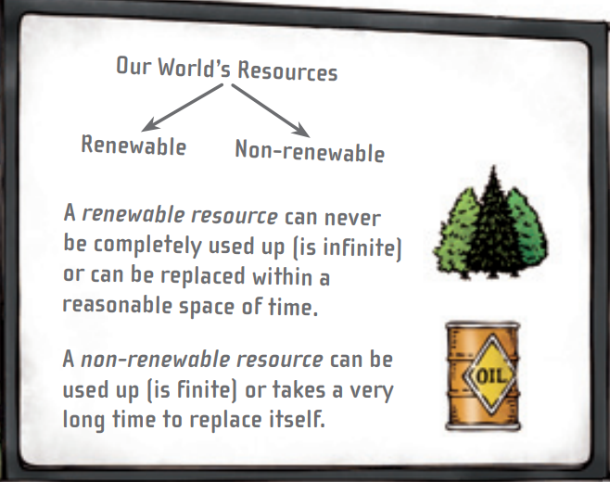
Instructions
You will need a partner for this task. First, we will explore renewable and non-renewable resources and then play a game of chance. A resource can be a person or a thing. Tip: Think about the probability of moving forwards is greater than the probability of moving backwards.

Your task:
Task 1 – Using resources
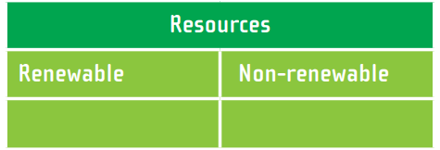
- Find different meanings for the word ‘resource’
- Discuss how a resource can be a person as well as a thing.
- Make a list of 10 different resources
- Classify the resources in a chart.
Task 2 – Construct and play the game in Figure it Out Classifying resources.
After you play the game:
Challenge and stretch your mathematical thinking by suggesting alterations to the spinner and then describe how those alterations would affect the probabilities. For example: If the wind segment was replaced with uranium, would that make the game longer or shorter? What would make the game harder or easier?

Day 3 activity 3 Climate change our Biggest Issue
Notes for teachers and whānau
Learners will read an article explaining what climate change is and why the author believes human-induced climate change is the biggest challenge the world has faced. The article explains the greenhouse effect and the reality that continued climate change is inevitable, given the high level of greenhouse gases already in the atmosphere. The article, however, finishes on a positive note, explaining what governments, scientists, community groups and individuals can do to lessen the impact of climate change by reducing greenhouse emissions.

I am learning to: create a glossary of topic specific words with pictures to illustrate what the word means.
What do I need?
- 30 minutes
- Look in your pack for a copy of Climate change: Our biggest challenge https://instructionalseries.tki.org.nz/Instructional-Series/School-Journal/School-Journal-Level-4-June-2018/Climate-Change-Our-Biggest-Challenge
- Optional device to create an online document for my glossary

Instructions
Think about what you know already about climate change and share this knowledge with someone.
The article you are asked to read in this activity contains many ‘topic-specific’ words which may be unfamiliar. As you read take note of these unfamiliar words, record them in a Google doc or in your Home Learning book to create an illustrated glossary. If you have access to a device, you can locate images which will illustrate the word. If you create the glossary in your home learning book, draw images to illustrate the word and its meaning.
The article is complex as it contains a lot of information and may require several readings.

Your task:
Skim read the article, to get a sense of its structure and purpose.
Read the article through carefully. Use strategies to work out word meanings such as:
- Using the context and reading on to see if the meaning becomes clear
- Looking for base words, prefixes, suffixes, chunks, or word families
- Take note of ‘topic- specific’ words that are unfamiliar as you read
Create a glossary using an online document or your workbook and illustrate the words where possible.
Re-read the article to help you understand the big ideas including radical change, revolution, and keeping New Zealand clean and green.

Day 3 activity 4: What might have been
Notes for teachers and whānau
Learners think about extinct endemic New Zealand species through story and art. Both the author and the artist are taking conservation actions by increasing awareness to wide audiences as they use their imaginations to recreate ‘what might have been’. This activity is designed to further help the learner understand that there are many ways an individual can support the Sustainable Development Goals, including using their creativity, as illustrated by the artist and the writer in this text.

I am learning to:
- make inferences to help me understand the impact humans can have on the environment and other animals
- Use my imagination to write a short story describing an encounter with an extinct, endemic animal OR draw or paint a detailed image of an extinct endemic animal
What do I need?
- 30 minutes
- Look in your pack for a copy of The Moa https://instructionalseries.tki.org.nz/Instructional-Series/School-Journal/School-Journal-Level-4-November-2017/The-Moa
- Optional digital: https://www.1news.co.nz/2019/09/20/the-scientist-turned-artist-who-captures-aotearoas-extinct-bird-life/

Instructions
This activity invites you to imagine ‘what might have been’ if Moas were not extinct and still lived in Aotearoa New Zealand. You will read a short story written by a Matamata Intermediate student, Lucy Buchanan, winner of the Elsie Locke Writing Prize in 2017.
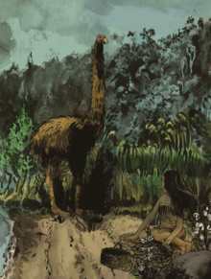
If you have access to a device, watch the short news clip (or read the transcript) about an artist with a science background, who is helping people to see and know animals that are now extinct through his paintings.

Your task:
Task 1 – Read The Moa and watch the video if you have access.
Task 2 – Choose one of these responses to your reading and/or viewing.
- Write a short story describing an encounter with an extinct animal endemic to New Zealand
- Draw or paint an extinct animal or species endemic to New Zealand.

Remember to do your end of day reflection and wellbeing activities (see p. 6 & 8).

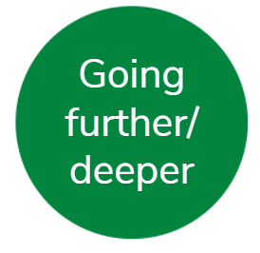
Day 4 activity 1: “It’s a Movement”
Notes for teachers and whānau
Greta Thunberg has made a significant impact on world leaders and youth across the world. Her speeches and events have involved hundreds of thousands of young people taking action for climate change. Learners will view one of her speeches to identify the main ideas and determine their response to her campaign. Learners are asked to seek the views of an adult about the speech, as Greta Thunberg became a household name, her ideas were viewed as both negative and positive. This activity asks the learner to form their own view or stance and seek to compare their stance with others. Note today our Inquiry focus is “going further, deeper”. This may include promoting opportunities to dive deeper through discussions, provocations, exploring further contexts, taking action, or thinking critically and drawing conclusions.

I am learning to:
- identify key ideas in a speech and link them to the Sustainable Development Goals
- understand people can adopt different roles in response to community challenges
- understand how individuals can act and inspire groups to collective action
What do I need?
- 30 minutes
- Greta Thunberg at COP24 in Katowice 2018 https://www.youtube.com/watch?v=VbDnPj0G0wY
Remember to start your day right (see p. 7).

Instructions
This activity invites you to understand how an individual can inspire groups of people to collective action. Greta Thunberg has made an enormous impact on the world stage, with world leaders and became a household name. People responded to her speech with diverse views and perspectives about the ideas she shared. Some saw her ideas, the events she organised and her actions as: divisive, radical, inspiring, provocative.

Your task:
Watch Greta Thunberg’s speech or read the transcript
Think critically about the key ideas and messages shared by the speaker
Transcript
My name is Greta Thunberg. I am 15 years old, and I am from Sweden. I speak on behalf of climate justice now.
Many people say that Sweden is a small country, and it doesn’t matter what we do. But I’ve learned that you are never too small to make a difference. And if a few children can make headlines by not attending school then imagine what we could all do together if we really wanted to. But to do that we have to speak clearly no matter how uncomfortable that may be.
You only speak of a green eternal economic growth because you are too scared of being unpopular. You only talk about moving forward with the same bad ideas that got us into this mess even when the only sensible thing to do is pull the emergency brake. You are not mature enough to tell it like it is, even that burden you leave to us children. But I don’t care about being popular. I care about climate justice and the living planet.
Our civilisation is being sacrificed for the opportunity of a very small number of people to continue making enormous amounts of money. Our biosphere is being sacrificed so that rich people in countries like mine can live in luxury. It is the sufferings of the many which pay for the luxuries of the few.
The year 2078 I will celebrate my 75th birthday. If I have children maybe they will spend that day with me. Maybe they will ask me about you. Maybe they will ask why you didn’t do anything while there still was time to act.
You say you love your children above all else and yet you are stealing their future in front of their very eyes. Until you start focusing on what needs to be done rather than what is politically possible, there is no hope.
We cannot solve a crisis without treating it as a crisis. We need to keep the fossil fuels in the ground, and we need to focus on equity. And if solutions within this system are so impossible to find then maybe we should change the system itself.
We have not come here to beg world leaders to care. You have ignored us in the past and you will ignore us again. You have run out of excuses, and we are running out of time. We have come here to let you know that change is coming whether you like it or not.
The real power belongs to the people. Thank you.

List the key ideas in the speech and match them to one or more of the SDGs
Key Idea’s in speech | Sustainable Development Goal
Invite an adult to view this speech and seek their response and perspectives.
My view about Greta Thunberg’s ideas | An adult’s view about Greta Thunberg’s ideas

Day 4 activity 2: Ecological Footprints
Notes for teachers and whānau
Learners will need to access an eco-footprint calculator online.
Learners will benefit from discussions to help make links between the information required for the ecological calculator and their own impact on the environment. Discuss the meanings of footprint, food footprint, and goods and services footprint. Note that eco-footprint calculators are unlikely to be specific to New Zealand and may not even have New Zealand on the list of selectable countries. If necessary, learners can pick the country or place that is likely to provide the closest match, e.g. Australia.

I am learning to:
- gather and enter personal lifestyle data
- interpret data displays in order to identify patterns and trends
- change input variables and observe the effect on outputs
- estimate sources of variation in eco-footprints
What do I need?
- 30 minutes
- Device to Access: Ecological footprint calculator https://www.wwf.org.au/get-involved/change-the-way-you-live/ecological-footprint-calculator

Instructions
This activity explores one idea using 3 different representations: a bar graph, a pie chart, and a ratio (3.6 Earths if everyone on Earth lived like Adena). When thinking about factors that can increase or decrease an eco-footprint, think of the things that lie outside your present sphere of influence, responsibility, or possibility (e.g. making more use of wind generation) and of things that you can do yourself (e.g. walk more, not ask for or buy the latest gadgets, make clothes last longer, take shorter showers).

Your task:
An ecological footprint is a measure of the amount of Earth’s resources required to provide all the stuff we use, such as the food we eat and the house we live in, the fuel to keep us warm and to run our car, and the energy to make all the things we buy.
- Access the online Ecological footprint calculator and find out how many Earths we would need if everyone in the world lived like you.
- In 2009, New Zealanders consumed an average of 57.4 global hectares per person. How does your ecological footprint compare with this figure?
- Suggest why a person’s eco-footprint might be more or less than this average.
- Below are three different ways to display data from eco-footprint sites.

Oromia took a quiz and generated a bar graph to display his ecological footprint:

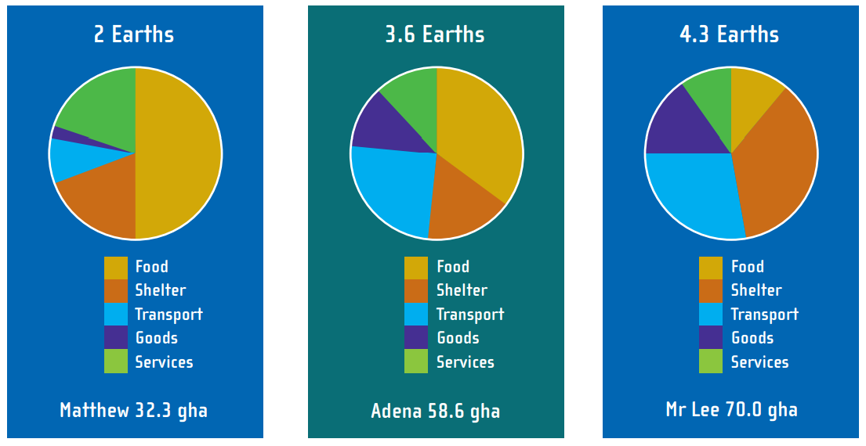
Matthew, Adena, and Mr Lee took a different quiz that generated pie charts to show how many Earths would be needed if everyone lived like them:

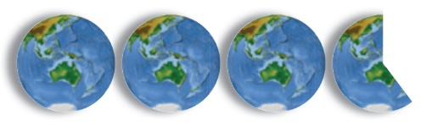
This is Adena’s eco-footprint shown as Earths

- Do these different displays provide different information? You could use a Venn diagram to compare the information that is the same and different.
- Discuss how Adena might shrink her eco-footprint.

- Make some changes:
- Repeat the quiz you did online, but this time change 1 variable (for example, use only public transport). What difference does this make to your eco-footprint?
- Set a target eco-footprint for yourself. How could you change your lifestyle to meet that target?
- Take the quiz again, imagining that you have made these changes. How close did you get to your target? What else would you have to do to meet your target?

Day 4 activity 3: Can we the people take the lead?
Notes for teachers and whānau
Learners will benefit from access to a device and the internet for this activity.
Act Now is the United Nations campaign for individual action on climate change and sustainability. Learners are invited to download the Act Now app to support and monitor their actions and will benefit from support and guidance from an adult.

I am learning to: Investigate simple changes that New Zealanders can make to lower our ecological footprints
What do I need?
- 30 minutes
- Look in your pack for a copy of the Act Now Action Guide https://www.un.org/sites/un2.un.org/files/actnow_action_guide_2021.pdf
- Optional digital:
Act Now app https://actnow.aworld.org/
Act Now site https://www.unep.org/interactives/things-you-can-do-climate-emergency/
Be a food hero https://www.un.org/en/actnow/food-hero
Climate change fast facts https://www.un.org/en/climatechange/climate-fast-facts
Just a kid | Global goals https://www.youtube.com/watch?v=Sl-mjCLInm0

Instructions
Our lifestyles have a profound impact on our planet. Our choices matter. From the energy we use, the food we eat and the way we travel, we can make a difference.

Your task
- Read the Act Now action guide.
- Identify simple changes you and your family can take.
- Use a chart to organise your thoughts. You won’t be able to make a change for all of them, but even identifying one change will make a big difference.
Impactful climate actions | My thoughts and ideas
1 Save energy at home
2 Walk, bike, or take public transport
3 Eat more vegetables
4 Consider your travel
5 Throw away less food
6 Reduce, reuse, repair, and recycle
7 Change your home’s source of energy
8 Switch to an electric vehicle
9 Choose eco-friendly products
10 Speak up
Digital options:
- Download the Act Now App to monitor your changes https://actnow.aworld.org/
- Check out https://www.unep.org/interactives/things-you-can-do-climate-emergency/ for actions you can take towards net-zero emissions.

Day 4 activity 4: When a Story breaks
Notes for teachers and whānau
This activity encourages the learner to think about how information is shared and the many ways we receive news. The article canvasses differing points of view on whether the wreck of the Rena should be salvaged or left on the Astrolabe Reef/Ōtāiti. It reveals the complexity of the advice and views to take into consideration.

I am learning to: evaluate different information sources
What do I need?
- 30 minutes
- Look in your pack for a copy of the article What now for the Rena https://instructionalseries.tki.org.nz/Instructional-Series/Connected/Connected-2016-Level-4-Getting-the-Message/What-Now-for-the-Rena

Instructions
Read What Now for the Rena. Find out how your family and friends discovered this environmental disaster and how they reacted. Think about how you are informed of local, national, and global events and consider your preferred platform.

Your task
Read the school journal story What Now for the Rena
Investigate how people in your whānau learnt about the environmental disaster.
Record in your responses to:
- How are people informed of major news events in 2022?
- Which media forms are the most popular with certain demographic groups?
- How are people’s views and perspectives of an event authentically shared?
- How do you prefer to receive and share your news and events?
- Research and describe attributes/benefits and disadvantages of media types:
Media format | Benefits | Disadvantages | Target audience
Twitter | Immediate, brief ( less than 140 characters) calling for concise brief messages  Massive audience potential  Widely accessible  Cheap | Brief – limited message size  Fake news spreads easily | 38.5% of users aged between 25-34 yrs  70% of users are men  23% of US adults use Twitter
Facebook
CNN
TVNZ
RNZ
Other
Remember to do your end of day reflection and wellbeing activities (see p. 6 & 8).

Day 5 activity 1: Ali finds a way
Notes for teachers and whānau
Learners will read a comic that focuses on making sure everyone is treated equally and making towns safer and easier for people to get around, including people with disabilities. The comic is set in the Middle East, you might want to locate this are on a map to help orientate the learner. Note our Inquiry focus is “present – share learning about the big idea” which includes thinking about who the audience is, and considering different ways of communicating learning – for example, presentation, video, poster, etc.

I am learning to:
What do I need?
- 30 minutes
- Look in your pack for a copy of Ali finds a way https://sites.unicef.org/disabilities/files/AliFindsAWay-digital.pdf
Remember to start your day right (see p. 7).

Instructions
You have looked at the benefits of well-designed cities and towns, and you imagined what could be done to make your hometown well-designed. Now we are going to meet Ali who lives in the Middle East, very different to where you live! In this comic we find out what Ali did to help make his town safer and easier for people to get around and making sure that everyone is treated equally.

Your task:
Read Ali finds a way
The comic illustrates actions to meet goal 10 – Reduced inequalities (reduce inequality within and among countries) and goal 11 – Sustainable cities and communities (make cities inclusive, safe, resilient, and sustainable).
Answer these questions:
- What inequalities did the story highlight?
- How were these overcome?
- What was it about the community that wasn’t inclusive, safe, resilient, or sustainable?
- How were these overcome?
Review your drawings for what your hometown would look like if the 2030 goals were achieved. Thinking about the experiences of Ali, are there any other changes you might make to your drawing?
Update your drawing or you might want to completely reshape your vision.
Label the changes to your community that you made to address goals 10 and 11.

Day 5 activity 2: Plan to share my message
Notes for teachers and whānau
Learners plan how they will communicate their commitment to action to a targeted audience using their preferred media platform, e.g.’ a script for a TV newsreader, a post for Facebook or Instagram, a tweet, a newspaper article etc.

I am learning to: create a storyboard to outline a plan.
What do I need?
- 30–60 minutes
- Optional digital: Learners can use an online tool to create their storyboard.

Instructions
Consider how effective the comic about Ali was in helping you to understand actions that could be taken for goals 10 and 11 in his community. Were you inspired? The purpose of this activity is to plan a communication about your plan to take action. When we share our plans it makes it easier for others to help us, and it keeps us on track.

Your task:
Reflect on your learning about the Sustainable Development Goals, the issue you care about, and the actions you have identified.
Write brief notes answering these questions:
- What change do you want to make?
- What is the anticipated timeline of your project?
- What are the steps in your roadmap?
- What are the key objectives at each point?
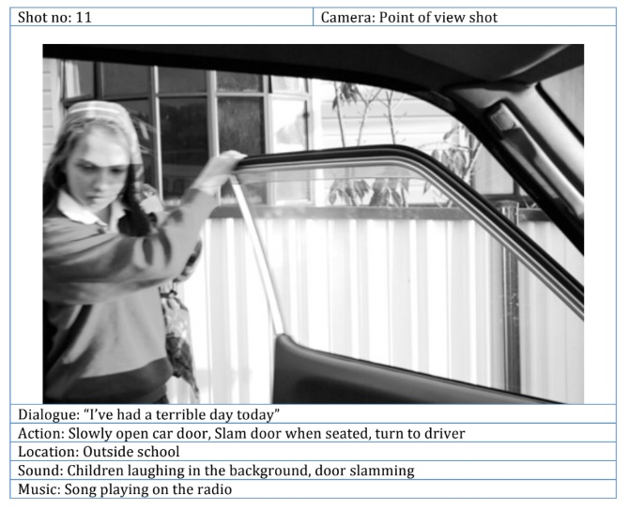
- What is your anticipated impact?
- How do you plan to measure impact?
Create a storyboard to outline the key parts of your communication. A storyboard can be used as a graphic organiser to order your thoughts. It is a comic strip that tells your message. You can indicate images, sounds, movement, dialogue, lighting etc that could be used to convey your message. Your storyboard can be created on the computer (like the example) or drawn on paper.
The drawings don’t have to be works of art. Stick figures with arrows to show movement will do. You could set out your storyboard like this:
Image
Text

Day 5 activity 3: Share my message
Notes for teachers and whānau
Your learner is encouraged to communicate their plan for action. This activity can take as long as needed to create a finished product from a plan. Adult guidance is required if the learner is intending to share their communication on social media.

I am learning to: communicate my commitment to the SDGs using preferred media or language of communication
What do I need?
- Resources identified to carry out my communication plan
- Optional digital: Sharing stories from changemakers https://worldslargestlesson.globalgoals.org/campaign/sharing-stories-from-young-changemakers/

Instructions
Now your thoughts are in order and your message is clear, it’s time to create your communication to share what you have learnt about the United Nations Sustainable Development Goals. The purpose for sharing is to educate your friends and family about the SDGs. You can do this with or without a device. You could create:
- Written text – comic, media statement, short story, etc
- Sound – song, soundscape, spoken word
- Images – infographic, poster, advertisement, still image
- Arts – dance, drama, painting, sculpture
- Digital platforms – tik tok, video, animation
- Any other idea you have that will let you share your learning persuasively with your friends and whānau.
Think about who your target audience will be and how you might communicate your ideas and plans either face to face or virtually.

Your task:
If you have access to the internet you can watch the videos of young people from all over the world who are taking action for the global goals. https://worldslargestlesson.globalgoals.org/campaign/sharing-stories-from-young-changemakers/
Choose your chosen medium for communication (see list above).
Create your communication.
Share your communication with your friends, whānau, teacher, and classmates.

Day 5 activity 4: Reflecting on my learning
Notes for teachers and whānau
In this last activity for the theme of environmental sustainability your learner is encouraged to reflect on their learning. This is a great opportunity to have a discussion and help them to maintain optimism about the future and taking action.

I am learning to: use thinking tools to reflect on my learning
What do I need?
- Someone to talk to
- Workbook

Instructions
Isn’t it exciting that people all over the world can work together on a plan like the Sustainable Development Goals! Everyday we can make one small change that makes life better for someone.

Your task:
Choose one of the following ways to reflect on your learning:
Reflection and action chart
I was surprised to find out ...
The most interesting thing I learnt was ...
I would like to know more about ...
I don’t understand ...
One thing I would like to do now is ...
Edward de Bono’s thinking hats
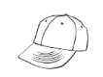
What are some of the facts you learnt about this topic?
How do you feel as a result of your learning?
What were some of the negative aspects of this topic?
What were some of the positive, encouraging, or hopeful aspects?
What ideas or possibilities can you think of about this topic?
What is the big idea that you have been left with as a result of your learning?

Remember to do your end of day reflection and wellbeing activities (see p. 6 & 8).

Context 2: Cultural Sustainability

Over the next five days we will investigate the theme of sustainability by looking at how we can understand and work towards cultural sustainability.

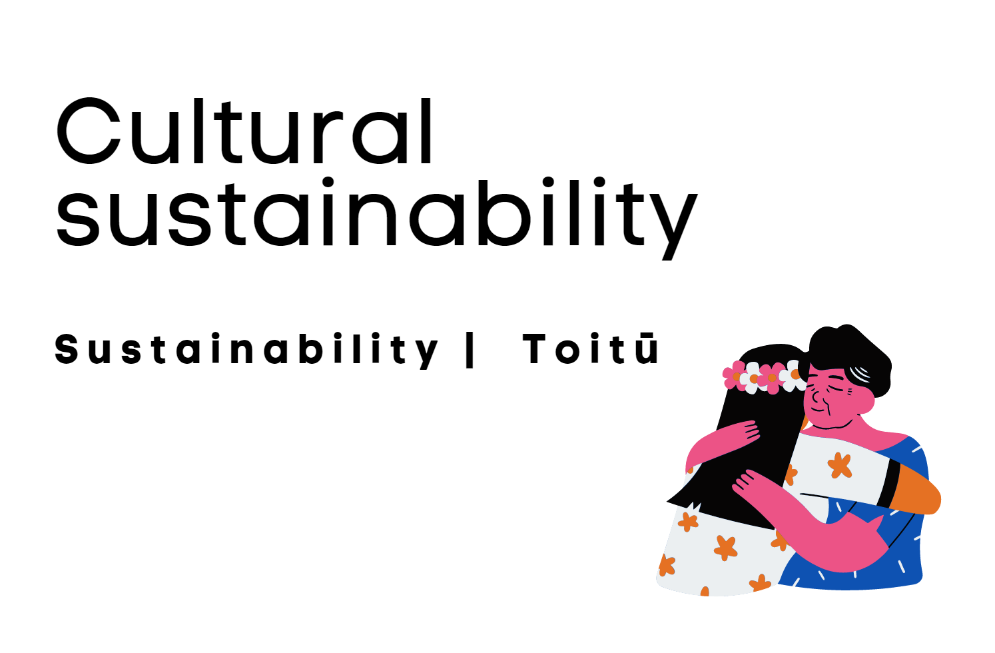

Day 6 activity 1: Human rights
Notes for teachers and whānau
As our learners launch into learning about cultural sustainability, they will begin by exploring ‘human rights’ and the concept of equity. They will read texts and make connections.
Learners will be exploring the learning areas of social science and literacy. Note that our Inquiry focus for today is “getting started” which includes generating questions, activating prior knowledge, and introducing the theme.

I am learning to: make connections between human rights and equality
What do I need?
- 30 minutes
- Copy of School Journal Level 4, November 2019 Year 8 - https://instructionalseries.tki.org.nz/Instructional-Series/School-Journal/School-Journal-Level-4-November-2019/Chinese-New-Zealanders
Remember to start your day right (see p. 7).

Your task:
Define these words using a dictionary and record them in your book:
- Human Rights
- Equality
- Equity
- Inclusion
- Justice

Complete a concept circle for ‘human rights’ using the words you have just defined:
equality, equity, inclusion and justice in the four quadrants. Explain the relationship between each word and the concept; then describe the relationships among the four words.

Read about Chinese migration to New Zealand in the text Chinese New Zealanders.
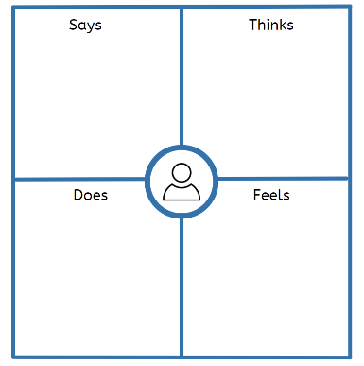
Write: what connections can you make between the text and the terms ‘human rights’ and equality?

Complete an empathy map for Chinese immigrants. An empathy map can help you gain a clearer picture of differing cultural perspectives by considering how different groups feel as well as predicting what each group might say, do or think

Day 6 activity 2&3: Human rights, why it matters
Notes for teachers and whānau
Now that learners have defined some of the key vocabulary and considered how important human rights are for individuals and groups they will explore how countries and people can reduce inequality. Learners will be exploring the learning areas of maths, specifically geometry.

I am learning to: identify ways that inequality can be reduced within and among countries
What do I need?
- 60 minutes
- Look in your pack for a copy of Why it Matters https://www.un.org/sustainabledevelopment/wp-content/uploads/2018/01/10_Why-It-Matters-2020.pdf

Your task:
Read: Why it Matters, one of many texts published by the United Nations around the 17 sustainable development goals. Goal #10 refers to ‘Reduced Inequalities’ and is all about ensuring that nobody is left behind. Inequality is an ongoing concern and despite many positive gains in many countries, the issue continues to a global one.
Inequality relates to culture, basic rights, responsibilities, and access.
Complete the following chart in your home learning book:
Topic/Question: | My Notes:
Why is reducing inequalities within and among countries important?
What are some examples of inequity?
What does discrimination have to do with inequity?
How can I/we help? What can we do?
Write: do you think reducing inequality is important for cultural sustainability? Why or why not?
Check out these facts from https://www.un.org/sustainabledevelopment/inequality/:
- Evidence from developing countries shows that children in the poorest 20 percent of the populations are still up to three times more likely to die before their fifth birthday than children in the richest percentage.
- Social protection has been significantly extended globally, yet persons with disabilities are up to five times more likely than average to incur catastrophic health expenditures.
- Despite overall declines in death during childbirth in most developing countries, women in rural areas are still up to three times more likely to die while giving birth than women living in urban centres.
- Up to 30 percent of income inequality is due to inequality within households, including between women and men. Women are also more likely than men to live below 50 percent of the median income
- Of the one billion population of persons with disabilities, 80 percent live in developing countries.
- One in ten children is a child with a disability.
- Only 28 percent of persons with significant disabilities have access to disability benefits globally, and only 1 percent in low-income countries.
Recommend: what three actions would you recommend to the United Nations in order to address the facts above related to inequality? Record these in your home learning book.
Choose one option:
- Create a poster to promote your 3 recommendations
- Write a persuasive letter to the UN to urge them to take action – to take your 3 recommendations onboard and activate them immediately!

Day 6 activity 4: Where on Earth?
Notes for teachers and whānau
Learners will learn about how maths is related to the world around them. These activities will develop students’ understanding of latitude and longitude and how they are used to describe locations. Using technology appropriately and using spatial visualisation to solve problems develops the key competency using language, symbols, and texts. Learners will be exploring the learning areas of maths, specifically geometry.

I am learning to: Interpret and use scales, timetables, and charts
What do I need?
- 30 minutes
- An atlas or globe, optional: Access to the internet
- Copy of https://nzmaths.co.nz/resource/where-earth-0

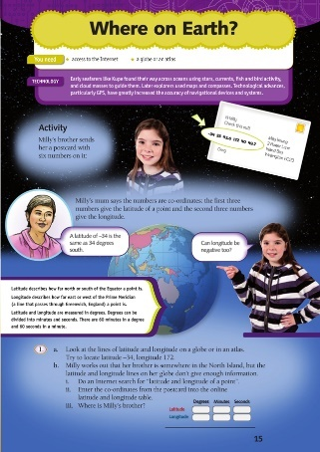
Your task:
Read this: Geometry is the study of shape, size, relative position, and space, and is one of the oldest branches of mathematics. Did you know: The literal meaning of geometry is to “measure the Earth”.
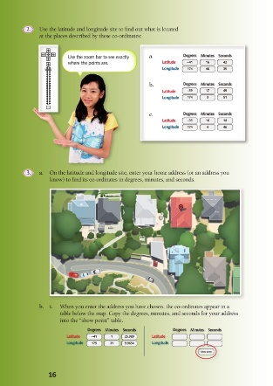
The accuracy with which we measure depends on both our needs and the sophistication of the tools available. The use of GPS technology enables people to pinpoint places on Earth with incredible speed and accuracy. In these activities, students explore latitude and longitude.
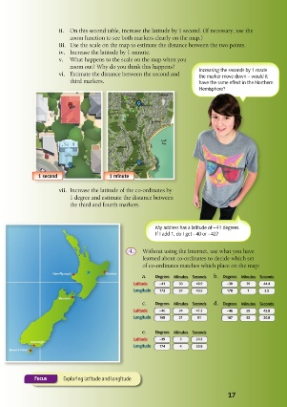
Some of you might wrongly perceive mathematics to be unrelated to you or your culture. In reality, mathematics is found in all cultures. For example, Polynesian peoples skilfully navigated across thousands of kilometres of ocean using sophisticated navigation techniques. Navigation skills were highly valued and were passed down orally, often by song. Important facts were memorised: the motion of specific stars and where these stars would rise and set on the ocean, weather conditions, times of travel, wildlife species and cloud formations on particular islands, the direction of ocean swells, colours of sea and sky, angles for approaching harbours.
Complete the tasks in the Where on Earth Figure it Out activity.

Remember to do your end of day reflection and wellbeing activities (see p. 6 & 8).

Day 7 activity 1: Cultural art Installation
Notes for teachers and whānau
We highly recommend learners watch the video for this activity.
Learners will explore an art installation to see how it relates to cultural sustainability. Learners will be exploring the learning areas of visual arts, te ao Māori and social science. Note our Inquiry focus is “explore, investigate, and discover” which includes choosing and evaluating information, and thinking critically.

I am learning to: respond to an art installation
What do I need?
- 30 minutes
- Lisa Reihana – Emissaries (in Pursuit of Venus) https://www.youtube.com/watch?v=TEZQ-O4vihY
Remember to start your day right (see p. 7).

Your task:
Respond to an Art Installation -- Lisa Reihana- Emissaries (In Pursuit of Venus)
In the video you will see how the artist Lisa Reihana was inspired to create her artwork. She was inspired for her art installation to talk across time. She used soundscapes and lighting to bring the past to life in an authentic way, endeavouring to capture a true and immersive representation of the historical Māori culture in moving vignettes.
Watch the video (highly recommend if possible) or read the transcript:
Transcript
It’s sort of around 24m long and 4m high. It’s delivered using five projects. There’s 20 speakers in the room and because the work slowly scrolls from right to left James and Shawn Cooper worked on a sound design that moves across the room but also created an ambience within the room which has the sounds to give you a sense of being outside. It was bringing the outside in. So there are sounds of birds and waves, and natural sounds to create the sense of being in this other place.
When I was in the National Gallery of Australia in Canberra 6 years ago I saw Les Sauvages De La Mer Pacifique. I was completely gobsmacked because I couldn’t see anything that I recognised and suddenly through what an amazing idea to bring a wallpaper back to life.
I found it strange mostly because it was supposed to be looking at Māori and Pacific people I couldn’t see them at all. They’ve got an image here and they have Grecian clothes, and they didn’t look like anything I would think of as Māori and Pacific people. But actually my ‘aha’ moment was when I, a couple of years later, pulled out the catalogue for the book and then really was struck by what a great and strange work it was, but why it was such a great place for me to talk across time. And that the people in the 18th century were using a whole lot of other illustrations and ideas and creating the wallpaper as a structure to put these images into. Whereas my interest in this particular work was to correct, a thinking of a woman 200 years later using video technology to construct this large tableau of images of Māori and Pacific people and correct what I thought they should actually look like.
It's taken me a long time. I spent a year just deciding where the horizon line would sit in my project because with technology once I’d set the pixel ratio of the work then I couldn’t go back. So I really was future proofing it for a presentation that still didn’t even exist yet. So it’s really thinking about time and many different ways and trying to keep the work as open as I possible could so that the conversations talk not only back to the 18th century but talk to people in the future who will get to see the work.
In Neoclassical France, entrepreneur Joseph Dufour used the latest printing innovations to produce Les Sauvages De La Mer Pacifique (1804), a sophisticated twenty panel scenic wallpaper. Mirroring a widespread fascination with the Pacific voyages undertaken by Captain Cook, de Bougainville and de la Perouse; it’s exotic themes referenced popular illustrations of that time.
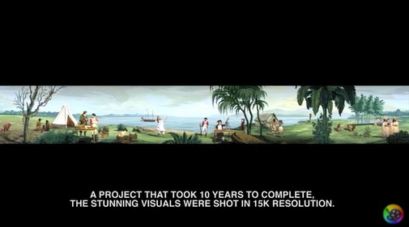
Two hundred years later, Māori artist Lisa Reihana employs twenty-first century digital technologies to animate Les Sauvages De La Mer Pacifique. Enlivened with the sights and sounds of dance and cultural ceremonies, a vast video panorama is populated by a myriad of people drawn from across New Zealand and the Pacific.

Think critically about how the artist’s thinking was conveyed using technology to ‘correct’ the viewer’s interpretation of early colonisation and cultural representation.
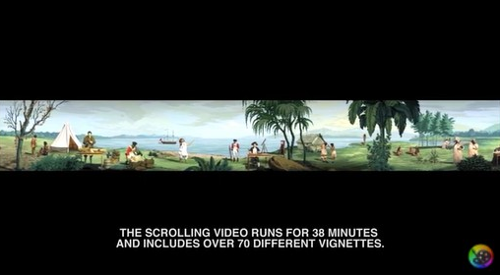
Consider why the artist gave such careful consideration to how time is conveyed to the viewer now and in the future

Respond: How is this piece related to cultural sustainability?

New Zealand Pavilion at the 2017 Venice Art Biennale Viva Arte Viva Emissaries Artist: Lisa Reihana Commissioner: Alastair Carruthers Curator: Rhana Devenport | Filmed and Edited By: Mickey Mayer Interviews courtesy of: Te Papa Tongarewa & Wintec Spark Extra footage from: Lisa Reihana

Day 7 activity 2: Cultural sustainability
Notes for teachers and whānau
In Aotearoa, New Zealand, cultural sustainability is super important because we are a bi-cultural country. This is the only place in the world where Māori come from. It is important for all ākonga to have a strong understanding of the content and intent of our founding document, the Treaty of Waitangi as well as how the Māori culture is important for all New Zealanders to sustain. Learners will be exploring the learning areas of Te ao Māori, literacy, and social science.

I am learning to: demonstrate knowledge of the Treaty of Waitangi
What do I need?
- 30 minutes
- Look in your pack for a copy of Te Tiriti o Waitangi https://instructionalseries.tki.org.nz/Instructional-Series/School-Journal-Story-Library/Te-Tiriti-o-Waitangi

Your task:
In Aotearoa, New Zealand, cultural sustainability is super important because we are a bi-cultural country. This is the only place in the world where Māori come from.
Optional digital: Watch He Whenua Rangatira: A Māori Land
https://www.youtube.com/watch?v=8w0zjqA3hUI
Now listen to the audio recording and read Te Tiriti o Waitangi by Ross Calman, Mark Derby, & Toby Morris.
Show what you know about Te Tiriti o Waitangi and te ao Māori. Choose one of the following:
- Create a crossword using paper with at least ten clues
- Write a multiple choice test with at least ten questions
- Create a simple board game with at least ten questions
- Create a quiz using Kahoot (www.kahoot.com ) with at least ten questions
- Create a Flippity Quiz Show with at least ten questions
- Create a set of Flippity Flash Cards (https://flippity.net/ ) with at least ten clues/words

Day 7 activity 3: Maths craft
Notes for teachers and whānau
Learners will experience the playful and curious side of maths in this activity. They will learn that making mistakes is part of learning as they endeavour to make a mobius strip and practice some different knots.

I am learning to: create Möbius strips and mathematical knots
What do I need?
- 30 minutes
- Copy of https://instructionalseries.tki.org.nz/Instructional-Series/Connected/Connected-2019-Level-4-Seeing-Beyond/Maths-Craft (print Slides 1-9 for learners)

Your task:
Today you will have some fun with Maths Craft! You will take a playful, creative approach to pure mathematics as you do craft activities that allow you to explore the properties of Möbius strips and mathematical knots. Shapes can be transformations and have the same features but look different. Mathematicians play with and extend ideas to look for recurring patterns and relationships.
Read the Connected: Maths Craft slides and follow the instructions to create Möbius strips and mathematical knots.
Optional digital: View videos on Möbius strips
https://thekidshouldseethis.com/post/17712032055
https://www.youtube.com/watch?v=ZN4TxmWK0bE
Extension:
Reread Knotty Adventures and then look at the image:
The image shows all of the different knots that have between 0 and 7 crossings. These are called prime knots because they cannot be made by joining smaller knots together. Joining two or more prime knots forms a composite knot.
Use the Prime Numbers Chart and Calculator on the Maths Is Fun site (optional: https://www.mathsisfun.com/prime_numbers.html to clarify the connection between prime and composite knots and prime and composite numbers.
Compare the prime knots chart with the photographs on page 8. Consider:
- Which have we already created?
- Which would you like to have a go at creating?

Day 7 activity 4: Cultural sustainability requires everyone to honour the Treaty of Waitangi
Notes for teachers and whānau
In this task learners will investigate the meanings of and connections between key themes as illustrated in the Te Tiriti o Waitangi text. Learners will be exploring the learning areas of te ao Māori, social science, and literacy.

I am learning to: connect the Treaty process with cultural sustainability
What do I need?
- 30 minutes
- Look in your pack for a copy of https://instructionalseries.tki.org.nz/Instructional-Series/School-Journal-Story-Library/Te-Tiriti-o-Waitangi

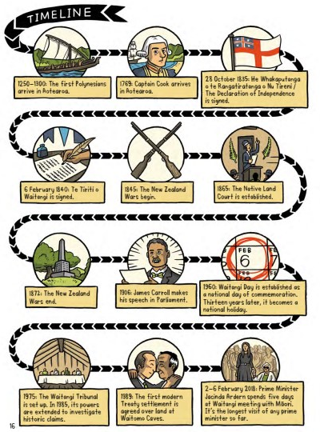
Your task:
Now re-listen to the audio recording and reread Te Tiriti o Waitangi by Ross Calman, Mark Derby, & Toby Morris from earlier today. You will have noticed that this comic provides a fresh approach to the story of Te Tiriti o Waitangi, New Zealand’s founding document. It covers a wide time span, from the arrival of Polynesian explorers to the signing of Te Tiriti, to the New Zealand Wars, and through to the modern-day Treaty settlement process. The text outlines the importance of addressing historical injustices to create a fairer society and brings to the fore the understanding that events can be interpreted in different ways. Toby Morris’s cartoon-style illustrations make the information accessible and engaging without sacrificing historical accuracy. The timeline at the back of the book will help you to make sense of the significant stages.
As you reread take note of the following in your home learning book:
- Explore key concepts from Te Tiriti o Waitangi text such as: Tino rangatiratanga, sovereignty, governorship, independence.
- Illustrate concepts as you read the text
- Make connections to your life- what does it mean to be independent? What does sovereignty have to do with me?
- Describe what is meant by ‘The Crown’ in 1840 and what we mean by ‘The Crown’ today.
- How does/did reading this text make you feel?
- How does this text relate to your community?
- Compare the concept of belonging to owning land. Why is this significant to cultural sustainability?
Remember to do your end of day reflection and wellbeing activities (see p. 6).

Day 8 activity 1: Human rights and cultural sustainability
Notes for teachers and whānau
In this task learners will examine the Sustainable Development Goals as published by the United Nations and make connections to both human rights and cultural sustainability as they do so. Learners will be exploring the learning areas of social sciences. Note that our Inquiry focus for today is "making meaning" which includes analysing data, organising, and sorting information, summarising, synthesising, making connections/conclusions, building deeper understandings, and thinking critically.

I am learning to: summarise information, make inferences and take notes
What do I need?
- 30 minutes
- Look in your pack for a copy of The Sustainble Development Goals https://www.ohchr.org/sites/default/files/Documents/Issues/MDGs/Post2015/SDG_HR_Table.pdf
Remember to start your day right (see p. 7).

Your task:
The Universal Declaration of Human Rights states that “recognising the dignity and equal rights of all members of the human family is the foundation of freedom, justice and peace in the world.” In this activity you will make some direct connections between the United Nations Sustainable Development Goals, human rights, and cultural sustainability. You have already done some learning around these.
Create a Word Square for the term ‘cultural sustainability’.
Word: cultural sustainability  Definition:  “Cultural sustainability is defined as values and attitudes that can be maintained or improved despite external influences. Cultural sustainability is an enabler and driver of sustainable development...” | Use it in a sentence:
Describe why it is important: | Illustrate the word:
Read the SDG table (look in your pack or use the link above) and complete the table below: Note that as you complete the table you will be taking notes and practicing the skills of synthesizing, summarising, and making inferences.
Choose 5 of the Sustainable Development Goals for your table and complete the table in your home learning book.
Sustainable Development Goal | Connections to human rights | Connections to cultural sustainability
e.g. #4 Quality Education | This is linked to the: right to education, equal rights of women and girls in the field of education, right to work, including technical and vocational training and international cooperation | Without access to education cultural sustainability is threatened as indigenous peoples will have less of a voice, reduced opportunities to share their values, and they will have fewer choices and they will have minimal finance to help their culture survive and thrive.

Respond: In your home learning book write a response to this question providing examples as needed. How do Human Rights relate to cultural sustainability?

Optional digital: for more information go to https://en.unesco.org/culture-development and watch the two videos on this page.

Day 8 activity 2: Human rights and the Treaty articles
Notes for teachers and whānau
The Treaty of Waitangi outlines three articles and three principles. There are some quite clear alignments between these and how human rights are honoured in our country. In this activity, learners will need to tap into their prior knowledge, access some key resources and use these to make judgements about how the principles and articles are connected with maintaining some of our human rights as outlined by the United Nations. Learners will be exploring te ao Māori, literacy, and social science.

I am learning to: make deep connections between the Treaty of Waitangi and basic human rights
What do I need?
- 30 minutes
- Your copy of The Sustainable Development Goals https://www.ohchr.org/sites/default/files/Documents/Issues/MDGs/Post2015/SDG_HR_Table.pdf from the last activity
- p. 8 from https://instructionalseries.tki.org.nz/Instructional-Series/School-Journal-Story-Library/Te-Tiriti-o-Waitangi# from activity 4 on Day 7

Your task:

Read this to gain familiarity with the principles of the Treaty of Waitangi:

Te Tiriti o Waitangi Principles

The three “P’s”, as they are often referred to, are the principles of partnership, participation and protection. These underpin the relationship between the Government and Māori under the Treaty of Waitangi. These principles are derived from the underlying tenets of the Treaty. They are used to bridge the gap between the literal differences between the Māori and English texts.

Partnership - Partnership involves working together with iwi, hapū, whānau and Māori communities to develop strategies for Māori education. Partnership encourages and requires Māori to be involved at all levels of the education sector, including decision-making, planning, and development of curriculum.

Partnership is:
- engaging with Māori community
- inquiry- place based learning-finding out about the Māori origins of your rōhe, mountains, rivers, history
- having Māori representatives on boards of trustees
- equity for Māori
- power sharing

Partnership relies on us welcoming and having genuine relationships with our Māori community. Historically for many Māori there have not been “open door” policies and Māori have not felt welcomed and valued in some schools.

Sometimes these relationships take time and effort. For most communities, once they feel there is genuine relationship building, they will be more than happy to be a part of the school and add expertise.

Protection

Protection means actively protecting Māori knowledge, interests, values, and other tāonga. Identity, language, and culture are important expressions of what it means to be a culturally located learner. Ka Hikitia (Ministry of Education, 2007) emphasises that “culture counts” and describes a commitment to “knowing, respecting and valuing where students are, where they come from and building on what they bring with them”

Protection is:
- valuing, validating and protecting local knowledge (place-based learning)
- normalising te reo Māori
- learning and including tikanga school-wide
- equity for Māori
- As classroom teachers we are able to implement these principles every day. Normalising te reo not only in your classroom, but in staff meetings, the staff room, on duty, at assemblies and in other areas.

Adding a Māori perspective to topics and inquiry is an opportunity for us to weave tikanga and Māori view point into everyday situations.

Participation

Emphasise positive Māori involvement at all levels of education, as expressed in NEG 9: “Increased participation and success by Māori through the advancement of Māori educational initiatives, including education in Te Reo Māori, consistent with the principles of the Treaty of Waitangi.”

Participation is:
- working to strengthen home-school relationships
- Māori participating in school decision making
- School environment reflecting the biculturalism of Aotearoa
- aspirations of Māori whānau reflected in school planning
- equity for Māori

Coming from the place of honesty and wanting to make a difference for the ākonga puts you in a perfect space to be treaty partners. Māori participants are an asset to our school communities.

Reference: https://www.schoolnews.co.nz/2016/11/te-tiriti-o-waitangi-living-the-values/

Reread page 8 of The Treaty of Waitangi text to remind yourself of the articles:

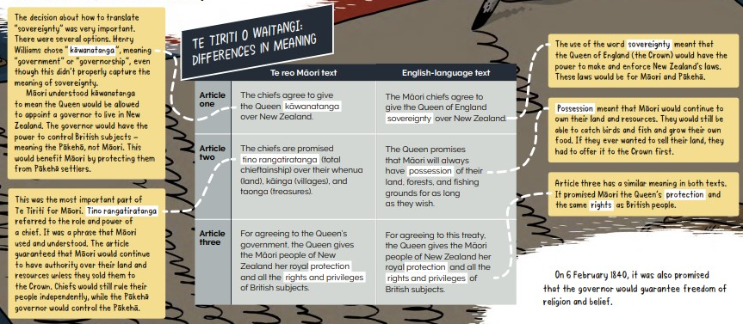

Complete the table to show how the principles and articles are connected to or aligned with human rights in New Zealand:
Human Right | Connection to the principles | Connection to the articles
Example: Right to an adequate standard of living | Participation - equity for Māori | Article 2 - tino rangatiratanga

Right to health

Right to education

Equal rights for all genders

Right to equality and non-discrimination

Right to participate in cultural life

Right to life, liberty and security of the persons

Right to Access to justice and due process

Right to adequate food & right to safe drinking water

Right to participate in public affairs

Day 8 activity 3: Cultural wordshapes
Notes for teachers and whānau
It is important for learners to be aware of cultural sustainability as a concept that matters as a multi-cultural country. Cultural sustainability is a necessary process in our social system that responds to maintenance and preservation of diverse cultural conditions without discrimination or inequality.

I am learning to: visually represent one of the sustainable development goals
What do I need?
- 30 minutes
- Your copy of The Sustainable Development Goals https://www.ohchr.org/sites/default/files/Documents/Issues/MDGs/Post2015/SDG_HR_Table.pdf from the last activity

Your task:

Re-read the SDGs as they relate to human rights table – select 5 SDGs that you think are most important for ensuring cultural sustainability. Remember cultural sustainability is about honouring and preserving the values, perspectives, heritage, history, customs, language, and identity of diverse peoples. Complete the table:

Sustainable Development Goals to support cultural sustainability

Example: SDG #4 - Quality Education

1.

2.

3.

4.

5.

Create a mind map for the term ‘cultural sustainability’. Use the Sustainable Development Goals – Related Human Rights table to help you with word selection.
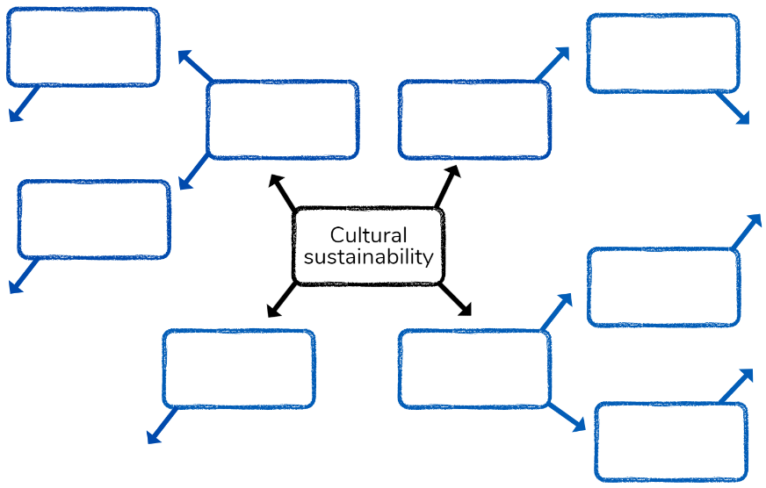

Create a word shape picture to visualise cultural sustainability.

Day 8 activity 4: Cultural iceberg
Notes for teachers and whānau
In this activity learners will explore the idea of the cultural iceberg which signals to learners that culture involves so much more that what we can observe. Learners will be exploring the learning areas of health, social science, and literacy.

I am learning to: draw a representation of the cultural iceberg
What do I need?
- 30 minutes
- Cultural Iceberg https://www.youtube.com/watch?v=woP0v-2nJCU

Your task:
The concept of a cultural iceberg is a visual metaphor for us about culture. The cultural iceberg explains that what is above the water, or what is ‘observable’ (language, arts, traditions, customs, traditions, food, dress, institutions- laws, practices, manners) and what is below the water, or ‘unseen’ (language here as well, beliefs, perceptions, worldview, power, decision making models, ideals, norms, roles, concepts e.g. justice etc.) combine to represent culture.
Watch the video or read the transcript below to learn more:
Transcript
In his book “Beyond Culture” Edward T Hall developed the iceberg analogy of culture. The cultural iceberg theory suggests that like an iceberg there are only some aspects of culture which are visible or which in other words, lie about the surface of the water. These can include language, food, greetings, art, music, and many others. These are the explicit manifestations of culture that are easy to see, taste or hear. But according to Hall’s theory these are only the tip of the iceberg. The majority of culture, like an iceberg, lies beneath the surface. These aspects are not immediately visible. They can include worldview, religion, spiritual beliefs, decision making models, power relationships, respect for authority, concepts of time, and many others. These are the implicit manifestations of culture. They can exert an important influence over behaviour, values, feelings, and thoughts. The more immersed we become in a cultural environment the more these hidden aspects are revealed to us.
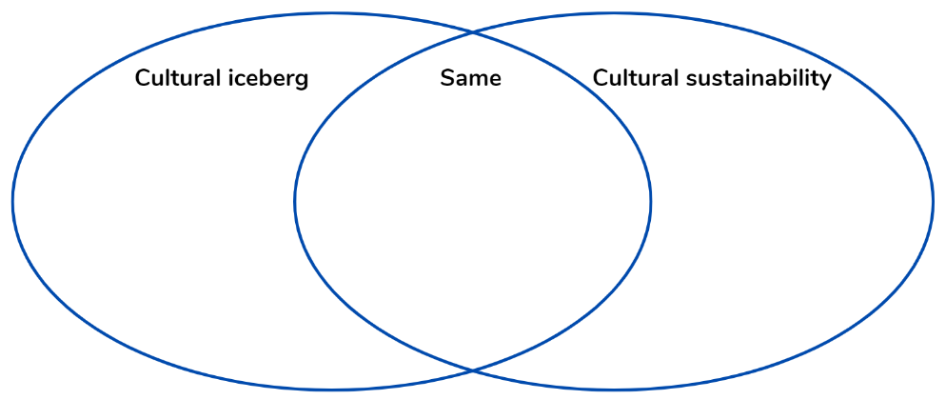
Complete a Venn diagram to demonstrate how the cultural icebergs relate to cultural sustainability by comparing and contrasting the two terms.

Draw your own visual representation to depict the cultural iceberg.
Remember to do your end of day reflection and wellbeing activities (see p. 6 & 8).

Day 9 activity 1&2: Mātauranga Māori

Notes for teachers and whānau
The people of Ihumātao are the mana whenua of Auckland’s oldest settlement. A Māori community has lived on that site for around 1000 years. Recently the mana whenua featured prominently in media and political debate over land ownership disputes. The history and legends from this site are based on the land that provided them with an abundance of food from soil and from the sea. Their role as kaitiaki of the land and waters continues today. To help learners understand the importance of this historical site as an abundant food source and as a site of Mātauranga Māori, learners will develop understanding of why the mana whenua and Māori knowledge is of such significant importance through exploring Māori food and medicine sources. Learners will be exploring the learning areas of Mātauranga Māori/Science and Literacy. Note our Inquiry focus is “going further, deeper”. This may include promoting opportunities to dive deeper, explore further contexts, take action, think critically, and draw conclusions.

I am learning to: understand why Māori highly value mana whenua and Māori knowledge as taonga

What do I need?
- 60 minutes
Science Learning Hub resources:
- Rongoā Maori https://www.sciencelearn.org.nz/resources/185-rongoa-maori
- Set of Native Plant and Māori Medical problems and uses cards: print p.2-3 https://static.sciencelearn.org.nz/documents/files/000/000/063/original/Using_rongo%C4%81_M%C4%81ori.docx?1528155914
- Optional digital: https://www.sciencelearn.org.nz/image_maps/72-matauranga-maori-fungi-as-food-and-medicine and https://www.sciencelearn.org.nz/resources/2678-maori-knowledge-and-uses-of-fungi-quiz

Your task:
Toitū he kāinga, Whatungarongaro he tangata
People pass on but our home in the land remains
Māori have deep respect and connection with their mana whenua or ancestral lands. Today’s learning activities asks you to consider how Māori have used their knowledge of the land and native plant species for food and medicine sources.
Although most of our science knowledge today to do with fighting infection has come through western culture, other cultures, such as Māori culture, have long been aware of plants that have medicinal properties that fight or prevent infection. Rongoā is the traditional Māori healing system. Rongoā is a holistic practice that often includes the use of medicinal properties produced from New Zealand native plants.
This activity looks at some common native plants that are used for rongoā. You will learn about f the plants’ medical uses and some of the diseases and problems that can be treated with various parts of the plants.
View the video Rongoā Māori or read the transcript:
Transcript
Rongoā practitioner Rob McGowan tells us about key wetland plants used to promote natural health. Rob also provides additional insights about rongoā and wellness.
Raupō (Typha angustifolia) has many uses:
- The pollen is mixed with water and baked into a gingerbread-like cake.
- The root or rhizome can be dried and cooked as a kind of porridge.
- The leaves and down are used to make poi.
There are rongoā plants that only grow in wetlands. In the old days, the pollen from the raupō was an important superfood. You didn’t need much of it, but very labour intensive to collect. In a time of need, famine, the roots of the raupō are really, really good to eat – plenty of starch in them – they’re a good energy food. Sometimes in a drought, the pūkeko will eat the roots of the raupō. How do you learn about the raupō being a good kai? You watch the pūkeko, and he’ll tell you what’s good. Harakeke – the flax that grows in the wetland – that’s a very, important rongoā for all sorts of things. Some of the berries on some of the swamp plants, especially the swamp mingimingi in the autumn time is a really good important food, because those tree berries are often rich in vitamins and antioxidants and all sorts of things. Going into winter, we eat the fruits of the autumn as a way of keeping us fit and well for winter.
We have to understand rongoā as Māori understand it. We can say, for example, rongoā is that, when you get a headache, instead of taking an aspirin or whatever, you will get a plant.
Rongoā is much more than healing sickness, and when you understand it in the old sense, it’s a way of being healthy rather than a way of healing. Sometimes you will use it for healing, but firstly, it’s a way of being well. And wellness isn’t confined to physical symptoms. You know, loneliness is a sickness. Loss makes you feel sick. Shame is a terrible sickness – people do bad things because of the shame within them. And so early on, ill health or sickness was seen as being something much more than physical, and unless you deal with the non-physical side of it, you often don’t succeed with the physical side of it.
Māori would say the basis of traditional medicine isn’t rākau, it’s wairua – taha wairua is the source of healing. And then we can go further than that. It’s not the plant’s chemistry, the physical properties that heal you. Firstly, it’s the mauri within the plant relating to the mauri within you, your mauri connecting, and that’s the foundation for your healing.
And so how do we heal Māori health issues? How do we heal diabetes? Not by telling people to stop drinking Coca-Cola. It’s by, in actual fact, restoring people’s belief in themselves and their connections that make them whole, and then they can take on the challenge of changing their diet or getting exercise or whatever. But a lot of our sicknesses are caused by the fact of how we feel and how we connect to our world.
Match the native plants with the medical problems they can relieve using the medical problems with the native plant cards (see your pack).
Explain to others how/why this is important knowledge for cultural sustainability.
Optional digital:
- Explore the Interactive tool Mātauranga Māori: Fungi as Food and Medicine https://www.sciencelearn.org.nz/image_maps/72-matauranga-maori-fungi-as-food-and-medicine
- Complete the Māori knowledge and uses of fungi quiz: https://www.sciencelearn.org.nz/resources/2678-maori-knowledge-and-uses-of-fungi-quiz
- Extension: https://www.sciencelearn.org.nz/resources/1687-ihumatao-past-and-present

Day 9 activity 3: Voyage from Hawaiki
Notes for teachers and whānau
In this activity learners will explore and practice some geometry concepts. The learner may need help using a protractor.
**NB: this video https://www.youtube.com/watch?v=LPc0imoebzI and more info about the activity https://nzmaths.co.nz/resource/voyage-hawaiki might be useful if they get stuck). Learners will be exploring the learning areas of maths, social science, and technology.

I am learning to: follow compass directions and interpret a scale map
What do I need?
- 30 minutes
- Look in your pack for a copy of https://nzmaths.co.nz/resource/voyage-hawaiki and https://nzmaths.co.nz/sites/default/files/HawaikiMapCM.pdf
- Ruler, protractor

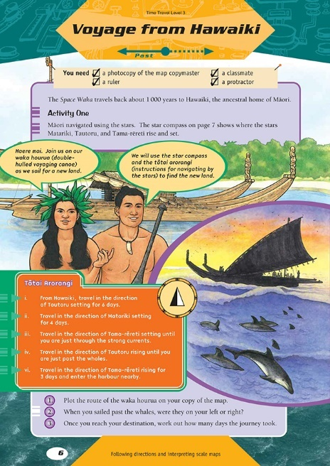
Your task:
Today we will learn about following compass directions and how to interpret the scale on a map. These activity is based on fact although this event is fictional.
You will be required to follow a set of directions to record a journey on a scale map. You will need to accurately measure distances with a ruler. To find the direction to travel in you will need to use a protractor.
Scale – there is a difference between a scale diagram and a sketch, and it is about accurate measurements.
You will need to use the key piece of information that 1 day’s travel equals 1 centimetre.
Complete the activities.

Extension: draw a scale diagram of your bedroom, classroom, or playground. Or use a real map of the Pacific to make up and plot journeys between the Pacific Islands. Or you might like to investigate how ocean-going vessels find their way now. What navigation methods are used?

Day 9 activity 4: Multi-cultural Aotearoa
Notes for teachers and whānau
Cultural diversity is one of the principles that underpins the New Zealand Curriculum. The principles inform curriculum decision-making in every school in Aotearoa. This activity will invite learners to identify and explore how we celebrate cultural diversity in New Zealand and why this is important for cultural sustainability. Learners will be exploring the learning areas of social science, literacy, and health.

I am learning to: explore the personal and wider cultural connections between place, language, time, events, people, and identity.
What do I need?
- 30 minutes
- Look in your pack for copies of Oho cards: https://hpe.tki.org.nz/assets/healthpe/Uploads/Oho/Downloads-My-culture-in-my-place-of-learning/Oho-My-culture-in-my-place-of-learning-sheet.pdf
https://hpe.tki.org.nz/assets/healthpe/Uploads/Oho/Downloads-Oho/Oho-cards-Printable.zip

Your task:
Today you will explore how your culture and learning community come together. Using the Oho Idea cards and the My culture in my place of learning activity sheet, discover and discuss ways to acknowledge, value and celebrate the cultures of yourself and others.
Choose six aspects about your culture that are important to you. Then, explore ways to acknowledge and value them in your classroom and school culture. Place cards on the activity sheet. Consider why you made each selection.
- Place - Select a My places card to represent a place that matters to you.
- Language - Select a My languages card to represent how your voice is or could be heard.
- Time - Select a My time card to represent when your whānau achievements, goals or aspirations are or could be shown.
- Events - Select a My events card to represent events that shape your culture.
- People - Select a My people card to represent people of inspiration in your whānau or community.
- Identity - Select a My identity card to represent aspects of your identity that are or should be visible.
Explore the different perspectives and ideas around how your culture is and could be represented in your place of learning. Then, discuss and compare your findings with your whānau or Class.
Reflect: how is this activity connected to cultural sustainability?
Remember to do your end of day reflection and wellbeing activities (see p. 6 & 8).

Day 10 activity 1: GPS Technology
Notes for teachers and whānau
Learners will learn about GPS by reading an article that explains the Global Positioning System – a technology that we’ve quickly become dependent on. It explains how it works and its benefits, while also prompting students to think critically about the risks of over-reliance. Learners will be exploring the learning areas of technology and social science. Note our Inquiry focus is “present – share learning about the big idea” which includes thinking about who the audience is, and considering different ways of communicating learning – for example, presentation, video, poster, etc.

Remember to start your day right (see p. 7).

I am learning to: I am learning to: describe how GPS technology works and list a variety of uses for GPS technology today
What do I need?
- 30 minutes
- Copy of the google slides https://docs.google.com/presentation/d/1S4h2OL5qb-E_WXH492eOZR7fsXr90KhTjbLgy2b4QnE/present?slide=id.p from the 2019 Level 4 Connected Journal ‘Seeing beyond’ https://instructionalseries.tki.org.nz/Instructional-Series/Connected/Connected-2019-Level-4-Seeing-Beyond

Your task:
Today we will learn more about the Global Positioning System, GPS.
- Listen to audio file and/or read ‘The Global Positioning System’ Connected (see your pack for a printout of the slides).
- Define key terms in your home learning book: constellation, satellite, trilateration, circumference, radius, synchronisation, and navigation
- Compare how navigation is supported by GPS Satellites and Radio Waves by creating a simple T chart.
- Write: a sentence to explain how different GPS is when compared to how early explorers navigated.
- Reflect: How might GPS have impacted migration to NZ?
- Connect: How can you relate GPS technology to cultural sustainability?
Extension: Investigate one of the uses of GPS today and how this development has benefited or challenged cultural views and beliefs e.g. use of the whenua, clock synchronisation, industrialised farming, farming, recreation, transportation, surveying/mapping, security and safety, disaster detection etc.
Optional digital: https://www.sciencelearn.org.nz/resources/2899-the-global-positioning-system

Day 10 activity 2: Culture is important!
Notes for teachers and whānau
This activity helps the learner to reflect on the value of culture, the reasons why we need to protect it and the part it plays in sustainability. Learners will be exploring the learning areas of visual arts and social science.

I am learning to: understand the value of culture and my role in protecting it
What do I need?
- 30 minutes
- Paper and a sharp pencil, optional: sharpie and coloured pencils

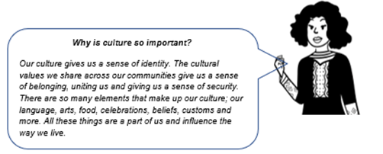
Your task:

Read the speech bubbles.

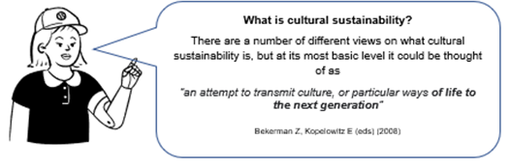
Here’s another definition of cultural sustainability:
“Cultural sustainability is defined as values and attitudes that can be maintained or improved despite external influences.”

In other words, cultural sustainability is a way of protecting, maintaining, or improving our cultures no matter what is going on in the world around it.
Create a cultural sustainability Zentangle using a tracing of your hand or other shape of your choice. A Zentangle is an abstract design using structured patterns (tangles) such as dots, lines, curves, etc. Give your piece a title. Consider what designs and shapes you could use to represent different cultures in Aotearoa. e.g. Māori patterns include koru, kōwhaiwhai, potama, pounamu, tukutuku or patiki. Here’s some inspiration!
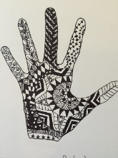
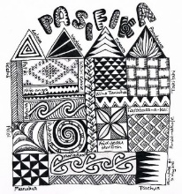
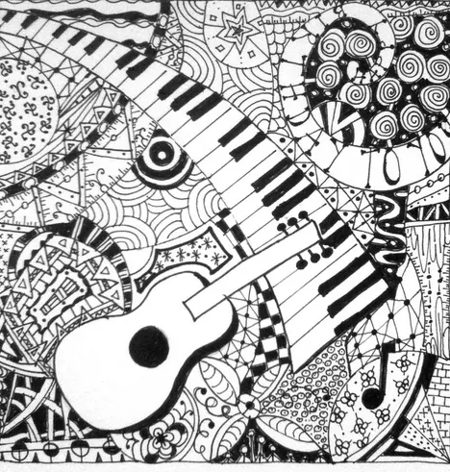
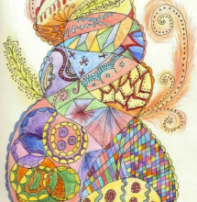
Images sourced from: https://wordpress.org/openverse/search/?q=zentangle

Optional digital: https://www.youtube.com/watch?v=qBwHUKHUdD8

Day 10 activity 3: Fake Facts
Notes for teachers and whānau
This activity invites learners to read two texts. ‘Fake Facts’ addresses the topical issue of fake news. Digital technology creates opportunities for us to create and share information but also exposes us to information that can be false or can do harm. The article encourages students to take a critical gaze on information and suggests strategies for evaluating what is based on facts and worth sharing. ‘The Science of Rongoa’ invites learners to consider a scientific approach to evaluating evidence and information. Learners will be exploring the learning areas of science and reading

I am learning to: to evaluate information sources and whether the information is worth sharing and explore the ideas in a text to make connections to my own life
What do I need?
- 30 minutes
- Copy of the Connected article ‘Fake Facts’ Level 4 2019 https://www.sciencelearn.org.nz/resources/2897-fake-facts
- Copy of School Journal article ‘The Science of Rongoa’ Connected Level 3 2015 https://instructionalseries.tki.org.nz/Instructional-Series/Connected/Connected-2015-level-3-Fact-or-Fiction/The-Science-of-Rongoa

Your task:
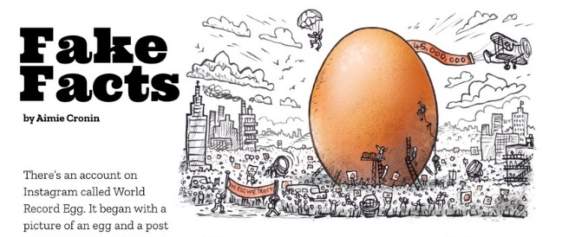
Note: you have two articles to read
Read the article Fake Facts
Think about and consider the advice from Elle Hunt on page 16 that we only post or share stories we know to be true from sources we know to be responsible.
Make connections across the text that justify this advice.
Respond to this question in your home learning book: What have we learned from the text to justify the idea that we need to think critically about sources of information?
Read the article ‘The Science of Rongoa’
Ask yourself these questions as you read:
- What types of medicines do you use in your whānau?
- Do you only use medicine prescribed by a doctor, or does your whānau use other types of medicine or treatments?
- What does the “Māori view of medicine” mean?
- How does this compare with other views of medicine?
- How did Chris come up with his hypothesis and how did he test it?
- What sort of questions do you think Chris was thinking about when he critiqued the scientific evidence?
According to mātauranga Māori (Māori concepts of knowledge and knowing), kawakawa has medicinal properties. According to modern science, it does not. By keeping an open mind and looking closely at the evidence, Howick College student Chris Ryan discovered that when the method of testing reflected how and why Māori use the leaves, modern science showed kawakawa does indeed have medicinal properties. His approach did more than support the value of kawakawa. It also showed the value of a more holistic approach to scientific investigation that draws together Māori and non-Māori approaches to science.
Summarise the main information on an ISP chart – a chart that is used to identify where information has been sourced.
Information | Source | Page
Synthesise the process Chris used, using a graphic organiser like this:
What Chris did? | He did this because?
Consider:
- How did Chris’s investigation compare with the investigations scientists had carried out on kawakawa previously? Did he disprove their findings?
- How did Chris change the scientific understandings we have about kawakawa?
- How do you think Māori found out about the uses of kawakawa and other medicinal plants?
- How are these methods the same as, and different from, the ways scientists work?
- How can Fake Facts be damaging to cultural sustainability?
Extension:
Think critically about ‘Fake Facts’ and the influence of social media:
Optional digital: https://www.sciencelearn.org.nz/resources/2939-read-news-like-a-scientist
- Why is it that when someone has made up their mind or formed an opinion over controversial issues, that it’s so difficult for them to see and understand another perspective or opinion?
- Does this matter?
- What examples are you aware of locally, nationally, or internationally where people have held strong opinions on?
- How has social media impacted the way people form opinions and perspectives.
- What might the dangers be for individuals, communities, and society?

Day 10 activity 4: Gamify your learning to share your learning!
Notes for teachers and whānau
In this activity the learner will have the opportunity to be creative and to ‘gamify’ the information they have learned about during this pack. Learners will be exploring the learning areas of technology, literacy, and science.

I am learning to: design a game to use an information cube.
What do I need?
- 30 minutes
- Material to create the game if needed e.g. dice, paper, cardboard, scissors, glue, coloured pencils etc.

Your task:
You will create a game, using all that you have learned, that provides a learning experience for the players about cultural sustainability.
Create a to share your learning with whānau or friends. There are lots of types of games to choose from.
- Board game
- Card game
- Dice game
- Pencil and paper game
- Role playing game
- Strategy game
- Cooperative game
- Skill game
- Video game
- Guessing game
- Singing game

Write instructions for how to play, including any rules.

Play the game with whānau and/or friends.

Ask them for feedback:
- What went well?
- Even better if?

Remember to do your end of day reflection and wellbeing activities (see p .6 & 8).

