A learning from home pack

For learners in years 7–8

Theme: Citizenship | Kirirarau

Context 1: Manaakitanga, Culture and Identity

Context 2: Rights and responsibilities

Layout of the resource
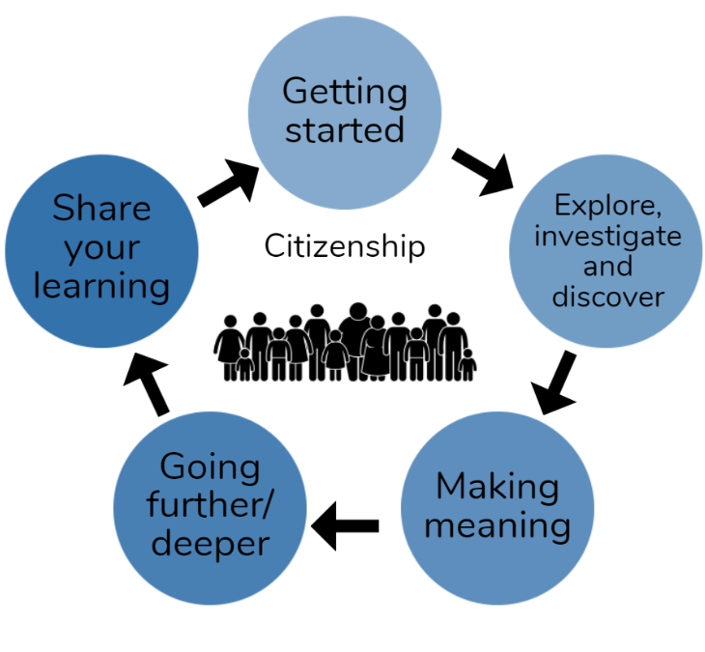
This pack is filled with learning activities that can be used at school or at home. All activities are framed around the theme of citizenship | kirirarau.
Suggestions are provided for starting the day with a karakia (see p. 8), check in with the teacher, and setting up the learning environment. You can replace these with how you want your learner to start their day. The pack is provided as a Word document so you can adapt it for your learners.
The activities follow an inquiry learning model (figure 1) exploring one big idea through two contexts. Each day the learner will work through one part of the model culminating with sharing their learning on days five and ten.
Figure 1 Inquiry learning model

Realities
You know your learners and have a good understanding of their learning situations. Many learners will be sharing space and materials. Some may have access to the internet and devices, and others may not. Learners will also have varying levels of adult support. This pack contains a mix of activities using materials found in most homes. Some activities will need support while others can be managed independently.

Resources
The pack uses books from the School Journal and Figure it out series. You might want to send these home with the learner, along with an exercise book, pencils, crayons, or felts, and some craft materials (glue, scissors, construction paper). Learners can bring their notebook back to class to share. All images have been sourced with permissions for use in this pack. If your learners do not have reliable access to the internet, here are the resources to print and send home to create a paper-based pack if you don’t have hard copies of the books.

Resources to print
- https://hpe.tki.org.nz/assets/healthpe/Uploads/Oho/Downloads-This-is-me-my-identity/Oho-This-is-me-my-identity-Cards-Printable.zip
- https://hpe.tki.org.nz/assets/healthpe/Uploads/Oho/Downloads-Sorting-my-places/Oho-My-places-Cards-Printable.pdf
- https://hpe.tki.org.nz/assets/healthpe/Uploads/Oho/Downloads-Important-life-moments/Oho-Important-life-moments-Cards-Printable.zip
- https://hpe.tki.org.nz/assets/healthpe/Uploads/Oho/Downloads-Important-life-moments/Oho-Important-life-moments-activity-sheet.pdf
- A copy of a selection of even numbered pages from https://elections.nz/assets/Community-learning/Your-Voice-Your-Choice-Inquiry-cards-2020.pdf
- https://nzmaths.co.nz/resource/census-sense
- https://nzmaths.co.nz/resource/campaign-trail
- https://nzmaths.co.nz/sites/default/files/2021-01/matariki-L4-3.pdf

Resources to send home
- https://instructionalseries.tki.org.nz/Instructional-Series/School-Journal-Story-Library/Hinepukohurangi-me-Te-Maunga
- https://instructionalseries.tki.org.nz/Instructional-Series/Junior-Journal/Junior-Journal-53-Level-2-2016/Toku-Pepeha
- https://instructionalseries.tki.org.nz/Instructional-Series/School-Journal/School-Journal-Level-4-November-2019/Chinese-New-Zealanders
- https://instructionalseries.tki.org.nz/Instructional-Series/School-Journal/School-Journal-Level-3-November-2018/Listening-Eyes-Speaking-Hands-The-Story-of-Deaf-Education-in-New-Zealand
- https://instructionalseries.tki.org.nz/Instructional-Series/School-Journal/School-Journal-Level-4-November-2018/Rise-Up-The-Story-of-the-Dawn-Raids-and-the-Polynesian-Panthers
- https://instructionalseries.tki.org.nz/Instructional-Series/School-Journal/School-Journal-Level-4-November-2017/Keeping-Promises-The-Treaty-Settlement-Process
- https://instructionalseries.tki.org.nz/Instructional-Series/School-Journal/School-Journal-Level-3-August-2017/Te-Tiriti-o-Waitangi
- https://instructionalseries.tki.org.nz/Instructional-Series/School-Journal-Story-Library/Te-Tiriti-o-Waitangi
- https://instructionalseries.tki.org.nz/Instructional-Series/School-Journal/School-Journal-Level-4-November-2020/Like-Share-Subscribe
- https://instructionalseries.tki.org.nz/Instructional-Series/School-Journal/School-Journal-Level-4-May-2020/The-Winning-Side
- https://instructionalseries.tki.org.nz/Instructional-Series/School-Journal-Story-Library/Once-a-Panther

Setting up the learning environment
Encourage whānau to support learners to set up a space for learning at home. Learners might like to design their own space as a separate learning activity. Some materials they may need could include pen, pencils, paper, a notebook, colouring pencils, glue, scissors, and a device to access the internet.
Many of the suggested activities and experiences include the optional use of online resources which can be accessed and viewed using a Smartphone.

Overview of the learning in this pack
In the first five days we will investigate the theme of citizenship by exploring what it means to be a citizen though manaakitanga, culture and identity. The second week will explore citizenship through the lens of rights and responsibilities.

Day 1 | Day 2 | Day 3 | Day 4 | Day 5
Launch our learning by exploring the concepts of pepeha, whakapapa, tūrangawaewae, whanaungatanga and identity | Investigate how aspects of popular culture can contribute to our sense of identity and how trends can influence us as citizens | Make meaning about how people find a place to belong in Aotearoa New Zealand. | Going deeper into the concept of citizenship by creating a utopic country where amazing citizens will want to live. | Share learning by presenting artefacts from ‘Project Geos’ to promote their utopic country to prospective immigrants.
Day 6 | Day 7 | Day 8 | Day 9 | Day 10
Launching our learning about rights and responsibilities and the Treaty of Waitangi. | Exploring rights and responsibilities as we learn about digital citizenship, the declariation of independence and our government. | Making meaning about rights and responsibilities of citizens through our elections, voting, then census and how our parliament functions. | Going deeper as we inquire into power, a dystopian future, and random acts of kindness. | Sharing what we know by creating an infographic about citizenship and looking a Matariki as a NZ citizen celebration.

Daily timetable
Below is a possible daily timetable. We have allocated 30 minutes for each activity; your learner may take more or less time than this for an activity. We suggest your learner takes the time they need to complete an activity. This may mean they choose which activities they will complete for the day, rather than complete them all.
At the start of each day the learner will draw up their timetable for learning. You can adjust the timing to suit the other activities that might be happening the day, such as Zooming with the class/teacher.
Time | Activity
9:00 am | Starting the day
9:30 am | Activity 1
10:00 am | Break
10:30 am | Activity 2
11:00 am | Fitness break
11:30 am | Activity 3
12:00 pm | Lunch time
1:00 pm | Activity 4
1:30 pm | Reflection time
2:00 pm | End of the school day

Daily fitness – Choose something each day
Please ensure that your learner includes fitness in their daily timetable. If possible, it would be great to do the fitness activity with your learner or have them complete it with others. Below are activities to choose from – or you can make up your own ideas!
Tama Tū, Tama Ora; Tama Noho, Tama Mate.
Through physical activity we thrive. Through inactivity we languish.
Your learner may prefer to go for a walk or run around your house. They could time themselves for fun! Maybe they’d like to go for a bike ride? Play a game with whānau? Have a boogie to a favourite song? Or do some yoga? It is up to you just get active!
Please note you can change or modify the exercises (in addition to those suggested) if you are not able to do the ones we have suggested, get creative and change it up
Skipping - Toru + Tekau + Rima Fitness Challenge:
Can you do this? Tekau tāruarua (10 reps), e rima ngā huinga (5 sets) – let’s go!
These are our toru (3) exercises
- Freestyle skipping (30 seconds), rest (30 seconds)
- Backwards skipping (30 seconds), rest (30 seconds)
- Speed skipping (30 seconds), rest (30 seconds)
Tekau tāruarua (10) reps – do each exercise 10 times. E rima ngā huinga (5) sets– do each set of toru (3) exercises rima (5) times. Hōngai tō puku – remember to brace your abs.
Ka pai!? Here we go! Haere mai? Good? Let’s go!
Fitness countdown
You don’t need anything for this activity but a positive attitude and a water bottle!
- tekau (10) jumping jacks **modify: right leg step out to the side then left leg
- iwa (9) forward lunges (on each leg) **modify: us a box and step up and down
- waru (8) squats (don’t let your knees go past your toes) **modify: sit in chair, stand up
- whitu (7) donkey kicks (each leg) – can do standing or sitting
- ono (6) sit ups **modify: touch knees
- rima (5) high knees **modify: lift knees up while laying down on back
- whā (4) push-ups **modify: do on your knees
- toru (3) star kicks (right leg – kick forward, side, back; then left leg)
- rua (2) burpees **modify: walk outs – walk out with your hands and walk back
- tahi (1) superman pose or high plank for as long as you can hold! **modify: on your knees
Take a rest and repeat. Tumeke!
Māori Movement
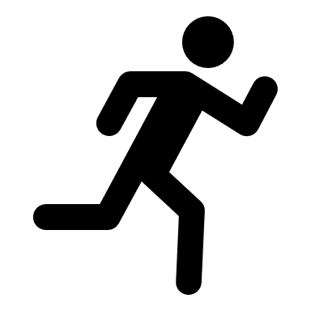
Start with a warmup here: http://www.Māorimovement.co.nz/warm-up Rongo-mā-Tāne is the Māori God of Cultivation and Peace. The Māori Movement we focus on is the Whakatō Kūmara (endurance movement).
Whakatō Kūmara is the action of planting kūmara or sweet potato.
Here is your challenge: http://www.Māorimovement.co.nz/courses/rongomatane/level-1-rongomatane
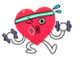
Create your own fitness circuit:
Select 5 or more of these exercises (or other exercises that you like) and create your own fitness circuit in your home or outside.
Remember every exercise can be modified to suit your physical ability and fitness level. Have a look at some of the suggestions here.
High knees, running on the spot or brisk walking or shuttle runs/line sprints.  Skipping or galloping.  Slip stepping or marching on the spot.  Skis – stepping side to side as if you are skiing, step wider if this is too easy for you. | Hops – on the spot – forward and back or tap your toes out in the front of you and aback.  Jumping, astride jumps/straddle jumps.  Knee lifts.  Heel to bottom kicks.  Squats –vary how wide apart you place your legs or go lower if you need a challenge. | Abdominal crunchies - tap your knees as you move up or tap your ankles.  Push-ups – either on your feet or on your knees.  Lunges or step-ups.  Double foot jumps – side to side – forward and back.  Leg lifts – lie on the ground on your back and lift your legs up and down.
Repeat your circuit or choose 5 exercises to do for either 20, 30, or 60 seconds each and rest for 20 seconds in between. You choose which length of time suits you! Ka pai!
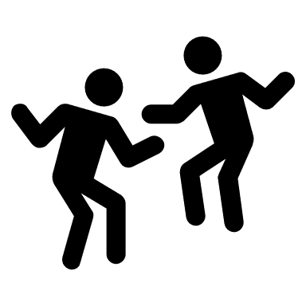
Whāia Dance – Maimoa Music
Go to https://www.youtube.com/watch?v=z_6p7Ize6bo and watch Maimoa sing Whāia (an original song sung in te reo Māori).
Practice singing it in te reo and then make up a little dance or fitness routine. Perhaps you have to star-jump up every time you ‘Whāia’? Maybe you have to lunge every time the singer changes? Have fun with it and move your body!

Daily wellbeing – Choose something each day
These activities are good to do at the beginning and end of the day but can be done anytime. They can help you get ready for learning, calm your mind and body, and can help you to reflect on your learning:
A-Z of self-care
What can you do to look after yourself today? Make an A-Z list. e.g.
A is for acknowledging how I feel
B is for belly breathing
C is for choosing healthy foods to eat
D is for ...
Learn to write and say some of these positive words in 3 or more languages:
- Grateful, happy, wellbeing, healthy, helpful, thank you, I’m sorry, appreciate
10 faces for 10 feelings
Use a compass or find something small and round to trace. Then make each of your circles into a face that shows an emotion. Lastly, label each face. Challenge: use te reo in your labels where you can. e.g.
furious | hinapōuri | harikoa | surprised
Here are some feeling words you could use.
energised  inspired  proud  relaxed  amused  confused  bored,  peaceful  accepted  loved | trusting  critical,  distant  indifferent  inspired  hopeful  thankful  curious  cheeky  sleepy | happy / harikoa  calm / tau  excited / hiamo  grateful / whakawhetai  disappointed / pāpōuri  frustrated / hōhā  optimistic / whakapono  amazed / mīharo  strong / kaha  sad / hinapōuri
Think about what situations make you experience each emotion you draw.
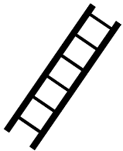
Ladder of happiness:
Draw or write something you need to make your life happy on each rung of your ladder.

Make a Happy playlist:
Choose ten feel good songs and write them down. Listen to one of them online if you can and see if they help to put you into a feel-good mood!
Gratitude checklist:
Check those that apply: |  | What else?  Add more as needed below:
- Good health  - Family that loves me  - Good friends  - Weekends  - Having a home  - An ability to read  - Opportunity to learn  - A bed to sleep  - Good teachers | - Clean water  - Internet  - Mobile phones  - Holidays  - Waking up today  - Grocery stores  - Entertainment  - Electricity  - Rights | e.g. A hot shower in the morning

Starting each day
Notes for teachers and whānau:
Starting the same way each day helps create a structure for your learner. Saying the karakia with your learner a few times will help them be able to do this more independently tomorrow and beyond. As part of the start of the day and setting up the learning environment, help your learner look through the activities suggested for that day and choose a fitness and wellbeing activity. They could fill out their daily timetable and think of other activities they might like to do, like reading. Remind your learner of when and how to check in with the teacher/you.

Karakia
Here is a karakia to welcome in the day.
Karakia mō te Ata https://www.youtube.com/watch?v=3em_pulEjT0
Kia hora te Marino  Kia whakapapa pounamu te moana  Hei huarahi mā tātou i te rangi nei  Aroha atu aroha mai  Tātou ia tātou katoa  Hui e taiki e! | May peace be widespread.  May the sea be like greenstone; a pathway for all of us this day.  Let us show respect for each other, for one another.  Bind us all together.

Planning my day
- Have you chosen which activities you will do today and in which order?
- Remember to choose a fitness activity (see p. 5)
- Have you chosen a wellbeing activity? (see p. 7)
- Have you done a ‘Wellbeing check-in'?
  - How are you feeling today?
  - How do you feel about your readiness to learn this morning?
  - What do you need extra help with today? Who could you get to help you? What strategies could you use to help make your learning more effective?
  - What would you like to do as a quiet time activity to end your day?
- Remember to do your Reflection at the end of the day (see p. 9)

Ending each day
Please ensure your learner does this at the end of each day.
Reflection can be challenging for all learners, but it can also provide them with rich opportunities to think about how their learning is progressing. Use the questions below as prompts to encourage your learner to think about what they have learned so far and help them to plan out their next steps. If you have concerns with their learning or find that your learner is needing more help, contact their teacher for more support.

Option 1: Reflections about my learning
Take some time to think about how you are feeling after today’s learning activities.
Reflect on the following prompts in your reflective journal.
- What did you enjoy most about today?
- What is one thing you feel you learnt today?
- What is one strategy that helped you with your learning?
- What did you find challenging or distracting?
- Is there anything you need extra help with? Who can you ask to help you with that?
- Is there anything you want to catch up on tomorrow?
Option 2: Reflections about my day
Choose 3-5 questions to respond to in your reflective journal:
- What was the best part of your day? Why?
- What did you worry about today? Are you still worried?
- What is a problem you had today? How did you solve it?
- On a scale of 1 – 10, with 10 being the best, how would you rate your day? Why?
- What goal do you have for tomorrow?
- Were you able to finish all of your work today? Why or why not?
Option 3: Reflections about myself
Choose 3-5 questions to respond to in your reflective journal:
- What does having a growth mindset mean? When did you last have one?
- How are you different from your parents/friends/a famous person of your choice?
- What's something that adults (parents, grandparents, teachers, etc.) say to you that's really stuck with you? Do you think they're right?
- What do you do when people don't seem to like you?
- What is your proudest accomplishment?
- What things are in your control? Out of your control? How does it feel to notice that some things are out of your control?
- If you could have one wish, what would it be?
- Where do you feel safest?
- What are you grateful for?
- What do you like about yourself?

Remember to finish with a wellbeing activity and/or your chosen quiet time activity.

Context 1: Manaakitanga, Culture and Identity

In the first five days we will investigate the theme of citizenship by exploring what it means to be a citizen through manaakitanga, culture and identity.

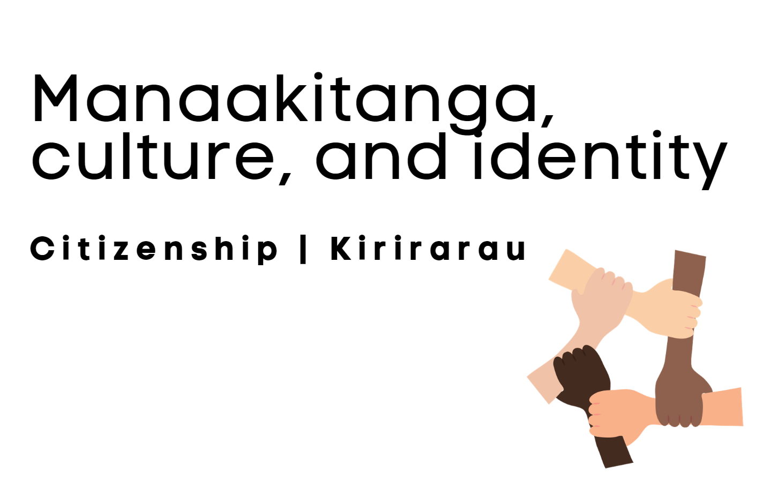

Day 1 activity 1-2: My pepeha
He kai kei aku ringa ~ There is food at the end of my hands.
Notes for teachers and whānau
For this first task the learner will explore the concepts of pepeha, whakapapa, tūrangawaewae, whanaungatanga, and identity. Having a deep and authentic sense of who we are as individuals, what we value, and how we connect to our heritage, positions each of us to be a confident, connected citizen of Aotearoa and the world. Learners will explore the learning areas of literacy, te ao Māori and social sciences. Note that our Inquiry focus for today is “getting started” which includes generating questions, activating prior knowledge, and introducing the theme.

I am learning to: explore and create a pepeha
What do I need?
- 60 minutes
- Look in your pack for a copy of these texts https://instructionalseries.tki.org.nz/Instructional-Series/School-Journal-Story-Library/Hinepukohurangi-me-Te-Maunga and https://instructionalseries.tki.org.nz/Instructional-Series/Junior-Journal/Junior-Journal-53-Level-2-2016/Toku-Pepeha
- Optional digital: https://pepeha.nz/
- Six60 Pepeha https://www.youtube.com/watch?v=y_CJFEKNvX8
Remember to start your day right (see p. 8).

Your task
Have your home learning book or digital doc ready to record your thinking. Follow the sequence below.
Listen, watch and/or read the song ‘Pepeha’ by Six60.
Ko Mana tōku maunga  Ko Aroha te moana  Ko Whānau tōku waka  Ko au e tū atu nei  Mana is my mountain  And Aroha is my sea  Whānau is my waka  And all of that is me  Ahakoa pāmamao  Kei konei koe  Though you are far away  I hold you near | I'll keep the home fires burning  So you can see clear  Kia maumahara mai rā  Nō konei koe  Ko Mana tōku maunga  Ko Aroha te moana  Ko Whānau tōku waka  Ko au e tū atu nei  Mana is my mountain  Aroha is my sea  Whānau is my waka  And all of that is me | Ko Mana tōku maunga  And all of that is me  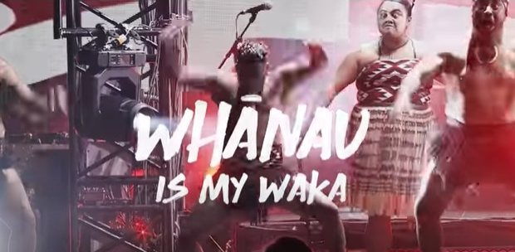

Brainstorm all the things that you know about a pepeha in a concept map like this one.

Read Hinepūkohurangi me Te Maunga and Tōku Pepeha which you will find in your pack (or use the links above).
Make connections: your pepeha shares with others who you are. It is also a way of sharing your family history and your family tree so you can share with others where you come from and how you are connected to the whenua (land) and tūpuna (ancestors). For Māori, and many New Zealanders, this can create a strong sense of belonging and contributes to your identity. Please note that there are a number of different ways to structure your pepeha and each iwi can have distinct differences with how these are written, recited and/or shared.
Read these te reo Māori concepts with their explanations:
Whakapapa | Genealogy and lineage, your family tree that links you to your tūpuna (ancestors), your descent. It places our people in a wider context, linking us to a common ancestor, our ancestral land, our waterways and our tribal (and sub-tribal) groupings.
Tūrangawaewae | Place where one has the right to stand, where we feel empowered and connected. Tūrangawaewae tends to be where we were either born or brought up, or alternatively, our ancestral land. It is a place where we feel we have a strong sense of belonging and a deep spiritual connection.
Whanaungatanga | Relationships and family connections. A relationship through shared experiences and living/working together which provides people with a sense of belonging. Whanaungatanga also serves to strengthen ties within and between whānau, hapū and iwi.

Consider what you would like to include in your pepeha and write it in te reo Māori. Hint: use the example in Tōku Pepeha as a guide or if you have a device, go to https://pepeha.nz/ to create yours online.

Share: When you are finished, recite your pepeha, explaining the stories that sit behind it.

Reflect: Then identify how your pepeha shares and/or explores the concepts of whakapapa, tūrangawaewae and whanaungatanga. Record your thoughts in your home learning book or digital doc.

Optional extra: Create a comic to reflect your pepeha like the one you read in Hinepūkohurangi me Te Maunga.

Day 1 activity 3: Health – my identity
Notes for teachers and whānau
In this activity the learner will make deeper connections to their identity – what makes them who they are. Learners will explore personal and wider cultural connections between place, language, time, events, people, and identity. Knowing about their own identity and being able to connect to or understand the uniqueness of others is the foundation of being a citizen. Learners will be exploring health, te ao Māori and literacy.

I am learning to: Explore the personal and wider cultural connections between place, language, time, events, people, and identity
What do I need?
- 30 minutes
- Look in your pack for copies of the My Identity and Emotion cards from: https://hpe.tki.org.nz/assets/healthpe/Uploads/Oho/Downloads-This-is-me-my-identity/Oho-This-is-me-my-identity-Cards-Printable.zip
- Look in your pack for a copy of My Place cards from: https://hpe.tki.org.nz/assets/healthpe/Uploads/Oho/Downloads-Sorting-my-places/Oho-My-places-Cards-Printable.pdf

Your task
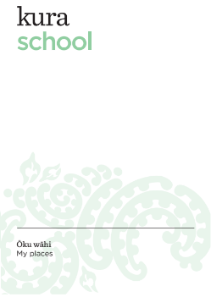
The tasks in this activity will help you clarify what our theme of learning is all about this week. You will begin to make thoughtful and meaningful connections to your identity, your emotions and the places that shape who you are. Have your home learning book or digital doc ready to record your thinking and follow the sequence below carefully.
Make connections to My Places and then research the stories behind their names using the internet or by interviewing whānau.
Using the My Place cards that are in your pack (or from the link above) select 4 or more My Place cards that represent places of significance to you.
Record in a table like this:
Ranking in order of Importance to me | My Place  (English and te reo Māori) | Significance of the place to you and/or  the history of the name
example | Matua Ngaru School / Te Kura Tuatahi o Matua Ngaru | This is the name of my school. The school name was gifted by local iwi and comes from the story of a local chief who climbed Pukeatuha mountain to seek guidance and he then saw a large wave (ngaru) coming up the river which signalled a change was needed for his people. In response to his vision, he moved their kāinga to the area where Matua Road is now located. So Matua Ngaru is the name of my school.
Make connections between My Identity and My Emotions: using the My Identity and Emotion cards in your pack (or from the link above) select 10 My Identity cards that represent important aspects of who you are. Then select an Emotion card that represents how each makes you feel.

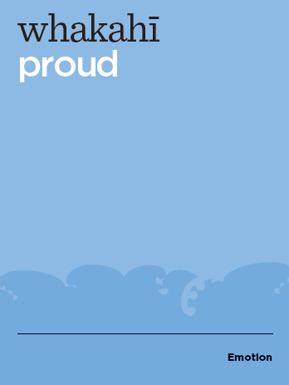

Record in a table like this:
My Identity Card (English and te reo Māori) | Emotion card (English and te reo Māori)
e.g. kirirarau / citizenship | whakahī / proud

Explain how these aspects of your identity and the emotions they evoke help to make you a good citizen.

Note: Tasks adapted from: https://hpe.tki.org.nz/planning-and-teaching-resources/all-resources/this-is-me-my-identity/

Day 1 activity 4: Visual pepeha
Notes for teachers and whānau
In this activity learners will create a visual representation of at least four aspects of their pepeha. This is an opportunity for individual creativity and expression. Learners will be exploring the visual arts and literacy.

I am learning to: reflect aspects of my pepeha in a visual form
What do I need?
- 30 minutes
- Paper, pencil, ruler and felt markers or coloured pencils

Your task
Follow the sequence below to create a visual representation of your pepeha. Combine visual and text, pictures and patterns and be creative!
- Get a piece of plain white paper.
- Using a ruler and a pencil draw a diagonal line from the top left corner to the bottom right corner. Repeat with a diagonal line from the top right corner to the bottom left corner. Note: if you’d like more than 4 triangles, split 2 or 4 of the triangles in half again using your ruler and pencil.
- Use each of the triangle pieces to reflect your pepeha. Each triangle can reflect a different aspect of your pepeha: for example you could draw:
- your mountain, your awa, your whānau, your kura, the country where you were born, yourself, your flag, a favourite place etc.
- you could also write out your entire pepeha in one of the triangles
- you may like to add a pattern to some of the triangles as well.

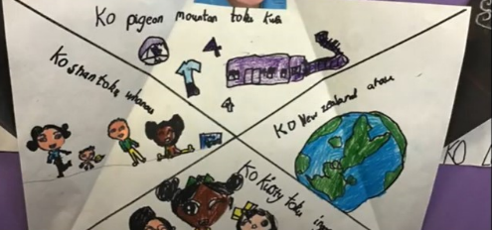
This is a screenshot from this video of Room 4’s visual pepeha: https://www.youtube.com/watch?v=7IoUARuPUGo, which depicts some visual pepeha examples from younger learners.

Remember to do your end of day reflection and wellbeing activities (see p. 7&9).

Day 2 activities 1 and 2: The ultimate participant
Notes for teachers and whānau
Learners explore how aspects of popular culture can contribute to our sense of identity. They look at how decisions and trends can influence us as citizens of Aotearoa and how we develop skills useful for good citizenship through sport. Note our Inquiry focus is “explore, investigate, and discover” which includes choosing and evaluating information, and thinking critically.

I am learning to: discuss and record examples of discrimination
What do I need?
- 60 minutes
Remember to start your day right (see p. 8).

Your task
Let’s explore how the environment in which you live affects your personal wellbeing and that of society (health promotion); and develop respect for the rights of others through accepting their abilities and demonstrating tolerance (attitudes and values). Read about the game of ultimate frisbee to become familiar with rules, objective of the game, and equipment used.
Rules and history of Ultimate Frisbee
Ultimate frisbee is a fast free-flowing game played world-wide which combines elements of netball, soccer, grid-iron, and touch footy. The basic aim is for the team with the frisbee to pass the disc up the field to others on their team and catch it in the end zone. At the same time the defensive team is trying to intercept it or knock it down. If they succeed, they get possession of the frisbee and try to score in the other endzone.
Central to ultimate, and central to individual and team conduct, is the underlying concept of the 'spirit of the game', which embodies sportsmanship. Players make their own calls when fouls etc are incurred. When disputes arise, the frisbee returns to the player who made the last pass and the game resumes. The absence of umpires leads to the need for a good, honest spirit even when playing in highly competitive situations. Resulting from this, the 'spirit of the game' award has become highly coveted at tournaments. Players undertake to be competitive but fair and truthful, physical but careful, intense but friendly and courteous. Ultimate is non-contact. Intercepting or knocking down the frisbee must be done without interfering with other players. A small amount of contact is unavoidable, but deliberate interference or aggressive play is not permitted. There is no running with the frisbee. When a player catches the frisbee, they must stop as soon as they can. They then have 10 seconds to pass the frisbee to someone else on their team. The 10 seconds is counted out loud by a defender who marks them and tries to prevent them from getting an easy pass away. If they have not thrown the frisbee by the time the count gets to 10, a turnover results. A turnover also results when the frisbee is thrown out of bounds, when it touches the ground, or when it is dropped. If it is knocked down, the team that threw the frisbee loses possession (unlike touch footy, where the last team to touch the ball loses possession). The traditional playing field is about 35 metres wide by 65 metres long with 20-metre-deep end zones, which can be varied to suit the number and fitness of players. Games can be played to points or to a time limit, although most games have a limit on both. Ultimate is also able to be played indoors. This is done on a basketball court with the Keyhole as the end zone. The number of players each team has is also reduced to five per team. Outdoor numbers vary depending on the size of the field used-usually 6-7 players per side.
Optional digital: watch this to learn more https://www.youtube.com/watch?v=PrinnxHyWlo
Imagine that you have just played a game of Ultimate Frisbee. Record examples of how people might feel left out during this game:

List examples of words or phrases that people may say during a team game that might be Aggressive, Passive, and/or Assertive in the table below:
Aggressive  e.g. words or phrases that are hurtful or unhelpful | Passive  e.g. words or phrases that are helpful or supportive | Assertive  e.g. words or phrases that assist your team to work efficiently and enable others to feel supported
“Why can’t you throw straight?” “You are so useless”. “Couldn’t you see that I was free”. | “I can’t help it if I’m no good at this game”. “Why am I so clumsy?”. | “I’m free - pass to me”. “Run to the goal area for the pass”. “That was a great pass”. “Wow - what a catch!”
Record the advantages and disadvantages of working cooperatively as a team in a team sport such as Ultimate Frisbee.
What are the advantages of working cooperatively as a team in a team sport? | What are the disadvantages of working cooperatively as a team in a team sport?
Using the table below, write your thoughts about our rights and responsibilities when playing team games using Ultimate Frisbee as the context:
My rights when playing in team games | My responsibilities when playing in team games
Choose another sport, a school situation, and a family/whānau situation where you can help people to feel included. Complete this table.
Situation | Description of the situation | Things I can say to help someone feel included | Things I can do to help someone feel included
Another sport
Another school situation
A family situation
Think about when you have played competitive games and what cooperative behaviours you and your teammates have enacted. Consider what impact saying passive or aggressive words/statements can have on others. Answer these questions:
- How necessary is it for each player to become involved? Why/why not?
- Why is inclusion important in team games?
- What can I do to help everyone to participate?
- How does my participation affect my ability to behave cooperatively?
- How does good sportsmanship prepare young people to be good citizens?
Optional Extra: create a ‘Fair Play’ Code for playing team games.
Activity adapted from: https://hpe.tki.org.nz/planning-and-teaching-resources/resource-collections/sport-studies-resource-collection/

Day 2 activity 3: The haka
Notes for teachers and whānau
Learners will consider how sport and culture can contribute to our sense of identity, and explore how customs, decisions, and trends influence us as citizens of Aotearoa. Learners will be exploring te ao Māori, literacy, and social sciences.

In this activity I am learning to: analyse how the haka contributes to a sense of belonging and identity for the All Blacks and sports fans in New Zealand
What do I need?
- 30 minutes
- Optional digital: https://www.youtube.com/watch?v=YgTdohtNwBg

Your task
Today you will be exploring more information about the haka as it relates to the All Blacks as a team. You will read, and if you have a device, you can also watch videos, to learn more about the two haka that are used by the All Blacks as a rugby team.

Read the text below.
For most non-Māori New Zealanders today their knowledge of the Haka is perhaps limited to "Ka mate, Ka mate", which was composed by Ngāti Toa Chieftain Te Rauparaha around 1820. Many sports teams and individuals travelling from New Zealand overseas tend to have the haka "Ka mate" as part of their programme. The team that has given the haka the greatest exposure overseas has been the All Blacks, who perform it before their matches.
ORIGIN OF THE HAKA
According to Māori ethos, Tama-nui-to-rā, the Sun God, had two wives, Hine-raumati, the summer maid, and Hine takurua, the winter maid. The child born to him and Hine-raumati was Tane-rore, who is credited with the origin of the dance. Tane-rore is the trembling of the air as seen on the hot days of summer and represented by the quivering of the hands in the dance.
Haka is the generic name for all Māori dance. Today, haka is defined as that part of the Māori dance repertoire where the men are to the fore with the women lending vocal support in the rear. Most haka seen today are haka taparahi, haka without weapons.
More than any aspect of Māori culture, this complex dance is an expression of passion, vigour, and identity. Haka is not merely a pastime of the Māori but was also a custom of high social importance in the welcoming and entertainment of visitors. Tribal reputation rose and fell on their ability to perform the haka (Hamana Mahuika). Haka reflected the concerns and issues of the time, of defiance and protest, of factual occurrences and events at any given time.
HAKA HISTORY
The centrality of the haka within All Black rugby tradition is not a recent development. Since an 1888 tour by the "New Zealand Natives" led by Joseph Warbrick the haka has been closely associated with New Zealand rugby. Its mystique has evolved along with the fierce determination, commitment and high-level skill which has been the hallmark of New Zealand's National game. The haka adds a unique component, derived from the indigenous Māori of New Zealand, and which aligns with the wider Polynesian cultures of the Pacific. The All Blacks perform the haka with precision and intensity which underpin the All Blacks’ approach.
KA MATE
The famous haka: Ka Mate Ka Mate, was composed by Ngāti Toa Chieftain Te Rauparaha around 1820, with the story of its composition being well known within the oral histories of Ngāti Toa and Ngāti Tuwharetoa, the two iwi (tribes) most associated with its origins.
During a time of conflict Te Rauparaha was being pursued by warriors of a rival iwi and was hidden by Te Wharerangi of Tuwharetoa in a kumara (native sweet potato) pit, with Te Wharerangi’s wife Te Rangikoaea being directed to sit on top. Guided by their Tohunga (scholar/priest) the warriors searched for Te Rauparaha and as they drew near, he muttered “Ka Mate Ka Mate” (It is death, it is death). Concealed from the Tohunga by the spiritual powers of both food and the woman above, Te Rauparaha was not discovered, and as the searchers passed overhead, he muttered “Ka ora Ka ora” (It is life, it is life). When the warriors finally departed Te Rauparaha was able to climb up out of the kumara pit chanting “Tenei te tangata puhuruhuru nana nei i tiki mai whaka whiti te ra”.
There are many interpretations of these words and “tangata puhuruhuru” may be a reference to the hairy man (Te Wharerangi), but Ngāti Toa oral tradition holds that Te Rauparaha was giving credit to the spiritual power of Te Rangikoaea as he ascended (Upane, Kaupane) from the darkness of the pit into the light of the sun (Whiti te ra! Hi!)
Ka Mate was performed by the New Zealand Native team on their long and arduous tour of 1888/89, and by the “Original” All Blacks in 1905. Haka were traditionally then performed prior to All Blacks matches outside New Zealand through until 1986 when All Blacks Wayne “Buck” Shelford and Hika Reid were instrumental in introducing Ka Mate to matches in New Zealand from 1987 and ensuring that it was performed with a precision and intensity that had on occasion been lacking in earlier years.
Text sourced from: https://www.allblacks.com/the-haka/

KAPA O PANGO – THE ALL BLACKS' OWN HAKA
In August 2005, before the Tri Nations Test match against South Africa at Carisbrook, the All Blacks first performed 'Kapa O Pango', a new haka for and about the All Blacks. A year in the making, Kapa O Pango was written for the team by Derek Lardelli, an expert in tikanga Māori (Māori culture and customs) of the Ngāti Porou iwi. Its words and actions celebrate the land of New Zealand, the silver fern, and its warriors in black. The name might be translated simply as 'team in black'. Rather than replace the traditional haka, Ka Mate, Kapa O Pango sits as an addition to the All Blacks' tradition. Kapa O Pango is performed at the team's discretion.
KAPA O PANGO
Taringa whakarongo!  Kia rite! Kia rite! Kia mau!  Hi!  Kia whakawhenua au i ahau!  Hi, aue! Hi!  Ko Aotearoa, e ngunguru nei!  Hi, au! Au! Aue, ha! Hi!  Ko kapa o pango, e ngunguru nei!  Hi, au! Au! Aue, ha! Hi!  I ahaha!  Ka tu te ihi-ihi  Ka tu te wanawana  Ki runga i te rangi, e tu iho nei, tu iho nei, hi!  Ponga ra!  Kapa o pango! Aue, hi!  Ponga ra!  Kapa o pango! Aue, hi! Ha! | Let me go back to my first gasp of breath  Let my life force return to the earth  It is New Zealand that thunders now  And it is my time!  It is my moment!  The passion ignites!  This defines us as the All Blacks  And it is my time!  It is my moment!  The anticipation explodes!  Feel the power  Our dominance rises  Our supremacy emerges  To be placed on high  Silver fern! All Blacks!  Silver fern! All Blacks!  aue hi!
Optional digital: Kapa O Pango explained https://www.youtube.com/watch?v=Doh-ST1jrPQ

The Key Competencies are an integral part of our New Zealand Curriculum. They are the capabilities people have, and need to develop, to live and learn today and in the future as good citizens. There are five key competencies:
- Thinking
- Relating to others
- Understanding language, symbols, and texts
- Managing self
- Participating and contributing
Complete the table below to indicate how you think the haka develops and/or demonstrates the key competencies for the All Blacks and sports fans in general.
Key competency | How the haka develops and/or demonstrates this key competency
Thinking
Relating to others
Understanding language, symbols, and texts
Managing self
Participating and contributing
Answer the following in your home learning book or digital doc:
- What is the history of the haka with regards to the All Blacks?
- Why did the All Blacks add another haka in 2005?
- How do you think the All Blacks feel when they perform the haka? Explain.
- How do you think sport fans feel when the All Blacks perform the haka? Explain.

Day 2 activity 4: All Blacks stats
Notes for teachers and whānau
Learners will be exploring statistics from the Rugby World Cup from 2007 and they will then use this data to create visual representations and to draw conclusions. Learners will be exploring the learning areas of social sciences and maths.

I am learning to: create visual representations of data and draw conclusions
What do I need?
- 30 minutes
- Graph paper

Your task
You will be looking at raw data from the Rugby World Cup series and using this data to make visual representations and to draw conclusions. Follow the sequence below.
Read the following statistics about the All Blacks at the Rugby World Cup since 2007.
RWC 2019  1 Nov 2019 vs Wales at Tokyo 40–17  26 Oct 2019 vs England at Yokohama 7–19  19 Oct 2019 vs Ireland at Yokohama 46–14  6 Oct 2019 vs Namibia at Tokyo 71–9  2 Oct 2019 vs Canada at Oita 63–0  21 Sep 2019 vs South Africa at Yokohama 23–13 | RWC 2015  31 Oct 2015 vs Australia at London 34–17  24 Oct 2015 vs South Africa at London 20–18  17 Oct 2015 vs France at Cardiff 62–13  9 Oct 2015 vs Tonga at Newcastle upon Tyne 47–9  2 Oct 2015 vs Georgia at Cardiff 43–10  24 Sep 2015 vs Namibia at London 58–14  20 Sep 2015 vs Argentina at London 26–16 | RWC 2011  23 Oct 2011 vs France at Auckland 8–7  16 Oct 2011 vs Australia at Auckland 20–6  9 Oct 2011 vs Argentina at Auckland 33–10  2 Oct 2011 vs Canada at Wellington 79–15  24 Sep 2011 vs France at Auckland 37–17  16 Sep 2011 vs Japan at Hamilton 83–7  9 Sep 2011 vs Tonga at Auckland 41–10 | RWC 2007  6 Oct 2007 vs France at Cardiff 18–20  29 Sep 2007 vs Romania at Toulouse 85–8  23 Sep 2007 vs Scotland at Edinburgh 40–0  15 Sep 2007 vs Portugal at Lyon 108–13  8 Sep 2007 vs Italy at Marseille 76–14

- Create a graph to depict all the results.
- Record the noticings that you can make about the All Blacks performance in each Rugby World Cup.
- Create a timeline of the events.
- Write five concluding statements about the All Blacks based on the results.

Stats from: http://stats.allblacks.com/asp/rwc.asp

Remember to do your end of day reflection and wellbeing activities (see p. 7 & 9).

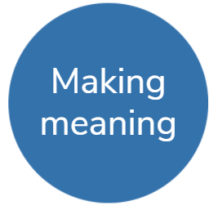
Day 3 activity 1&2: Whakapapa me te whānaungatanga | Culture and identity

Notes for teachers and whānau
Learners will explore how people find a place in Aotearoa New Zealand. Over time people from a wide range of cultures have participated in and contributed to Aotearoa New Zealand, while retaining and adapting their distinctive identities. The histories of Chinese, Indian, and other Asian communities, Pacific communities, refugee and faith-based communities, disability communities, and the Deaf community demonstrate how this has been experienced. Some have met barriers. Advocating for the right to citizenship and respect for difference has contributed to the development of a more diverse nation. Learners will be exploring social sciences and literacy.

I am learning to: compare and contrast how different groups and/or cultures have contributed to Aotearoa as citizens
What do I need?
- 60 minutes
- Look in your pack for a copy of these texts:
Chinese New Zealanders https://instructionalseries.tki.org.nz/Instructional-Series/School-Journal/School-Journal-Level-4-November-2019/Chinese-New-Zealanders
Listening eyes speaking hands: The story of Deaf education in New Zealand https://instructionalseries.tki.org.nz/Instructional-Series/School-Journal/School-Journal-Level-3-November-2018/Listening-Eyes-Speaking-Hands-The-Story-of-Deaf-Education-in-New-Zealand
Rise Up: The story of the Dawn Raids and the Polynesian Panthers https://instructionalseries.tki.org.nz/Instructional-Series/School-Journal/School-Journal-Level-4-November-2018/Rise-Up-The-Story-of-the-Dawn-Raids-and-the-Polynesian-Panthers

Remember to start your day right (see p. 8).

Your task
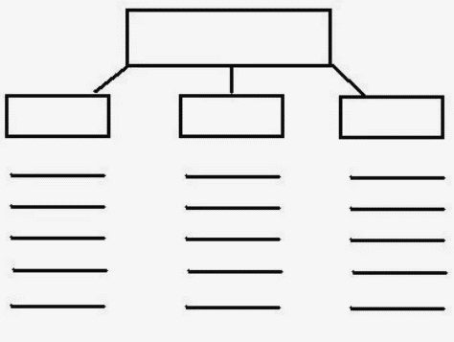
How we celebrate and acknowledge diversity in New Zealand is something we should be proud of, but there is always room for improvement! Today you will read some texts that will provide you with additional information to help you learn more about different groups of people and to connect with different points of view and perspectives. Follow the sequence below.
Complete the following tasks in your home learning book or digital doc.
Create and populate a structured overview chart so you can take notes as you read:
- Place the main topic in the box at the top of the diagram.
- Write the three main ideas in the second tier of boxes.
- Write supporting ideas, notes or key words using the lines underneath each box
Read the three texts (in your pack or at the links above):
- Chinese New Zealanders
- Listening Eyes, Speaking Hands and
- Rise up, the story of the Dawn Raids and the Polynesian Panthers.
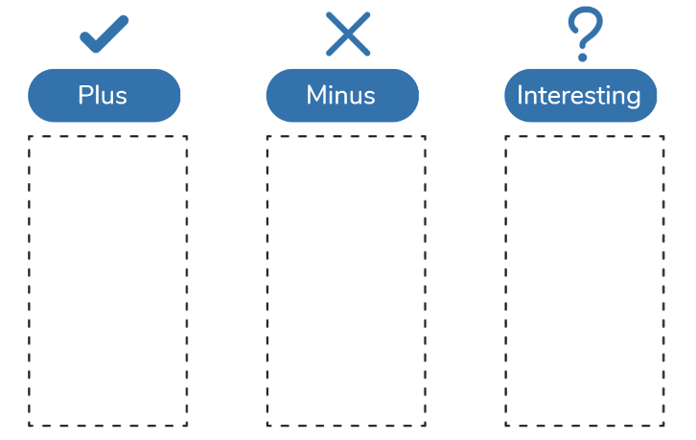

Re-read your notes and complete a Plus-Minus-Interesting chart for the three groups you have read about.
Add any questions that you have as you go through this activity under your PMI chart.

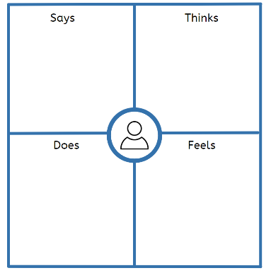
Complete an empathy map for each group. An empathy map can help you gain a clearer picture of differing cultural perspectives by considering how different groups feel as well as predicting what each group might say, do or think.

Think about what inferences you can make and what conclusions you can draw about the contributions and challenges these three groups have made and experienced as citizens of Aotearoa.

Summarise your thinking in the table below.
 | Challenges Faced | Contributions to NZ | Other notes
Chinese New Zealanders

Deaf people

Pacific New Zealanders

Day 3 activity 3: Biographies of the Treaty
Notes for teachers and whānau
Learners will read about 3 historical Māori figures and their perspectives and influence on the Treaty of Waitangi. They will complete a graphic organiser to help understand that beliefs motivate actions. Learners will be exploring social sciences and literacy. Note that our Inquiry focus for today is "making meaning" which includes analysing data, organising, and sorting information, summarising, synthesising, making connections/conclusions, building deeper understandings, and thinking critically.

I am learning to: compare and contrast the contributions of important Māori figures to the Treaty of Waitangi
What do I need?
- 30 minutes

Your task
You will explore the history and perspectives of three key historical figures and compare and contrast their contributions and perspectives. Read the information below:
Ngāpuhi chief Hōne Heke | Tāraia Ngākuti Te Tumuhuia | Tāmati Wāka Nene
Ngāpuhi chief Hōne Heke was an influential northern Māori voice in favour of the Treaty of Waitangi. However, he later became a leading opponent of British rule in NZ.  Heke, a Christian, had a close relationship with missionary Henry Williams, and, at the signing of the Treaty in 1840, he believed Williams' assurances that the authority of Māori chiefs would be protected.  'Governor,' he told Hobson, ‘You should stay with us and be like a father. If you go away, then the French and the rum sellers will take us Māori over.' The following day, he was the first of more than 40 northern chiefs to sign (although his signature is fourth, those of more senior chiefs having later been inserted ahead of his).  Four years later, disillusioned by the failure of colonisation to bring his people economic prosperity and by the increasing control of the British government over Māori affairs, Heke ordered the cutting down of the flagpole at the British settlement of Kororāreka (which had recently been renamed Russell). This was intended to show displeasure at the British government without threatening Pākehā settlers. Over the following months, the flagpole was re-erected and cut down again three times. The final felling, in March 1845, signalled war between British troops and some northern Māori. | Tāraia Ngākuti Te Tumuhuia (?–1872) belonged to the Hauraki tribes Ngāti Tamaterā and Ngāti Maru. Much of his life was taken up with warfare, and he remained a chief of the "old school" - rejecting the intrusion of Europeans in the traditional Māori world.  When Thomas Bunbury brought the Treaty of Waitangi to Hauraki, Taraia refused to sign. From then on he claimed the right to resolve disputes in the time-honoured way, by force if necessary.  In 1842 he attacked Ngāi Te Rangi, a Tauranga tribe who had long been enemies of Ngāti Tamaterā. Several Ngai Te Rāngi were killed or captured, and some were eaten. When challenged by Crown officials he insisted that as he had not signed the Treaty, his affairs were no business of the governor, especially as no Europeans were involved. Later, however, he accepted a Crown settlement of the dispute, returning prisoners and compensating the aggrieved Tauranga Māori.  Because of this and other such incidents colonial officials debated whether it was lawful to use force against Māori who had not signed the Treaty. Opinion was divided. Ultimately, the Colonial Office in London concluded that all Māori were British subjects, whether or not they had signed the Treaty. However, the colony had so few police and troops that it would be difficult to enforce British law. It was decided that the Crown would rule by "moral persuasion” and a liberal attitude towards Māori inter-tribal matters.  In 1850 Tāraia became the leading chief of Ngāti Maru and Ngāti Tamaterā. In later life he successfully resisted pressure to open Hauraki lands to gold mining, but eventually lost the cause. In the 1860s Tāraia was in favour of the King Movement, but by this time he was too old and frail to go to war himself. However, a contingent of Ngāti Maru fought in the Waikato campaign, and Tāraia sent a cask of gunpowder to King Tāwhiao. He died at Thames in 1872; he was said to have been over 80. | A leading Ngāpuhi chief, Tāmati Wāka Nene was an early friend of Pākehā and one of the Wesleyan missionaries' 1st converts, taking the baptismal name of Thomas Walker (Tāmati Wāka). He protected the Anglican and Wesleyan missionaries and also greatly assisted the British Resident, James Busby.  Nene was one of its most influential supporters in the debate at Waitangi over the Treaty and he was among the first to sign. He arrived at the gathering when agreement was very uncertain and spoke to argue that British intervention was necessary for peace and stability, given the lawless Pākehā who were already there. The situation had already passed out of the control of the Māori chiefs, he thought. However, although he agreed that the Governor should be as a father, judge, and peacemaker, he declared that Māori customs should also be preserved, and their lands should never be wrested from them. His speech was the turning point of the debate, leading to the general agreement.  During the 1845 conflict with Hōne Heke and Te Ruki Kawiti, Nene again allied himself with the British, providing support and advice to the imperial forces. He was later a friend of Governor Grey. His epitaph read: 'tē hoa o te Kāwanatanga me te matua o te Pākehā' ('friend of the Government and parent of the Europeans').
'Hōne Heke': https://nzhistory.govt.nz/people/hone-heke (MCH), updated 8-Apr-2019 | 'Tāraia Ngākuti Te Tumuhuia': https://nzhistory.govt.nz/people/taraia-ngakuti-te-tumuhuia (MCH) updated 8-Nov-2017 | 'Tāmati Wāka Nene': https://nzhistory.govt.nz/people/tamati-waka-nene (MCH) updated 8-Nov-2017

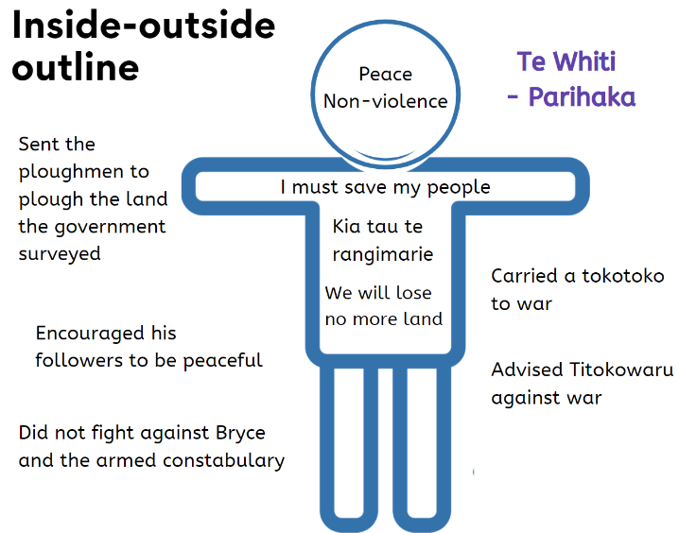
Choose two of these people and create a citizen ‘Inside-Outside’ outline for each one. This strategy will help you demonstrate how beliefs are connected to actions.
Draw the outline of a person and write the thoughts and feelings the person has about the Treaty of Waitangi on the inside, you must be able to justify what you include. On the outside, write or draw the actions the person has taken.
Write 2-3 sentences about how each person’s beliefs have affected their actions. How were they the same? How were they different? Explain. How did these men demonstrate the qualities of good citizenship?

Day 3 activity 4: Maths about me
Notes for teachers and whānau
Learners will be reconnecting with some basic maths and applying their problem-solving strategies. Encourage your learner to work systematically: to draw, make a list/table and/or use equipment to help them visualise the process as they work through the problems. Learners will be exploring the learning area of maths.

I am learning to: apply problem solving strategies to mathematical problems.
What do I need?
- 30 minutes
- Coloured pencils

Your task
In your home learning book, do the following to practice your maths skills!
Put on your creative thinking hats to solve these problems that are all about you!

End points in my Name:  Gill is writing her name using capital letters. She notices that “G” has 3 endpoints, "I" has two and "L" has two.  - How many points does she have in her name?  - How many points do you have in your name?  - Whose name in your family has the most points?  - What name could have a total of 12 points? | Value of my name:  Ngawai is playing with her name and with numbers. She lets all the vowels (a e i o u ) equal 5 and all the consonants (the rest) equal 10. So the value of Ngawai’s name is:  10 + 10 + 5 + 10 + 5 + 5 = 45.  - What is the value of your name?  - Who has the highest value name in your family?  - Can you find a name that has a value of 30? 45? 85? 100?  Extension: create your own key for each letter in the alphabet and repeat the tasks above. | Name in the mirror:  Lindsey has written her name as a reflection in the mirror.  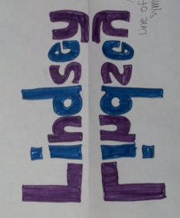  Can you try writing your name as a reflection?

Complete this Number of the Day problem. Today’s number is 666.
 | - Write it in words  - 50 less than  - 20 more than  - Add 62  - Subtract 17  - Next odd number is  - Halve it. Double it | - Is it a prime or composite?  - Times by 100  - Times by 1000  - Round to the nearest 10  - Round to the nearest 100  - What is the place value for each digit? | - Is it odd or even?  - Is it divisible by 5?  - Complete the pattern: add 9: 842,___,___,__  - Find one tenth  - Write a word problem whose answer is 666
BONUS: if the answer is 666 write 5 questions

Remember to do your end of day reflection and wellbeing activities (see p. 7 & 9).

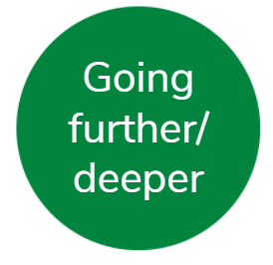
Day 4 activity 1-2: Project Geos
Notes for teachers and whānau
Learners will create their own utopic country where amazing citizens want to live. They will have a required task: to create a map and a variety of optional tasks e.g. to design a flag, write the national anthem, create a fact sheet (or promotional poster) incl: languages, population, climate, industries, flora/fauna, government/laws, and they may choose to design a traditional dress, a coat of arms, map out a timeline of the country’s history and more. Learners will be exploring social science, literacy, visual arts, HPE and music. Note today our Inquiry focus is “going further, deeper”. This may include promoting opportunities to dive deeper through discussions, provocations, exploring further contexts, taking action, or thinking critically and drawing conclusions.

I am learning to: draw a map that includes a variety of geographical features
What do I need?
- 60 minutes
- Paper, ruler, coloured pencils
Remember to start your day right (see p. 8).

Your task
For the first three sessions today and tomorrow you will invent artefacts and information about a fictional country that you get to create. We are calling this ‘Project Geos’ – creating a utopic country of great citizens! You will have some optional tasks and 2 required tasks.
Choose a theme for your country. A theme could be ‘feet’ with the country name of New Footland and places like Toe Jam Bay, Big Toe River, The High Heel Mountains, and a capital city of ‘Ankle’. The country map could be roughly made into the shape of a foot. Other themes could be sports, animals, insects, musical instruments, horses, or something else that tickles your fancy. You need a name for your country and its capital city.
Write:
My theme is: _______________________________________________
Name of country: ____________________________________________
Name of capital city: __________________________________________
Plan for drawing your map. Identify names for the following places and geographical features in your country and wirte them in this table.
5 cities | 2 rivers | 2 lakes
1 ocean | 1 gulf | 1 bay
1 peninsula | 1 mountain range | 1 island

Draw your country map using pencil on a blank piece of paper. Your map must inlcude all of the features as listed above.
Read and follow these tips before you begin:
- Write the name of your country in the top left of your map paper using a ruler and capital letters
- Lightly draw the outline of the country in pencil and ensure it looks ‘authentic’ (not too smooth or straight)
- At least one city must be on the coastline (as a shipping port). **Ports are often in bays as they provide protection against ocean storms and they are also often situated at the mouths of rivers.
- Cities can be indicated with a dot or you can draw a box around the city area to indicate its size and borders
- Rivers start as Small streams in the mountains (like tree branches) and become larger as the flow towards the ocean – note that your rivers should not be drawn too wide
- A bar scale should be drawn in the lower ight Corner of the page with 1 cm on the map = 10 km of actual distance
- Draw your mountain ranges as a series of small open bottomed triangles
- All labels must be neat and printed horizontally (except for rivers, you may label the river along the actual river)
- Add colour – note that you do not have to colour in the entire map, you could shade blue around the outside to inidcate water and shade green around the inside to inidcate land.
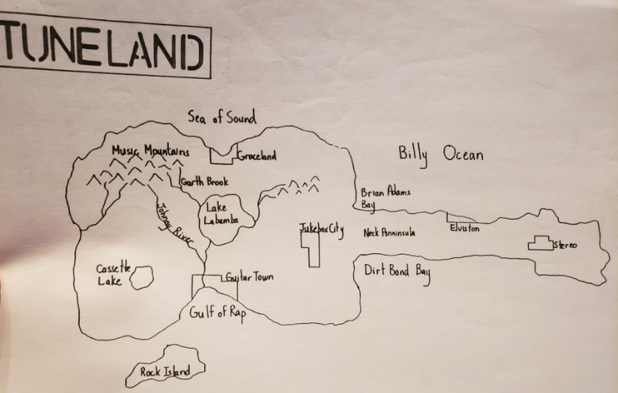

Day 4 activity 3: Project Geos – my choice
Notes for teachers and whānau
Now that the learner has created a map for their country, they can choose which other aspects to focus on using a choice grid. Learners will be exploring the learning areas of social science, literacy, visual arts, HPE and music.

I am learning to: create artefacts to represent my utopic country
What do I need?
- 30 minutes
- As indicated in the choice grid

Your task
Choose from the choice grid.
Design a flag  Look at examples of flags and choose your colours and design carefully. Consider: will your flag represent your country theme? If so how? | National Anthem  Write (and record yourself singing) the national anthem. Make it simple and catchy. | Create a fact sheet  Include: type of government, languages spoken, population, climate info), flora/fauna, key landforms/geography, economics, transportation
Climate  Describe the climate and relate this to where it is located (e.g. if close to the equator it would be hot and humid). Outline expected precipitation and temperatures for each season. | Industry and Natural Resources Each country has different industries, and these are often dependent on the natural resources. Outline and describe the key industries / natural resources | Traditional dress/fashion  Design a traditional dress or common fashion trends. What types of clothes do the people in your country like to wear? Why?
Government and Law  Describe the type of government and key laws. Why is this country a great place for citizens to live? Is it safe? | Flora & fauna  List, describe and draw the flora and fauna (plants and animals) that are common to your country. You can make these up for fun. | Coat of Arms  Design a coat of arms to reflect the identity of your country. This represents and depicts what is important to a country.
National Animal & Plant  Describe the significance of the national plant and animal. Draw them. | National Sport  Invent a national sport. Write the rules of the sport and how it came to be. Why is it so popular? | Tourism  Outline the tourist attractions for your country. Create a brochure to promote.
Historical Timeline  Create a timeline to identify key historical events e.g. battles, treaties, settlements, government, law changes etc. | Come live here!  Design a promotional poster about your country and why the good citizens of the world would want to migrate there. | Language  Create a language for your country and make a list of key words and phrases in your country

Day 4 activity 4: Life moments
Notes for teachers and whānau
Learners will be guided to explore how important events in our lives have shaped our identities. Using the Oho My events, my time and My identity cards, the Ata Impact and Emotion cards, and the Important life moments activity sheet, explore how events and our responses to them have shaped who we are. Learners will be exploring the learning areas of social sciences, health, and literacy.

I am learning to: Explore the personal and wider cultural connections between place, language, time, events, people, and identity
What do I need?
- 30 minutes
- Look in your pack for a copy of: Oho My events, My time and My identity cards, Ata Impact and Emotion cards – access and print from https://hpe.tki.org.nz/assets/healthpe/Uploads/Oho/Downloads-Important-life-moments/Oho-Important-life-moments-Cards-Printable.zip
- Important life moments activity sheet: https://hpe.tki.org.nz/assets/healthpe/Uploads/Oho/Downloads-Important-life-moments/Oho-Important-life-moments-activity-sheet.pdf

Your task
You will explore important life moments and how this can contribute to shaping us as citizens of the world. Follow the sequence below.
Choose an event that is particularly meaningful to you or your whānau. For example, it might be something you’ve done, something you want to do, something you want to find more about or something that is requiring focus.
Follow this sequence:
- My events: select a My events card that represents a meaningful event.
- My time: select a My timecard that represents when this did or will take place.
- Impact: select an Impact card that represents what was or will be significant about this event.
- Emotion: select an Emotion card that represents how this did or might make you feel.
- My identity: select a My identity card that represents how this has shaped or will shape who you are.
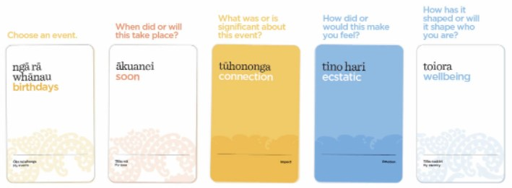
Place cards on the activity sheet like this example:
Write why each selection was made and how it relates to the other cards in your home learning book or digital doc.
Remember to do your end of day reflection and wellbeing activities (see p. 7 & 9).

Day 5 activity 1&2: Project Geos
Notes for teachers and whānau
Now that the learner has created a map for their country they can choose other aspects to focus on using a choice grid. Learners will be exploring social sciences, literacy, visual arts, HPE and music. Note our Inquiry focus is “present – share learning about the big idea” which includes thinking about who the audience is, and considering different ways of communicating learning – for example, presentation, video, poster, etc.

I am learning to: create artefacts to represent my utopic country
What do I need?
- 60 minutes (or more if you’re having fun!)
Remember to start your day right (see p. 8).

Your task
Choose from the choice grid.
Design a flag  Look at examples of flags and choose your colours and design carefully. Consider: will your flag represent your country theme? If so, how? | National anthem  Write (and record yourself singing) the national anthem. Make it simple and catchy. | Create a fact sheet  Include: type of government, languages spoken, population, climate info), flora/fauna, key landforms/geography, economics, transportation
Climate  Describe the climate and relate this to where it is located (e.g. if close to the equator it would be hot and humid). Outline expected precipitation and temperatures for each season. | Industry and natural resources  Each country has different industries, and these are often dependent on the natural resources. Outline and describe the key industries / natural resources | Traditional dress/fashion  Design a traditional dress or common fashion trends. What types of clothes do the people in your country like to wear? Why?
Government and law  Describe the type of government and key laws. Why is this country a great place for citizens to live? Is it safe? | Flora and fauna  List, describe and draw the flora and fauna (plants and animals) that are common to your country. You can make these up for fun. | Coat of arms  Design a coat of arms to reflect the identity of your country. This represents and depicts what is important to a country.
National animal and plant  Describe the significance of the national plant and animal. Draw them. | National sport  Invent a national sport. Write the rules of the sport and how it came to be. Why is it so popular? | Tourism  Outline the tourist attractions for your country. Create a brochure to promote.
Historical timeline  Create a timeline to identify key historical events e.g. battles, treaties, settlements, government, law changes etc. | Come live here!  Design a promotional poster about your country and why the good citizens of the world would want to migrate there. | Language  Create a language for your country and make a list of key words and phrases in your country

Day 5 activity 3&4: Sharing Project Geos
Notes for teachers and whānau
Provide an audience for your learner so they can showcase their utopic country to you. Learners will be exploring social science, literacy, visual arts, HPE and music.

I am learning to: create a compelling presentation to promote my country to prospective immigrants
What do I need?
- 60 minutes

Your task
Select from the artefacts that you have created this week for your utopic country as part of ‘Project Geos’. Your job is to present your country to prospective immigrants and promote your country to them. Consider it an ‘elevator pitch’ where you have 5 minutes or less to capture their interest in your country.
Choose a compelling way to share the results of country creating! It is important to share this as a storyteller so you can inspire others.

You may like to:
- Create an information report that refers to the different artefacts you have created.
- Design a cartoon to promote your country.
- Create a poster to promote your country.
- Make a news clip or movie trailer of your country.
- Another way of your choice.

Congratulations on completing your first week of learning about ‘Citizenship’.

So what do you think?
How does knowledge about our identity, culture and manaakitanga help us be/become better citizens?

- Write a response in your reflective journal.
- Ka pai! Ngā manaakitanga.

Remember to do your end of day reflection and wellbeing activities (see p. 7 & 9).

Context 2: Rights and responsibilities

Over the next five days we will investigate the theme of citizenship by looking at how we enact our rights and responsibilities as a citizen.

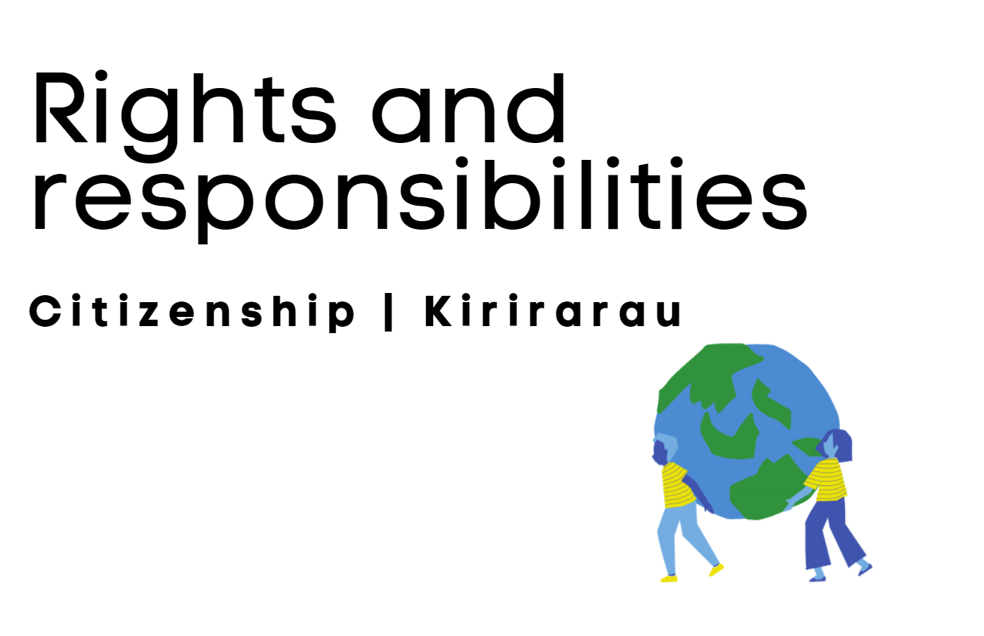

Day 6 activity 1: Rights & responsibilities
Notes for teachers and whānau
This week learners will explore Citizenship by unpacking their rights and responsibilities as citizens of Aotearoa and of the world. Learners will be exploring literacy and social sciences. Note our Inquiry focus for today is “getting started” which includes generating questions, activating prior knowledge, and introducing the theme.

I am learning to: outline the rights and responsibilities of a New Zealand citizen
What do I need?
- 30 minutes

Your task
Citizens in every country have rights and responsibilities. Check out these definitions:
- CITIZEN: a person who is a member of a particular country because of being born their or who has been granted citizenship and who has right and responsibilities specific to that country **note, citizen can also refer to being part of a small community like a classroom or a larger community like a city
- RIGHT: a right is a freedom. A key aspect of our government’s job is to protect our rights in New Zealand.
- RESPONSIBILITY: responsibilities are things that you should do. In New Zealand, it is our responsibility to follow the laws (rules) of our country. Note: we also have responsibilities in our classrooms and families.

The www.govt.nz website clearly outlines what those are for us here in Aotearoa:
Privileges and responsibilities of a citizen
When you become a New Zealand citizen, you will have the same privileges as a person who was born here. You will also have the same responsibilities.
Your privileges  You are entitled to:  - live in New Zealand indefinitely  - travel overseas on a New Zealand passport  - vote  - stand for parliament or local government  - have full access to education  - have full economic and social rights  - represent New Zealand in sports. | Your responsibilities  You must:  - obey and promote the laws of New Zealand  - not act in a way that is against the interests of New Zealand  - register on the electoral roll — you do not have to vote, but you must enrol to vote  - pay tax  - behave as a responsible New Zealander.
Source: https://www.govt.nz/browse/passports-citizenship-and-identity/nz-citizenship/privileges-and-responsibilities-of-a-citizen/

Complete the following table as it applies to you and your life:
 | At home | At School | In New Zealand
Rights I have
Responsibilities I have
Rules or laws I must follow

Day 6 activity 2&3: Treaty rights and responsibilities
Notes for teachers and whānau
In this activity, learners will look at the Treaty of Waitangi with a retrospective and future focused lens to examine what the rights and responsibilities are of New Zealand citizens to honour the Treaty. Learners will be exploring the learning areas of te ao Māori, social science, and literacy.

I am learning to: identify our rights and responsibilities as related to the Treaty of Waitangi | Te Tiriti o Waitangi
What do I need?
- 60 minutes
- Copies of the following school journals:
- https://instructionalseries.tki.org.nz/Instructional-Series/School-Journal/School-Journal-Level-4-November-2017/Keeping-Promises-The-Treaty-Settlement-Process
- https://instructionalseries.tki.org.nz/Instructional-Series/School-Journal/School-Journal-Level-3-August-2017/Te-Tiriti-o-Waitangi
- https://instructionalseries.tki.org.nz/Instructional-Series/School-Journal-Story-Library/Te-Tiriti-o-Waitangi

Your task
The Treaty of Waitangi | Te Tiriti o Waitangi is an important foundational document for our country. In this task you will be our rights/responsibilities as they relate to the Treaty. Set up the following Inquiry Chart in your home learning book. Tip: Leave a lot of space in your book for your notes.
Topic: Our rights and responsibilities as set out in Te Tiriti o Waitangi | Question 1: What are the rights of New Zealanders as set out in the Treaty? | Question 2: What are the responsibilities of New Zealanders as set out in the treaty? | What new wonderings have arisen for me? What new questions do I have?
Source 1: Te Tiriti o Waitangi by Ross Calman
Source 2: Te Tiriti o Waitangi by Toby Morris
Source 3: Keeping Promises: The Treaty Settlement Process by Mark Derby
An inquiry chart helps you to gather information about a topic from several sources. It will help you strengthen reading skills and foster critical thinking.
Read the three texts. Now re-read and as you re-read, take notes in your Inquiry table with information relating to the two questions.
Extra: make a poster to advertise the rights and responsibilities of New Zealanders as set out in Te Tiriti o Waitangi.

Day 6 activity 4: Rights and responsibilities in sports/games
Notes for teachers and whānau
Last week learners looked at the game Ultimate Frisbee and what it takes to be the ‘ultimate participant’. In this activity, learners are invited to choose a sport or game of their choice and to consider what their rights and responsibilities are if/when the participate. Learners will be exploring the learning areas of health, physical education, and literacy.

I am learning to: identify the rights and responsibilities of game/sport participants
What do I need?
- 30 minutes

Your task
Choose a game or sport of your choice. Complete the tasks below in your home learning book:
- Descibe the game/sport
- Outline the rules of the game/sport
- What are the rights of participants?
- What are the responsibilities of participants?
- What are some possible problems or challenges associated with this game/sport?
- Do you think playing games/sports helps us learn to be better citizens? Why or why not?

Complete a Problem/Solution chart for one of the possible problems you identified.
What is the problem?
What are the effects?
What are the causes?
What are the solutions?

Optional: have some fun, play your game or sport with others if possible

Remember to do your end of day reflection and wellbeing activities (see p. 7 & 9).

Day 7 activity 1: Online rights and responsibilities
Notes for teachers and whānau
In this activity learners will read a humorous play that is a take on a familiar scenario: thoughtless online behaviour and our sometimes-unhealthy relationships with screens. The play cleverly side-steps the usual sides by portraying the adults getting it wrong and the kids getting it right and the lesson is about ‘digital citizenship’. Learners will be exploring the learning areas of literacy, health, and social science. Note our Inquiry focus is “explore, investigate, and discover” which includes choosing and evaluating information, and thinking critically.

I am learning to: describe rights and responsibilities as related to digital citizenship and the key competencies
What do I need?
- 30 minutes
- Look in your pack for a copy of Like, share, subscribe https://instructionalseries.tki.org.nz/Instructional-Series/School-Journal/School-Journal-Level-4-November-2020/Like-Share-Subscribe
Remember to start your day right (see p. 8).

Your task
Read the play Like, Share, Subscribe. Find some family members to read with you or do so alone using different voices for the different characters.
The play describes a scenario where some rights were over-stepped, and some responsibilities were overlooked. What is the ‘moral’ of this story from your perspective? Write it in your home learning book.
Read about digital citizenship:
Being safe online is part of being a good digital citizen. Digital citizenship is about learning to work, live and share in digital environments in a positive and safe way.
We must all understand that when we are provided opportunities, such as the access to the Internet and use of online products/digital tools, we need to be diligent in helping others as well, such as informing adults of potential problems.
Your teachers have a responsibility to help you understand that protecting others both online and in the real world are essential skills to have.
You could say that digital citizenship is about your ability to engage positively, critically, and competently in the digital environment, drawing on the skills of effective communication and creation, to practice forms of social participation that are respectful of human rights and dignity through the responsible use of technology.
Ultimately, in many ways, digital citizenship is about enacting the Key Competencies in online spaces.
Complete: make connections to the Key Competencies and Digital Citizenship in the following chart:

Key Competency | Connection to digital citizenship – how is this competency modelled/enacted when you are online?
Thinking

Relating to others

Understanding language, symbols, and texts
Managing self

Participating and contributing

Optional digital: Learn more about digital citizenship using the games and activities on these two websites:
- DQ World site https://au.dqworld.net/lang:en_GB/#!/landing and
- Google’s ‘Be Internet Awesome’ site which links to the ‘Interland’ game https://beinternetawesome.withgoogle.com/en_us

Day 7 activity 2: The Declaration of Independence
Notes for teachers and whānau
Learners will explore the significance of the Declaration of Independence for Aotearoa and how it highlights our rights and responsibilities. Learners will be exploring the learning areas of literacy and social science.

I am learning to: write poetry by reflecting on the past
What do I need?
- 30 minutes

Your task
He Tohu is a permanent exhibition at the National Library of three constitutional documents that shape Aotearoa New Zealand:
- 1840 Te Tiriti o Waitangi – Treaty of Waitangi
- 1835 He Whakaputanga o te Rangatiratanga o Nu Tireni – Declaration of Independence of the United Tribes of New Zealand
- 1893 Women’s Suffrage Petition – Te Petihana Whakamana Pōti Wahine.
Today you will read and learn more about the Declaration of Indepedence | He Whakaputanga p te Rangartiratanga o Ne Tireni and how it contributed to the foundation of our rights and responsibilities in Aotearoa.
Read this:

Tino rangatiratanga me te kāwanatanga | Government and organisation
“The signings of He Whakaputanga o te Rangatiratanga o Nu Tireni | The Declaration of Independence (1835) and Te Tiriti o Waitangi | The Treaty of Waitangi (1840) emerged from a long period of complex interactions between hapū/iwi and newcomers in which Māori were the majority. These interactions, particularly those with missionaries, helped to facilitate the treaty process. Also important were the international events and ideas of the time that informed the Crown’s thinking and actions.
From the Crown’s perspective, the signing of He Whakaputanga o te Rangatiratanga o Nu Tireni | The Declaration of Independence guaranteed New Zealand’s independence and freedom from foreign interference; from a Māori perspective, it continued to safeguard them from the challenges posed by European contact, it strengthened alliances with Great Britain, and it affirmed the existing authority of the chiefs.
For the Crown, the signing of Te Tiriti o Waitangi | The Treaty of Waitangi reflected the strength of the humanitarian movement in British politics, while responding to pressure from investors, the immigration plans of the New Zealand Company, and the ongoing possibility of foreign interference. For iwi, the British Crown was a new element in the ongoing competition for mana.
Prior to the Treaty, engaging and trading with Pākehā was about enhancing mana. There was a desire to continue this mutually beneficial trading relationship; a treaty that curbed Pākehā lawlessness ensured its ongoing viability. Also, prior to the Treaty Māori were coming to believe in the special bond and a partnership of equal status between chiefs and the Crown. The missionaries did not discourage the idea that this partnership would continue with the signing of Te Tiriti.”
Cited from: https://aotearoahistories.education.govt.nz/years-7-8/know#18-73

He Whakaputanga - Declaration of Independence 1835
“In 1835 on October 28, 34 Northern chiefs gathered at Waitangi at the home of James Busby, British Resident. They made their mark on history as they signed He Whakaputunga o te Rangatiratanga o Nu Tireni ( Declaration of Independence of the United Tribes of New Zealand). Recognised by King William IV, it declared New Zealand’s independence as a sovereign nation under the Māori chiefs. Signatures continued to be added until 1839, by which time it had 52 signatures. These included the signature of Te Wherowhero, the chief of Waikato who would later become the first Māori king.
The signatories were concerned about the intentions of the growing number of Europeans. British and Māori were both concerned about France competing for influence and the news of French warships sailing to New Zealand. As a significant mark of Māori national identity, it would prevent other countries from making formal deals with Māori.
What was the significance of He Whakaputunga to the Treaty of Waitangi? Because of it, the British felt that the Treaty of Waitangi was required to bring law and order as more and more settlers, mainly British, arrived. In the Declaration, the chiefs had agreed that in return for their protection of British subjects in their territory, King William would protect them against threats to their authority. Britain felt the Treaty would protect Māori as foreign interests continued to arrive, with the United States and France competing for influence in New Zealand, as well as private French and British companies planning settlements. It would also cement the special relationship between Māori and British, built up over decades of personal, political, and economic ties between the two peoples.”
Cited from: https://www.waitangi.org.nz/declaration-of-independence-he-whakaputunga-185he-whakaputanga-declaration-of-independence-1835/ (28/10/2019 Imogen Rider)

Using what you have read in the previous activities about the Treaty of Waitangi and what you have just read about the Declaration of Independence compare and contrast the two documents.
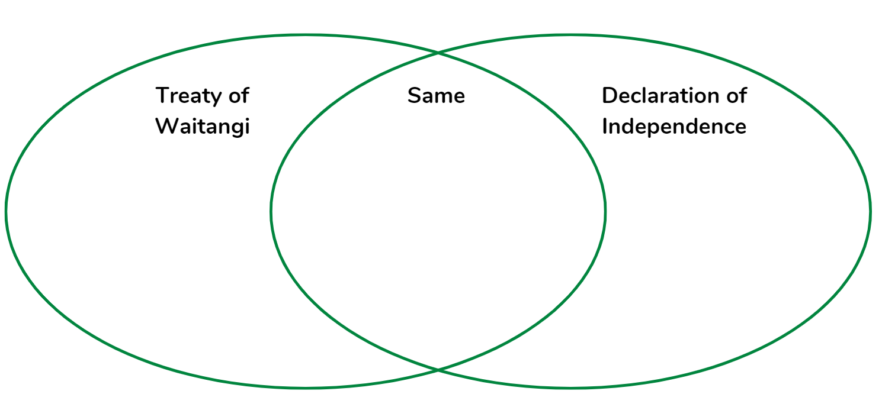
Complete a Venn diagram in your home learning book to do so:

Write a cinquain poem or an acrostic poem to convey the significance of the Declaration of Independence.
Cinquian | Acrostic
This is a 5 lined poem where:  - Line 1: One word (a noun, the subject of the poem)  - Line 2: Two words (adjectives that describe the subject in line 1)  - Line 3: Three words (-ing action verbs –participles – that relate to the subject in line 1)  - Line 4: Four words (a phrase or sentence that relates feelings about the subject in line 1)  - Line 5: One word (a synonym for the subject in line 1 or a word that sums it up)  Example:  Independence  Sovereign, useful  Signing, mahi tahi  A foundational document  Declaration | An acrostic is a type of poem where you spell out a name, word, or phrase with the first letter of each line of your poem  Example:  T - together  R - respect  E - equity  A - agreement  T - the articles  Y - young nation’s founding document

Share your poem with whānau, your teacher or your class.

Optional digital: Watch ‘Lost in Translation 2’ at https://www.nzonscreen.com/title/lost-in-translation-te-tiriti-o-waitangi-episode-two from NZ On Air (watch the entire video or from around 7:45 to 8:50).
Read more at the following links:
- https://natlib.govt.nz/he-tohu/about/he-whakaputanga
- https://www.rnz.co.nz/programmes/the-aotearoa-history-show/story/2018717296/4-te-tiriti-o-waitangi
- https://instructionalseries.tki.org.nz/Instructional-Series/School-Journal-Story-Library/Te-Tiriti-o-Waitangi

Day 7 activity 3: Parliament – the governing system in NZ
Notes for teachers and whānau
Learners explore parliament and make connections to how government impacts their own rights and responsibilities. Learners will be exploring the social sciences.

I am learning to: explain key features of our parliament
What do I need?
- 30 minutes
- Optional digital: device to watch How parliament works https://www.youtube.com/watch?v=X2F2NqlIaHE

Your task
The type of government we have in New Zealand is a representative democracy. Watch the video ‘How parliament works or read the transcript below and then complete the scavenger hunt questions at the end.
New Zealand's Parliament grounds and buildings are part of the history of our country. The decisions made here have helped to shape the way we live in Aotearoa, New Zealand today. We've had a parliament since 1854 and Wellington has been the capital city since 1865. This Parliament belongs to the people of New Zealand it's a place where you can discover how we are governed and where you can have a voice in the decisions that are made here. Parliament's job is to represent the people of New Zealand, provide us with a government, make decisions about how the tax money is spent, make laws for the country, and keep the government accountable for the decisions it makes.
Now let's look at how it works.
Our parliament has two parts. New Zealand is a representative democracy – the people who make the decisions here represent us. We call those people members of parliament or MPs and there are usually about 120 of them, called the House of Representatives. We also have a head of state – the sovereign, a king or queen. The sovereign is usually represented by a New Zealander who was appointed as the governor-general. The governor-general closes Parliament before a general election, opens it after the elections, and signs off new laws that are made every 3 years. We choose MPs using a voting system called mixed-member proportional or MMP. To vote you need to be 18 or over and a New Zealand citizen or a permanent resident. You need to enrol in the area where you live. New Zealand is divided up into geographical areas called electorates. There are 64 general electorates and 7 Māori electorates, and you can decide depending whether you go on the general or Māori roll. Anyone who is New Zealand citizen enrolled to vote can stand as a candidate in the election. Most candidates belong to a political party which can increase your chance of getting into Parliament, but you can also stand independently. Under MMP you get two votes – an electorate vote to choose someone to represent your electorate and a party vote to choose the party you would like to be the government. Candidates win seats in parliament depending on how people vote. Some MPs become electorate MPs and represent an electorate as well as their party. Other MPs come into Parliament based on how many votes their party gets. In most cases the party that wins the most seats forms the government. They need to have over half the seats in order to govern. This is called having the majority. If one party does not have a majority it can invite other parties who have won seats to make agreements with them and join them in government. This means they will have enough people to make the big decisions for the country. Under MMP the government is usually made up of more than one party. The other parties who are not in government form a group called the opposition.
But how does the work get done?
The House of Representatives must meet in the debating chamber about 90 days each year. The speaker oversees the day-to-day business of the house and is the house’s chairperson. The Government sits to the right of the speaker. The Prime Minister sits 4 seats down at the front and appoints other government MPs as ministers. They are called the executive and are responsible for making decisions about things such as health, police, education, and transport. The government carries out its ideas by proposing laws and deciding how taxpayers’ money is spent. The opposition MPs sit to the left of the speaker's chair. The leader of the Opposition always sits 4 seats down at the front on the side. The opposition keeps the government accountable asking ministers questions in the house, debating proposed laws, and work with government MPs and select committees. Party whips make sure their party's MPs are in the house to speak or vote as needed.
Sitting at the table in front of the speaker's chair is the clerk of the house. The clerk of the house advises the speaker and the MPS about the rules and practices of parliament. When new laws are proposed there must be plenty of opportunity for debate and discussion. New laws must be debated several times in the house and voted forth before they become laws. Usually after the first debate laws are sent to select committees which are small groups of MPs who look at the new law in detail. This is the stage where the public gets a chance to put forward their point of view on the new law as well. Once the law is voted through all its stages it is signed off by the governor-general. This is called giving it the Royal Assent. The law now becomes one of the hundreds of laws we have in New Zealand.
So there you have it.
Parliament is where laws are made, and tax spending is approved. It helps to shape our country and gives us a place to air our views. What happens here makes a difference to all our lives. And one more thing – don't wait until you can vote to get involved in what happens here! Now you know a bit more about this place there are lots of things you can do to participate in the work of Parliament. It even has its own TV channel so you can watch at any time. You can also watch it live by sitting in the public galleries or read about it in the newspaper or on the internet. Start talking about what happens here with friends, family, or whānau and contact an MP if you have an issue that is important to you for your community. You can even put together a petition or follow a new law that could affect you and make a submission to a select committee. Parliament belongs to the people of New Zealand and the people who work here represent you.
This is your place
Complete the Scavenger Hunt questions in your home learning book:
- What does MMP stand for and what does it mean?
- Who is the Govenor General and what is the function of this role?
- What is the ‘job’ of parliament?
- What is an MP?
- When do elections take place and who can vote?
- What is meant by ‘royal assent’?
- Who or what is the ‘opposition’?
- Describe the role of the ‘speaker’?
- What does the term ‘House of Representatives’ mean?
- How does a proposed law become a real law?
Write a paragraph outlining how parliament impacts your rights and responsibilities as a New Zealand citizen (or permanent resident).
Optional digital: have some fun and try to create your own parliament using this interactive online tool: https://www.parliament.nz/en/visit-and-learn/educators-and-students/create-your-own-parliament/

Day 7 activity 4: Elections
Notes for teachers and whānau
Learners will read ‘The Winning Side’ to learn more about elections. Learners will be exploring literacy and social sciences.

I am learning to: Explore some of the terms and processes involved in elections
What do I need?
- 30 minutes
- Look in your pack for a copy of The Winning Side https://instructionalseries.tki.org.nz/Instructional-Series/School-Journal/School-Journal-Level-4-May-2020/The-Winning-Side

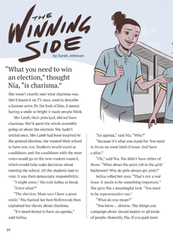
Your task
This story references general elections, in the context of an election to a school council. “The Winning Side” introduces a few big ideas: the need for a platform, the importance of giving everyone a voice, and why we vote.
Create a KWL chart for elections before reading the story.
Read the text.
Try to answer their questions in the “Want to know” column of your KWL chart in the ‘Learned’ column.
Know | Want to Know | Learned

Complete a concept circle citizenship using the words: election, rights & responsibilities, courage and democracy in the four quadrants. Explain the relationship between each word and the concept; then describe the relationships among the four words.

Remember to do your end of day reflection and wellbeing activities (see p. 7 & 9).

Day 8 activity 1: Voting is a right and a responsibility
Notes for teachers and whānau
In this activity learners will learn more about the voting process and why it is both a right and a responsibility to vote. Learners will be exploring social sciences, literacy, and visual arts.

I am learning to: explain why voting is important, how it is a right and a responsibility
What do I need?
- 30 minutes
- Optional digital: Watch ‘Have your say’ found at https://school-leavers-toolkit.education.govt.nz/en/government-and-voting/
Remember to start your day right (see p. 8).

Your task
Before we begin, refresh your thinking about government and voting by watching the video Have your say or read the transcript:
On camera: Two friends, Alex and Sam, walk across the grassy area of a city square. Funky pop music softly playing.
Alex to camera: The cool thing about living in a democracy is that everyone gets to have their say. The representatives we choose to elect can shape how our whole country runs, so it's an important subject to think about.
On camera: Alex turns to look at Sam.
Sam to camera: The government is a building called the Beehive. It's where the Prime Minister sleeps at night and also where you can post complaints about public transport.
On camera: Alex gives an awkward smile, his lips pressed together.
Alex to camera: That is... incorrect.
Sam to camera: The government is a place where... um...
On camera: Sam leans into Alex's ear and whispers rapidly to him. Alex whispers back and gives a reassuring smile to the camera. Now Sam and Alex sit at a table in a trendy cafe with boxes of burgers and fries and glasses of juice in front of them.
Alex to Sam: Ok, so this is Parliament, our law-making system in Aotearoa and it’s divided into two parts.
On camera: Alex grabs a handful of his potato fries and a handful of Sam's kumara fries and places them on the wooden table.
Alex to Sam: House of Representatives...
On camera: Alex puts his burger on the table above the fries.
Alex to Sam: And Head of State, which is the sovereign, like a King or Queen. So, it's Parliament's job to make laws and represent the people of our country.
Sam to Alex: How do they do that?
On camera: Alex moves his burger box to the side.
Alex to Sam: Well, you need a government. A government is a group of Members of Parliament that hold confidence in the majority of seats in the House of Representatives.
On camera: Alex separates the potato fries from the kumara fries.
Alex to Sam: A majority can be made up of one party or a group of parties. When it's a group, it's called a coalition.
On camera: Alex moves the kumara fries to sit next to the potato fries.
Alex to Sam: There's 120 seats in Parliament, and several seats are reserved for Māori. And Māori have the option of enrolling in a separate electoral roll to vote for candidates in these seats.
Sam to Alex: So, how do they make laws? Does the burger king decide?
On camera: Sam points to Alex's burger.
Alex to Sam: Nope. Before a law goes through Parliament, it’s called a bill.
On camera: Alex holds up a ketchup packet and places it next to the pile of fries.
Alex to Sam: Then there’s a series of formal stages before they are become finalised and become a law. New laws are called Acts of Parliament.
On camera: Alex thumps his fist on the ketchup packet, causing sauce to burst out.
Sam to Alex: So all these small fries form the giant potato of democracy.
Alex turns to the camera: Yup. So it's pretty much people like us making big decisions for our country. That's why it's important to pay attention to our representatives and stay involved in the decisions that they're making. There's more information about government and voting on the website.
On camera: Alex smiles.
On camera: Holding her glass of juice, Sam looks at the burger, fries, and ketchup on the table.
Sam to Alex: How often do you reckon they clean these tables?
On camera: Alex purses his lips awkwardly.
Text on screen: School Leavers' Toolkit logo and http://school-leavers-toolkit.education.govt.nz/

Read this: MMP is the voting system we use in New Zealand. It stands for ‘Mixed Member Proportional’. We use MMP to choose who represents us in Parliament.
Optional digital : MMP https://www.youtube.com/watch?v=pljoleVHFug
Parliament has 120 seats for its members of Parliament (MPs). During an election, political parties try to win as many seats in Parliament as they can. Under MMP, you get two votes — a party vote and an electorate vote. When you vote for a party, you help to choose how many seats in Parliament each party gets. The party vote largely decides the total number of seats each political party gets. Parties with a bigger share of the party vote get more seats in Parliament. Parties also try to win as many electorate seats as possible. When you vote for a candidate, you help to choose who represents the electorate you live in. This is called your electorate vote. The candidate with the most votes wins and becomes an MP.
Create a comic strip to explain the MMP voting system.
Write a paragraph to explain why voting is your right and your responsibility.

Optional digital: learn more about our government and voting here: https://school-leavers-toolkit.education.govt.nz/en/government-and-voting/
Extra for experts: Have Your Say: Level 3 & 4 Student Resources https://docs.google.com/presentation/d/15jilLQotp9BpdpCCC5wDQgzO1wMHPGkDoKQQiKpov2w/copy

Day 8 activity 2&3: Your voice, your choice inquiry cards
Notes for teachers and whānau
Learners will do an independent investigation on one or more of the inquiry cards. If they get stuck, this link: https://elections.nz/assets/Community-learning/Inquiry-cards-teacher-guide-2020.pdf may be of use. Learners will be developing their inquiry and critical thinking skills and exploring content related to social sciences.

I am learning to: use visual clues in images to make predictions and to research information to draw conclusions
What do I need?
- 60 minutes
- Look in your pack for a copy of a selection of even numbered pages from https://elections.nz/assets/Community-learning/Your-Voice-Your-Choice-Inquiry-cards-2020.pdf

Your task
Choose at least one Inquiry Card to respond to.
Take notes in your home learning book.
Do some additional research if needed to gather more information.
Create a visual way to reflect what you have learned. You might like to:
- Make a poster
- Create an information cube
- Write a play or skit
- Make a poem or rap
- Draw a comic slip
- Create a flow chart
- Make an infographic
- Draw a timeline
- Create a puppet show
- Make a performance or re-enactment
- Draw a concept map
- Write a report
- Share it as an infomercial
- Create a PowerPoint presentation
- Make a kahoot
- Write a persuasive argument
Choose another inquiry card if time permits.
Sources for you to explore (optional):
- https://www.parliament.nz/timeline/index.html
- www.elections.nz
- https://school-leavers-toolkit.education.govt.nz/en/government-and-voting
Share your learning with a family member, classmates or your teacher.

Day 8 activity 4: Census sense
Notes for teachers and whānau
In this activity learners will explore census data and learn that the census helps our government make informed decisions. Learners will be exploring the learning areas of social sciences and maths.

I am learning to: order whole numbers and to find a percentage of a whole number
What do I need?
- 30 minutes
- A calculator
- Look in your pack for a copy of Census Sense https://nzmaths.co.nz/resource/census-sense

Your task
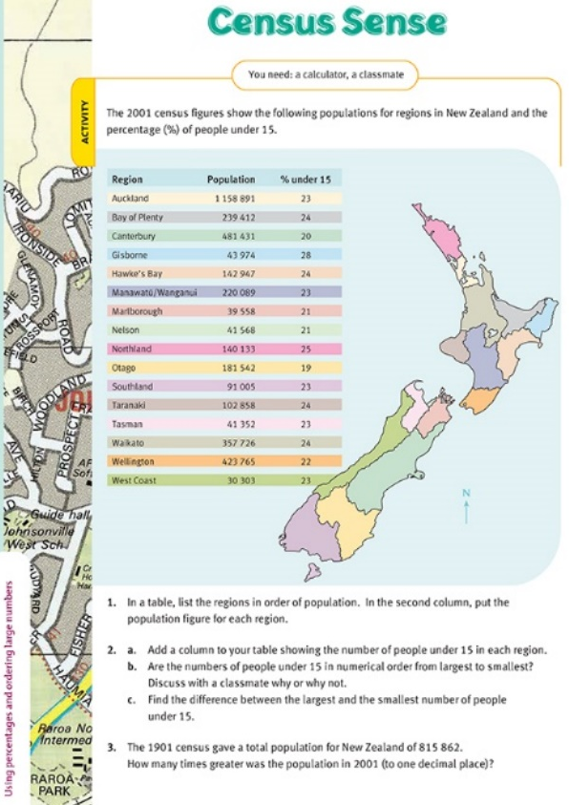
Read: This activity will help you get a better sense of numbers in the tens of thousands and hundreds of thousands. The task uses authentic data and therefore reinforces the relationship between mathematics and our lives.
As it is after the 2001 census, if you have a device you can access the latest census data for comparison on the Department of Statistics website www.stats.govt.nz .
Remember, to find a percentage using a calculator you will need to convert the percentage to a decimal and multiply. E.g. to find 23% of 30303 (people under 15 years old on the West Coast) you would first convert 23% to 0.23 and then enter 0.23 x 30303.
Complete questions #1-3 in your home learning book.
Remember to do your end of day reflection and wellbeing activities (see p. 7 & 9).

Day 9 activity 1: On the campaign trail
Notes for teachers and whānau
In this task the learners will use the context of a ‘campaign trail’ to practice calculating fractions of a whole number. Learners will be exploring the learning areas of Maths.
Note today our Inquiry focus is “going further, deeper”. This may include promoting opportunities to dive deeper through discussions, provocations, exploring further contexts, taking action, or thinking critically and drawing conclusions.

I am learning to: find a fraction of a whole number
What do I need?
- 30 minutes
- Copy of: https://nzmaths.co.nz/resource/campaign-trail

Your task
Before you start the Figure it Out activity read the following:
- To find a fraction of a whole number we can divide by the reciprocals. In essence, this means that multiplication problems can be turned into division problems. For example, 1/6 of 30 is the same as calculating 1/6 x 30, which is 30/6. This could be written as: 1/6 x 30 = 30 x 1/6 = 30 ÷ 6.
- The reciprocal of a number is the number that results in 1 when it is multiplied by the original number. For instance, the reciprocal of 1/6 is 6 because 6 x 1/6 is 1.
- The reciprocal of a fraction can be found by swapping the numerator and the denominator. For example, the reciprocal of 2/3 is 3/2. This also works for whole numbers where the denominator is 1 in fraction form. For example, because 6 = 6/1, the reciprocal is 1/6, and the reciprocal of 1/7 is 7/1 or 7.
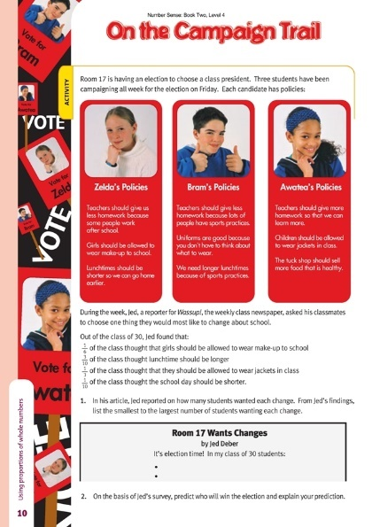
- Therefore, finding a fraction of any number is the same as dividing the number by the reciprocal of the fraction.
- To find half of any number we would divide by two e.g ½ of 10 is the same as dividing 10 by 2. And to find a quarter of any number we would divide by 4 e.g ¼ of 12 is the same as dividing 12 by 4.
Please do not use a calculator!
Hint: for question 2, there is no one correct answer so be sure to show your work/explain your thinking.
Complete this task in your home learning book.

Day 9 activities 2 and3: Power of the people
Notes for teachers and whānau
Learners will explore the concept of Power by reading a comic based on the true story of the Polynesian Panthers in 1970s New Zealand. Inspired by the Black Panther Party in the United States, the Polynesian Panthers were a group of young New Zealanders who wanted to tackle the widespread prejudice faced by Pacific communities. Once a Panther encourages the reader to reflect on the positive change the Polynesian Panthers created and the ongoing legacy of the dawn raids for Pacific communities. Learners will be exploring social sciences and literacy.

I am learning to: read for meaning, make inferences and understand how people participate individually and collectively in response to community challenges
What do I need?
- 60 minutes
- Look in your pack for a copy of Once a Panther https://instructionalseries.tki.org.nz/Instructional-Series/School-Journal-Story-Library/Once-a-Panther

Your task
Read the comic ‘Once a Panther’. The comic is told from a personal, present-day perspective. Once a Panther will help us reflect on the positive change the Polynesian Panthers created and the ongoing legacy of the dawn raids for Pacific communities. As you read, you will have questions, make connections, find information, make inferences, and synthesise ideas across the text. The text explores a variety of themes and ideas such as:
- power
- racism
- fighting for what is right – how groups organise to respond to community challenges
- concepts about immigration, identity, belonging, and what makes someone a “Kiwi”
- how events and movements in one part of the world can inspire action in another part of the world.

Choose one theme or idea and create a concept map. Extract key information or phrases from the text to add to your concept map.
Draw an image to reflect this theme or idea.
Answer 2 of the following questions in your home learning book:
- What rights and/or responsibilities were demonstrated or ignored in the comic? Explain your thinking.
- How does the comic demonstrate the concept of ‘power’?
- Can you think of a time when you knew something wasn’t right, but it took a particular event to make you really want to take action?
- How does each person (in the comic) feel about the situation? How can you tell?
- How would you feel if this happened to your family? Explain.
- What is the significance of this event in Uncle’s life and his family’s life? Explain.
- What message is the author trying to convey?

Day 9 activity 4: RAK
Notes for teachers and whānau
In this activity, learners will explore the idea of ‘random acts of kindness’ and how they can contribute to society. Learners will be exploring the learning areas of health and social science.

I am learning to: enact a random act of kindness
What do I need?
- 30 minutes
- Newspapers, scissors, glue and paper

Your task
Have you heard of RAK? Iti s an acronymn for ‘Random Act of Kindness’ and it is a global movement. Too often we are immersed in all of the negative media from around the world, and while these current events are important and significant, the RAK movement prompts us to imagine a world where kindness is the norm. If this is what we want, we all need to be intentional about it and hope that everyone ‘pays it forward’.
Here are some examples:
Simple | More complex
Give someone a compliment, complement a friend in front of their parent/teacher  Plant a tree  Let someone go ahed of you in line  Put coins ina n expired parking meter  Buy a meal for a homeless persons  Help someone struggling to carry their groceries  Help someone who looks lost  Pick up litter  Leave positive post its in the loo!  Forgive someone who has wronged you or make amends with someone you have wronged. | Write a thank you letter to: your local constable, firefighter, Principal, doctor, nurse or whoever!  Visit a retirement village or kindergarden and play games, read or perform for them.  Give blood  Rescue that cat up the tree  Organise a donation drive  Help out at your local animal shelter  Be an organ donar  Figure out a friend or family member’s half birthday (six months from their full birthday) and surprise them with a little treat on that day.

Look at some newspaper articles and clip any articles that demonstrate kindness.
Create a one page ‘scrap book’ of RAKs by gluing these onto a piece of paper.
Choose one RAK to complete next week.

Remember to do your end of day reflection and wellbeing activities (see p. 7 & 9).

Day 10 activities 1and 2: Citzenship Infographic
Notes for teachers and whānau
To culminate the learning from the week, learners will create an infographic to represent data and information (images & text) visually to help others understand more about citizenship and rights & responsibilities. They will develop their visual language skills as they create their own infographic. Learners will be exploring social sciences. Note our Inquiry focus is “present – share learning about the big idea” which includes thinking about who the audience is, and considering different ways of communicating learning – for example, presentation, video, poster, etc.

Remember to start your day right (see p. 7).

I am learning to: visually represent my learning about rights, responsibilities, and citizenship in an infographic
What do I need?
- 60 minutes

Your task
You may remember from our previous learning packs that infographics are a powerful way to communicate information because they can depict a variety of things in one document. They are often used for scientific and social science topics. They are also able to show relationships between pieces of information. They are visual, simple, with limited text. They are usually used to supplement an article, essay, or opinion piece.
Infographics generally have 3 parts: a visual component – the graphics and colour, content component – statistics and data and a knowledge component – the insights or conclusions that come from the data.
Examine the infographic on digital citizenship and write your answer to these questions in your home learning book:
- What are the visual components? How do the graphics help you understand the message?
- What are the content components? What content is being shared? How do you know it is true?
- What are the knowledge components? What is the main message being communicated?
Create an infographic about citizenship, rights and responsibilities using all of what you have learned this week.
Consider:
- Who is your intended audience?
- What is your infographic going to communicate? E.g. the knowledge component. How will you ensure this is credible? (Fact checking).
- What visual components will you use? (What images, diagrams, data charts?)
- What content components will you use? (What facts, stats, or information?)
- How will you use colour to amplify the effect?
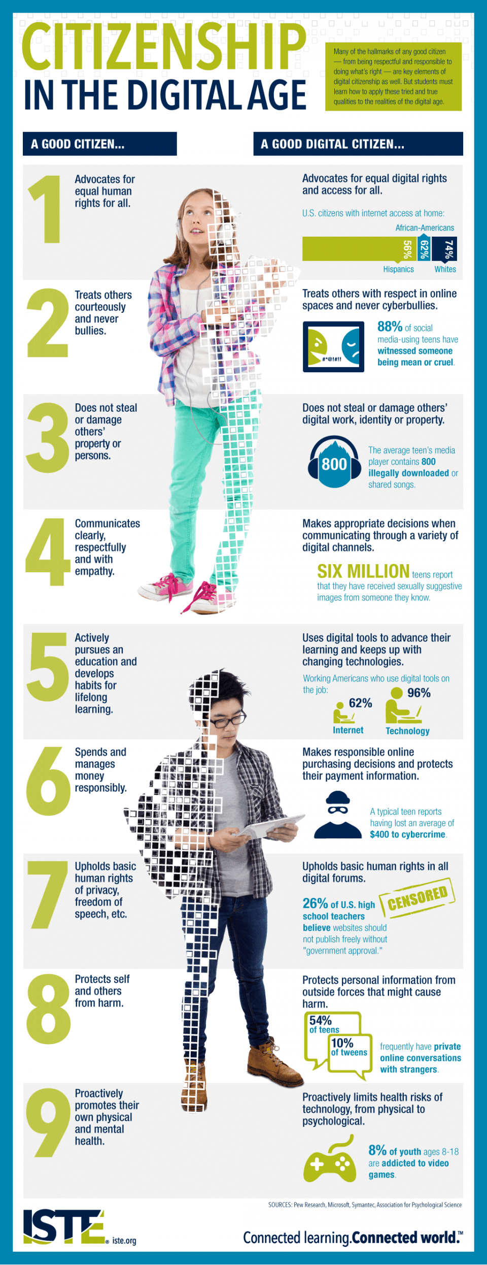
Source: https://elearninginfographics.com/citizenship-digital-age-infographic/

Day 10 activity 3&4: Matariki
Notes for teachers and whānau
Matariki is a significant event and celebrated in many schools. 2022 is the first year Matariki will be a public holiday and public holidays are a right for New Zealand citizens. Learning about Matariki is an opportunity to reflect on our bicultural responsibilities and rights; and a chance to honour our ancestors, show care for our natural environment, and celebrate our bi-cultural and multi-cultural heritage. It is also an opportunity to enrich mathematical experiences in meaningful contexts. Learners will investigate mathematics in the astronomy of Matariki, and how to recognise the star cluster in the dawn sky. A famous tukutuku design will help with some algebra and we will finish by using percentages to build kites to fly at the Matariki celebrations. This information may help if your learner gets stuck: https://nzmaths.co.nz/resource/matariki-level-4. Learners will be exploring te ao Māori, science, maths, and visual arts.

I am learning to use the context of Matariki to:
- recognise the properties of a figure stay constant as the figure is rotated (turned)
- use compass directions to locate objects
- represent the relationship between numeric variables using tables and graphs
What do I need?
- 60 minutes or more
- Activity and resources from https://nzmaths.co.nz/resource/matariki-level-4
- Copy of https://nzmaths.co.nz/sites/default/files/2021-01/matariki-L4-3.pdf

Your task

In this activity you will learn more about Matariki as you develop and practice some key math skills.
Why do you think the star cluster Matariki important in Aotearoa/New Zealand at this time?
Matariki is a cluster that wanders the skies in relation to other star formations. For 11 months of the year it is visible as it wanders. In early May it disappears below the horizon and reappears close to the horizon in late May/early June. The ‘rising of Matariki’ refers to its appearance above the horizon just before the dawn. That is why it was used as a consistent marker to determine the New Year. The first new moon following the ‘rising of Matariki’ is when the New Year begins, but celebrations occur in the last quarter of the lunar cycle before.
A rotation is a turn that can be described as an angle about a given point and a direction of that turn. For example, you can see that Figure A has the Matariki cluster of stars in its most easily recognised position. Figure B shows the same cluster turned 90° clockwise.
Mathematically we are interested in the features of the figure that stay constant as it is rotated. These features allow us to spot the cluster however it is orientated. Distances we see between stars stay the same as does their position relative to each other.
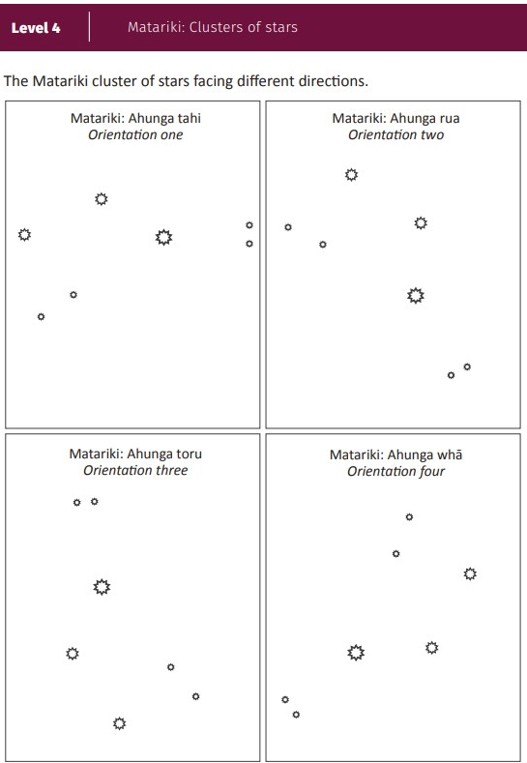
Look at this image to see how the Matariki star cluster looks as it rotates by 90, 180 and 270 degrees. What do you notice?
Write: How will you recognize the Matariki star cluster? Consider what shapes or patterns you see and the distances between the stars.
Draw the pattern you will look for in the night sky to identify the Matariki star cluster.
Matariki occurs in the middle of winter. Traditionally this was a time when adequate food was stored and whānau engaged in cultural pursuits like storytelling, games, creating art, and singing. So it is appropriate for us to learn about the mathematics of tukutuku panels that adorn the wall of wharenui (meeting houses) of marae.
Let’s look at a traditional design called kaokao. This kaokao pattern symbolises the strength of the warrior. The kaokao pattern has reflective symmetry which can also help us to solve the difficult challenges that lie ahead. You can see:
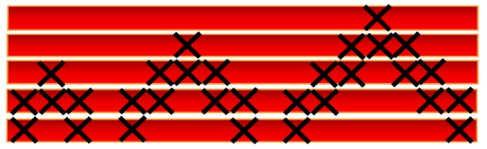
- horizontal wooden rods or laths, usually coloured red or black, called kaho
- cross stitches, made from a variety of coloured fibres, called tuinga.

These two components form the variables in the pattern when you consider it from an algebraic perspective. Variables are changeable quantities, for example, as year changes so does the date of Matariki. Associating changes in variables is an important idea in mathematics as it is the foundations of functions. Relationships can be represented in a variety of ways, including tables, graphs, and rules.
Each kaho (horizontal rod) has three tuinga (cross-stitches) so the pattern is easy. For example, a tukutuku panel might grow like this:
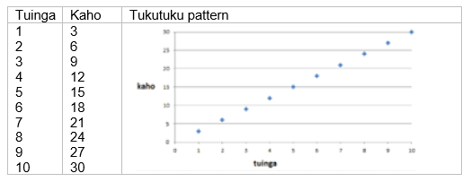
The data could be organised in a table or a graph like this:

Answer:
- what do you notice about the tuinga and kaho numbers in the table and graph?

Complete the table for up to 20 in the tuinga column in your book.
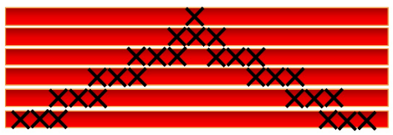
Here is another pattern with 6 kaho (horizontal rods).

Answer these questions:
- How might you count the tuinga (crosses)?
- To make the same pattern with 24 kaho, how many tuinga would be needed? Show your working out.
- Can you find a general rule to find the number of tuinga for any number of kaho?
Extension: more problems to solve: https://nzmaths.co.nz/sites/default/files/2021-01/matariki-L4-2.pdf

Matariki tukutuku kites:
Matariki was traditionally a time to fly kites. Some iwi believe flying kites helps us to get closer to our ancestors whose souls are embodied as stars in the sky. In previous times kites were made from everyday materials, toetoe, raupō and harakeke (flax).
Optional digital: watch this video ‘Keeping Kites Flying – Tales from Te Papa episode 115’ at https://www.youtube.com/watch?v=1VsWzwpxLfg
Think: How do you think the kites were constructed from the natural materials?
Read: Toetoe formed the skeleton or frame of the kite, raupō leaves formed the sail, and flax was used to tie the parts together, and as the line. Often kites were made in the shape of birds. After all birds fly! These kites were ‘delta kites’ as they were based on a single triangle (tapatoru). Plans for making a delta kite can be found in the handout ‘Matariki tukutuku’.
If natural materials are hard to come by then it is still appropriate to use recycled materials in keeping with the environmental focus of Matariki. The sails can be made from materials such as vinyl wallpaper or tough plastic rubbish bags. Bamboo garden stakes, long skewers, or lengths of dowel make good spines and struts for the skeleton. Traditionally Māori used supplejack for framing their kites.
The size of manu tukutuku (kite) that your ākonga might make is constrained by two things, the size of the rectangle of material and the length of the rods that will form the frame. For example, bamboo skewers are 30cm long and will fit along the side labelled 75%. Longer lengths of dowel or bamboo up to 150cm might also be used. So the size of the sail and keel will need to be adjusted accordingly which is an excellent opportunity to apply percentages. This is an excellent application of proportional reasoning. If 30cm skewers are used, 75% is about three-quarters so 100% must be 1⅓ of 30cm which is about 40cm. Many of the measurements can be estimated accurately, e.g. 10% is one tenth. If you are using 30cm skewers the measurements become:
All measurements can be scaled for a larger manu tukutuku. It is important to sketch the dimensions of your plans on paper before you cut out the materials. You could get a whānau member to check your calculations.
Traditionally kites were flown on the morning of the new moon. You might like to organise a dawn viewing of Matariki and a kite flying regatta to welcome the arrival of new stars in the heavens.
Make your own Matariki tukutuku – make a kite using the instructions in the handout (find it in your pack or at this link: https://nzmaths.co.nz/sites/default/files/2021-01/matariki-L4-3.pdf ).

Remember to do your end of day reflection and wellbeing activities (see p. 7 & 9).

