A learning from home pack

For learners in years 4–6

Theme: Citizenship | Kirirarau

Context 1: Manaakitanga, Culture, and Identity

Context 2: Rights and responsibilities

Layout of the resource
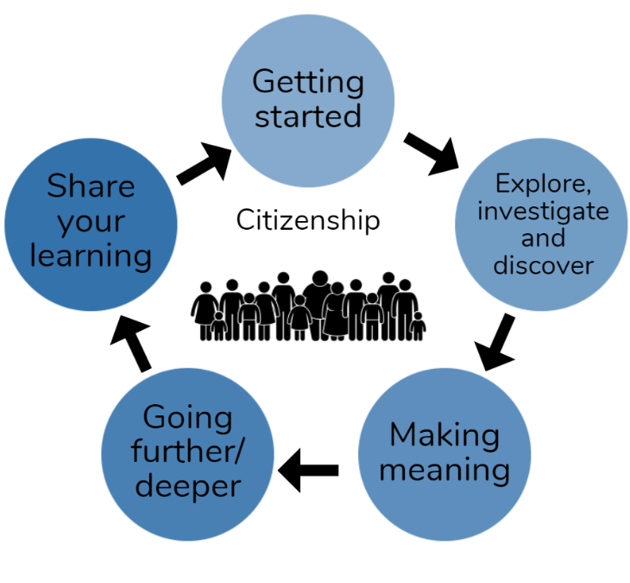
This pack is filled with learning activities that can be used at school or at home. All activities are framed around the theme of citizenship | kirirarau.
Suggestions are provided for starting the day with a karakia (see p. 7), check in with the teacher, and setting up the learning environment. You can replace these with how you want your learner to start their day. The pack is provided as a Word document so you can adapt it for your learners.
The activities follow an inquiry learning model (figure 1) exploring one big idea through two contexts. Each day the learner will work through one part of the model culminating with sharing their learning on days five and ten.
Figure 1 Inquiry learning model

Realities
Many learners will be sharing space and materials. Some may have access to the internet and devices, and others may not. Learners will also have varying levels of adult support. This pack contains a mix of activities using materials found in most homes. Some activities will need support while others can be managed independently.

Resources
The pack uses books from the Ready to Read and Figure It Out series. You might want to send these home with the learner, along with an exercise book, pencils, crayons, or felts, and some craft materials (glue, scissors, construction paper). Learners can bring their notebook back to class to share. All images have been sourced with permissions for use in this pack. If your learners do not have reliable access to the internet, here are the resources to print and send home to create a paper-based pack if you don’t have hard copies of the books.

Resources to print
- https://nzmaths.co.nz/sites/default/files/ShapesinLife.pdf

Resources to send home
- https://instructionalseries.tki.org.nz/Instructional-Series/Ready-to-Read-Colour-Wheel/My-Name-is-Laloifi
- A small bag of 3D (three-dimensional) shapes (if available)
- https://instructionalseries.tki.org.nz/Instructional-Series/School-Journal/School-Journal-Level-3-November-2017/My-Name-is-Rez
- https://instructionalseries.tki.org.nz/Instru ctional-Series/School-Journal/School-Journal-Level-3-May-2015/Tautai
- https://instructionalseries.tki.org.nz/Instructional-Series/School-Journal/School-Journal-Level-2-August-2017/Up-the-Guts
- https://instructionalseries.tki.org.nz/Instructional-Series/Junior-Journal/Junior-Journal-49-Level-2-2014/Kele-s-Car

Setting up the learning environment
Encourage whānau to support learners to set up a space for learning at home. Learners might like to design their own space as a separate learning activity. Some materials they may need could include pen, pencils, paper, a notebook, colouring pencils, glue, scissors, and a device to access the internet.
Many of the suggested activities and experiences include the optional use of online resources which can be accessed and viewed using a Smartphone.

Overview of the learning in this pack
Citizenship | Kirirarau will be explored through two contexts.
- Days 1–5 look at this idea through the context of manaakitanga, culture, and identity.
- Days 6–10 look at this idea through the context of rights and responsibilities.
Learners will explore, investigate, discover, and make meaning as they go through each task. There are times where they look a little deeper into the topic. Some of the tasks may be independent hands-on tasks while some may involve connecting and sharing with others.

Day 1 | Day 2 | Day 3 | Day 4 | Day 5
Launching our thinking – culture and identity; how do we describe these? | Who me? What’s in a name (ingoa)? | Making meaning – our culture and identity shapes who we are. | Delving deeper – your new pet rock. | Sharing your learning – this is what I have discovered about culture and identity.
Day 6 | Day 7 | Day 8 | Day 9 | Day 10
Kickstarting our learning – rights and responsibilities are all around us. | Exploring roles – what are people’s rights and responsibilities? | Making meaning – Te Tiriti o Waitangi. | Deep thinking – debates and random acts of kindness. | Leaving a koha – gifts for your whānau.

Daily timetable
Below is a possible daily timetable. We have allocated 30 minutes for each activity; your learner may take more or less time than this for an activity. We suggest your learner takes the time they need to complete an activity. This may mean they choose which activities they will complete for the day, rather than complete them all.
At the start of each day the learner will draw up their timetable for learning. You can adjust the timing to suit the other activities that might be happening the day, such as Zooming with the class/teacher.
Time | Activity
9:00 am | Starting the day
9:30 am | Activity 1
10:00 am | Break
10:30 am | Activity 2
11:00 am | Fitness break
11:30 am | Activity 3
12:00 pm | Lunch time
1:00 pm | Activity 4
1:30 pm | Reflection time
2:00 pm | End of the school day

Daily fitness – Choose something each day
Please ensure that your learner includes fitness in their daily timetable. If possible, it would be great to do the fitness activity with your learner or have them complete it with others. Below are activities to choose from – or you can make up your own ideas!
Tama Tū, Tama Ora; Tama Noho, Tama Mate.
Through physical activity we thrive. Through inactivity we languish.
Your learner may prefer to go for a walk or run around your house. They could time themselves for fun! Maybe they’d like to go for a bike ride? Play a game with whānau? Have a boogie to a favourite song? Or do some yoga? It is up to you just get active!
Please note you can change or modify the exercises (in addition to those suggested) if you are not able to do the ones we have suggested, get creative and change it up.
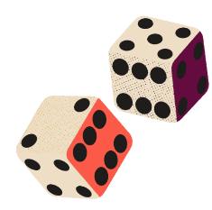
Roll for fitness - Two dice, two activities.
For each number on the dice, make up an exercise such as 1 = 10 star jumps, 2 = jumping lunges.
Take turns to roll the dice and then carry out the two activities related to the numbers on the die.
Get your family involved if you can.
9-Minute Exercise for Kids – https://www.youtube.com/watch?v=oc4QS2USKmk&t=67s
Hallway or large space fitness
Set up a fitness trail in your hallway or large space and get creative with what you do at each station.
For example, at station one – a few soft toys, toss through your legs behind you.
At station two – frog leaps backwards and forwards.
Les Mills Born to Move sessions - https://www.tvnz.co.nz/shows/les-mills-born-to-move
Chair squats and triceps dips
Using a chair in your home, secure it carefully by pressing it gently against a wall. Pop on one of your favourite songs. Squat down to touch the seat and stand back up. Repeat 20-30 times. After that, rest for one minute.
Next, place your hands on the chair with your fingertips facing the back. Place your legs out front either bent or straight and lower your arms down while keeping your hands in place – this is called a triceps dip. Repeat 12-15 times before taking a one-minute break. Complete these two exercises as many times as you like.

Daily wellbeing – Choose something each day
These activities are good to do at the beginning and end of the day but can be done anytime. They can help you get ready for learning, calm your mind and body, and can help you to reflect on your learning.
Fill my cup
Take five minutes to “fill your cup”.
Close your eyes and imagine a cup or a mug, it might be your favourite cup or an imaginative cup. As you close your eyes, visualise the cup empty. Then, take five minutes to think of or reflect on all the things that would “fill your cup”. For example, it might be your favourite song, playing your favourite game of sport, spending time with your grandparent, arts, and crafts time, or other.
Reflection Questions
Use a page in your home learning book to reflect on these questions:
- How is my learning going at the moment?
- What am I finding tricky?
- What am I most enjoying?
- What would I like more help with?
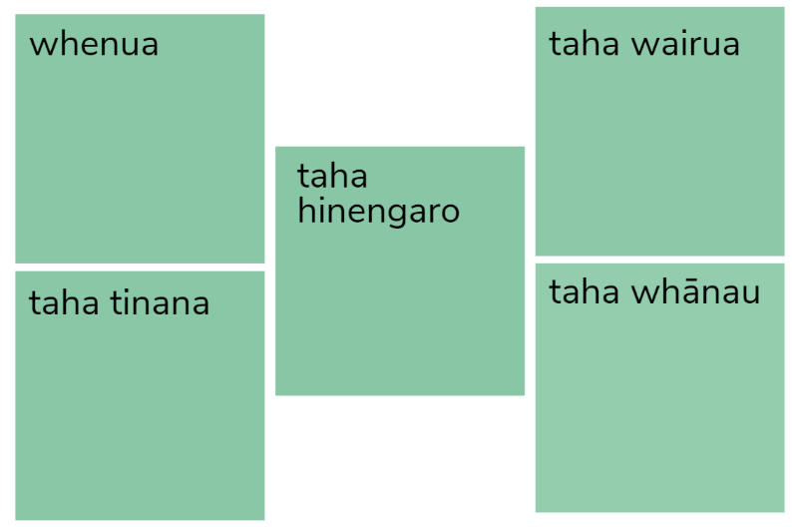
“Te Whare Tapa Whā” check
In your home learning book draw five boxes. Then write the following headings in each of the boxes
- whenua (land/environment)
- Taha tinana (physical wellbeing)
- Taha hinengaro (mental and emotional wellbeing)
- Taha wairua (spiritual wellbeing)
- Taha whānau (family and relationships).
Take time to think about your current connections with your te whare tapa whā. Write down anything that comes to mind in each of the boxes.
End of day gratitude - watch and respond to this short clip Gratitude Meditation for Kids
https://www.youtube.com/watch?v=Wsc5Diz5hAI&t=32s
Today I am a star because …
Draw a star in your home learning book.
On each of the points on the star write down why you are a star today.
For example, I made my bed without being asked, I offered to help with breakfast, I helped my baby brother when he was crying.

Starting each day
Notes for teachers and whānau
Starting the same way each day helps create a structure for your learner. Your school might have your own way to do. In this pack we provide a karakia to settle into the day. Saying the karakia with your learner a few times will help them be able to do this more independently tomorrow and beyond. As part of the start of the day and setting up the learning environment, help your learner look through the activities suggested for that day and choose a fitness and wellbeing activity. They could fill out their daily timetable and think of other activities they might like to do, like reading.
Remind your learner of when and how to check in with the teacher/you.

Karakia
Here is a karakia to welcome in the day
Karakia mō te Ata https://www.youtube.com/watch?v=3em_pulEjT0
Kia hora te Marino  Kia whakapapa pounamu te moana  Hei huarahi mā tātou i te rangi nei  Aroha atu aroha mai  Tātou ia tātou katoa  Hui e taiki e! | May peace be widespread.  May the sea be like greenstone; a pathway for all of us this day.  Let us show respect for each other, for one another.  Bind us all together.

Planning my day
- Have you chosen which activities you will do today and in which order?
- Remember to choose a fitness activity (see p. 5).
- Have you chosen a wellbeing activity? (see p. 6).
- Have you done a “Wellbeing check-in”?
  - How are you feeling today?
  - How do you feel about your readiness to learn this morning?
  - What do you need extra assistance with today? Who could you get to help you? What strategies could you use to help make your learning more effective?
  - What would you like to do as a quiet time activity to end your day?
- Remember to do your Reflection at the end of the day (see p. 8).

Ending each day
Please encourage your learner to do this at the end of each day.
Reflection can be challenging for all learners, but it can also provide them with rich opportunities to think about how their learning is progressing. Use the questions below as prompts to encourage your learner to think about what they have learned so far and to help them to plan out their next steps. If you have concerns with their learning or find that your learner is needing more help, contact their teacher for more support.

I am learning to: reflect on my learning, my day and myself
What do I need?
- A notebook or online doc that you can use each day for your reflection activity (We will call this your “reflective journal”.)
- Materials for your quiet time activity
What did I learn today and how has that helped me as a learner?
What am I most proud of and why?
What would I like more help with? Who can help me with this?
Remember to finish with a wellbeing activity and/or your chosen quiet time activity.

Context 1: Manaakitanga, Culture and Identity

In the first five days we will investigate the theme of citizenship by exploring what it means to be a citizen through manaakitanga, culture and identity.

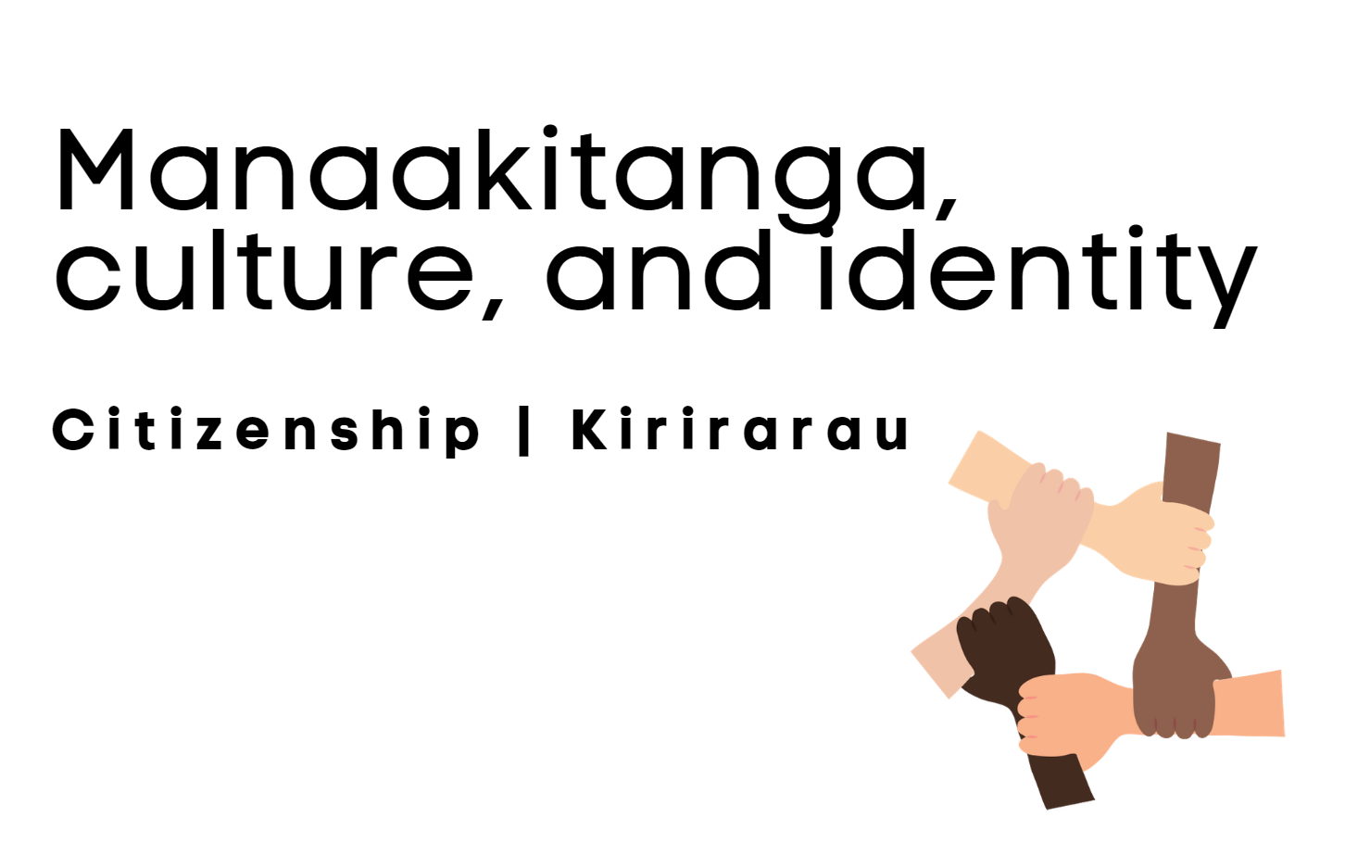

Day 1 activity 1: Inquiry getting started
Notes for teachers and whānau
In this getting started activity, the learner will be exploring what culture means. Learners will be exploring the learning area of social sciences.

I am learning to: use a graphic organiser to share my prior knowledge
What do I need?
- 30 minutes
- Home learning book
Remember to start your day right (see p. 7).

Your task
Copy the table below onto a full page in your home learning book. Make sure the headings are either in bold or highlighted so they stand out.
You will refer to these throughout the week.
Beliefs | Values | Norm | Codes of Manners | Dress
Language | Religion | Rituals | Art
To start our learning focus this week you need to imagine that someone asks you “What is your culture?” It’s a good question, but do you often stop and think about it?
The table above has nine headings that you may like to use to list some things that highlight your culture. These are only ideas; you are welcome to add other headings and ideas too.
Write/draw/sketch as many things that come to mind when you think about your culture. Remember, there is no right or wrong answer, this is about YOUR culture.
You may find it beneficial to talk with other people in your whānau about your culture and as you talk, record the ideas you are discussing.

Day 1 activity 2: The way we do things around here
Notes for teachers and whānau
In lesson one your learner was introduced to culture and took some time to think about their culture. Today’s lesson will ask your leaner to think about the concept “culture is all around me”. Learners will be exploring the learning areas of social sciences.

I am learning to: Use prior knowledge and personal experience to create a detailed brainstorm
What do I need?
- 30 minutes
- Home learning book

Your task
In this lesson we are going to explore the concept “culture is all around me”. You will think more about your everyday life and culture.
Divide your page into four boxes (fold in half horizontally and vertically) and in each of the four boxes write the headings – Home, Family/Whānau, School and Community.
Some say culture put simply is “the way we do things around here”. Using this idea, record the way you do things at – home, with your family/whānau, school, and in your community. Remember that not everyone will “do” the same things in these places, and it is what makes things unique to your culture. For example, you may write “music practice” in the school box but someone else may not. This tells you that music and learning to play/practice music is part of your culture.
You may like to use this example as a starting point:
Home  - Everyone home by dark.  - No shoes inside.  - Everyone helps to prepare meals.  - Chores completed Saturday morning. | Whānau  - Each person has their birthday celebrated with a gathering.  - We visit grandparents every Sunday.  - Attend church together every Sunday.
School  - Part of the kapa haka group.  - Complete home learning tasks on time.  - Ask questions when I am unsure about my learning. | Community  - Play in a summer and winter sports team.  - Check on my neighbours when needed.  - Clean up rubbish when we are out walking as a family.

Day 1 activity 3: My ingoa (name)
Notes for teachers and whānau
Today your learner will explore what’s in a name. They are encouraged to use their own name for this lesson, but they certainly don’t have to, they may like to start with another whānau member’s name. This lesson is an opportunity for your learner to learn more about their name and/or some family history while connecting with their culture and identity. Learners will be exploring the learning areas of social science and literacy.

I am learning to: use a graphic organiser to record prior knowledge and my questions
What do I need?
- 30 minutes
- Home learning book

Your task
Every name (ingoa) has a story. Let’s spend some time today exploring yours! Or if you feel more comfortable, exploring a whānau member’s name.
In your home learning book write the title – What’s in a name/ingoa? Then under this title draw a KWHL (Know, Want to know, How I will learn, what I have Learned) chart. An example is below.
In the “K” box, write down everything you already know about your name such as origin, who chose your name, how to pronounce your name, if you were named after anyone, language/village/country it first originated, other.
Then, use the “W” box to write down anything you would like to know about your name for example, where it originated, other ways of spelling your name.
The “H” box is a space for you to write down how you will learn that such as ask a whānau member, use the internet, read a name book.
The “L” box will be left blank for now but can be completed once you learn answers to questions you have – we will be exploring more tomorrow.
Extension activity/whānau challenge – do you know how to sign your name using New Zealand Sign Language (NZSL)? If you are keen to learn how to finger spell your name so you can communicate it in NZSL, then click here: https://www.nzsl.nz/alphabet.
What I KNOW about my name | What I WANT to know about my name | HOW I will learn more about my name | What I have LEARNED about my name

Day 1 activity 4: Name codes
Notes for teachers and whānau
This is a light-hearted, riddle-type maths lesson to get the students connecting names and numbers. They will need to use the code to solve the questions. You may like to have them write codes for other members of their whānau/pets, and so on. Learners will be exploring the learning areas of maths – number.

I am learning to: use a number code to solve word problems
What do I need?
- 30 minutes
- Home learning book
- Calculator

Your task
What’s your name worth?

Sam and Tom were cracking their name codes together. Sam said his name ended in an “m”, and Tom said his did too. Tom said his name had three letters, and Sam said his did too. They noticed they only had one vowel each. Sam said his total was 12 and Tom said his total was double that.
- Use the table below to check to see if they are correct.
- Use the table to work out the total for your name?
- Use this table to work out the code for members of your whānau?
- Who has the largest total in your whānau?
- Was anyone exactly double your name like Sam and Tom?
- Find the total for these names: Helen, Zachary, Quinn, Mike.
- What names do these codes spell? (Hint: these are common European names): a) 8+2+8+18+8
b) 2+2+10
c) 18+12+2
2 | 4 | 6 | 8 | 10 | 12 | 14 | 16 | 18
A | B | C | D | E | F | G | H | I
J | K | L | M | N | O | P | Q | R
S | T | U | V | W | X | Y | Z

Remember to do your end of day reflection and wellbeing activities (see p. 6 and 8).

Day 2 activity 1: My name is a part of my identity
Notes for teachers and whānau
In this lesson, your learner will be encouraged to explore the questions they had about their name in yesterday’s task. Learners will be exploring the learning areas of art, social sciences, and literacy.

I am learning to: explore, investigate, and discover the answers to questions I had in my KWHL chart (Day 1 activity 3)
What do I need?
- 30 minutes
- Access to a device – to research
- Optional: a phone/device to call a whānau member (if applicable)
Remember to start your day right (see p. 7).

Your task
Your name (both first name and surname) is a huge part of your identity. In activity 3 yesterday, you completed a KWHL chart about your name. Hopefully, you had some questions/wonderings recorded in the “W” (WHAT I want to know …) section of your chart because this activity is all about exploring those questions or wonderings.
Learning new stories about your whānau is always such a special way to deepen our sense of who we are or our identity. In today’s task you are urged to do the following.
- Talk with members of your whānau about your name (first name and surname) and what they know about your name. You may have to call someone on the phone or over video call. As they talk, you may like to draw pictures or make sketches of what they are talking to you about. What do you notice about what you have drawn as they talked? Is there a theme? Did the person you were talking to mention anyone else with your name?
- Do you have a nickname? If yes, do you know why you are called that and where/who it came from?
- If you have access to a device, you may like to sit with an adult and research the questions you had about your name. www.names.org is a great place to start your research if you are trying to find out the meaning or origin of your name. You may even want to explore more about the country, location or village your name originates from.
- Now that you have learnt more about your name, it is time to get creative. Your final task today is to create a “doodle” sketch of your name with images that represent who you are surrounding the sketch. There are no limits – be as creative as you like! You may want to glue it onto some card and display it on your bedroom door. Or you may even like to create an acrostic poem using your name and then things that describe you after each letter of your name.

Day 2 activity 2: 3D (three-dimensional) shapes
Notes for teachers and whānau
The maths activity today allows your learner to investigate the features of a solid shape and learn the names for them. They will build on this knowledge in further maths lessons this week. Learners will be exploring the learning areas of maths – geometry.

I am learning to: explore and describe faces, edges, and corners of 3D shapes
What do I need?
- 30 minutes
- Home learning book
- Magazines, junk mail, newspapers
- Examples of solid shapes (if available) – cubes, prisims, cylinders
- A device to watch this short clip - https://www.youtube.com/watch?v=_y17uHBwa_8

Your task
When we describe a 3D shape, we will often – name the shape, talk about how many faces (a flat or curved surface on a 3D shape, for example, a cube has six faces a sphere has just one) it has, and how many edges it has. Today, we are going to explore some of the shapes you might have around your home. You are welcome to work with a whānau member to complete this task.
- Watch the short clip linked above as an exemplar on counting faces and edges.
- Collect pictures of 3D shapes from magazines, junk mail or websites.
- Stick these onto a chart you have drawn into your home learning book (see example).
- How many faces (see description above) and edges do the shapes you have found have? Write the answers to these next to each shape.
- Was there a shape that was hard to find? Can you find any examples around your whare (house)?
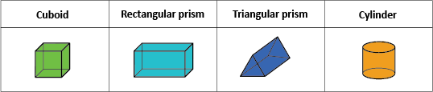

Day 2 activity 3: The importance of my name
Notes for teachers and whānau
This simple text highlights the importance of correct pronunciation of someone’s name. The activity your learner is asked to complete focuses on learning and pronouncing Māori place names. However, your learner may want to learn and practice other class members names, members of their community, other. Learners will be exploring reading and te reo Māori.

I am learning to: read and respond to a short text. Use the ideas in this text to investigate correct pronunciation
What do I need?
- 30 minutes
- Look in your pack for a copy of My Name is Laloifi https://instructionalseries.tki.org.nz/Instructional-Series/Ready-to-Read-Colour-Wheel/My-Name-is-Laloifi
- A device to assess this guide: https://tereoMāori.tki.org.nz/Reo-Māori-resources/Ka-Mau-te-Wehi/Introduction-to-teaching-Te-Reo-Māori/Pronunciation-guide

Your task
You are going to read a short text titled My Name is Laloifi. This text is to introduce you to the importance of saying someone’s name correctly. Remember, your name is a part of your identity! As well as pronouncing people’s names correctly, it is important to pronounce place names correctly.
- Read My Name is Laloifi.
- Respond to these questions:
- What game did Ms Clarke play to help her class learn Laloifi’s name?
- How did Laloifi feel when they learnt and pronounced her name correctly?
- Why is it important that names are pronounced correctly? Have you been a in a similar situation like Laloifi? What happened and what did you do?
- Practice saying and writing Māori place names – Ingoa Wāhi o Aotearoa. First, head to the Māori pronunciation guide (linked above). Then, complete the table below, filling in the missing gaps. You may like to use a device to listen to and research the correct pronunciation. Add in towns and cities near you. Ask your whānau to share any place names they would like to practice.
Māori name | Pronunciation | English name (if applicable)
Tāmaki Makaurau | Taa-ma-key ma-ko-row | Auckland
Te Kauwhata | Te koh-fah-tu | N/A (Not applicable)
Kaikōura |  | N/A
 |  | Wellington
 | Toe-paw | N/A
 | Tea-ma-roo | N/A
Oamaru

Day 2 activity 4: Me and my community
Notes for teachers and whānau
In this activity your learner will explore what makes them a good citizen. We will start by focusing on “me and my community”. Learners will be exploring the learning area of social sciences.

In this activity I am learning to: use a Venn diagram to investigate and discover
What do I need?
- 30 minutes
- Home learning book

Your task
So far this week, we have been exploring identity and we have focused much of this exploration on the mana (pride/importance) of an ingoa (name). In this activity, you are going to investigate and discover what makes you a good citizen.
- Draw a Venn diagram on a whole page in your home learning book. In the left-hand circle write the heading – My home/My culture and in the right-hand circle write the heading – My community. In the inside overlapping circle write the heading – Same. (See example below).
- Think about all the things you do in your home/as part of your culture (you may like to look back to your brainstorm from Day 1: activity 2 for ideas). Then, think about all the things that happen in/make up your community. As you record your ideas, think about things which happen in both your home and the community, and record these inside the smaller overlapping circle. Use the example below as a starting point. Ask members of your whānau if they can help you.
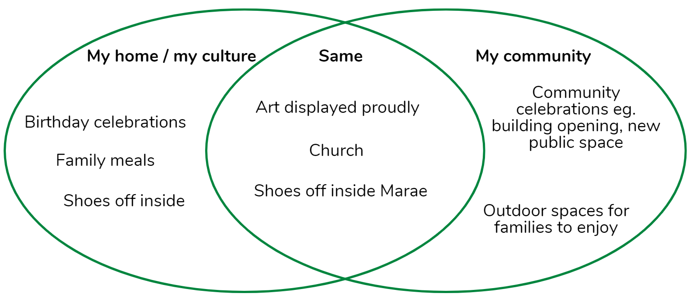
Remember to do your end of day reflection and wellbeing activities (see p. 6 and 8).

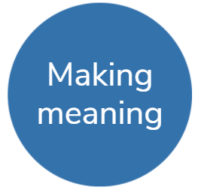
Day 3 activity 1: Our life in stories

Notes for teachers and whānau
Your learner will read a graphic text about a girl named Rez. Rez was born in a Kurdish refugee camp and came to New Zealand as a young girl, with her family. This graphic text is a memoir of her life. Today’s activity will support your learner with the tasks that follow. Learners will be exploring literacy – reading.

I am learning to: read for meaning and make connections through someone else’s shared experiences
What do I need?
- 30 minutes
- Look in your pack for a copy of My Name is Rez https://instructionalseries.tki.org.nz/Instructional-Series/School-Journal/School-Journal-Level-3-November-2017/My-Name-is-Rez
Remember to start your day right (see p. 7).

Your task
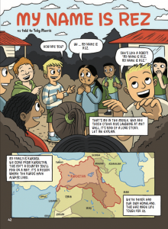
In this activity you are going to read a graphic text titled My Name is Rez. You may not have seen a graphic text before. They are similar to a comic but contain a complete narrative.
- Skim and scan the text before you begin. What do you notice about how it is written? What do the images tell you?
- Read the graphic text. You may like to read this more than once or have someone read it with you. As you read, take time to look at the images in each section as they tell the story too.
- This week our focus is on culture and identity. In your home learning book:
- Write down three things that Rez found challenging when she moved to New Zealand.
- Write down three things that Rez appreciated about moving to New Zealand.
- Sports and clubs/groups are often a great way to learn about a new culture. What was Rez thinking as she watched her teacher and class play football?
- Create a T chart listing the negative and positive aspects of adapting to life in New Zealand for Rez.

Day 3 activity 2: Welcoming a new visitor
Notes for teachers and whānau
In this activity, your learner is going to use the information they have gathered, discovered, and investigated over the past three days to write an informal letter welcoming a new visitor into their home or community. Encourage them to look over the work they have done to highlight important parts of their culture and identity they want to talk about. Learners will be exploring the learning areas of literacy – writing.

I am learning to: Use information I have learnt, to write an informal letter
What do I need?
- 30 minutes
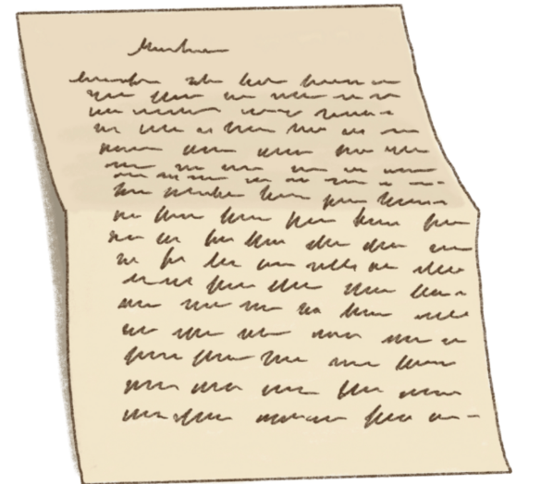
- Home learning book

Your task
Over the past three days, you have been exploring and investigating more about your culture and identity. Today, we are going to write a letter to a new visitor to your home/in your community – a pet rock. This is an informal letter, so don’t worry too much about the structure of a letter. We are focusing more on what we will tell our new visitor about our culture and identity.
- Go back through the home learning you have done in the past three days and read over your ideas. Revise the things you have written down or drawn about your identity and culture. Write down five things that you notice and stand out as important. These are the things worth telling your new visitor in your letter to them.
- Brainstorm the things you will include in your letter and in which order. Remember, if they are a new visitor to your home or community, they will want to know as much information as they can to help them prepare and settle.
- Write a letter to your pet rock and introduce the pet rock to your culture and identity and the “way you do things around here”. For example – we take our shoes off before coming inside, we wash our hands before preparing or eating a meal, after dinner we complete our homework, on Saturday morning we all strip our beds and help with cleaning.

Imagine that this letter is the information they might receive before arriving in your home/community.

Day 3 activity 3: A welcome poster
Notes for teachers and whānau
Today’s activity is art focused. Students are encouraged to create a poster (static image) welcoming their pet rock to their home and/or community. Learners will be exploring the learning areas of art and visual literacy.

I am learning to: create a static image (poster)
What do I need?
- 30 minutes
- Home learning book or plain A4 paper
- Colouring pencils, felts, crayons, paints, other

Your task
In activity 2, you wrote an informal letter to your new visitor – a pet rock. You told the pet rock all about your home and/or community. In this lesson, you are going to get creative and arty and design a welcome poster for the pet rock.
- Plan your poster – this poster is to help your new visitor to make meaning and understand more about the new culture they are arriving in. What images will you include: an image of your whare (home), the local park, local library, the local swimming pool, your church? Will you include key words about life in your home or community?
- Create your poster – make it as informative as you can. Remember posters contain key ideas. Have fun!

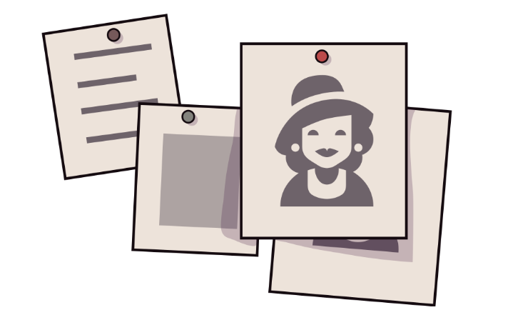

Day 3 activity 4: Maths - geometry
Notes for teachers and whānau
This activity builds on the previous maths activity. Today the learners will explore 3D (three-dimensional) nets using a box from around their home. Learners will be exploring the learning area of maths – geometry.

I am learning to: make a net from a solid shape
What do I need?
- 30 minutes
- Scissors
- A4 paper
- 3D box from around your home – cereal box, tissue box, crackers, other.

Your task
During the maths activity yesterday, you explored the attributes of a 3D shape. In this activity, you are going to be exploring making a net from solid shapes by drawing around 3D solid shapes as you roll them along a piece of paper.
- Find a solid shape to use. You may like to use a tissue box, a cracker box, a washing powder (sealed) box.
- You are going to “unwrap” the solid shape by rolling the shape and tracing the faces (the flat surfaces of a solid shape) as you roll. Start by tracing around the base. After that, roll or tip the shape onto another face, and then trace around that. Remember to roll your shape sideways, too – you may need to roll back over a face you have already drawn to move to another area you need to “unwrap”. Line it all up carefully. Keep tracing each face until you have “unwrapped” all of your shape.
- Can you roll it in different ways to make different nets? What do you notice? Could the net still be folded up to make the same shape?
- If possible, carefully unstick the box you have used to form its net. Look at the similarities and differences between the box and the nets you have drawn.
Challenge - Can you try drawing a net without using a solid shape to draw around?

Remember to do your end of day reflection and wellbeing activities (see p. 6 and 8).

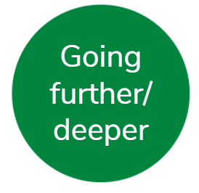
Day 4 activity 1: Introducing your culture
Notes for teachers and whānau
Now it is time for your learner to apply their knowledge and understanding about identity and culture and establish a pet rock’s identity. They will be introducing the pet rock to their whānau tomorrow when they share their learning. Learners will be exploring the learning areas of social science, health, and literacy.

I am learning to: apply knowledge about culture and identity to a scenario
What do I need?
- 30 minutes
- Home learning book
- Sketching pencil or coloured pencils.
Remember to start your day right (see p. 7).

Your task
The pet rock you wrote to yesterday has decided that they would love to join your home and/or community. However, they are worried, as they don’t know much about their culture and identity. They have asked you, as their new owner, to help them establish one.
If possible, you may like to go outside first and look around your garden to see if you can find yourself a pet rock/stone/piece of wood. This will help you as you embark on this activity.
Task 1 – Think of a name for your pet rock
This will be their first part of their identity. Remember what you have learnt this week about your name and use this knowledge and discovery to think of the perfect name for your pet rock.
Task 2 – Think about your pet rock’s home
What will they need as part of their home? Where do they sleep, eat, bathe? What do they like to eat? What do they like to do to relax?
Task 3 – Think about what your pet rock will do?
Do they have hobbies? Do they attend school, clubs, sports, church, other?
Task 4 – Ko wai au?
Use this thinking to create a Ko wai au? (Who am I?) fact sheet for your pet rock. Write down 10 facts about your pet rock. You will share this fact sheet with your whānau tomorrow.

Day 4 activity 2: Reading
Notes for teachers and whānau
Tautai is a beautiful story about the connections people make through their name. This story may be a challenging read for your learner so they may benefit from having you read this to them or sharing the reading. Learners will be exploring the learning areas of reading and social science.

I am learning to: make meaning from a text and use this knowledge to further explore identity
What do I need?
- 30 minutes
- Look in your pack for a copy of Tautai https://instructionalseries.tki.org.nz/Instru ctional-Series/School-Journal/School-Journal-Level-3-May-2015/Tautai

Your task

This beautiful story Tautai, tells the tale of Tigi‘ilagi and the connection he makes with someone who shares the same culture.
- Read the story Tautai.
- Copy the boxes below into your home learning book and then create a story map/comic strip to show the main events in the story. You can use as many boxes as you like.
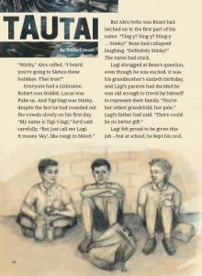
- Tigi‘lagi felt massive pride in his name and the connection he made with the pilot. Can you think of a time that you have felt proud of your culture or your identity?
Draw this event using a comic strip similar to the one you have just created for the story. It might be when your name was pronunced correctly at an event; it may have been when you danced your traditional dance on stage in front of your classmates; it may have been when you shared your culture with another culture such as when someone visits another country.

Day 4 activity 3: Exploring culture further
Notes for teachers and whānau
During the week, your learner has focused on their own culture and identity with some connections to their community. They no doubt have questions about the multitude of cultures represented in New Zealand. In this activity they are encouraged to think about other cultures and questions they may have about that culture. Learners will be exploring the learning areas of social science.

I am learning to: develop questions and wonderings I have
What do I need?
- 30 minutes
- Home learning book
- A device to watch this short clip: https://www.youtube.com/watch?v=FOEB87B0Zas
- Optional (if available): A chance to speak with and listen to someone from a different culture.

Your task
We can sometimes learn most about culture by listening to other people’s stories and experiences. This will often generate lots of questions about what it means to be from another culture. Questions help us to learn and to be able to show respect for cultural differences when they arise. We may not be able to find the answers to all the questions we have, but, raising awareness and knowing we have a question is often what helps us consider another person or culture.
If you have a device available watch the short (Understanding Traditions and Cultures for Kids) clip-on culture https://www.youtube.com/watch?v=FOEB87B0Zas
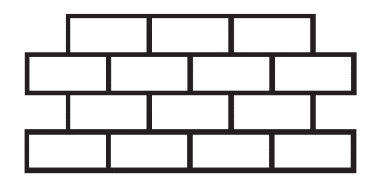
- Sketch out a question “wall” on a page in your home learning book; use the concept of bricks or squares. You can add bricks to the question wall as you go.
- Use the bricks or squares you have drawn to write questions you have about other cultures. These might be generalised questions like “What foods do you like to eat?” or “What sports do you play” or be focused on a particular culture like “What is the tikanga on a marae?” See if you can write at least six questions.
- Once you have spent time writing questions, see if your whānau can help you with someone to phone or video call to chat to and listen to their stories about their culture. As they talk, see if they are helping to answer some of your questions. If you feel comfortable, ask them if you can ask them a few questions you have regarding other cultures.

Day 4 activity 4: Maths – making nets
Notes for teachers and whānau
This lesson follows on from the other geometry lessons this week and asks them to create a 3D shape using a net. Learners will be exploring the learning area of maths – geometry.

I am learning to: construct a 3D shape using a net
What do I need?
- 30 minutes
- Cardboard – any large-sized scrap cardboard will work, perhaps a delivery box
- Scissors
- Glue or tape
- Felts or coloured pencils

Your task
On day two and day three this week, you have been exploring the nets of a 3D shape. In today’s maths lesson you are going to make a 3D shape using one of the nets you have drawn.
Yesterday, you explored making a net from a 3D shape you had in your home. Today, we are taking it one step further and constructing a 3D shape from a net. You can use the net you created yesterday when you rolled your shape on the paper, edge-by-edge, or you can find a new 3D shape to construct a net from. You may like to even construct a 3D shape from a net you have drawn without using an exemplar. It is up to you!
- Draw the net onto the cardboard. Remember to add flaps on the sides where you will add glue/tape and press together. Know that you can always cut flaps off later, so you are best to add too many flaps rather than not enough.
- Decorate your 3D box using felts, colouring pencils. It is easier to decorate it before it is cut out.
- Cut out the net and fold along the lines. Ask an adult to help you if cutting the cardboard is tricky.
- Bend the flaps in and glue them one at a time, sticking the flap underneath the edge it meets with.
- If you want to use the 3D shape you are making to house your pet rock, then you will need to leave one side open (as a door).
Remember to do your end of day reflection and wellbeing activities (see p. 6 and 8).

Day 5 activity 1: My whare – our culture
Notes for teachers and whānau
In this lesson, your learner will draw/sketch a simple whare and then add important aspects of their culture in and around the whare (house). Learners will be exploring the learning areas of social science and visual art.

I am learning to: use visual art to share my learning
What do I need?
- 30 minutes
- Home learning book or A4 piece of paper
- Felts or colouring pencils
Remember to start your day right (see p. 7).

Your task
Throughout the week, you have carefully considered the culture of your home or community. For this task, you are going to present the key ideas you would like to share with others as a piece of art.
Starting with a blank page in your home learning book/piece of paper, sketch the front of a house/whare on the page. If it is safe to do so, you may like to sit out the front of your whare and draw your home.
Think about all the things you have discovered, explored, and researched this week. What are some of the main/important things you would like to share about your culture on your piece of art? Is it the sport you play, the pets you have, the foods you eat, the chores you do, the celebrations your whānau celebrate? Draw these representations on and around the sketch of your whare.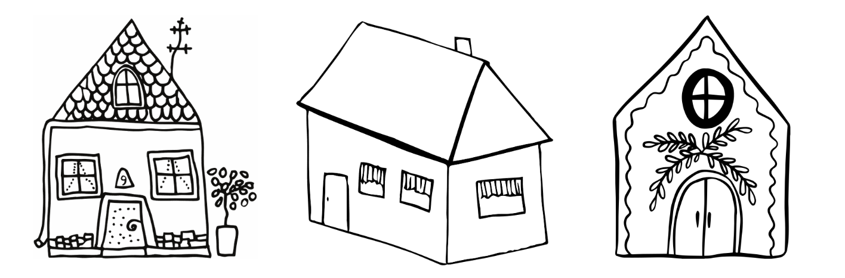Spend this learning time creating your art piece, and then share this with someone in your whānau. Ask them to look at the piece of art first and see if they can tell you what they notice about your culture. After that, share your story through the art.

Day 5 activity 2: I love my culture because ...
Notes for teachers and whānau
In this activity your learner challenges themselves by writing a list of the ten things they love about their culture. They are encouraged to share this with their whānau. Learners will be exploring the learning areas of writing and oral language.

I am learning to: make a list of ideas and share this orally with an audience
What do I need?
- 30 minutes
- Home learning book

Your task
Positive affirmations are so good for us. They help us to feel good and to realise what we have and to celebrate those things. A great way to capture those positive affirmations is to write them in a list and then say them aloud.
In your home learning book write the heading – I love my culture because…
Underneath this write a list of ten things that you love about your culture.
1.
2.
3.
4.
5.
6.
7.
8.
9.
10.
Ask a whānau member to sit down and then share your ten things with them. After you have read your list to them, see if they can add anything else to your list.

Day 5 activity 3: Introducing your pet rock to the whānau
Notes for teachers and whānau
In this activity your learner will spend time sharing and introducing their pet rock to you. They have created an identity and culture for the rock as well as sharing their culture with the rock. This activity is primarily drama-focused; however, if your learner isn’t too keen on drama, they can always sit and talk with you about their rock instead. Learners will be exploring the learning areas of social science drama, and oral language.

I am learning to: explore and use elements of drama in an informal presentation
What do I need?
- 30 minutes
- Bench/table (to act as your stage)
- Optional: props from around the home

Your task
This week you were asked to consider introducing a pet rock into your home and/or community. You spent some time sharing your culture with your new visitor, as well as creating an identity and culture for your pet rock. Now it is time to share your new visitor with other members of your whare. Remember, they don’t (yet) know who the new visitor is, so you will need to include a detailed introduction including their name, age, favourite foods, favourite sports, hobbies. Drama is a great way to communicate this with your whānau.
Create an informal presentation (often called a “skit”) introducing them to your pet rock and share this with your whānau. Your whānau will be keen to know lots about their identity and their culture so that they can welcome the new visitor into the home. Remember, culture is often described as “the way we do things around here” so the more your whānau knows about your pet rock, the more they can be welcoming of their culture.
Practise your presentation/skit. Include props (if available). Be as creative and imaginative as you like. Ask someone in your home to help you if you like – drama is often best enjoyed when working with someone else.
Share your presentation/skit with members of your whānau either in person or by recording it and sharing it over a video messaging service.

Day 5 activity 4: Shapes are all around us
Notes for teachers and whānau
To finish off the week, your learner is going to get everyone involved in a scavenger hunt for shapes. Learners will be exploring the learning areas of maths – geometry.

I am learning to: identify two- and three-dimensional shapes in my environment
What do I need?
- 30 minutes

Your task
Here are some shapes you might not be familiar with.
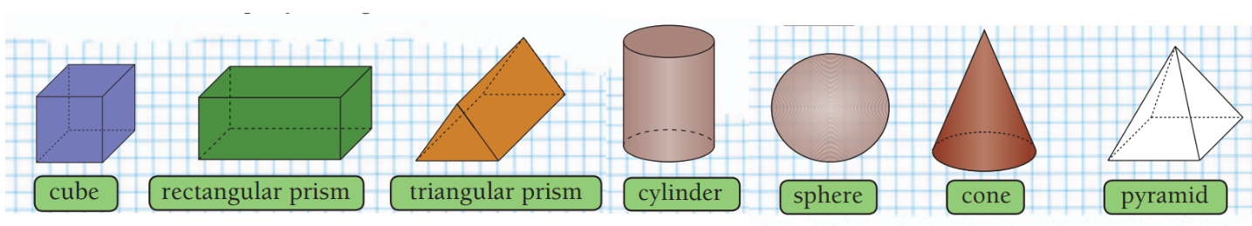
Look carefully at the photographs below.
In your book, draw and name all the different shapes you can see.
With a whānau member, see if you can find things that are shaped like a:
- cube
- square
- circle
- sphere
- rectangle
- triangle
- pyramid
- cone
- cylinder
- triangular prism
- rectangular prism.

Remember to do your end of day reflection and wellbeing activities (see p. 6 and 8).

Context 2: Rights and responsibilities

Over the next five days we will investigate the theme of citizenship by looking at how we enact our rights and responsibilities as a citizen.

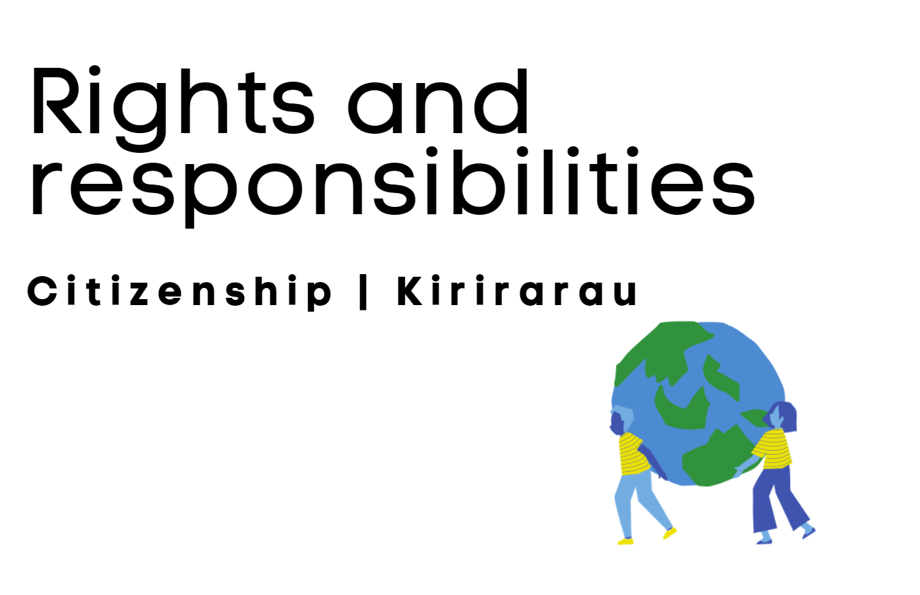

Day 6 activity 1: Understanding Rights and Responsbilities

Notes for teachers and whānau
Today your learner will explore the concept of rights and responsibilities within their home.

I am learning to: understand what a right and responsibility is and how we can enact them
What do I need?
- 30 minutes
- Rights and Responsibilities https://www.youtube.com/watch?v=CC7_glf2snc
Remember to start your day right (see p. 7).

Your task
Watch Rights and Responsibilities (or read the transcript). Note: the clip speaks about American rights, however, we also have these rights in New Zealand.
Transcript
What is a citizen?
Well, a citizen is a member of a group or a community. A citizen can be part of a small community like a classroom, or part of a large community, like a city. Citizens help their communities. A citizen can help the community on his or her own, or citizens can work together to make their community better. When you work to help the whole community, you work for the common good. Some citizens lead the community, help keep us safe, or have special jobs that help it run smoothly. But everyone has a responsibility to be a good citizen.
What is a responsibility?
A responsibility is something you should do. A responsibility could be doing chores at home, or doing your homework, or following the rules. It’s also our responsibility to be respectful of people’s cultures and obey laws.
A law is a rule that tells you how to behave. There are laws against stealing and littering, and laws about wearing helmets and seatbelts. Laws can help keep people safe, make sure everyone is treated fairly, and protect people’s rights.
What is a right?
A right is a freedom that is protected. The government’s job is to protect the rights of its citizens. We have rights in school too. We have the right to be safe but it’s our responsibility to follow the safety rules. I guess being safe is a right and a responsibility.
Copy the table below and write definitions for “right” and “responsibility”. Don’t worry if your definition is basic or you aren’t sure, we are only just getting started! There will be lots to learn and a chance to come back and add to this definition later in the week.
Write your understanding of how rights and responsibilities work together. You may find it easier to use an example.
Write at least two rights you have in your home and the responsibility that comes with these.
RIGHT – A right is… | RESPONSIBILITY – A responsibility is…
How do rights and responsibilities work together?
A right I have in my home is … | The responsibility that comes with that right is …

Day 6 activity 2: My amazing community!

Notes for teachers and whānau
Rights are also often referred to as privileges. Going forward, your learner may find that an easier concept to understand, particularly when thinking about rights and responsibilities in their home and community. Learners will be exploring the learning area of social sciences.

I am learning to: think about the rights and responsibilities I have as a citizen and the impact
What do I need?
- 30 minutes
- A device to view this webpage - https://www.govt.nz/browse/passports-citizenship-and-identity/nz-citizenship/privileges-and-responsibilities-of-a-citizen/

Your task
Use a device to access the New Zealand Government – New Zealand citizenship webpage (“Privileges and responsibilities of a citizen”). Take time to read the information on this page. It outlines your privileges as a New Zealand citizen as well as your responsibilities.
One of the responsibilities as a citizen of New Zealand is to behave as a responsible New Zealander. Let’s think about what that means within our local community.
Make a list of some of the special places/events you have and enjoy in your community, for example, children’s play area, annual Matariki festival, skatepark, library, outdoor swimming pool/splash pad, library, community hall.
Now let’s think about the rights and responsibilities that come with those special places/events. Use a table with three columns to record your ideas. You may like to sit and discuss this with members of your whānau. The first row has an example completed for you.
Special community place/event | Rights (privileges) | Responsibilities
Children’s Day festival | To feel safe at the festival.  To speak and perform on stage (if willing).  Can attend free of charge.  Can access the stalls.  Able to sit wherever you like to watch the entertainment. | Queue and wait patiently.  Not obstruct someone else’s view.  Only take what you need and leave enough for other people (at the stalls).  Remove all my rubbish.  Return the festival environment to its original state when finished.
What do you notice about the things you have written in your table?
Is there a common theme?
Write down what behaving as a responsible citizen means to you or how it impacts on your enjoyment at an event.

Day 6 activity 3: Sport and outdoor recreation

Notes for teachers and whānau
In this activity your learner is going to consider their rights and responsibilities when it comes to playing sports or participating in outdoor activities. This is their final “getting started” activity before they begin to explore, investigate, and discover an interest area on day 2. Learners will be exploring the learning areas of health and physical education.

I am learning to: use a brainstorm to record my ideas and wonderings
What do I need?
- 30 minutes
- Home learning book

Your task
You may have heard the term “fair play” when people talk about sport. So, what is fair play and how does it relate to our learning context of rights and responsibilities? Let’s spend some time today understanding rights and responsibilities in sport or outdoor recreation so that (if you choose to) you can explore it further throughout the week.
Fair play is a concept that upholds fundamental values that are important in sport. Most importantly, it is about the players/athletes abiding by the rules of the competition.
Thinking about either a sport you play or an outdoor recreation activity you like to do, complete a brainstorm and list the rights you have as a player, athlete, or participant in the activity. Include the responsibilities you have. Write the name of the sport or recreation activity in the centre, Then, write your brainstorm ideas around it. You may want to use the example below to get you started.
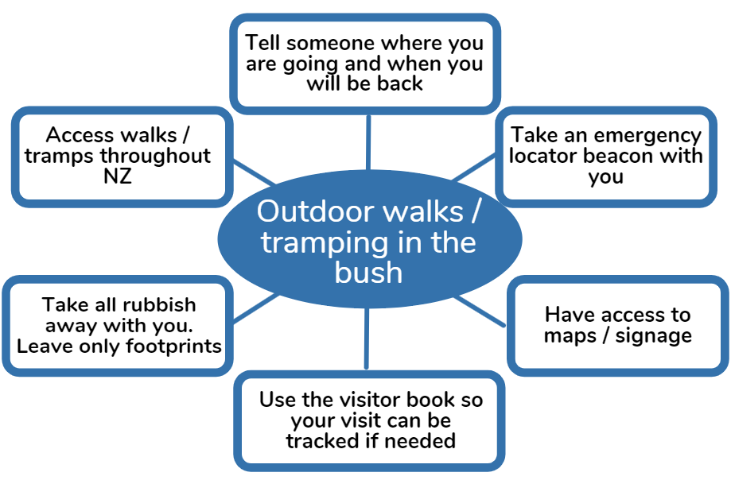

Day 6 activity 4: Maths - Statistics
Notes for teachers and whānau
Today, your learner will explore statistical investigations. This will be their maths’ focus throughout the week. Please encourage them to call/speak with as many friends and whānau as they can. This will enable them collect sufficient data.

I am learning to: identify which graph shows the data most clearly
What do I need?
- 30 minutes

Your task
Your maths task today will help you to practice your statistical investigation skills. Get ready to create your own statistical investigation.
The students in Room 8 wanted to find out which fruits were preferred by class members. Mr Winiata drew their suggestions and a ? on the board:
- Why do you think Mr Winiata drew a question mark?
Each student chose one of the fruits or the ? and drew it on a square of paper. Jo collected all these squares in a box. The students found different ways of arranging the choice squares to display the results. Jo made a strip graph like this: 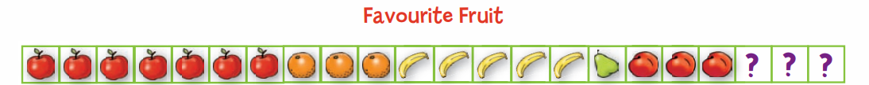
Kim made a bar graph. Tarak made a pie chart.
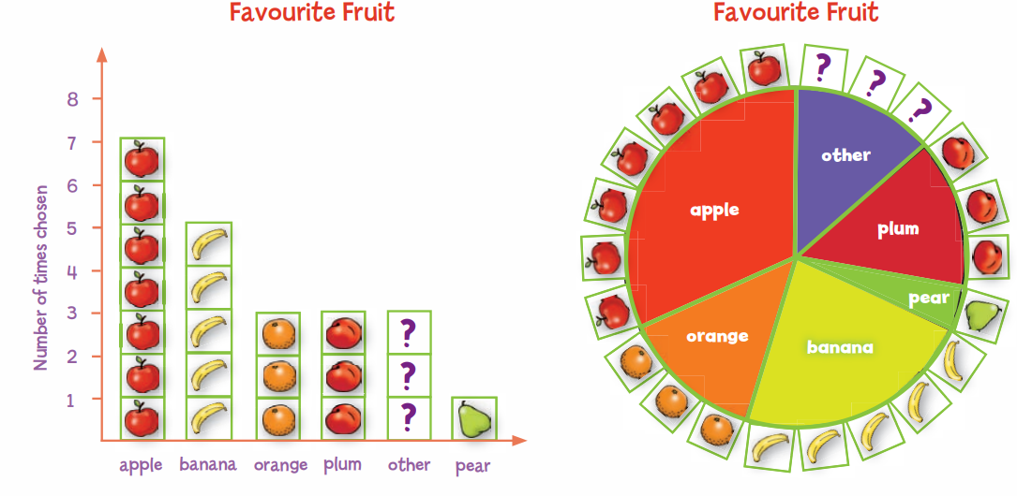
- Which graph do you think most clearly shows Room 8’s favourite fruit? Explain why.
- Using Room 8’s five fruit choices and a ?, ask each of your whānau to draw their favourite fruit on a square of paper. You are welcome to ask your whānau to choose their top three if you would like more data to work with.
  - Make a bar graph with the squares. What fruit is most popular in your whānau?
  - Compare your graph with Room 8’s bar graph. What differences can you see?
  - Which would show these differences more clearly: strip graphs or pie charts?
Remember to do your end of day reflection and wellbeing activities (see p. 6 and 8).

Day 7 activity 1: Reading
Notes for teachers and whānau
This reading activity links to yesterday’s rights and responsibilities in sport activity. Your learner will read the story and then make connections back to the brainstorm they created.

I am learning to: read and comprehend a text and make connections to new learning I am exploring
What do I need?
- 30 minutes
- Look in your pack for a copy of - https://instructionalseries.tki.org.nz/Instructional-Series/School-Journal/School-Journal-Level-2-August-2017/Up-the-Guts
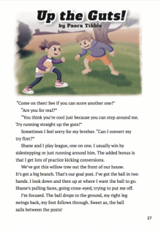
Remember to start your day right (see p. 7).

Your task
Read the story Up the Guts! by Paora Tibble. You may like to sit with someone in your whānau and read it together as there are lots of characters speaking in the story. Sometimes reading it aloud with someone else helps you to better understand the text.
Although this is a narrative, the author mentioned rules and regulations of the sport Rugby League as well as responsibilities the players have. Re-read the text and write down three rules/regulations or responsibilities the players must follow in rugby league.
1.
2.
3.
When thinking about the responsibilities you have as a player in a team sport like rugby league, why is it important that you practice the sport at home/at an organised practice?
How does this help you as a player to follow the rules, regulations, and responsibilities of the sport?
Write your response to this in your home learning book.
Let’s now look back at the brainstorm you completed yesterday about the rights and responsibilities in a chosen sport/outdoor activity. Having just read this text, is there anything you can add to yesterday’s brainstorm? You might like to add the idea mentioned above – that is, our responsibility to practice the sport/activity so that we approach the sport/activity in a safer way, and we are better prepared.

Day 7 activity 2: Being a good friend
Notes for teachers and whānau
As part of the getting started focus this week, your learner has thought about rights and responsibilities in the home, community, and when playing sport/outdoor activities. In this activity, learners are going to explore and investigate how knowing these rights and responsibilities helps make them a good friend. They will be exploring the learning areas of literacy, visual art, and social sciences.

I am learning to: explore ways that knowing my rights and responsibilities help me to be a good friend
What do I need?
- 30 minutes
- Home learning book
- Felts, coloured pencils
- A device to watch this short song – What makes a good friend? https://www.youtube.com/watch?v=avHdx18pi_U

Your task
This week you have been learning about rights and responsibilities. Yesterday, we focused on rights and responsibilities as a citizen or member of your whānau, local community, and sports team. Today, we are going to explore how being aware of these rights and responsibilities goes hand in hand with being a good friend.
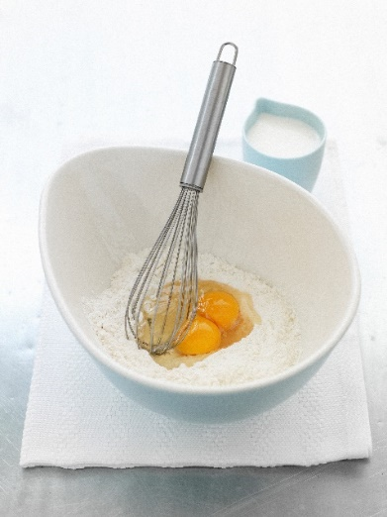
Let’s get “cooking” …
Use a whole page in your home learning book to draw yourself a big cookie jar or cooking bowl (whichever you prefer).
Next, think about the “ingredients” you would add to your jar to make “a good friend”. You can add as many ingredients as you like because there really are no limits when it comes to being a good friend!
You can write or draw your ingredients. You may like to watch the link above to help you get started with ideas.
Now that you have added your ingredients to your jar/bowl, your next task is to look over the words/images you have included. After that, think about a time when you were a good friend. Use a comic strip to draw/sketch how you were a good friend. Add some of the words you listed too. What responsibility did you have to put into action?

Day 7 activity 3: Taking responsibility of others
Notes for teachers and whānau
This activity makes connections to last week’s pet rock activities. If your learner didn’t complete last week’s activities, that’s not a problem because the activity also caters for those that might not yet have a pet rock. Learners will be exploring the learning areas of social sciences and the arts – drama.

I am learning to: consider how we take responsibility of others and demonstrate it in our everyday lives
What do I need?
- 30 minutes
- A pet rock – this may be your pet rock from week one or a new rock from your garden or local surroundings.

Your task
When we think about rights and responsibilities in our homes and community, this also includes animals. For this activity, your rock is your pet, and you are the owner.
Last week, you spent some time creating an identity and culture for your rock (if you didn’t complete last week’s learning activities, today’s activity can still be completed with a new pet rock). In today’s lesson, you are going to explore the responsibilities you have as a pet rock owner.
Copy this table into your home learning book. After that, list the responsibilities you would have to uphold to meet your pet’s needs.
Your pet’s needs | Your responsibility as the owner
For example, shelter | - Provide an inside space for my pet away from the heat, cold, rain  - Provide a warm place for my pet to sleep/rest.
Do you have a pet in your home? Is it your responsibility to look after them? What tasks are you expected to do to look after them and take responsibility?
If you don’t have a pet in your home, would you like one? If yes, what would you do to show that you are a responsible pet owner?
Write your response in your home learning book.

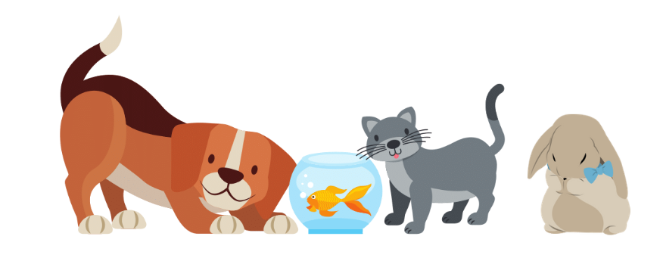
Day 7 activity 4: Maths – statistical investigations
Notes for teachers and whānau
This activity is a continuation of the day 6 maths task. Learners will be exploring the learning area of maths, looking at statistical investigations.

I am learning to: use graphs to communicate findings and tell stories.
What do I need?
- 30 minutes
- Note paper/small squares of paper cut up (to give to members of your whānau).

Your task
The Room 8 students decided to investigate favourite winter sports. They each wrote their favourite winter sport on a square piece of paper. The girls used red paper, and the boys used blue paper. They made graphs with the squares.
- Compare the two graphs. What is the same? What is different?

- As a whānau, use the paper squares to find out everyone’s favourite winter sport. (You might like to phone or text whānau or friends to ask them their choices.)
This time, make a single graph that shows everyone’s favourite sports. On it, show which are girls’ choices, and which are boys’ choices. Discuss what the graph tells you.
Remember to do your end of day reflection and wellbeing activities (see p. 6 and 8).

Day 8 activity 1: Who looks after us?
Notes for teachers and whānau
Day 8 is focused on making meaning. Your learner will investigate who looks after people in the community and what responsibilities come with that job/role. They may like to discuss the learning tasks with you before completing them.

I am learning to: make meaning of the responsibilities certain community roles/jobs have
What do I need?
- 30 minutes
- Optional: phone/video message call with someone who holds a community role/job
Remember to start your day right (see p. 7).

Your task
Every job or role comes with responsibilities. Some jobs or roles are dedicated to helping members of the community and come with greater responsibilities, such as a police person, firefighter, teacher, doctor, or nurse.
Make a list of jobs or roles that have the responsibility to help members of your community. Next to each job or role write down what responsibilities they have.
Job or role | Responsibilities
For example, Fire fighters
Choose one of these people to inquire into further.
Draw that person in the centre of a blank page. After that, add questions you would like to ask them about their responsibilities on the left-hand side. Then, on the right-hand side, write down any rights you think they may have/need in the job/role they do.
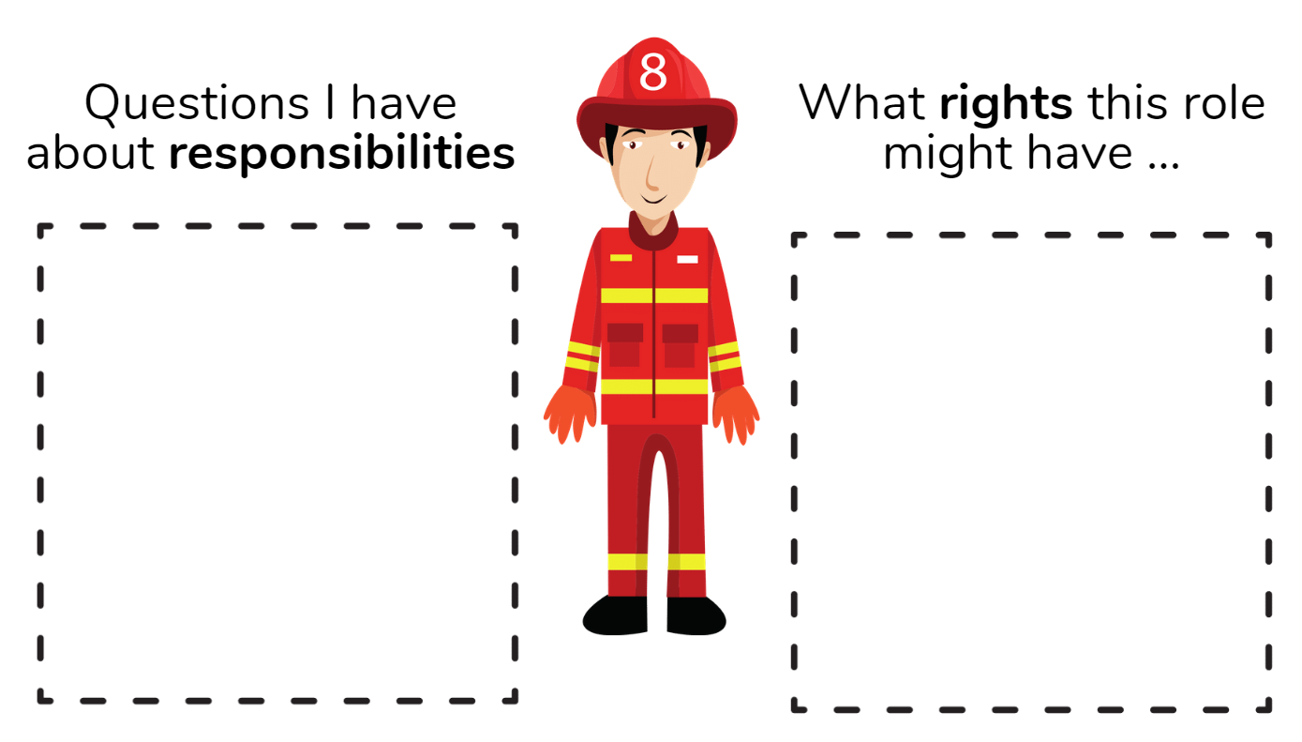
Would you like to have a job or role in the community where you are responsible for other people? Why or why not? Record your response in your home learning book.
Optional task – call someone you know who has an important job or role in the community and ask them questions about the responsibilities they have.
Day 8 activity 2: Thanking those with responsibilities
Notes for teachers and whānau
In this activity your learner will write a letter to someone in their community thanking them for the job or role they do. The first part of this activity introduces them to formal greetings and terms of address in te reo Māori which they will use in their letter. Learners will be exploring the learning areas of Māori and writing.

I am learning to: write a letter using greetings and terms of address in te reo Māori
What do I need?
- 30 minutes
- Home learning book
- Optional – an opportunity to send the letter or call the person and read them the letter.

Your task
Write a letter to someone in your community thanking them for the enormous responsibilities they take on as part of their job or role.
Before you get started with the letter, you are going to take some time to practice a few greetings and terms of address that you might like to use in your letter in te reo Māori. Some of these phrases or vocabulary you may already know; others may be new to you. Challenge yourself to include at least four of these in your letter.
Te reo Māori | English translation | How you might use this phrase or vocabulary in your letter
Tēnā koe | Hello (to one person) | As your opening line when addresing the person by name
Kia ora | Hello, good morning, good afternoon and thank you (to any number of people) | In your first sentence or as a way of thanking them
Kia pai te rā | Have a good day | At the end of your letter
Hei te tau tītoki | See you sometime | If you know them and intend to see them sometime
Hei reira | See you there (a place known or mentioned) | If you are mentioning somewhere you will both be
Kia manahau! | Enjoy! | If there is something the person will particuarly enjoy
Ka nui te mihi | Regards | At the end of your letter to sign off
Kei te pēhea koe? | How are you (to one person) | At the beginning of your letter
Ka mau te wehi! | Awesome! Fantastic! | If you are sharing something in your letter that is awesome or fantastic
Ngā mihi nui | Thank you very much | To thank them.

Day 8 activity 3: Let’s get arty!
Notes for teachers and whānau
For this activity, your learner is going to create an A4-sized mural highlighting one of the focus areas this week. For example, keeping a pet, responsibilities when using a community facility, a job or role which comes with responsibilities for helping the community.
Learners will be exploring the learning area of visual arts.

I am learning to: use pencils, felts, or crayons to create an A4 mural which shares a message
What do I need?
- 30 minutes
- Home learning book or an A4 piece of paper
- Coloured pencils, felts, crayons.

Your task
Throughout this week, you have explored, discovered, made meaning, and investigated rights and responsibilities within the home, your community, and in the workforce. For today’s activity, you are going to create an A4 mural of one of the areas we have explored. To help you get started with your planning, you might like to use one of these ideas.
- A mural about keeping a pet, their needs or rights as an animal, and the owner’s responsibility.
- A mural showing an amazing facility you have in your community, like the local pools, and ways people will need to show responsibility when using this facility.
- A person who has a job or role focused on helping the community and their rights and responsibilities.
Murals often contain key words (think word art) and large images overlapping each other. Have fun and be creative. You will have a chance to display your artwork tomorrow when you share your learning.
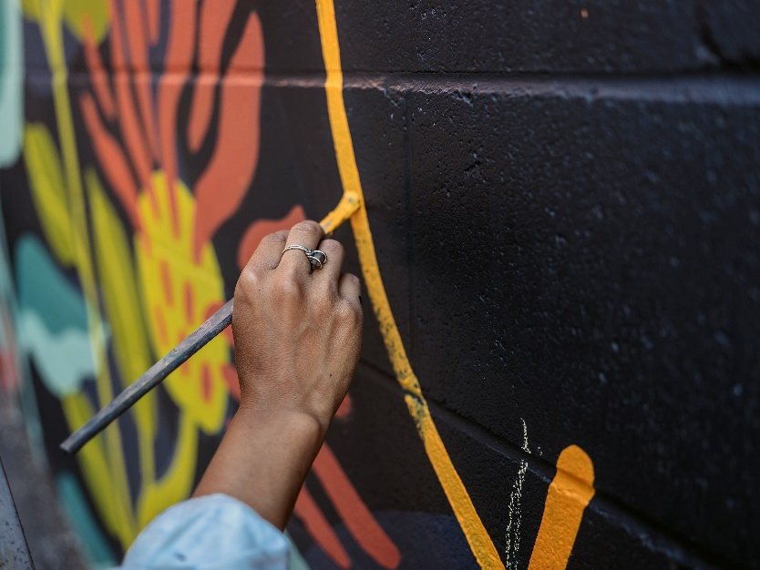

Day 8 activity 4: Statistical investigations continued
Notes for teachers and whānau
This activity is a continuation of the day 6 maths task. Learners will be exploring the learning area of maths, looking at statistical investigations.

I am learning to: carry out a statistical investigation
What do I need?
- 30 minutes
- Note paper/small squares of paper cut up (to give to members of your whānau).

Your task
During your maths activities this week, you have been investigating Room 8’s favourite fruits and winter sports activities. Room 8 used choice squares to vote on their favourite fruit and winter sports. After that, they used graphs to communicate their findings. You have also used choice squares as a way of collecting data from your whānau and friends to find out their favourite winter sports.
Now let’s brainstorm other questions that people could answer using choice squares. For example, I wonder if:
- boys and girls like the same TV programme
- our whānau like the same things for breakfast as we do
- our whānau like the same animals as pets?
Make up a question of your own (or use one of these examples) to ask as many whānau and friends as you can. Use choice squares to help you find the answer.
Collect responses on choice squares. Make the squares into a graph.
Reflection – you have used choice squares to collect and display the data. What makes this an effective way to collect and display data?
Remember to do your end of day reflection and wellbeing activities (see p. 6 and 8).

Day 9 activity 1: Persuasive writing
Notes for teachers and whānau
In this activity, your learner is asked to think about all the reasons for or against a persuasive topic. They will then be asked to write persuasively in the following activity. You may like to sit with them as they brainstorm their ideas for or against the topic.
Learners will be exploring the learning areas of writing.

I am learning to: plan my ideas to persuade someone
What do I need?
- 30 minutes
- Home learning book
Remember to start your day right (see p. 7).

Your task
Record your thoughts about these questions in your book:
- How have your personal responsibilities shifted when you learn at home?
- What are you responsible for now that is new and different?
- How do you feel about these shifted responsibilities?
Persuasive writing intends to convince readers to believe an idea or opinion and to do an action.
It is my responsibility to get myself organised and ready for learning each morning.
Your activity is to plan your ideas to persuade someone on the topic below (you will write your persuasive text in the next activity). You can either be for or against the topic, that is up to you to decide.
Use this fishbone graphic organiser to plan your ideas:
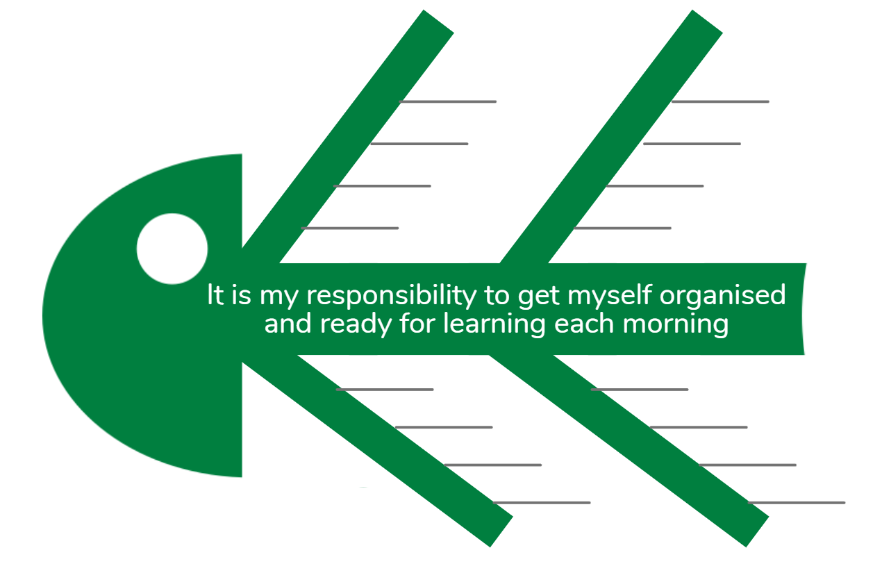

Day 9 activity 2: Writing continued
Notes for teachers and whānau
In this activity, your learner will be writing their persuasive text using the plan they developed in activity 1. They may need your support to stick with their side of the argument – for or against.
Learners will be exploring the learning areas of writing.

I am learning to: write to persuade someone
What do I need?
- 30 minutes
- Your persuasive fishbone plan from Day 9 activity 1
- Home learning book

Your task
In the previous activity you used the fishbone diagram to plan your ideas for or against the topic It is my responsibility to get myself organised and ready for school each morning.
Your next task is to write your persusaive text for or against this topic. Your plan will help you with the ideas and you might like to use this reminder to help you with the structure:
Introduction – stating whether you are for or against the topic (agree or disagree with the argument)
Main point 1 – first main reason you are for or against
Main point 2 – another reason you are for or against
Main point 3 – another reason you are for or against
Conclusion – revisiting the reasons you have given and re-stating your position (for or against)
While you are writing, think about our overarching context for this week – rights and responsibilities. Think about ways to include ideas about your rights and responsibilities in your home in this persuasive text.
Remember, you are trying to challenge your audience to agree with your position (for or against) the topic. You will have a chance tomorrow to share your persuasive text with your whānau.

Day 9 activity 3: Reading – financial responsibility
Notes for teachers and whānau
Your learner will be reading a short play from a Junior Journal. They will then think about how the two characters took responsibility for their money, and how they can take responsibility for money they might earn.
Learners will be exploring reading.

I am learning to: comprehend text and make connections to what I am learning about
What do I need?
- 30 minutes
- Look in your pack for a copy of Kele’s Car https://instructionalseries.tki.org.nz/Instructional-Series/Junior-Journal/Junior-Journal-49-Level-2-2014/Kele-s-Car

Your task
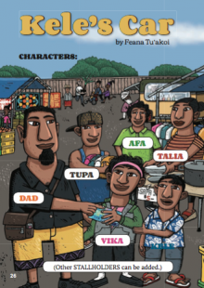
Read Kele’s Car. Because this is a play with six characters, you may like to ask other whānau members if they want to join in as you read it aloud together.
In this play, Kele and Vika enjoy the markets with their dad. Dad gives them the task of taking responsibility for the money they have earnt and want to spend. But what happened?
Copy the table below into your home learning book and then write down the actions and outcomes Vika and Kele took with their money.
 | Vika | Kele
Actions

Outcomes

Do you think Kele showed responsibility for his money? Why or why not? Write your response in your home learning book.
How did Vika’s actions show kindness and consideration towards Kele? Write your response in your home learning book.
In your opinion, how did Dad stepping in to talk them through the consequences of Vika buying the car for Kele, help both boys to be responsible with their money? Write your response in your home learning book.
How do you take responsibility for any money you might earn/be given? Give an example of when you have been (or someone you know has been) responsible with your money.

Day 9 activity 4: Problem solving – pocket money
Notes for teachers and whānau
Having just read a play about two boys spending their pocket money, your learner will hopefully enjoy this maths problem-solving task. They may need some help initially, and if you have it, play money and a calendar would be helpful materials.
Learners will be exploring the learning area of maths – problem solving.

I am learning to: double numbers and add a series of two-digit numbers
What do I need?
- 30 minutes
- Play money (if available)
- A calendar (can be an old calendar)

Your task
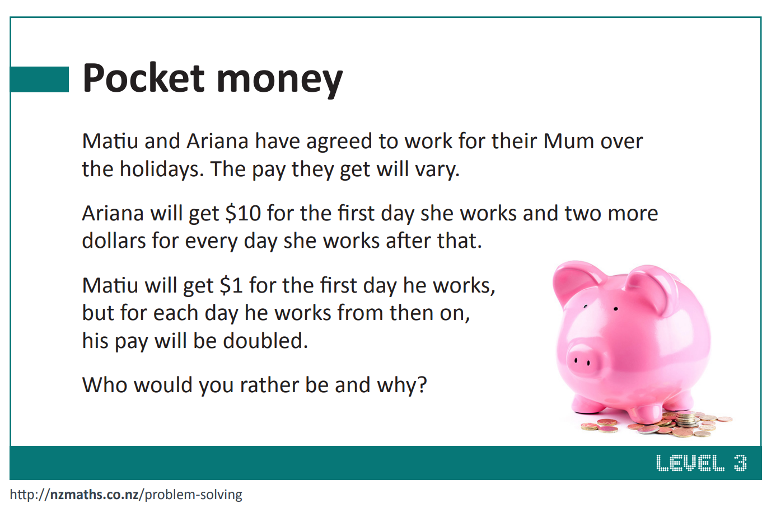
Solve this problem.

Remember to do your end of day reflection and wellbeing activities (see p. 6 and 8).

Day 10 activity 1: Do you agree?
Notes for teachers and whānau
To start the final day of activities, your learner will share their persuasive text. They may like to share this with people at home or call someone by phone/video messaging. They then ask the opinion of another person to see if they agree or disagree.
Learners will be exploring literacy.

I am learning to: share my persuasive text with an audience and seek their opinion.
What do I need?
- 30 minutes
- Your persuasive text from day 9.
- Optional: phone or video messaging a friend of whānau member
Remember to start your day right (see p. 7).

Your task
Over the past two days you have spent time planning and writing a persuasive text. You have chosen to either write for or against the topic It is my responsibility to get myself organised and ready for school each morning.
Today you are going to challenge an audience and hear their opinion – either people in your home, or via phone/video messaging. Share your persuasive text with them. You may like to present this to them like you are giving a speech or having a debate, standing up in front of them/the camera. Or you may simply wish to sit next to them and read it aloud to them.
After you have shared your persuasive text with them, ask them to tell you what your three main reasons for or against the topic were.
After that, ask them their opinion. Are they for or against the topic? If they share the same opinion as you, do they have different reasons? What are they? If they have a different opinion, ask them to tell you why they think that (remember back to the fishbone plan you made where you listed three main points). Do they have three main reasons?

Day 10 activity 2: Displaying the data
Notes for teachers and whānau
This week your learner has posed investigative questions, designed data collection methods, and collected and collated data. This activity allows them the chance to complete the statistical investigation cycle by displaying collected data, and then make statements and conclusions.
Learners will be exploring the learning area of maths – statistics.

I am learning to: display collected data and make statements about the displays of data, and conclusions based on a statistical investigation.
What do I need?
- 30 minutes
- Home learning book
- Coloured pencils, felts, crayons

Your task
As part of your home learning this week, you have been learning how to carry out statistical investigations. Throughout days 6-8 you explored Room 8’s statistical investigations, then you posed an investigative question, designed the data collection method, and collected and collated the data.
Think back to how Room 8 displayed the data they collected on the choice squares. Now, look back at the data you collected when you asked your whānau and friends an investigative question. Display this collected data in an appropriate format – strip graph, bar graph, and so on.
In your home learning book, write statements about the data you have just displayed. You might include statements like:
- More boys liked …
- There are twice as many people who chose … than …
To conclude your statistical investigation, write two overall statements that conclude your statistical investigation. For example:
- The evidence presented here shows that overall …
- By asking (insert question you asked), I can see that the most popular choice was …
Finally, share the data you have displayed, and statements you have made with your whānau.

Day 10 activity 3: Outstanding citizens
Notes for teachers and whānau
To conclude the week, your learner will share with their whānau a scenario where outstanding citizens take on their own responsibility with no expectation for reward.
Learners will be exploring the learning area of social sciences.

I am learning to: understand that citizens often see a need and take on a responsibility with no expectation to do so
What do I need?
- 30 minutes
- A device to watch this short clip Jake Numanga sings goodbye at Rarotonga International Airport https://www.youtube.com/watch?v=d-T3tQes8oA
- Home learning book

Your task
Have you ever heard of the saying “out of the goodness of their own heart”? People often say this about someone who goes above and beyond without any expectation for reward or payment. You could say that these people take on extra responsibilities without wanting anything in return. Jake Numanga is one of these kinds of people. If you have access, you could use the link above to see him in action.
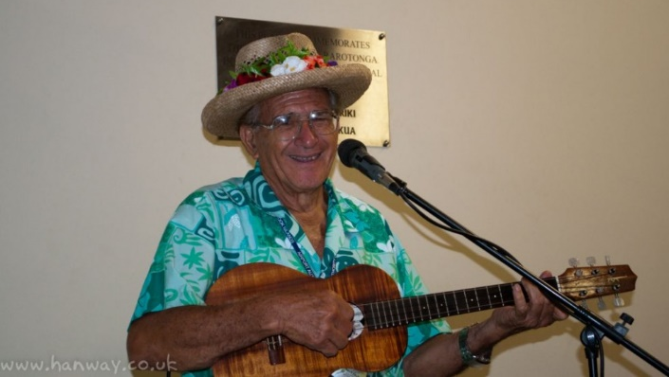
Jake Numanga is from the Cook Islands and for over 30 years, he has been welcoming and seeing off every flight from the Cook Islands International Airport by playing his ukulele and singing, no matter what time of day or night!
Discuss with your whānau why this makes Numanga an outstanding citizen and why what he does demonstrates someone taking on amazing responsibilities to help others.
Source: http://www.hanway.co.uk/leaving-on-a-jet-plane/
David Letele (also known as the “Brown Buttabean”) is another example of an amazing citizen who wanted to help take responsibility for other people’s health and wellbeing. He created a fitness gym and welcomed people. He also gives out free meals for the homeless and runs a foodbank for people in need.
Do you or your whānau know an outstanding citizen who has taken on amazing responsibilities, all in the name of helping others?
In your home learning book write down who this person is and then make a list of the things they do to help others.

Day 10 activity 4: Random acts of kindness
Notes for teachers and whānau
To finish their amazing learning this week, your learner is going to think about random acts of kindness they could do in the home, at school, or in the community. Learners will need access to images that they can either cut out and arrange in a physical collage or copy and paste into a digital collage.
Learners will be exploring the learning areas of social science.

I am learning to: think about how I can contribute to the needs of others
What do I need?
- 30 minutes
- A range of images – these can be cut from magazines, newspapers, junk mail; drawn by hand; or accessed online if choosing to create a digital collage.

Your task
Talk with your whānau about the Random Acts of Kindness (RAK) movement.
- What kind of things could people do as random acts of kindness?
- What things could you do at home, at school, or in your community?
- Have you ever received a random act of kindness? How did it make you feel?
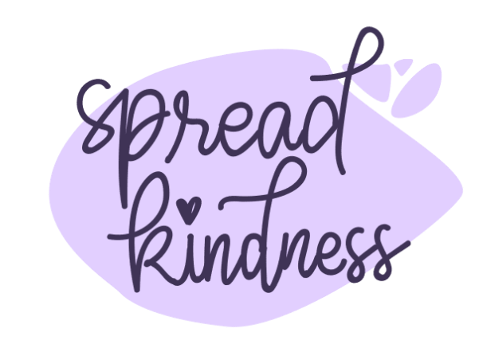
- Have you ever done a random act of kindness for someone? How did that make you feel?
Source images that represent random acts of kindness. Instead of using pictures of people, your challenge is to record acts using only pictures of objects. (You can find images in magazines, newspapers or draw them by hand, or use the internet).
Create a collage and label each act, either on paper or in an online document.
Share your collage with your whānau and with the rest of your class.
Challenge yourself to complete at least one of the “Random Acts of Kindness” from your collage next week.

Remember to do your end of day reflection and wellbeing activities (see p. 6 and 8).

