Home Learning TV: Middle Literacy

Segment lesson planning details
Title for segment: | Unwanted Pests
Year levels: | Middle years 4-7
NZC learning areas: | English: Students will show some understanding of ideas within, across, and beyond texts – curriculum level 3
Purpose of lesson:  (What learners will learn) | We are learning to ask question related to the text
Success Criteria – students will be able to:  (how they will know when they have learnt it) | We will be successful when we have  - considered possible solutions to questions that arise from reading our text  - used our answers to help us design our own innovation
Segment production details
Equipment requirements: | Presenter may like to bring in items which could be used to make a tracking device (Slide 16 may also be used for this purpose)
Copyright requirements:
Please be specific: Source: (Seven Sizzling Sausages by Sam Smith –url link to the source), intended use (to demonstrate alliteration), Length (timings for video clips)
Segment links and attachments (list all links to recordings or attachments, the source and confirm that copyright permissions are granted)
Links to recordings /resources | Designed for Good (Article) School Journal Level 3 May 2017  slides to support this lesson
Attachments
Segment plan content
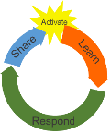 | Teaching and learning activities linked to purpose | High level script (key points/questions)
Activate: Activating prior learning, knowledge of contexts and relationships  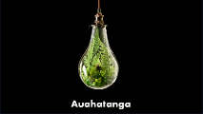  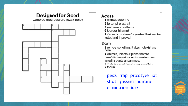  SLIDE 3  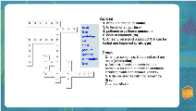  SLIDE 4 | Teacher welcomes students  Teacher introduces the concept of innovation as the focus of the lesson today  Teacher introduces vocabulary prior knowledge activity as a challenge for students to problem solve in order to complete  Teacher shares slide 3 and explains that this is a vocabulary crossword using the script provided  Teacher shows slide 4 – this has completed crossword vocabulary activity  Teacher uses the think aloud to explain a strategy they used to complete the crossword  Teacher links to Māori language | Mōrena tamariki ma, Tālofa Lava, Mālo e lelei, Welcome,  In our mahi today, we will be looking closely at the concept of innovation. The word innovation means to renew or to improve or replace something, to be forward thinking. The Māori word for this is auahatanga.[slide2] You don’t have to start from scratch and come up with a totally new idea or product every time. Instead, you change, modify or improve others’ ideas. Nearly everyone’s ideas are connected in some way to someone else's ideas.  For example, a hangi can still be cooked underground but many are now opting to use hangi steamers. The steamers are an innovation from the original hangi, but they also follow traditional hangi in many ways.  Teacher shares slide 3– this is a vocabulary challenge  I thought we would start together with a challenge. I have prepared a crossword task with key vocabulary from the text in today’s lesson. BUT… I am not telling you what the text is about just yet!! Your challenge is to problem solve to complete the crossword AND THEN to see if you can predict what the text might be about. What innovation do you think we will be reading about today?  Are you up for the challenge? Ka pai!!  Use the key words in blue – pests, trap, prototype, rat, stoat, possum humane, elimination, lure and the clues, across and down, to complete the crossword puzzle. See how many words you can place. I will give you 3 minutes. Let’s see how you get on. Kōrero/discuss with your family/whānau/ainga/anau/kaiako to help you complete this crossword  Teacher shares slide 4  This has the answers to the crossword. She asks:  How did you go? Is this what you thought? Kei runga noa atu!  Did you manage to place most of these words?  When I complete crosswords and the words have been provided, I also use other clues - like the numbers of letters in a word and identical beginnings and or ending letters. Elimination was quick to place, and I thought instantly that 4 down and across, must begin with the letter ‘p’. I was right - possum and pests. Do you use clues like this as well?  Did you know that paihamu or paihama means possum and that kiore or hinamoki are types of rats?  Were you able to use vocab from the crossword to predict what our text today is about?  Our text is called Designed for Good. It is about designing a new kind of trap for pests. It tells the story of a project that developed an effective and humane trap for pests like possum and kiore.
Learn: Introducing learning  Reinforce routines, provide multiple exposure to concepts, and strategies. Scaffolding learning  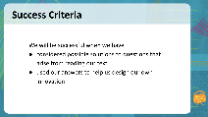  SLIDE 5  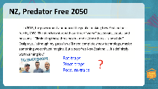  SLIDE 6  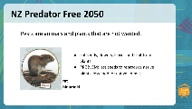  SLIDE 7  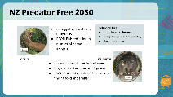  SLIDE 8  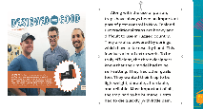  SLIDE 9  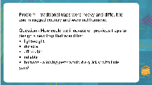  SLIDE 10  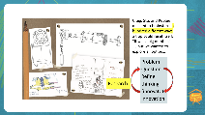  SLIDE 11  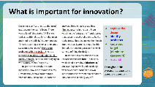  SLIDE 12 | Teacher shares Slide 5- success criteria and unpacks this with students  Teacher explains, checks students' understanding and encourages students to explain to another whanau member.  Teacher shares slide 6  This is the first section of text that students will read  Teacher shares slide7 as she discusses what she knows about rats  Teacher shares slide 8. This has text about stoats and possums. Show slide while reading script. Adlib to reinforce information shown on slide.  Teacher shares SLIDE 8  Teacher shows slide10 – this summarises the problem to be solved through innovation  Teacher shares slide 11 – this explains the process of a brainstorm  Share slide 12– text | Let's review our goals for today. Join me as we read the success criteria for our lesson. Slide 5  We will be successful today when we have considered possible solutions to questions that arise from reading our text and when we have used our answers to help us design our own innovation.  Turn to a whanau/ainga/anau member or your friend/hoa and explain to them what you will be learning to do today.  He patai? any questions?  Teacher shares slide 6  Let’s read a small section of today’s text. ……. (PAUSE). Did you know that the goal for 2050 is to be pest free? No rats! No stoats! No possums! I wonder if the three people in the illustration, one of whom must be Craig, have created an innovation or a prototype of a trap to make this goal a reality? Imagine that - total elimination from NZ soil of these three pests.  What do we know about these pests?  Rats (Kiore, hinamoki) arrived with early Polynesian settlers, sailors and voyagers and today can be found nationwide. What do you know about rats? ….. (PAUSE)  I know that rats are not picky about where they live and some love to climb to high, out-of-the-way places. I’ve seen them run up and along the tops of fences as they hunt and search for food. They eat baby chicks, wetas, eggs, insects, lizards, bats, and even snails. They will also eat fruit and the seeds of plants and flowers. Rats breed quickly and have large litters. All of this is a problem: we have fewer seeds to reproduce native plants, less food for native animals, and less native animals and insects.  Teacher shares slide 7  The information on our next slide tells us that rats eat seeds, flowers, leaves and fruit from plants, native birds and insects. This causes a series of problems – there are less seeds to reproduce native plants, less food for native animals, less native animals  No wonder our native flora and fauna are at risk, and rats are not the only pests in the country.  What do you know about stoats and possums?  You can korero with family/ whānau /lou aiga/kaiako or a friend and tell them what you know. …...(pause)  What did you learn? Ka nui te pai  Teacher shares slide 8  In Aotearoa we have similar problems with other animals. Have you ever seen a stoat? Do you know what one looks like? Stoats are bigger than weasels and smaller than ferrets. Stoats were brought into NZ in the late 1800s to control the rabbit population. Unfortunately, they also have a liking for baby birds, eggs in nests, weta and freshwater crayfish (kōura). They are also great climbers. They eat eggs and reduce the number of native animals.  Possums were introduced from Australia in the 1800s to establish a fur trade, but they soon became a pest, destroying native plants and eating birds’ eggs. The government in 1921 made it illegal to bring in any more possums but by then it was too late. Possums quickly joined our list of pests. They eat leaves, seeds, and fruit of trees. Larger trees disappear and native animals have trouble finding food and shelter. Traditional lures, combining flowers and spices inside flax woven traps were used.  Let’s recap the main ideas we have learned so far about the problem of pests. If they are available, summarise in 2 or 3 sentences what you have learned so far for a whānau/ainga/anau member or your friend/hoa.  Pests certainly create problems for many people and have had a huge impact on our environment. The three designers in today’s reading wanted to help solve this problem. They wanted to innovate on the many different kinds of pest traps used over time and develop a more humane solution.  Teacher shares slide 9  Let’s read what our three designers identified as their goals/whāinga in their innovation process for designing their ‘pest’ traps. Listen/whakarongo as I read – or follow along reading with me  Along with the use of poison traps have always been an important part of pest control in New Zealand. But traditional traps are heavy and difficult to use. They are also powered by springs which have to be reset by hand. The designers new that their model had to be self-setting. They wanted their trap to be lightweight, durable, affordable and reliable. Most important of all the trap had to be humane. Pests had to die quickly with little pain.  Teacher shares slide 10  This summarises the problem. Take a look and check your understanding/  Pause (1 minute) – animation?  Teacher shares slide 11  To summarise, the problem that these innovators wanted to solve was the lack of humane, practical pest traps that would work in the many kids of rugged terrain of New Zealand. What a challenge they set themselves!  What would you do in their situation? How might you solve this problem? Korero with family/ whānau /lou aiga/kaiako or a friend to share ideas about what you might do.  The team started with a brainstorm. Why do you think they did this?  Let’s take a look…  Do you notice the various brainstorms and the cycle of problem, research, innovation and refine? This is the cycle that this team used as they innovated and created a new form of pest trap. Remember that there were already pest traps available, but this one was to be an innovation that would fit all of the new criteria the designers wanted to meet.  Teacher shares slide 12  Let’s read on and see what this team did. Whakarongo as I read – or join along with me  Did you notice how:  - The engineers explored the design. “There were problems with this design. This sentence told me that they did this.  - They identified problems… The trap sometimes misfired and it didn’t kill quickly enough.  - They decided that they needed to know more about possums. I summarised this as knowing your target (eliminate guesswork). They filmed possums in the bush to gather information about possums.  - Then they researched the best lure to place inside their traps. They consulted with an expert.  Throughout this process, they identified problems, thought about their target, and researching. Isn’t it interesting that they discovered that possums are attracted to cinnamon? Kōrero with family about past and existing knowledge of ways to trap pests. Share what your whānau and friends know about trapping and/or killing pest animals. Ask whānau and friends to share how approaches differ between different cultures.
Respond: Providing opportunities to use and practice  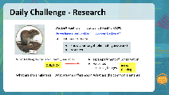  SLIDE 13  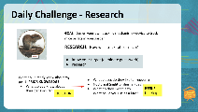  SLIDE 14  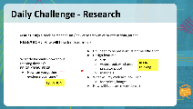  SLIDE 15  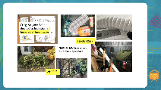  SLIDE 16  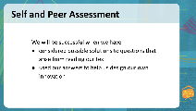 | Teacher shares slide 13. This slide illustrates the first steps in designing a pest tracking device.  Teacher shares slide 14 for next steps of her plan  Teacher shares SLIDE 15  Teacher shares slide 16  Teacher shares slide 16. This is the self and peer assessment that aligns to lesson success criteria | Our challenge today is to come up with a plan to find out whether you have a pest problem in our own backyard, at your local park, at the marae, at school. One way of doing this is to construct a pest tracking device. I am going to share a process for doing this with you and as I do I want you to take notes on the process and add your own ideas  Teacher shares slide 13  There are three steps  Let's start/timata  – Step 1, tuatahi  We need to begin by researching to find out what pest tracking devices are currently available. This is important because innovations are about ideas and ideas build upon ideas. I know that the New Zealand Department of Conservation has pest tracking devices that they use so I have added researching this to my plan.  Once we have found out information on what is available, we need to ask some questions about existing pest trackers. How are different traps similar? How are they different? What are the common elements about commonly found tracking devices?  When we have answered these questions, we will know more about what is already in use today. From this we can innovate. Can you see how I have added this to my plan? Ka pai!  Teacher shares slide 14  Now you can record what you might do to do your own research – make a plan for your research – you might like to take notes from my plan to help you. Korero with whanau for their suggestions.  How did you go? Kei runga noa atu!  Okay! Ka pai. Now to the next step  Teacher shares slide 15  Step 2, tuarua  We need to build our knowledge around what we already know about our pest - rats or mice. What do we know about their behaviours? Where do they like to be? When do they venture out of their homes? What do they like to eat that I could use as a lure?  I know that they like eating food scraps and living in warm places and my compost bin is ideal for this. I could set my tracking device near these areas.  Can you see what I have planned?  You might like to record how you will build your own knowledge of the pest you might investigate. Later you could try this step for yourself  Teacher shares slide 16  Step 3, tuatoru  How can we gather this evidence over time? What will I use to capture evidence of the presence of pests? I’m thinking that in my design I need something that shows rats or mice have been there. I’ve read that an ink pad or a container of food colouring, near some paper may do the job. I might need to see which colour would be best.  I’ve also been looking around to see what I can make my device out of –  I have decided that I could cut and join several drink bottles together or use a spare piece of tubing. That means my pest might come into my trap! I will need to research, innovate, test, and refine and see what I come up with!  Share ideas of how you might gather your evidence with family, whanau, and friends. You might have friends who are also watching this lesson and will be thinking of what they could do. Some of your friends might even have experience of living with, or removing, pests! See what you can find out.  Here are some photos I’ve taken to capture my thinking.  Before we finish – let's check back on our success criteria for today’s mahi  How have we got on – teacher adlibs  You can assess your own learning or ask someone from your whanau to help you.
Share: Learner and parent reflection on learning and engagement and what they can do next | Slide 18 | Today, we have been exploring innovation. What is it? and what it may look like for you? We have considered possible solutions to questions that arise from reading our text and we have used our answers to help us design our own innovation. Each step along the way was an innovation on the previous idea. As so often happens, one idea led to another.  Now it’s your turn. You might like to research for yourselves to find out more about tracking devices, you might like to follow the plan you have made. If you do you may like to take notes and take photos to help you.  Invite your friends/ whānau/anau/ainga/ teacher/Kaiako to help you with the challenge. Remember to include their thoughts and suggestions.  I hope you share your ideas with whanau and friends. You might even like to work with others to plan a practical model of a pest trap that you could build once Covid restrictions ease  Ka kite ano, tofaa soifua  Kia Haumaru te noho - be safe

