Lesson Plan - Queen of the Board

Segment submission
Programming slot (segment type):  e.g. Middle Science & Maths | Junior Literacy | Intended screening date:  e.g. 15/04/2020
Submitted by (Name): | Julie Beattie | Email address / Tel no.: |  | j.beattie@learningsolutions.co.nz
Segment lesson planning details
Title for segment: | Queen of the Board
Year levels (e.g. Yrs1 – 4): | Yrs 3-4
NZC learning areas: | English: Reading Level 2  - Recognises that oral, written and visual language features can be used for effect.  English: Writing Level 2  - Uses language features appropriately, showing some understanding of cause and effect.
Purpose of lesson:  (What learners will learn) | Learners will:  - ask questions of the text to clarify their understanding of the main characters.  ● identify the main events in the text and reflect on how the characters used dialogue to interact  ● learn how to structure their writing using descriptive action details
Success Criteria – students will be able to:  (how they will know when they have learnt it) | Learners will be able to:  - use a planning framework to identify the main events and the characters  - unpack the main events and identify how the writer used voice alongside the description to build a picture of the characters in the story  - use oral, written and visual language to create meaning and effect.
Segment content/context details (as appropriate)
Māori specific content i.e. the learning draws on Mātauranga Māori: | Greetings: Kia ora  Farewell: Ka kite anō  Taniwha page 10  Tuakana Page 11 | Pacific specific content i.e. the learning is focused on Pacific knowledge: |  | Greetings: talofa, Malo e lelei, Fakalofa Atu, Kia orana, Bula vinaka
Segment production details
Equipment requirements: | Text: Queen of the Board by Anahera Gildea, illustrated by Taeri Christopherson SJ
Copyright requirements:
Please be specific: Source: (Seven Sizzling Sausages by Sam Smith –url link to the source), intended use (to demonstrate alliteration), Length (timings for video clips)
Segment links and attachments (list all links to recordings or attachments, the source and confirm that copyright permissions are granted)
Links to recordings /resources | Queen of the Board audio https://drive.google.com/file/d/1RgkwXHe3M-fP_z5IrDrKPPpYSkB4UO2T/view
Attachments
Segment plan content
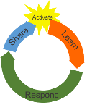 | Teaching and learning activities linked to purpose |  | High level script (key points/questions)
Activate: Activating prior learning, knowledge of contexts and  relationships | 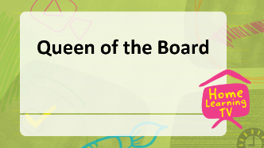  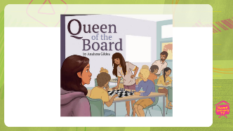  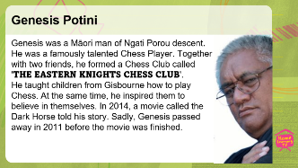  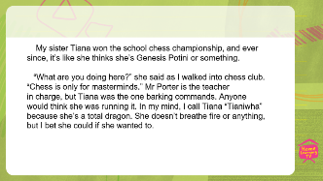 |  | (***ON CAMERA***) (0.46 mins) Kia ora, talofa, malo e lelei, Fakalofa Atu, kia orana, bula vinaka, It is great to see you! Welcome to anyone joining us for the first time. I’m excited to be sharing ideas and new learning in reading and writing today, as we read our story together.  It is titled “Queen of the Board'' by Anahera Gildea, illustrated by Taeri Christopherson. It’s a story about family relationships and the challenge of learning something new. Mmm, I wonder what kind of board the story is talking about, a surfboard or a skateboard maybe?  Look at the picture on the title page to help you decide what the story is about.  NEXT SLIDE  I noticed there are some children and two of them look like they are playing a game. Is the story about children learning to play a game? What else can you see? I wonder what the boys are doing with the black and white board on the table? Yes, that’s very good thinking, it is a game. But now I am wondering, what games have boards with black and white squares? Maybe it could be draughts or checkers or a game like that?  Next question, who is Queen of the Board? Could it be one of the boys? No, I don’t think so, because then it would be called King of the Board. What can you see in the Title page? this will help us decide who the main characters are and the main events in the story  If they are with you, share your thoughts with your whānau about who the “Queen of the Board'' might be and why. If not, think about this on your own and try to come up with an answer. Pause….. So, let's listen to the story and check our thinking about who the Queen of the board is. You can read along with the narrator of the story if you want to. Don’t forget to look at the pictures as they may help you decide what the events are and how the characters are described.  (***ROLLVT***) Next Slide 8:38 mins  Ready?  (***ON CAMERA***)  What an interesting story! Did you think it would be about two young sisters who play chess? Did you work out that the board in the story is a Chess Board?  Is there is anyone in your whānau who knows about chess? If there is, then you might like to share this story with them. Did you know that playing Chess helps you get better at Mathematics?  Next Slide  Now, do you remember Miri's first thought is that her sister Tiana “thinks she is Genesis Potini or something.” Some of you might have heard of him, if you like playing chess. Potini was Māori man of Ngati Porou descent and lived on the East Coast. He was known for his great skill as a talented speed chess player. Together with two friends, he formed a chess club, called the Eastern Knights where children could learn to play chess. At the same time, he inspired them to believe in themselves. In 2014, a movie called the Dark Horse told his story. Sadly, Genesis passed away in 2011 before the movie was finished.  Next Slide (1:30 mins) When you were listening to the story about the Queen of the Board, did you work out who the main characters were? Pause. Āe good thinking, it is the sisters Tiana and Miri. Tiana is a very good chess player and Miri, her younger sister, is just learning to play. There seems to be something happening between the two sisters. What do you think? As we read, think of the words or actions that could help us work out what is happening?  Re-read this part of the story using the slide.  Have you noticed the difference between the two sisters and how they interact when Miri walks into the chess club? Tiana asks Miri, "What are you doing here,” and then says that “chess is only for masterminds.” How would you feel if you were Miri? Perhaps you would be sad, cross, or upset. Imagine what you might say to Tiana. Although Miri doesn’t say anything to her sister, in her head she compares her sister to a taniwha, which is a Māori word for a supernatural creature, a bit like a dragon. It could also be a kaitiaki or guardian.  Miri decides to call her Tianiwha. Keep looking for more examples in the text of Tania’s speech and actions and Miri’s thoughts that tell us that something is going on between the sisters. Do you know what it is yet? What do you think Miri is thinking about Tiana but not saying? Have you ever thought something about a person but didn’t say anything? I have. These types of thoughts are called inner thoughts, because you think them, but you don’t say them, you keep them inside you.
Learn: Introducing learning  Reinforce routines, provide multiple exposure to concepts, and strategies. Scaffolding learning | 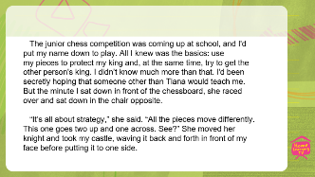  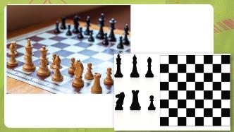  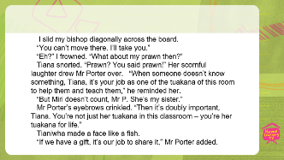  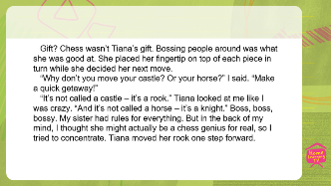  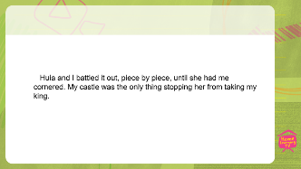  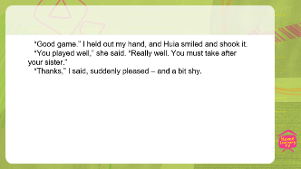  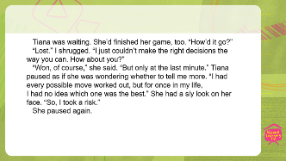 |  | Next Slide (0:46 mins) Miri admits she doesn’t know much about chess. Can you tell that Miri is secretly hoping that someone else will help her to play Chess?  How do you think she feels when it is Tiana after all? How does the author show what Miri thinks about Tiana most of the time but does not say?  Re-read this part of the story using the slide.  Even when Tiana makes fun of Miri by taking her castle off the board and waving it in her face, she says nothing. Remember a castle is called a rook. Because Miri is new to playing Chess, she doesn’t remember all the correct names of the chess pieces. What might help Miri to remember the names of the chess pieces? He whakaaro pai tēna, good thinking. A list of all the pieces would help. Let’s go to the whiteboard and make a list for Miri.  (***WHITEBOARD***) (***ADLIB***) Presenter to write the names of the chess pieces as if they are calling the names: Rook, Pawn, King, Queen, Knight, Bishop. Did you know there are eight Pawns, one King and Queen and two Rooks, Knights and Bishops on each side?  (***POWERPOINT OS***) Next Slide (0:10) Look at the picture of a Chess Board. You can see where the pieces go to be ready for a game.  Can you remember what the pieces in the front row are called? Pause. Ka pai they are called pawns  Next Slide (1:30mins)  Re-read this part of the story using the slide.  Why do you think Mr Porter speaks to Tiana? Good answer, she was making fun of Miri and laughing at her. Mr Porter speaks to Tiana about being a tuakana which means helping and teaching people in the Chess Club things they don’t know. What does being a Tuakana mean? Pause. Not sure? Tuakana is a Māori word for older brother or older sister, while teina means younger brother or sister.  After Mr Porter talks to Tiana about helping and teaching and being a tuakana for life, Tiana makes a face. What kind of face does Tiana make? Yes, she makes a face like a fish. If they are with you, you can ask your whanau to join in making a fish face and share why Tiana made a face.  Mr Porter says that if you have a gift, you should share it. What kind of gift does Mr Porter think Tania has? Talk to someone in your whanau about what Tiana’s gift might be? A gift could be something you are good at or something you find easier than others. It doesn’t have to be a sport or game; it could be Mathematics, art or Science or even knowing lots of things about dinosaurs. Why should we share it? PAUSE. Have you shared your gift with anyone? How did it make you feel?  (***POWERPOINT OS***) Next Slide (0:31mins)  Re-read this part of the story using the slide.  Miri continues to have thoughts about Tiana but doesn’t say anything. Does she think Chess is Tiana’s gift?  PAUSE. No, she thinks Tiana’s gift is being ‘boss boss bossy’. Well done for noticing. Soon Miri is thinking about her sister differently. With someone in your whanau, find the sentence that shows what Miri is really thinking about her sister. PAUSE.  Yes, Miri thinks “Tania might actually be a chess genius”.  Next Slide (0:23 mins)  Let’s skip forward to later in story. Have a read of these two sentences:  Re-read this part of the story using the slide.  Some questions I am wondering about and maybe you can help me with the answers: Who is talking? What is the battle? What is the correct name for the chess piece that is called a “castle”? What happens when the King is taken? PAUSE  It was Miri talking because Huia was her chess partner in the competition.  The battle refers to Huia and Miri’s game of chess.  The correct name for the Chess piece is a Rook.  When the King is taken, the game is over.  Did you manage to answer all or just some of them? Well done! You used the words and the pictures to help answer the questions.  Next Slide:  Re-read this part of the story using the slide.  Who does Huia compare Miri to? Good reading, it was Tiana. When Huia said, “You must take after your sister,” she was comparing the skill of Miri to her sister Tiana, so Miri must have improved.  Next Slide:  Re-read this part of the story using the slide.  What risk did Tania take? You guessed it; she used her imagination. Something she told Miri not to do.  Next Slide:  Re-read this part of the story using the slide.  (ADLIB to summarise story)
Respond: Providing opportunities to use and practice | Tiana Miri  Start Bossy Chess Genius Tuakana Loud Sly Acts like a taniwha Quiet Shy Wants to Play Chess Only knows basic rules Brave Calls her sister taniwha Imagination  Finish Listened to her sister for advice Used her imagination Proud of her progress even though she still loss |  | (***WHITEBOARD***) (***ADLIB***) Presenter to use the headings from the two frameworks and add the events and then the characteristics for Miri and Tiana.  There is a lot to think about from reading our story and the change of the characters and events so here is a simple framework to help us remember.  ADLIB  As we read “Queen on Board,” together, we explored what the writer did to develop the characters and events. Next time you write a story, try thinking about how you can make it more interesting by describing characters and showing how they change over time. Share with your whanau or caregivers, either now or after the lesson.
Share: Learner and parent reflection on learning and engagement and what they can do next |  |  | (***ON CAMERA***) Presenter reads out the suggestions (1.14 min) Here is some Mahi for you to do after the lesson.  - Remember we are learning to use a planning framework to identify characters and events. Think about how the writer used talk and thoughts to develop the characters in Queen of the Board. Share your ideas with someone in your whanau.  - Imagine you are Miri and write a response to Tiana’s question, “What are you doing here”? Would you stay quite like Miri?  - Ask someone to teach you to play chess. ‘Chess for Kids’ it is a good site to look at if you need help.  - Write about something you are good at.  Ka kite anō

