Home Learning TV: Junior Literacy

Segment lesson planning details
Title for segment: | Tom’s Tryathlon
Year levels (e.g. Yrs1 – 3): | Yrs 1-3
NZC learning areas: | English
Purpose of lesson:  (What learners will learn) | To make connections between own experiences and the experiences within the text
Success Criteria – students will be able to:  (how they will know when they have learnt it) | We will be successful when we are able to  Link ideas and experiences in the text to things we know and have done  Identify and discuss the feelings and actions of Tom when he trains for, and competes in, the triathlon  Design your own triathlon (tryathlon) for your whānau/family.
Segment content/context details (as appropriate)
Māori specific content i.e. the learning draws on Mātauranga Māori: | Whānau support, values of whanaungatanga | Pacific specific content i.e. the learning is focused on Pacific knowledge: |  | Whānau support, working as a team
Segment production details
Equipment requirements: | Audio needs to be set in slides for production – we have given a guide alongside notes in the lesson
Copyright requirements:  Please be specific: Source (Seven Sizzling Sausages by Sam Smith –url link to the source), intended use (to demonstrate alliteration), and length (timings for video clips) | Images in slides as follows  https://pixabay.com/vectors/dino  -dinosaur-triceratops-green-306331/  https://pixabay.com/vectors/children-toys-tricycle-skateboard-4260186/  From these images I took the tricycle.  https://pixabay.com/vectors/silhouette-boy-green-isolated-3137201/  skipping  https://pixabay.com/vectors/dancers-dancing-performer-hip-hop-36048/  dancing  https://pixabay.com/vectors/walking-dog-women-people-2797219/  walking  https://pixabay.com/vectors/emoji-smilie-whatsapp-emotion-2762568/  emoji
Segment links and attachments (list all links to recordings or attachments, the source and confirm that copyright permissions are granted)
Links to recordings /resources | Toms Tryathlon Purple (no link available)  Tom’s Tryathlon Audio
Attachments | slides to accompany presentation
Segment plan content
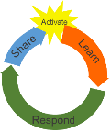 | Teaching and learning activities linked to purpose |  | High level script (key points/questions)
Activate: Activating prior learning, knowledge of contexts and relationships  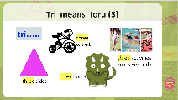  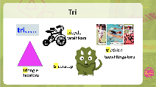  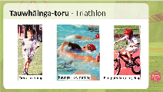  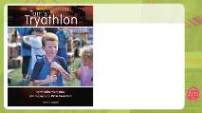 | Setting the Scene  Teacher greets students  Teacher shows next slide  Teacher shows next slide  Teacher shows next slide  Teacher shows next slide |  | Mōrena tamariki ma, Tālofa Lava, Mālo e lelei  How are we today? Kei te pehea tātou?  How are we feeling? I’m excited to be joining you all today. I hope you are excited to be here too.  Today we are going to be reading and listening to a text titled Tom’s Tryathlon. But before we do, we are going to start with a vocabulary challenge. Are you ready? Ka pai!  Teacher shows next slide  I love challenges. This challenge is a vocabulary challenge.  Did you know that the prefix tri means toru (three). A prefix is a word that is placed before another word. Our prefix today is tri.  To help you with our word challenge, I’ve provided you with a visual and two clues. The first clue gives you three words that start with ‘tri’ and the second clue provides pictures  - three sides  - three wheels  - three horns  - three activities (run, swim, ride)  I wonder if you can match the pictures and the words. That is your challenge. Give it a go and don’t give up. I’m sure your whānau/anau/ainga/family/friends can help if they are in the room with you. ……  Teacher shows next slide  How did you get on? Were your whānau able to help you? A team effort often makes a challenge a lot easier. This is an example of demonstrating manaakitanga - when whānau help and support each other.  Did you match these words? The words were  - Triangle - The picture was a good clue with this one.  - Tricycle - I used to ride one of these when I was little. So, I already knew this one. Did you have a taraihikara?  - Triceratops - a three-horned dinosaur and  - Triathlon - the pictures and clues helped me work out this word.  Remember ‘tri’ means three. Remind those close by what ‘tri’ means and some words you know that begin with ‘tri’. …. (PAUSE). In Māori three is toru. You might know the Māori word for triangle, tricycle, triathlon. I have listed these kupu on our slide. Read with me...tapatoru, taraihikara, tauwhainga-toru  Next Slide  Let's find out a bit more about the word tauwhainga-toru - triathlon. Do you know what events athletes compete in in a triathlon? Athletes compete in running (oma), swimming (kaukau), and cycling (eke paihikara). Remember a triathlon is a race where you run, swim and bike. Athletes compete in all three events during one race.  To prepare for these events, athletes put in long hours of training. You might know of some New Zealand triathlon events our athletes compete in including - (Taranaki Toa, Iron Māori, and Auckland Marathon). Athletes set themselves challenges and their family/whānau support is important to them as they train to achieve their goals. Do you know of a whānau/family member or a friend who may have trained for something and have appreciated and benefited from the support of their whānau? Ka pai!  Next Slide  Today we are going to read about a young boy, Tom, who sets himself a challenge. He knows it won’t be easy and will need manaaki (care) and the tautoko (support) of those around him to help him succeed.
Learn: Introducing learning  Reinforce routines, provide multiple exposure to concepts, and strategies. Scaffolding learning  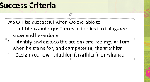  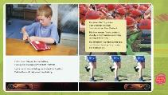  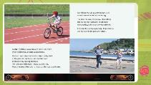  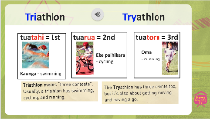  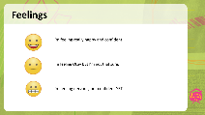  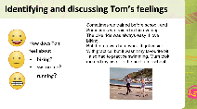  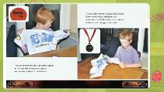  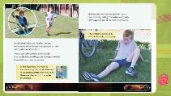  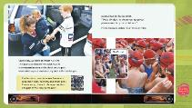  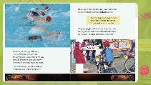  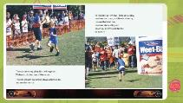  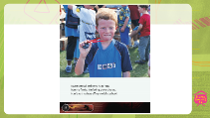  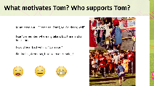  SLIDE 13  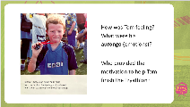 | Introducing Text/task  Teacher shows next slide  Teacher shows next slide  Add slide 6 picture of Tom  Play audio  0.00-0.41  Play audio 0.41-1.10  Teacher shows next slide and plays audio 1.10-2.12  Next slide  Teacher shares slide showing the emoji feelings  Next slide  This slide is titled Identifying and discussing Tom’s feelings  Teacher shares Slide 18. This slide has statements and images from the text that show how Tom was supported by friends and whanau. This reinforces resilience, determination and whanaungatanga  Next slide |  | Teacher shows next slide  Let’s read our success criteria for today. This is what we want to learn in this lesson.  Today we will  - Be linking ideas and experiences in the text to things we know and have done  - Identify and discuss the actions and feelings of Tom when he trains for, and competes in, the triathlon  - Designing your own triathlon (tryathlon) for whānau/anau/ainga  Teacher shows next slide  Let’s start by meeting Tom. This is Tom and he is enrolling to compete in the Weetbix Tryathlon. This event is run around New Zealand. Have you heard of it before? Perhaps some of you have entered this event yourselves?  Let's listen/whakarongo to Tom introducing himself.  After audio to 0.41 the presenter talks  Let’s take a closer look at the word/kupu - tryathlon. Can you see the two different spellings of the word?  T-R-I-athlon - we know tri means three, three sports -swimming, biking and running.  T-R-Y-athlon - We know that try means to give something a go.  Let’s listen to Tom as he tells us the difference between these two words.  Play audio 0.40-1.10  Ka pai! Were we right? Yes! We were, and Tom tells us that he is going to enter the Kiwi Kids Triathlon. Let’s listen to see what happens next in the story.  Teacher shares slide 8  Next Slide  In that part of the story, we learnt more about how Tom is preparing for the three different parts of the tryathlon. Let’s have a look at this slide which puts them in order,  ADLID: Reading and discussing slide  As Tom trains for his triathlon, he experiences different feelings. Sometimes he feels really good about things, other times not so good. This is all part of showing resilience and determination about achieving personal goals. Even when Tom doesn’t feel that good about things, Tom keeps on going – he doesn’t give up. Take a look at the emojis I have used on this slide to represent these feelings.  Can you see the smiley face – this means I’m feeling really happy and confident  Can you see the straight face – this means I’m feeling OK but I’m not that sure  Can you see the face with teeth! – that means I’m feeling nervous and not confident yet! I probably will be - later - BUT NOT YET!  Next slide  Let's go back to this part of the text – presenter to re-read  I will give you time to think about the feelings Tom has about each action. Use the emojis to help you decide.  How did you go? Ka nui te pai?  This is what I think? Is it similar to you?  I think Tom is feeling really happy and confident about the bike ride because he said it was easy. I think he was not feeling confident YET about the run because he said it was hard work. I think he was ok about the swim.  Did you notice when Tom said - But the run was hard work. It got easier with practice, but it wasn’t my favourite bit. What do you think this shows us about resilience, determination and achieving goals?  Share with family/ whānau /anau/ainga/kaiako or a friend and tell them what you think.  Did you share your thoughts? Ka pai  Did you think that sticking to something, whether it was easy or not, was important? Did you notice how Tom’s dad and his mum both helped him? Toms’ dad is training with him as he runs, and his mum and sister take him to practice the swim. Think about the support Tom had from his whānau? Think about how your whānau support each other and how you help each other to reach your goals.  Back to the presenter  We are now going to listen to more of the story and hear how Tom’s gets on as he prepares for race day.  When you listen to the audio, I want you to think about Tom’s feelings when he was training and who provides the motivation for Tom to keep going. Look for examples that show manaakitanga and whānaungatanga.  Audio 2.12-5.51 and the slides to match the audio  How do you think Tom felt during the swim? Did you notice Tom describing the water as very splashy?  Can you retell what happened at the transition area? Transition means to change. That was the part of the story when Tom took off his goggles and swim cap and put on his shoes and helmet? Ka pai  The next audio and text section tells us about the end of the triathlon. Let’s listen and read to see how Tom gets on!  Play audio 5.51 - end with the slides to match  Wow! Tom! You did it – homai te pakipaki - tino pai rawa Tom! *clapping*  Did you notice how Tom stayed determined to keep going and reach the end. Did you notice the manaakitanga of others around him? (Spectators, officials, whānau, and other competitors)  Wow! That was fun!  Teacher shares next slide  On this slide I have written some statements from the text. These statements tell us about feeling and support towards reaching Tom's goal. Listen to the statements I read each statement out. Read along - each statement is also on the slide.  Did you hear mum cry out – ‘Come on Tom, you’re doing well!”  I can’t remember where my bike is, but the marshal helps me  Did you hear dad yelling, “Go mate!”  Did you notice Tom recounting – I’m feeling tired now, but I keep on running?  Did you notice Tom saying – I can hear the crowd and they’re cheering?  Kōrero with whānau about how Tom was feeling and how these statements show this. Decide which emoji you think best shows how Tom feels.  Can you see examples of how the people supporting Tom to reach his goals are demonstrating manaakitanga? This includes the people watching – the spectators who were clapping and cheering, and his mum and dad’s words of encouragement. The manaakitanga of his whanau is strong and it inspires him to be the best he can be and to complete the race. He’s set his own challenge. He is determined and has the grit to meet the challenge he has set himself.  Kōrero with your whānau/ anau/ ainga/family or friend about the importance of whānau supporting and encouraging you when you set yourself goals that you may have found challenging and how this helped you achieve your goals.  Share of other athletes or other people you know of within your culture who have demonstrated resilience and determination towards achieving goals.  Pause – 30 sec  Alongside Tom's determination and resilience to complete this triathlon was also Tom’s motivation to receive a medal at the end of the Tryathlon.  Teacher shares SLIDE 19 and reads the text on the slide  Let's read the end again.  I got my medal and some huge hugs from my family.  I’m feeling pretty pleased.  I can’t wait to show off my medal at school!  Imagine Tom’s excitement at the end of the race. How would you feel in Tom’s position? Think of how YOU felt when you set yourself a goal and then achieved that goal.
Respond: Providing opportunities to use and practice  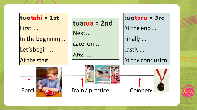  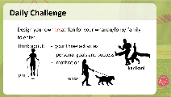  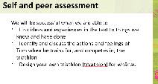 | Teacher shares next slide and encourages students to self-assess to see what they have achieved today. The teacher also invites others who may be with the students to be involved – thus the opportunity for both self and peer assessment |  | Next slide  Let's think about the steps Tom took to reach his goals. Can you remember what Tom did at the beginning – what he did first (pause- animation)  Ka pai  First Tom read about how to enter, what was going to happen on the day and what he needed to do – can you see where Tom has received a pack with all of the information, he needs in order to compete in the Tryathlon? lelei tele  What did Tom do next?  Next Tom began to train  Do you remember what he trained in? E tu – lets stand up if you can and mime these actions together  Tom trained to do the run  Tom trained to do the swim  Tom trained to do the bike  At the end Tom won a medal!! Yeah - (teacher holds hands up in celebration)  Teacher shares Slide 21  Today’s Daily Challenge is for you to design your own tryathon for your whānau, anau, ainga, family to take part in. This should be a fun triathlon that everyone can enjoy.  You will need to think about the three activities you would like your family to do. I’m thinking that my three activities could be piu (skipping), kanikani (dancing) and hīkoi (walking). I needed to think about where I am and what activities I could do when I am at home, with things we already have around. It may be different if I am organising my triathlon to be done inside or outside. Think about where you are, and what three activities you think all your whānau could do? …. (PAUSE)  You might like to kōrero to each member of your whānau about their own personal goals for completing your fun triathlon.  Finally, you might like to discuss the motivation to inspire each person to succeed and participate. Whānau members could waiata, pakipaki, cheer or offer words of encouragement to each other. Even a smile makes a difference! Ka pai  Teacher shares next slide This is the self and peer assessment slide  Let’s review what we set out to achieve today. How do you think we went? …. (PAUSE)  We will be successful when we are able to  Were we able to link ideas and experiences in the text to things we know and have done – yes, we did this REALLY well – well done team!  Were we able to Identify and discuss the actions and feelings of Tom when he trains for and competes in the triathlon? Āe - I think so – we learned lots about feelings and actions. We have learned about the importance of whanaungatanga and manaakitanga as we set and achieve our goals.  Now we have made a start on designing our own tryathlon for our family/whānau/ainga/anau/ or friends  Well done – Kei runga noa atu koe!
Share: Learner and parent reflection on learning and engagement and what they can do next  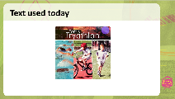  SLIDE 19 | Debrief prompts student’s reflection on learning outcomes and progress  Includes opportunity to share learning or learn together with whanau, HLTV or others  - Reiterates the task if done outside of the lesson  - Introduces ‘independent learning’ through a provocation  Guide whānau |  | See if you can share and run your own whānau triathlon. Check on how whānau are feeling before they start, during each event and at the end of all three events. Think about how you might motivate them to have a try. Think about how you can all achieve this together through demonstrating manaakitanga and whanaungatanga.  You might even want to find out some more information about a triathlon you can compete in or plan a training programme for yourself.  Ka Kite ano, Tofa soifua, nofo’a, thank you for listening and participating in our lesson today.

