Home Learning TV – Middle Science
Segment lesson planning details
Title for segment: | Takahē
Year levels (e.g. Yrs1 – 3): | 4-6
NZC learning areas: | Science - nature of science (participating and contributing); living world (ecology)
Purpose of lesson:  (What learners will learn) | To introduce the takahē as one of Aotearoa’s unique bird species, a taonga that is critically endangered
Success Criteria – students will be able to:  (how they will know when they have learnt it) | - talk about why our native birds, manu māori, are important to our national identity  - identify some key features of takahē  - describe some of the ways in which DOC is working to conserve takahē
Segment content/context details (as appropriate)
Māori specific content i.e. the learning draws on Mātauranga Māori: | Our Māori connections are centred on inclusive language and the use of Māori narratives and whakataukī | Pacific specific content i.e. the learning is focused on Pacific knowledge:
Segment production details
Equipment requirements: | white board, screen for showing images and video
Copyright requirements:
Please be specific: Source(Seven Sizzling Sausages by Sam Smith –url link to the source), intended use (to demonstrate alliteration), and length (timings for video clips)
Segment links and attachments (list all links to recordings or attachments, the source and confirm that copyright permissions are granted)
Links to recordings /resources
Attachments
Segment plan content
 | Teaching and learning activities linked to purpose | High level script (key points/questions)
Activate: Activating prior learning, knowledge of contexts and relationships | Connecting with the audience.  Introducing the topic for the day - takahē - using a game.  Reviewing other native birds before introducing key features of takahē | Kia ora - [greeting in languages of your choice]  [Touch base with audience if they’ve sent in texts or emails.] While I’m showing you the cool messages I’ve received, check that you’ve got your science journal, or some paper and something to write with.  Remember - if you want to share your ideas or learning with me, text 5811 or email info@hltv.co.nz. The keyword for this episode is Shawn.  [on screen: text 5811 or email info@hltv.co.nz  Keyword: Shawn]  Filename: Hedbanz_FairUse_editorial.jpg [Optional image]  [Presenter - do you have access to the game ‘Hedbanz’ - https://www.thewarehouse.co.nz/p/hedbanz-game/R1709221.html - or can you get one / make one - you need an image that goes on your forehead, the idea of the game is to ask questions and then work out what the image is (who you are for that round of the game). Use this as the intro, something about how you like playing games and maybe that you’ve had fun playing them while in lockdown.]  Today we’re going to start with a game - I am going to give you some clues about an animal, and I want you to guess what it is.  The first clue relates to this week’s theme - Identity. In our last episode we looked at how New Zealanders identify with our native ferns, and especially the silver fern - kaponga.  Today we’ve got a very special, very unique living organism that we’re going to talk about. Something that is only found here in Aotearoa. I’m going to put some clues up on the screen, and I want you to guess what it is.  If you’re watching this with someone, share your ideas. Otherwise, write them down. I wonder whether you’ll guess what I’m talking about?  [words coming up bullet point at a time on the screen:  - has two legs  - is blue and green  - lays eggs  - cannot fly  - is about the size of a chicken  - has a red beak  - is really, really rare and endangered  Can you guess?  I’m sure you’ve all worked out it’s a bird. But which one? What large birds can you think of that are unique to Aotearoa, and that are blue and green with red beaks - and that are endangered?  The pukeko isn’t endangered. There are lots of them. It can fly. And it’s not blue and green.  Image Filename: TAK_ART_03_The_takahē’s_evolutionary_history_Pukeko.jpg  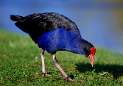  https://www.sciencelearn.org.nz/images/3783-pukeko-porphyrio-porphyrio-melanotus  What about the kākā - again, it can fly. And it’s the wrong colour.  Image  Filename: kaka_JudiLM.jpg  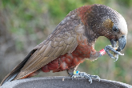  https://www.sciencelearn.org.nz/resources/1157-protecting-native-birds  Here’s a large bird. It can’t fly. Hmm. But it’s not blue and green.  Image -  Filename: Kakapo_Ralph_JakeOsbourne_CC BY-NC 2.0.jpg  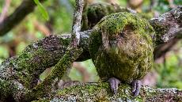  All of these are beautiful native birds, manu taketake. But they’re not the bird I’m thinking about!  This video will give it away.  Play video (1:13 minutes)  Takahe PROMO 2019 FINAL.mov  https://vimeo.com/366384424  Well, who guessed it?  Did you guess from my clues we would be learning about takahē today?  The video we just watched was made by the Science Learning Hub for the Bird of the Year competition. Have you heard of that competition before? It runs every year and we’re all able to vote for our favourite native bird - manu māori.  Last year the hoiho - the yellow eyed penguin won, but I think the takahē must have been a close second … that video certainly shows what an amazing bird the takahē really is!  Let’s watch it again, and note down some of the characteristics of the takahē. Think about what you’re seeing, and what you’re hearing. If you don’t feel like writing, maybe you could do a summary sketch?  Replay video:  Takahe PROMO 2019 FINAL.mov  https://vimeo.com/366384424  What were some of the things you picked up?  - Tough - lives in brutal alpine conditions  - Green and blue  - Strong red beak for stripping tussock grass  - Parents share chick rearing  - LOTS of poo!  - Came back from the dead - WHAT???
Learn: Introducing learning  Reinforce routines, provide multiple exposure to concepts, and strategies. Scaffolding learning | Learning about takahē using video, image, teacher talk and viewer observation  - their call  - their endangered status  - key features  - habitat  History of science story  Habitat – protected population, adaptations | Let’s start there - that sounds pretty intriguing!  Takahē once lived throughout Te Waipounamu South Island. Māori said that their night cry sounded like the striking of two pieces of pounamu.  Let’s hear them -  Filename: TAKAHE_VID_01.mov  https://vimeo.com/417006446  What do you think they sound like?  Over time their numbers dwindled - drastically. Some of their habitat - where they lived - was turned into farmland. Introduced predators like stoats, ferrets, dogs and cats ate their eggs and the young chicks. And they were hunted by people.  By the late 1800s, only four takahē were known - and these were killed and turned into museum specimens! Presumably the hunters didn’t think they were the last ones - but no one saw or heard the takahe call after that!  The South Island takahē was officially declared extinct in 1898 - it was thought to have suffered the same fate as the moa and the moho, or North Island takahē.  But in 1948, fifty years later, Dr Geoffrey Orbell and his team rediscovered them in a remote valley in the Murchison Mountains in Te Waipounamu.  Filename: TAK_ART_04_Takahē_–_conservation_efforts_Joan_Telfer__Rex_Watson_and_Neil_McCrostie_with_takahe.jpeg  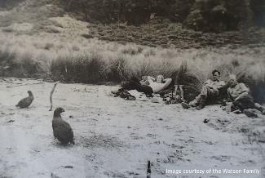  [image - https://www.sciencelearn.org.nz/images/3793-rediscovery-of-the-takahe-1948  This old photo was taken in November 1948, and it shows proof of living takahē! In the photo you can see Joan Watson, Rex Watson and Neil McCrostie, they were part of the team that searched for the takahē. They are sitting on the shore of a lake, now known as Lake Orbell, named after Dr Geoffrey Orbell who never gave up believing they were still alive!  Words on the screen:  Ka tū te moho. Kia ora ake anō. The takahē stands, in order to live again.  What an amazing story! But the story does not end there - the takahē were rediscovered but there were not many of them left - they were still endangered!  Let’s find out more about them -  Filename: TAK_ART_01_Takahē_–_an_introduction_MatingPairGeoffdeLisle.jpg  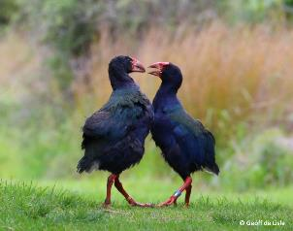  [Image https://www.sciencelearn.org.nz/images/3799-takahe-porphyrio-hochstetteri]  Here we have Bargie (male bird on left) and Ihi, photographed together on Kāpiti Island in 2016.  They are also endemic to Aotearoa New Zealand, which means they naturally live here and nowhere else in the world.  How big do you think the adults are? The video we watched earlier said they are about the size of a chicken - but how big is that? Ask someone else how big a chicken is - use your hands to estimate or predict how tall they might be in real life. [They stand about 50 cm tall as adults - show this with your hands off the table].  How high would it be if a takahē was standing next to you?  Here is a very old photo of a takahē - one of the first to takahē in a takahē breeding programme at Pūkaha Mount Bruce National Wildlife Centre. The man on the left is Elwyn Welch, an amateur ornithologist who played a key role in establishing the takahē breeding programme.  FILENAME: Takahe_conservation_MtBruce_1959_ Masterton District Library and Archive.jpg  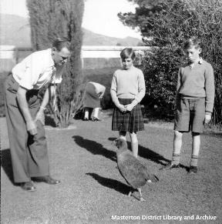  Image -  https://www.sciencelearn.org.nz/images/3788-early-efforts-saving-the-takahe  You can see how big they are! Wow, is that what you predicted? Ka pai!  Let’s look at this video of takahē in the wild. While you’re watching, think about what you can notice about the environment that they’re living in.  Play video - TAKAHE_VID_02.mov  https://vimeo.com/416174580  Our wild takahē population lives in harsh alpine conditions - high in the Murchison Mountains in Fiordland. It might look cozy in the tussock grasses but the weather is often very cold and windy. They feed on an alpine grass species called snow tussock. They use their strong beaks to cut and strip the tough blades.  Filename: TAK_ART_01_Takahē_introduction_HabitatMurchisonMountainsBANNER.jpeg  Image -  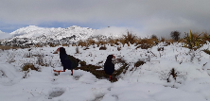  https://www.sciencelearn.org.nz/images/3800-takahe-in-tussock  When winter snow covers the tussock, takahē move down to forested areas for shelter and to feed on fern rhizomes - remember we learned about these in our last episode - they’re the underground stems of ferns, and they’re very nutritious! After the snow melts, takahē return to the grasslands to nest among the tussock.  Let’s have another look at them in the wild. This time, I want you to notice how their feet and their beaks work together while they eat.  Play Vid_04  https://vimeo.com/416174717  TAKAHE_VID_04.mov  See how they use their feet to hold the grass, and their beaks - I wouldn't want to get my finger in that beak!  Takahē are pretty special!  Although the harsh environment of the Murchison Mountains in Fiordland is less than ideal, scientists believe that takahē survived there because of its remote location. The rugged area was relatively isolated from the main threats to takahē: humans, deer and introduced predators.  To help protect the takahē species, the Department of Conservation runs a Takahē Recovery Programme - birds are bred in captivity and then released back into the wild, usually into ecological sanctuaries where there are no predators.  This video shows takahē being released into a new area early in 2018 - the Kahurangi National Park - 600 km north of the Murchison Mountains. This was a fantastic milestone for takahē, establishing a new population in the wild!  Well done DOC!  Let’s have a look. In this video, you’ll see some takahē being released - and the efforts that DOC goes to, checking up on them and learning about factors that increase the likelihood that the birds will successfully be re-established in the wild.  play VID_05  https://vimeo.com/416174774  Would you like to be involved in a project like that? What do you think you’re like about it?  [Anecdote - One thing that I would like is … ]  I also like the creativity that DOC brings to the task. In the early days, DOC rangers became quite famous in the bird world because of the way they used hand puppets – to feed and interact with young takahē - the rangers didn’t want the chicks to become used to humans.  Filename: TAK_ART_04_Takahē_–_conservation_efforts_Puppets.jpeg  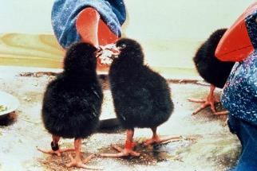  Image -  https://www.sciencelearn.org.nz/images/3785-takahe-puppets
Respond: Providing opportunities to use and practice | Summary of key points  A final ‘fun fact’  Invitation to explore further. | So - we’ve learned a lot about takahē today. We’ve learned that they were thought to be extinct - but then a wild population was discovered. Seventy years later, they’re still critically endangered - but a lot of people are working hard to help save them.  Before we go, I’ve got one last picture for you -  FILENAME: Takahe_Poo.jpeg  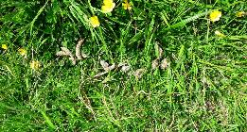  https://www.sciencelearn.org.nz/images/3778-takahe-poo  Takahē mostly eat plants, and they have a very fibrous diet. They can produce 7–9 metres of poo each day. A row of takahē droppings is called a latrine. Can you see the takahē poo in the photo! A very cool takahē fact!  They’re a pretty cool animal, and one of our taonga. In our last science episode, we looked at ferns and how they are part of our national identity. Our native birds, manu taketake, are also part of our national identity, and takahē are one of those that many people don’t know much about.  You know a lot more about them now, though. I wonder what you could do with that information? Do you think that, like the Science Learning Hub, you could campaign for them in the 2020 Bird of the Year competition? Or maybe you could make a poster showing off their special features - or raise some money and donate it to the takahē recovery programme.  If you’ve got a great idea, perhaps you could share it with me, or tell your teacher or kaiako.  Text your ideas to 5811 or email info@hltv.co.nz keyword Shawn.  [On screen: Text 5811, email info@hltv.co.nz keyword: Shawn]  [Shout out to the Science Learning Hub for support planning this episode]  [Sign off]
Share: Learner and parent reflection on learning and engagement and what they can do next

