Home Learning TV: Middle Literacy and Language
Segment lesson planning details
Title for segment: | Photographs
Year levels (e.g. Yrs1 – 3): | Year levels 4 - 7
 | English
NZC learning areas: | English and Social Sciences
Purpose of lesson:  (What learners will learn) | Consider how images (photographs) represent a neighbourhood.  Make links to the language features in writing a factual article.  Focus on key vocabulary/phrases  Show how a poet uses language to extend and elaborate an idea/image
Success Criteria – students will be able to:  (how they will know when they have learnt it) | Take a deliberately chosen photograph as a visual representation of something important to them in their neighbourhood.  Understand the link between visual images and how they represent ideas.  Identify and use language features to create a poem
Segment content/context details (as appropriate)
Māori specific content i.e. the learning draws on Mātauranga Māori: | The range of photographs highlight the diversity within the neighbourhood. The storyline recognises differences between people and their ways of doing things. | Pacific specific content i.e. the learning is focused on Pacific knowledge: |  | The poet talks about her parents coming from Samoa. The photographs captured in the story reflect aspects of Pacific culture. The content talks about the living room as capturing the identity of her Samoan parents. She saying she couldn't recreate this room herself as it wouldn't represent her. The visuals reflect aspects of Samoan culture.  (Although the slected pieces for the lesson does not focus on the living room aspects. Another time?)
Segment production details
Equipment requirements: | Whiteboard  Highlighter
Copyright requirements:
Segment links and attachments (list all links to recordings or attachments, the source and confirm that copyright permissions are granted)
Links to recordings /resources | - http://instructionalseries.tki.org.nz/Instructional-Series/School-Journal/School-Journal-Level-4-November-2016/The-Great-Ordinary-The-Photographs-of-Edith-Amituanai  - http://instructionalseries.tki.org.nz/Instructional-Series/School-Journal/School-Journal-Level-4-November-2016/At-the-end-of-the-driveway
Attachments | Powerpoint
Segment plan content
 | Teaching and learning activities linked to purpose |  | High level script (key points/questions)
Activate: Activating prior learning, knowledge of contexts and relationships | Presenter - Greetings etc.. She could be holding a photograph or have 2 or 3 on the desk in front of her. (my personal jpegs if needed are attached as examples).  Setting the context – about a photographer and is a non-fiction article. (Front-loading of the article to come)  Frontloading new expressions/vocabulary. |  | Even though you are watching and learning from our home learning Tv, I hope you also take the chance to get out for a walk or perhaps on your bike or scooter in the area near where you live. We call this area near us our neighbourhood. Sometimes it seems it is very ordinary, but it is good to take notice of things around you and in your neighbourhood.  What we are learning about today is: (show on ***whiteboard***)  How and why we take photos and what photos can mean to us . We will also read parts of an article about a photographer and be thinking about how photos are used to document a neighbourhood  When I went on a walk recently, I took some photographs of things in my street - some chalk writing on the concrete, some windows with bears looking out and some posters that had been made for Anzacday.  (***close up photos***)  Do you like to look at photographs? Or perhaps you like to take photographs like I do. Maybe you like to take photographs with someone’s phone ..or maybe there is someone in your whānau that has a special camera that takes photographs. Have a think or ask someone near you…Why do people like to take photos? (pause/think time)  Perhaps you said to To remember something, or to remember a special event in your whānau.  A photograph is a record of something that has happened. It’s a record in pictures. Sometimes it shows what is important to us, sometimes it just shows very ordinary things. Someone who is a photographer is an artist because they have grabbed our attention and they are telling us something, but without using any words. In the article we will read today, the photographer says her photos are like a document because it is for people in the future.  So we might say a photograph is a ‘record of something ordinary in pictures’ or document for the future’. These phrases/expressions might be new for you -  ***whiteboard***(presenter writes and speaks 2 definitions) A photo is a record of something ordinary in pictures. A photo is a document for people in the future..
Learn: Introducing learning  Reinforce routines, provide multiple exposure to concepts, and strategies. Scaffolding learning | Preparing to read the article  Noticing langauge features in the text and explicitly drawing attention to them  Making sense of what we  read  Making sense of what we  read  Making connections to students and their neighbourhoods.  Questions to viewers |  | I have an article for us to read today about a photographer who takes photos of her neighbourhood. Her name is Edith Amituanai and she lives in Rānui in Auckland. She likes to bike around and take photos of the things and the people she sees.  The title of the article is The Great Ordinary, The photographs of Edith Amituanai. It is written by Hannah Sperber. The article is written as a Non-fiction, describing a real person and real events. We can see there are sub-headings with some sections of text underneath and a lot of Edith’s photographs. This layout helps us to read the article in sections. *camera*(Camera has close up of title and photograph of Edith (p 16) .. and then draws back to roll over the whole article while presenter is speaking.)  *Presenter reads aloud the first section of text (p 16 under photo of Edith)*  Most people in Rānui, West Auckland, know Edith Amituanai as that girl who bikes around the neighbourhood. A few know her as the manager of the local league team. But Edith is also a photographer whose work has been shown in art galleries around the world. Her photos have been bought by collectors, and they’ve won prizes and been published in books. Edith is low-key about these achievements. She too sees herself as that girl who bikes. “I just happen to take a picture now and then.”  What have we learned about Edith from this opening paragraph? We have learnt that Edith is quite famous! It doesn’t say that exactly in the words, but it tells us that she has ‘won prizes’, has been ‘published in books’, and that her photos have ‘been shown in art galleries around the world’ These words help us make the inference that she is famous.  *(Presenter writes the phrases up on the whiteboard as she speaks)*  But what sort of photos does Edith like to take? Let’s take a look at the photos more closely. Here’s what it says in the article: * (presenter reads aloud /Camera Close ups of the 4 photos on page 22 and page 23*  ...Edith is most interested in the familiar, especially young West Auckland faces and scenes. “I feel like what’s around me demands to be shown. It’s important – and right here!” Edith says it’s easy to think that the more exciting things are happening somewhere else. “But that’s not true. We can connect to the big picture ... by looking at what’s happening in our own neighbourhoods. What’s fascinating to me is usually just next door or just down the street – right under my nose!”  So we have learned that Edith likes to take photos of people and things that others might think are just very ordinary. What did you think about her photographs? Have you got any photos in your room where you are watching TV? Do they show ordinary things? (think time/pause)  Let’s turn now to read a section of the article about Edith’s work on a new project. It is a project about photographs Edith calls ‘ the end of my driveway’. Here’s the sub-heading, ‘the end of my driveway’. *close up*  As I read this paragraph, listen out for the people that Edith has taken photos of at the end of her driveway. Who has she photographed? What are the people doing? *Presenter reads the paragraph aloud. Camera holds on the text and photo above it so that it can be read by viewers*  In 2011, Edith began work on a new project. She stood at the end of her driveway and took photos of students  walking to school. She didn’t hide her camera. A few kids noticed and asked what she was doing. Her response?  “I told them that I was making an important document!” Edith named the project “The End of My Driveway”. Most of the photos in the series show kids deep in their own worlds, as if there’s no camera there at all. Some of them are with friends, chatting and laughing. Others are alone. A few look purposeful, like they’re running late for school. One or two are slouching, maybe still waking up. Each photo is different, but they share one important thing: none of the students is posing. These are just ordinary kids starting an ordinary day, something Edith was very keen to capture. That’s because she sees her work as a kind of record – or “document” as she puts it – for people in the future. “When I’m dead, in a hundred years from now, maybe people will look at these photos and see what this time and  place really looked like.”  Did you notice that Edith mainly took photos of students on their way to school. That is who she has photographed. What were the students going to school doing? Here’s what it says ..*(Presenter re-reads and writes the words on the whiteboard at the same time)*. Some of them are with friends, chatting and laughing. Others are alone. A few look purposeful,like they’re running late for school. One or two are slouching, maybe still waking up.)*  We know that Edith didn’t hide her camera, and a few kids noticed her. What did they say to her? And what did Edith say in return? *camera focus on text* A few kids noticed and asked what she was doing. Her response? “I told them that I was making an important document!”  The words tell us that Edith thinks that her photographs are like a document and that they will be a record for the future.  Questions to viewers: What do you think about taking photographs at the end of your own driveway? What would you take photos of? What people would you see out in your neighbourhood? (pause/thinking time)  Edith sent one of her photographs to a NZ poet, Tim Upperton. He’s written poems for poetry collections in Aotearoa. A photograph makes a record for the future, but so can the words that we write. Here’s one of Edith’s photo of the students at the end of her driveway. Listen to the words that Tim wrote to go with it. *(Camera on ‘At the end of the driveway’ poem and photo while presenter reads aloud)*
Respond: Providing opportunities to use and practice | Directly relevant to learning intention  Involves student participation – with options about how it can be done  Teacher uses think out loud to model the writing process |  | So Edith reminds us, that Sometimes the best subject is right under your nose.  You just need to look at the world closely and in new ways. Try looking at your surroundings as if you were an alien from another planet. It would be good if you could go into your neighbourhood and take photos.. (NB - quoted from the text)  When your whānau are at home together perhaps you could all go for a walk or bike ride together. Stop and take a close look at the things in your neighbourhood that seem ordinary but might be worth taking a photo of.  Perhaps you can write a poem to go with one of your photos. Borrow Tim’s opening lines and start your poem with ‘ At the end of the driveway the world begins. At the end of the driveway the world is going’ (*whiteboard* presenter writes opening lines.)  At the end of the driveway the world begins.  At the end of the driveway the world is going  Hmm now what do I see at the end of my driveway, what do you see?  I think I will make a list of some of the things I see  A family walking past going for a walk  The rubbish truck lifting my rubbish into the air  Boy’s on bikes laughing as they cycle.  A cat stretching out on the hot pavement his tummy showing  A man from the council on his tractor mowing  I like the sound of all those images, I will just break them into 2 lines each like Tim did so now I have my own poem. I am also thinking about the lesson we had about rhyme and I can see that Tim used rhyme in his poem for instance  “In summer sun and winter storms  kids walk to school in their uniforms.”  Can you see the rhyme? Yes that’s right storms and uniforms. I think I rhyme the last word of line 2,4 and 6.  At the end of the driveway the world begins.  At the end of the driveway the world is going  The rubbish truck lifting my rubbish into the air  A man from the council on his tractor mowing  Boy’s on bikes laughing as they cycle  A cat stretching out on the hot pavement his tummy showing.  Yes, I am happy with that.  Now it is your turn to write your own poem. Remember use these sentences  At the end of the driveway the world begins.  At the end of the driveway the world is going  I’ll give you time to jot it down …  You could ask each person in your whānau to contribute a line of the poem and make it a family poem you have written together.
Share: Learner and parent reflection on learning and engagement and what they can do next |  |  | So today we’ve thought about photos and why we take them. You have lots of things you can experiment with: taking photos of different things around your neighbourhood.  Ask your whānau if you can go for a walk in your neighbourhood and explain what things are important to you…  Show your whānau the first line of the poem and see if each member can write their own line to make up your family poem.  We would love to hear from you if you do take a photograph and write a poem from the end of your driveway. You could text or email them into me at info@hltv.co.nz or text to 5811.

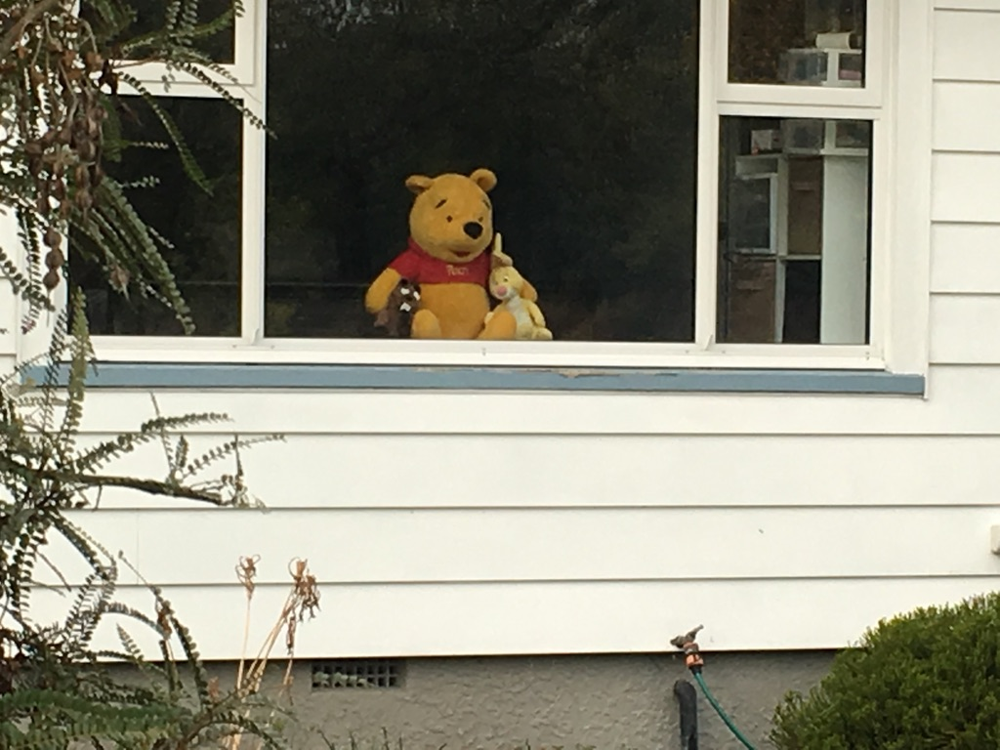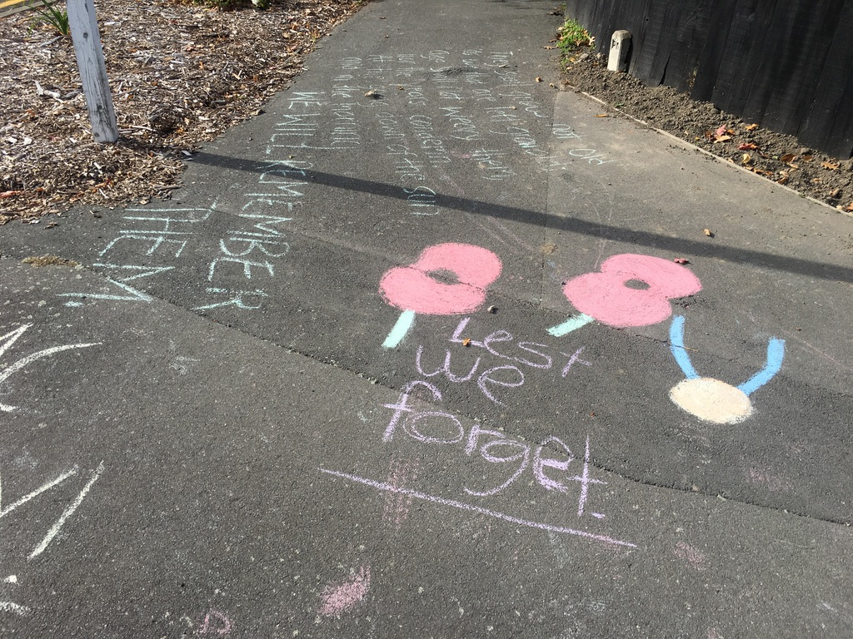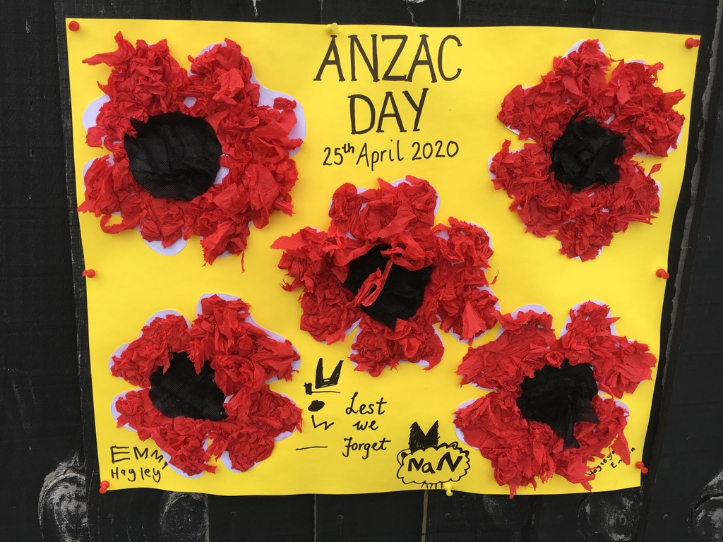
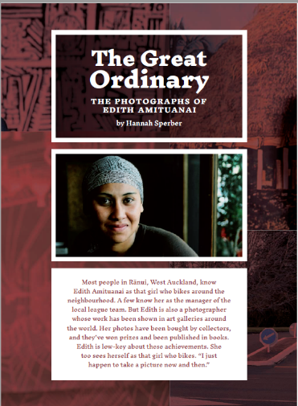
Photos from page 22 and 23
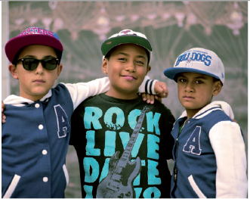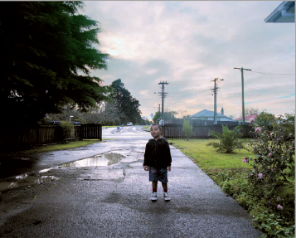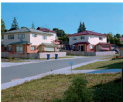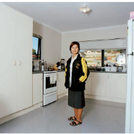

Sub heading close up
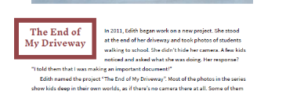

At the end of my driveway text and photo for screen
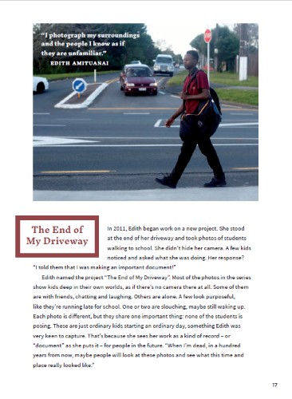
Close up of text – What did Edith say in return
