Home Learning TV: Middle Literacy
Segment lesson planning details
Title for segment: | Enterprising kids - Middle School Languages and literacy – Enterprise lesson 1
Year levels | Years 4-7
NZC learning areas: | English
Purpose of lesson:  (What learners will learn) | Read and think critically about the challenges faced by a group of students as they learn about building their own game
Success Criteria – students will be able to:  (how they will know when they have learnt it) | Students will be able to:  Analyse the actions students undertook to design and create their game  List the challenges faced by these students and the solutions they found  Design your own game for friends, family, and whānau to play
Segment production details
Equipment requirements:
Copyright requirements:
Please be specific: Source: (Seven Sizzling Sausages by Sam Smith –url link to the source), intended use (to demonstrate alliteration), Length (timings for video clips)
Segment links and attachments (list all links to recordings or attachments, the source and confirm that copyright permissions are granted)
Links to recordings /resources | https://instructionalseries.tki.org.nz/Instructional-Series/School-Journal/School-Journal-Level-4-May-2020/Game-Changers  School Journal Level 4, May 2020  slides to support this lesson
Attachments
Segment plan content
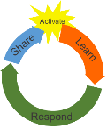 | Teaching and learning activities linked to purpose | High level script (key points/questions)
Activate: Activating prior learning, knowledge of contexts and relationships  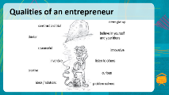 | Welcome students - if a new series of home learning not the welcome back statement  Linking to prior knowledge  Teacher shares slide 2 | Mōrena tamariki ma, Tālofa Lava, Mālo e lelei  Welcome to home learning! Nau mai hoki mai  Today, we are going to explore the actions and qualities of people who are enterprising, creative, and inventive.  We describe people as “enterprising” when they are resourceful, when they are curious, when they think creatively, and when they showcase innovation. Enterprising people often make and design new things for themselves and for others.  I want you to think of a time when you or a member of your whānau have made something new. You may have made up a game, designed something new for your bedroom, worked on making a tapa cloth, created a Māori art piece, and or created jewellery.  What did you do to make/create/design these things?  Did you have to decide if these were good ideas?  Did you have to change what you were doing along the way – especially if something didn’t work out just as you wanted it to?  Did you have to plan to solve problems, explore other ways of doing things?  Were you curious? Were you creative? Were you innovative?  Ka pai! You were being innovative and enterprising!  Over the years many people from our past and present have been enterprising and inventive problem solvers. Polynesians invented new kinds of waka that let them explore Te Moana-nui-a-Kiwa centuries ago. Māori created and invented many items that are still in use today - Hinaki, hangi, Kapahaka - waiata, waiata-ā-ringa, poi, taiaha and a wide range of different games.  Māori have many examples of creativity including Māori art and designs, street art, moko design. Cook Island Māori designed and made beautiful hand-sewn bedspreads called tīvaevae. Samoan mats (i.e. toga) are precious taonga to Samoan families and have a wide range of different designs.  Kōrero with your family/whānau/anau/ainga and share experiences of people you recognise as enterprising and creative. Discuss the qualities these people have. You might like to talk about a person in your whānau, a person from the past, your Koro, your Nana - who else can you think of?
Learn: Introducing learning  Reinforce routines, provide multiple exposure to concepts, and strategies. Scaffolding learning  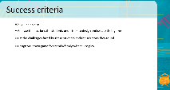  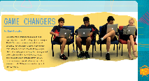  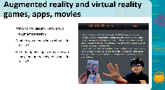  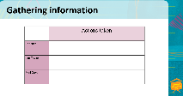  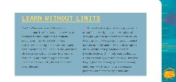  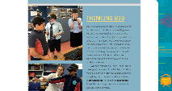  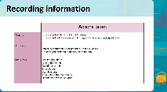  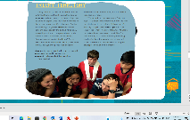  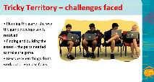  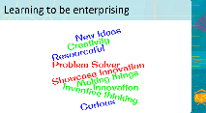  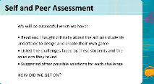 | Teacher introduces content of text  Teacher shares success criteria with students. This is slide 3.  Teacher shares slide 4  Teacher shares thinking using the think aloud approach  Teacher shares slide 5 – this slide describes Augmented and Virtual reality  Teacher shares slide 6 (recording information graphic to fill in) slide 7 (text- Learn without limits) and then slide 8 (text – Thinking Big)  Teacher shares slide 9 – this is the same as slide 6 (graphic) but now has some ideas filled in. Teacher adlibs to tell students what he/she recorded and why?  Teacher shares slide 10 – text - Tricky territory  Teacher shares slide 11 – challenges  Share slide 12 – qualities of being enterprising  Share slide 13 – success criteria for today's lesson  teacher adlibs | In this lesson we are going to learn about a group of students from Newlands Intermediate in Wellington. Perhaps some of you go to this school, live near this school, or have friends and whānau who attend this school.  These students called themselves the Minidevs and they worked together, and with an expert called Jim Taylor, to learn about creating successful digital technologies. They became part of a software development team that worked on a project called Mixiply and they learnt how to build their own game. Very clever, aye!  Before we learn more let’s share the success criteria for this mahi today  Hono mai ki au - (join me now)  The text is called Game changers and I did wonder: why this title was chosen? Based on what you know about the text so far – what do you think?  Game changers…..well, to me it means an idea or action that significantly changes what we know or do. This makes me think that these students made something quite different or new or they did something that stands out and is very innovative. What do you think? Share your thoughts with others.  The platform these students used makes games and apps using augmented and virtual reality. What do you know about augmented reality and virtual reality?  Talk to your family/whānau/ainga/anau/kaiako or a friend and share what you each know about augmented and virtual reality games, apps, and movies. How did you go? Kei runga noa atu koe!  Here is an explanation from the text – listen/Whakarongo as I read and check your own understanding. Is this what you thought? Ka pai!  There are many innovative New Zealanders who have taken virtual reality and created projects presented on other digital platforms. We also have iwi, hapū and marae throughout the country that are now using virtual reality to tell their own stories.  If you enjoy movies, I highly recommend that you watch the first Māori virtual reality movie called ‘Whakakitenga’.  As we read the text in the next two slides, you will learn about the Minidevs and how they work together to be innovative and creative in this project. To help you record some key ideas, I have a graphic for us to fill in  The graphic asks us to think about the tasks each person undertook as they prepared to design the game. Please take notes as I read.  What did you find out?  Did you record - read from the slide  What did you learn about ‘learning without limits?’  What did you learn about thinking big?  Did you notice how all these people worked together as a team? What I found interesting about this text was how it demonstrates innovation and challenge through the practices of Mahitahi - working together as one and Manaakitanga – supporting each other as a team and accepting others’ opinions.  What do you think? He aha to whakaaro?  We have successfully identified some of the actions this team took to develop their game. Ka pai!  The last section we will look at today is titled ‘Tricky Territory’. I wonder what we will read about in this section of the text. I think we might read about some of the challenges the Minidevs faced when working on their game – what do you think?  Let’s read and find out  Did you find the challenges – the tricky bits – the students encountered once they were underway with planning their game?  Let's see what the author told us  What I found interesting about this text was that, in order to be innovative and creative you will face challenges. Overcoming challenges and finding a way to make things work is part of being enterprising and resourceful.  At the beginning of the lesson, I described enterprising as being creative, inventive, resourceful, and curious. Let's revisit that slide.  Turn to a whānau/ainga/anau member or your friend/hoa and summarise in 2-3 sentences what you have learned about being enterprising from reading about these students today.  Share other qualities that you also consider important. You might like to make connections to Māori and Pasifika role models who demonstrate qualities of self-belief, enterprise and aspiration.  Well done, Tino pai  Let's check in with our success criteria today and see how we have got on - teacher adlibs
Respond: Providing opportunities to use and practice  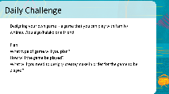  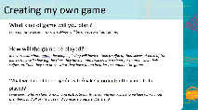 | Teacher shows slide 14  Teacher shows slide 15 and models own game  Teacher uses think aloud to talk about the game as it is planned and write down high level details of the plan using iPad - 1. Treasure Hunt 2. Selfies with found clues 3. clues, map, instructions (or something along those lines =)) | Now it's time for you to create your own game.  This should be a game that you can play with a whānau/ainga/anau member or your friend/hoa.  Your game can be an inside game or an outside game. You could use digital tools – maybe try a kahoot or quizlet or actionbound. You could make an innovation on a pick a track like this team did or you could use materials you have at home – cardboard, pens and some recyclable materials and make a board game, or a card game. You might even like to make a treasure hunt – it is totally up to you.  Take a few minutes to think about what your game will be. You can kōrero with ainga/family or anyone else in your bubble to share ideas and see if they can help you.  Remember the advice to start small – once you have come up with your awesome idea you can plan your game.  I am going to start to plan my game – watch what I do and you can do the same for your game  I will use the template on the slide to help me plan [slide 16]  I am going to design my own. Mine will be a treasure hunt game.  In my treasure hunt game, the people playing will have to take a selfie of themselves at each of the places they visit showing the clues they have found. I will create a sheet for them to save their selfies on. Then they can prove what they have found in order to complete the game.  I will need to have clues, a map, and instructions.  Rules for playing will be to include all whānau members, find all of the clues and complete a puzzle at the end
Share: Learner and parent reflection on learning and engagement and what they can do next  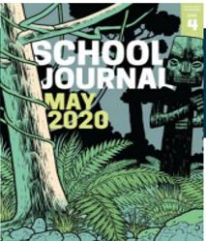 |  | This text has reminded us that we can all be enterprising if we set goals and work towards achieving them. Share what you have learned about being enterprising with whanau. Also share with them what you have learned.  You might like to find out more about the project Mixiply and the Minidevs – if you have internet access you can learn more about them online. You might also like to explore more about augmented reality and virtual reality games.  Have fun creating your own game! Remember – learn without limits, think big and be innovative.  Tino pai! – Ka kite ano, Tofa soifua, see you again

