Home Learning | Papa kāinga TV

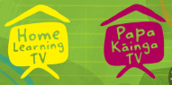
Junior literacy Enterprise Mum’s octopus

Segment lesson planning details
Title for segment: | Junior literacy and languages Enterprise Mum’s Octopus
Year levels (e.g. Yrs1 – 3): | Years 1-3
NZC learning areas: | English
Purpose of lesson:  (What learners will learn) | To make connections between own experiences and the experiences within the text
Success Criteria – students will be able to:  (how they will know when they have learnt it) | We will be successful when we are able to  Link ideas and experiences in the text to things we know and have done  Identify and discuss actions of characters – what they do, how and why?  Plan a mussel/kutai recipe that you could make with your whānau to share at kai time or take to a whānau celebration.
Segment production details
Equipment requirements: | Audio to be embedded by production team as noted
Copyright requirements:
Please be specific: Source: (Seven Sizzling Sausages by Sam Smith –url link to the source), intended use (to demonstrate alliteration), Length (timings for video clips)
Segment links and attachments (list all links to recordings or attachments, the source and confirm that copyright permissions are granted)
Links to recordings /resources | Text and link to text  https://instructionalseries.tki.org.nz/Instructional-Series/Ready-to-Read-Colour-Wheel/Mum-s-Octopus  Slides to accompany this lesson
Attachments
Segment plan content
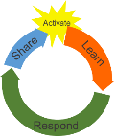 | Teaching and learning activities linked to purpose | High level script (key points/questions)
Activate: Activating prior learning, knowledge of contexts and relationships  Slide 2  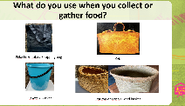  Slide 3  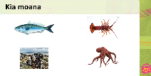  Slide 4  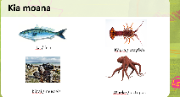  Slide 5  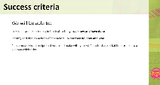 | Teacher greets students  Teacher links to students’ prior knowledge of collecting kai and kaimoana  Teacher shares own example through a think aloud  Teacher shares slide 2 – this has different carrying items  Teacher shares Slide 3 asking students to link to their prior knowledge and experiences to kaimoana and match pictures and words  Teacher shares Slide 4 – this has labelled kaimoana  Teacher shares slide 5 - this is the success criteria for this mahi.  Teacher clarifies success criteria with students | Kia ora koutou, Talofa lava, Mālō e lelei, Bula Vanaka, Namaste and hello everyone.  Today we are going to listen/whakarongo to and read (panuihia) a text called Mum’s Octopus. In this text mum and her whānau are collecting kaimoana from the beach.  If you were collecting kaimoana from the beach, what might you put the seafood into? What might you carry with you to collect this kai?  If they are with you, you can korero with your family/whānau/ainga/anau/kaiako or a friend about what you might use and why  How did you get on?  I was thinking about this and wondering if I might take a beach bag – a beach bag would be waterproof so it would not matter if the kai was wet! Or I might use a chilli bin? Or a special basket?  We all have different ways of carrying our food/kai, each container can have a different purpose.  Teacher shares slide 2  Here are some examples of bags you might use to carry food and other things. Bags like shopping bags can be used for many different items – but bags like food baskets are only used for food. Take a look and see what you recognise. Ka pai!  Teacher shares slide 3  Here are some different kaimoana that can be collected from our beaches. Which ones do you recognise? Talk with whānau/ainga/anau/kaiako or a friend and see which ones you recognise?  Pause for task  Teacher shares slide 4  On this slide the kaimoana are labelled. Let’s look  How did you go? Ka nui te pai? – were you able to recognise most of these?  Teacher shares slide 5  Before we start to read – let's check on our success criteria for today’s mahi.  We will be able to:  Link ideas and experiences in the text to things we know and have done  Identify and discuss actions of characters – what they do, how and why?  Plan a mussel/kutai recipe that you could make with your whānau to share at kai time or take to a whānau celebration.  Does this sound do-able. I think so….  This means that we will be using our prior knowledge, thinking about what happens in this story, what the characters do, why they do it and how they do it. We would also be thinking about the words the author has used to help us understand.  He patai? any questions?
Learn: Introducing learning  Reinforce routines, provide multiple exposure to concepts, and strategies. Scaffolding learning  Slide 6  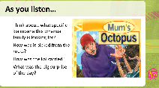  Slide 7  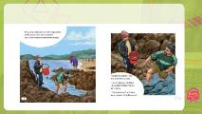  Slide 8  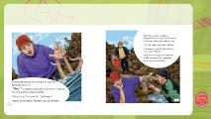  Slide 9  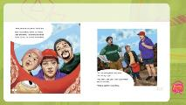  Slide 10  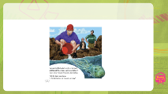  Slide 11  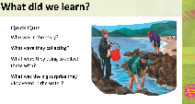  Slide 12  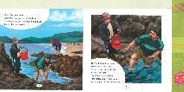  Slide 13  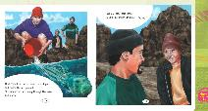  Slide 14  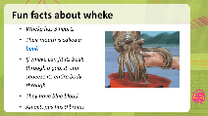 | Teacher shares slide 6. This slide is showing Mum, Dad and Sione with audio embedded by production team  Teacher plays audio  Audio is embedded in the slide 6 – students listen for the purposes listed on the left-hand side of this slide  Teacher shares slide 11 with quiz questions  Teacher quickly recounts answers to the quiz.  Teacher reinforces cultural connections to the practices of collecting kai moana.  Teacher shares slide 12. After reading this information the teacher probes students' understanding of mahitahi and whānaungatanga. She invites students up to the screen to view the images that help them understand the actions of Sione.  Teacher asks questions after reading the text on slide 12  Teacher shares slide 13 and asks students to turn to a whānau member and retell what is happening here. She asks them what they would do if this was them!  Teacher shares slide 14. These are fun facts about the wheke/octopus | Teacher shares slide 6  Let’s meet the people in our text. There is mum, dad and Sione.  I wonder what kaimoana they will collect. I wonder what they might take with them to collect this. I wonder if what they find is what they expect – or if they get some surprises?  Listen to the text.  Let’s see what we can find out as we listen/whakarongo  Ka pai! Great story/Kōrero pai  What did we learn? Can you retell what you have just heard to your family/whānau/ainga/anau. Have a try and see how you get on? Pause…  Teacher shares slide 11  Here is a quick quiz for you – see if you can answer these questions!!  Who was in the story?  What kaimoana were the whānau collecting?  What were they using to collect and carry the kaimoana?  What was the big surprise they discovered in the moana?  How did you go? Did you answer that Mum, Dad and Sione were in the story?  Did you notice that they were collecting mussels – kutai?  Did you see that they were collecting and carrying using a bucket?  Do you agree that the big surprise was the Octopus?  Ka pai – good listening and thinking!  Now let’s think about the cultural practices we have just observed.  What cultural practices are the whānau doing when collecting kutai?  Talk to your family/ whānau /anau/ainga/kaiako or a friend and tell them what you think. Ask for their ideas too.  (Pause)  Did you notice how they only collected the big kutai and how they returned the wheke back into the moana? These are cultural practices whānau use and respect when collecting kaimoana. Did you also notice how they only took a bucket? - enough to feed their whānau  How did you get on? Ka pai!  Teacher shares slide 12  Let’s reread a few pages to find out a bit more information. As we read, we are going to look closely at the pictures/pikitia, the vocabulary (words/kupu) used and the information in the sentences. Think about what the whānau were doing and what your whānau would do in a similar situation.  Read along with me.  Mum, dad and Sione were collecting mussels at the beach. Sione held the bucket while mum and dad hunted for the mussels.  They felt around the rocks and under the seaweed. “Here’s a big one,” said Dad. He twisted it off and threw it up to Sione. “That makes nine,” said Sione as he dropped it into the bucket.  Can you see how the whānau are working together when collecting kaimoana? Come closer to see what Sione is doing to help mum and dad as they collect kutai. Do you notice that Sione is helping by holding the bucket and counting the mussels? Mahitahi - working together as a whānau is important in this story - just as it is in our own lives.  Remember that the next part of the story is when she finds the octopus - dad is keen to keep it but mum wants to put it back, let’s reread and find out what did happen at the end.  Teacher shares slide 13  Look at the illustrations on this page? What is happening? Did you make connections to the cultural practices of returning seafood back to the moana when you choose not to take it with you.  Kōrero with your family/whānau/ainga/anau/kaiako or a friend and tell them what is happening. Ask them what they would do if this was them! Tell them what you would do……  How did you get on? Did you retell how Mum tipped the octopus out?  Did you retell how she watched it shoot away through the water?  Did you notice when Sione said ‘I’d rather eat mussels, anyway’?  Ka pai! Well done tamariki ma!  Teacher shares slide 14  To finish this part of the lesson I have collected some fun facts about wheke that I would like to share with you. Let’s take a look…  - Wheke have 3 hearts  - Their mouth is called a beak  - If wheke can fit its beak through a gap, it can squeeze its entire body through  - They have blue blood  - An octopus has 9 brains  Were you surprised? Have you ever caught an octopus before? Look closely again at the picture. Korero with whānau about what you can see.
Respond: Providing opportunities to use and practice  Slide 15  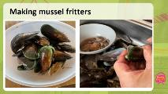  Slide 16  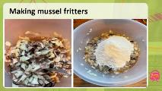  Slide 17  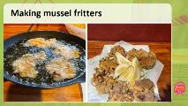  Slide 18 self-assessment  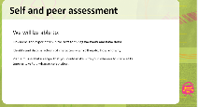 | Teacher shares Slide 15 These are Kutai fritters.  Teacher reads the recipe to students – 1. Shell the mussels and keep the juice in the bowl.  Teacher shares Slide 16. This slide illustrates the next steps of making kutai fritters.  Teacher shares slide 17. This slide illustrates the finished Kutai fritters.  Teacher shares slide 18  This is the Self and peer assessment slide - | In this story the whānau collected food from the moana. Take time to reflect on the food you collect and enjoy from the moana.  Now - Our task is to think creatively about a mussel/kutai recipe that you could make with your whānau to share at kai time or take to a whānau celebration.  Before we start this task I want you to talk with your whānau and see if they already have a kutai recipe they have used and shared at a whānau celebration.  I am going to share my kutai fritter recipe with you. Look at the pictures I have taken of my whānau preparing this kai.  As you look at the pictures I will share my recipe - it is a favourite recipe of mine  Teacher shares slide 15  First, I will…. shell the mussels and keep the juice in the bowl  Can you see the mussels? Can you see how I am taking them from the shell?  Teacher shares slide 16  Second, I will cut the mussels – see how I cut them into small pieces  Next, I am going to dice one onion and add to the mussels  Can you see what I am doing?  Then…. I will add flour and 1 egg to form a mixture.  Can you see my mixture forming?  Teacher shares slide 17  Now my fritters are ready to cook in a frying pan with a bit of vegetable oil. AND – Yeah! They are ready to eat. Yum. Do you think these look good!  Now it’s your turn…  Think about what event you might want to make your kutai mussels for. You might like to cook for a whānau dinner, whānau celebration, or to take on a picnic or to sell at the markets. Kōrero with your family/whānau/ainga/anau/kaiako or a friend and tell them what you think and ask for their ideas too! Ka pai!  Now it is your turn to start planning for your recipe. Maybe you would like to make a cultural dish using kutai for example - mussel chowder, seafood salad, steamed mussels in a shell, or toroi. What else might you make?  You might like to work with someone from your family/whānau/ainga/anau/kaiako or a friend.  How did you go? Ka nui te pai?  Now make a list of what you will need. You will need to think about ingredients and cooking materials (bowls, spoons, frying pan, measuring tools) to use.  Have a go at making your recipe, once you have done this you might like to write your recipe and sketch your kai or take photos of your dish and send to friends or whānau e.g., email or text.  Teacher shares slide 18  Let’s check back to our success criteria and see how we got on today  We will be successful when we can...  Link ideas and experiences in the text to things we know and have done  Identify and discuss actions of characters – what they do, how and why?  Plan a mussel/kutai recipe that you could make with your whānau to share at kai time or take to a whānau celebration.  How did you go?  I think we all did well today, and we had fun too, didn’t we? Ka pai! Great work everyone.
Share: Learner and parent reflection on learning and engagement and what they can do next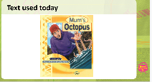 |  | Have fun making and creating your own mussel recipe. Use your recipe or a whānau favourite recipe to help you. Think about what you have at home that you might be able to use. Ask someone to cook with you.  Share Mum’s Octopus – the story we have read today – with a whānau member or friend. You might like to act out your favourite part  Haere rā, enjoy your day

