Home Learning TV - Middle Science and Maths

Segment lesson planning details
Title for segment: | Turning Old into New
Year levels (e.g. Yrs1 – 3): | 4-6
NZC learning areas/ KCs: | Science: Nature of Science: participating and contributing - exploring various aspects of an issue, making decisions about possible actions  Material World - grouping materials based on observations of chemical and physical properties  Science Capabilities - Interpret representations  Characteristics of technology - society and environments impact on and are influenced by technology (L3); technological development expands human possibilities (L4)
Purpose of lesson:  (What learners will learn based on the above) | Some resources are renewable and others are not  Some materials and objects can be recycled into different forms  Solving one ecological problem can create another one - recycling plastics into fabric can lead to increases in microfibre in the environment  Understanding the scale of large numbers
Success Criteria – students will be able to:  (how they will know when they have learnt it) | - consider different aspects of plastics as an issue, in order to make informed decisions  - interpret representations associated with plastic recycling  - use a shipping container as a ‘benchmark’ to understand that 2.5 million tonnes is an extremely large amount
Segment production details
Teacher talking time: | 20 minutes + videos and presenter anecdotes |  | Studio requirements: | White board and pens; screen for images
Equipment requirements: | Range of recyclable materials: glass jar or bottle, tin can, aluminium can, plastic with a variety of recycling codes, e.g., meat tray, milk bottle, some other plastic item, paper; plastic container the presenter talks about using as a lunchbox; other non-recyclable items (for game idea at the end)
Segment links and attachments (list all links to recordings or attachments, the source and confirm that copyright permissions are granted)
Attachments
Segment plan content
Stage | Teaching strategies linked to purpose | Learning tasks and activities |  |  | High level script (key points/questions for presenter)
Beginning of lesson:  Activating prior learning and relationships | Connecting with the audience, introducing the context for the episode. | Linking with everyday experiences |  |  | Kia ora koutou, ngā mihi nui ki runga o te kaupapa o te rā.  How are you all doing? How’s everything in your bubble today? It’s great to be back with you for some Science. I hope you’ve got something to write with, as well as some paper or your science journal ready.  [Personal anecdote linking to the theme - perhaps about producing more rubbish …]  Have you noticed that your bubble is producing more rubbish than it usually does – or maybe you’re all producing LESS rubbish? Why do you think that is? If you’re watching this with someone, maybe you can talk about it.  In my bubble, [presenter’s experience/anecdote – include a comment about recycling not being collected.]  Does your bubble normally try to recycle some of your rubbish?  Today we’re going to find out a bit more about what recycling actually means.
 | This script is based around the Ministry of Education’s Connected article, Turning old into new. Text from the article is in bold and italics.
Main part of lesson (a)  Main part of lesson (b) | Using a Connected article to introduce key concepts  - Objects are made out of materials  - Materials can be renewable or non-renewable  - Plastics are made of non-renewable materials; some plastics can be recycled  Presenter uses questioning to unpack key concepts throughout the text.  Using shipping containers to support developing number sense: scale of large numbers.  Engaging students with observation and classifying by their longevity.  Classification isn’t always straightforward and may require breaking down into parts.  Introducing new concepts - how are products sorted for recycling?  Sometimes, solutions lead to more problems. | Filename:  Turning Old into New_MOE.pptx  Turning Old into New_MOE.pdf  Linking to everyday experiences (the stickiness of chewing gum, but also that chewing gum generates waste)  Thinking about the amount of rubbish that New Zealanders generate.  Thinking about which items would break down fastest.  Interpreting an infographic to understand that different materials take different lengths of time to break down.  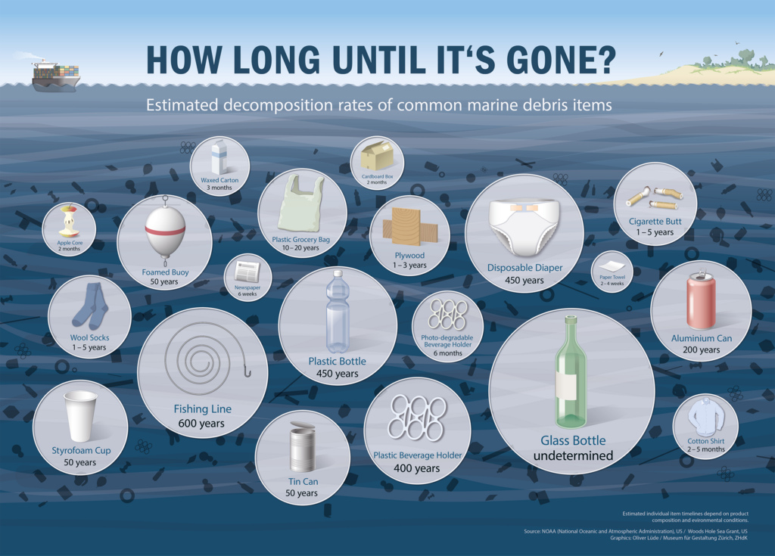  Questions to focus students’ attention while listening.  Thinking about the materials used to make everyday items - some sources are renewable, others aren’t.  Contextualising learning using everyday objects  Emotional connection - are you surprised plastics are made from oil?  Reinforcing concepts.  Students consider their own environments.  VIMEO: https://vimeo.com/410460951  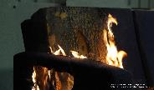  Images and video to help explain concepts.  Questions to focus engagement with multimedia.  Video - recycling sorting -  VIMEO: https://vimeo.com/292234946  Vimeo Link: https://vimeo.com/410460983  Asking questions to help students make conceptual connections.  Recycling_2.jpg  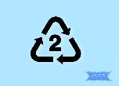  Students practice interpreting recycling symbols  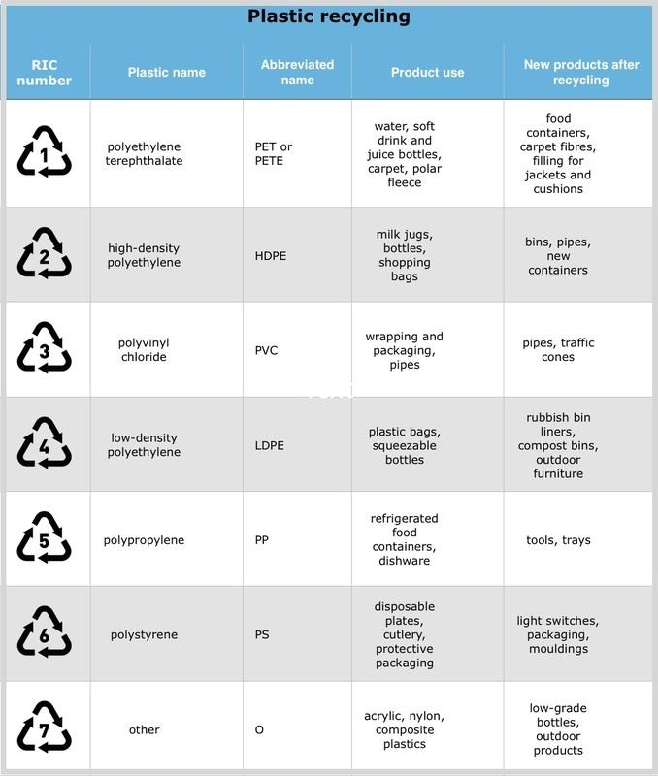  Students encouraged to interpret the table with the presenter.  Exposure to different kinds of texts (here, texts supported with images)  Connecting the image with what they are hearing  Filename: MicrofibreWashingBag_Guppyfriend.jpg  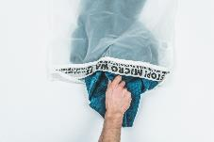 |  |  | [slide 1]  Turning Old into New  by Naomi Arnold  Ever stepped on a fresh wad of chewing gum?  It digs into the grooves of your shoes and can be impossible to pick out. But what if that stringy substance could be made into your next pair of sneakers? One company in England collects old chewing gum and turns it into everything from mobile phone covers to shoes.  That’s quite something, don’t you think? Collecting old chewing gum - I wonder how they actually do that?  If a fresh pair of gumboots isn’t for you, take a look around. What else can be broken down and turned into something new?  The answer might surprise you.  [slide 2]  A world of materials  Everything around you, from your desk to your clothes to your drink bottle, has come from the natural world. Think about the future of each of those things. What will happen when we don’t want them anymore? Where will they go and how much space will they take up? What will we need to buy to replace them?  One solution is to recycle them – to take the materials they’re made from, break them down, and turn them into something new. You already know that recycling is a good idea because it reduces pollution and saves money. It’s also a good idea because some of our most prized possessions are made from materials that can’t be replaced – and some of those materials are running out.  What happens to our rubbish?  You never really throw anything away. What isn’t recycled is usually buried underground in huge pits called landfills. Every year, New Zealanders send 2.5 million tonnes of waste to landfills – enough to fill 714,286 shipping containers. A train travelling at 100 kilometres per hour would take at least twenty days to move all this waste past a single point.  Let’s stop and think about these numbers in another way… 714,286 sounds like a lot of shipping containers. And have you seen shipping containers? They are pretty big. How many shipping containers do you think it would take to cover a football field?  …  It turns out that you would only need 400 to cover a football field, so if we stacked all 714,286 on a football field the stack would be nearly 4 and a half kilometres high! That’s more than 5 times the height of the tallest building in the world.  The waste inside landfills breaks down very slowly, with some materials lasting millions of years. The breakdown process also produces methane gas, which contributes to global warming. To make matters worse, about three-quarters of that waste could’ve been recycled.  Wow - did you hear that? Some things take millions of years to break down into tiny pieces that are available for plants to use for growth!  I think it is interesting to think about how long different things take to break down. I have some things here from my rubbish. It’s OK, I’ve washed them so I don’t stink out the studio.  Which one do you think would take the longest to break down? Which do you think would break down fastest? How long do you think that would take? If you’re watching this with someone, have a quick chat, or else draw some of these things. Put them in order, starting with those you think will break down fastest.  [Presenter to arrange items in a line - but not in order.]  [Show infographic - presenter to make comments and use the infographic to help sort the items into the order. Ask - what order did you have these items in? Did you change your order as we were looking at the infographic?]  Wow, if it takes that long for some things to break down, it would be good if we could reduce how much we send in our rubbish to be buried in landfills.  I’m sure that caring for Papa-tū-ā-nuku doesn’t involve burying heaps of rubbish that takes such a long time to break down!  Let’s find out more about what these different objects are made from. While I’m reading, I want you to focus on anything that might surprise you.  [slide 3]  Break it down  Every tiny component that combines to form your favourite object has come from Earth. Earth's natural resources can be made and remade into things that are useful to us in a process called manufacturing. With some materials, it’s easy to know where they’ve come from. Others take a little more figuring out.  - Wood comes from trees or plants. Some woods, like wood from pine trees, are considered renewable because they can be grown back again quickly. Other woods, like those from rainforests, take a long time to grow back and aren't considered renewable.  - Metal comes from rocks that are mined from the ground. It’s non-renewable because there’s a limited amount available on Earth, and we can’t make more of it.  - Plastic is a little more complicated. There are many different kinds of plastics, but most of them are all made from the same natural resource – oil.  So what surprised you?  Had you heard the words ‘renewable’ and ‘non-renewable’ before?  Renewable materials can be easily replaced.  Non-renewable materials can’t be easily replaced.  One thing that surprised me was that wood that takes a long time to grow isn’t classified as renewable. The article says that rainforest timber takes a really long time to grow - a bit like our Kauri tree.  Metals and most plastics are also from non-renewable materials.  [Point to recyclable items and comment, or re-group them.]  Take a moment to look around you now. What things can you see that are wood, or metal, or plastic?  You might like to start a list of things near you:  chair  window  television  carpet  Of course, lots of things are made from a mixture of materials.  [Presenter to choose an item to discuss, or use the following.]  Think about a chair - one that’s covered in fabric, and has a wooden frame. The fabric might be from natural materials, or it could be more manufactured, and even contain some plastic. .  Although the frame is made of wood, it could be held together with screws - so there’s some metal.  Phew, so when the chair is no longer useful, I wonder what should happen to it? if I can’t repair it, can it be recycled? I think I need to learn some more.  Now you probably know that lots and lots of different things are made using plastic. But where does plastic come from? We read a little earlier that most plastics are made from oil. Did that surprise you?  [slide 4]  Making plastic  Most plastic comes from oil found in Earth’s crust. Oil forms from the remains of plants and animals that lived millions of years ago. When they died, the plants and animals were covered by mud and sand. Over millions of years, the mud and sand built up in layers and turned into rock. The heat and pressure from the rock turned the plant and animal matter into oil and gas.  There’s a limited amount of oil available, making it a non-renewable resource. This means that plastic is non-renewable, too. Some experts predict that we could run out of oil in fifty years, so we need to get better at using what we already have.  Let’s read this caption.  Caption: The molecules that make up this plastic model might once have been part of a dinosaur.  Do you think that’s true? That the plastic making up a toy dinosaur could once have been part of an actual dinosaur?  Remember that we’ve just learned that most plastics are made from oil - and that oil comes from plant and animal matter that has been covered under pressure for millions of years. So maybe it is possible!  What else can we say about the plastic if it comes from oil - is it renewable or non-renewable?  You decide, and write it down or tell someone. What did you decide?  That’s right - plastic is non-renewable - the oil that goes into making plastic has taken millions of years to form!  Look around you now. What can you see that is made of plastic?  The television has a lot of plastic in it and oil products are sometimes used to make the soft filling of our chairs and couches. That’s why when there are fires, some couches burn really fast - it’s because of all the oil products that they contain.  [Optional, for the presenter to decide based on script time once personal anecdotes are included.]  Let’s watch this video. While you watch, see if you can see something that tells us that this fire was part of a controlled situation.  [Play video]  That looked pretty powerful and scary, didn’t it?  How did you know that the situation was one that was being controlled? Let’s watch the video again  [Presenter points out the person in a lab coat behind the window.]  This video was made during some research investigating ways to slow materials from burning.  [End of optional section]  What other plastic items can you see when you look around?  Before the lockdown, when I was going to school like you were, I used this plastic container as a lunch box.  But if most plastics are made from oil, and oil is non-renewable, it means that if this lunch box gets thrown away, that’s material that can’t be used again.  What else can I do? You probably know that some types of plastic can be recycled.  Let’s see what our article says.  [slide 5]  Beyond the bins  When you put a glass jar or plastic bottle into your recycling bin or bag, it’s collected by the council. Then where does it go?  Let’s look at this video to see what happens to our recycling once it has been collected. This was made at the Materials Recycling Facility, or MRF, in Auckland.  While you’re watching, talk to someone about what’s happening.  (Show video - 2:22mins)  So that video shows us how different technologies are used to sort the different materials. Can you remember some of them?  Let’s see -  - sorting by size  - sorting by weight  - magnets  - infrared light and smart cameras to sort plastics  What happens next? Well, glass can be melted down at very very high temperatures and turned into jars and bottles. Some gets turned into “glasscrete” or “glassphalt”, which is used to make roads. It can also be ground down into soft sand and added to sports fields to drain away water.  What about plastic? At this stage, only some plastic can be recycled in New Zealand. Let’s see what Flight Plastics does with the plastic that they get.  (Show video - 1:33)  So what happened to Barry the Waterbottle? Can you tell someone?  That’s right, Barry the waterbottle got recycled into Barry the food container.  I think it’s great we’ve got Flight Plastics helping us to recycle plastic.  But … hmmm … [Looking at array of plastic props] - not all plastics can be recycled.  Do you know which ones can be?  You can tell by looking at the recycling symbol on the plastic.  [Show image]  Perhaps you can quickly grab a plastic container. While you do, I’m going to put these into order.  [Presenter sorts plastics by recycling number, talking as he does so.]  Great. Have you got one?  Can you find this symbol on it?  I’ve been looking at the symbols on my collection here, and I’ve sorted them from 1 to 7.  Let’s look at this table and see what we can learn about the different types of plastic.  [Presenter to interpret the table while using his props and asking questions, e.g., - This is a number 2 - what can we learn about number 2 plastics?]  If you grabbed a plastic item, what is it now, and what could it be recycled into?  Can you do a quick sketch of that?  [Optional - presenter could choose to focus on the plastic name - e.g.  I love meeting new science words, and here we can see that each plastic type has a specific name. Let’s say some of them together … These names tell us a little about the molecules in the plastic.]  We’ve seen what Flight Plastics does with the plastic that they receive.  Let’s read what this article says about what sometimes happens:  [slide 6 - includes a diagram to support the text]  - The bottles are taken to a recycling facility where they’re separated by colour. Their caps and labels are then removed, and the bottles are washed and sterilised.  - The bottles are put into a grinder, where they’re cut into small chips.  - The chips are melted, and that liquid is pushed through tiny holes. As the liquid comes in contact with the air, it cools and turns into very fine threads – thinner than the hair on your head.  - The threads are stretched to bond the fibres together and make them stronger. They are then torn into short pieces and carded before being spun into yarn.  - The yarn is woven into polyester clothing and other materials.  This is a really helpful way to show the process. Scientists often use diagrams to highlight the sequence of things. Presenting information like this helps the reader to quickly get the important information and the numbers make sure it is in the right order.  So that sounds good, right?  But how good is it, really?  Let’s keep reading. While I’m reading, think about how the words connect with the image -  [slide 7]  The problem with microfibres  In 2011, ecologist Mark Browne made a shocking discovery. Based on a survey of eighteen shorelines around the world, 85 percent of the human-made debris he found was synthetic microfibres (tiny fibres) from our clothing.  Clothing microfibres enter the sewerage system via washing machines and are released into the ocean. Recent studies have shown that microfibres could be poisoning our underwater wildlife, which has knock-on effects for the rest of the food chain – including humans.  Oh no, so now it sounds like the plastic bottle that was recycled to make my polar fleece top, could be releasing microfibres into the sea!  How is the image depicting this?  Can you see the connection that’s being made between washing machines (where fibres come off our clothes), and natural waterways?  Let’s keep reading - I think there might be some good news - Yes!  Two German inventors have been working on a solution. They’ve developed a laundry bag that traps microfibres that come off clothing as it’s being washed. Clothing is put inside the bag and put into the washing machine as normal, except 99 percent of microfibres are stopped from entering the ocean.  Look, here’s a picture. Can you see that they’re clearly labelled as stopping micro waste?  I love stories about people who are doing things to help protect Papa-tū-ā-nuku!  [Optional section depending on the presenter’s choices for other anecdotes.]  What are some other ways we could think about when washing our clothes?  Have you got any ideas? Quickly draw something or tell someone.  (Presenter turns to the board and talks while thinking and writing - could share an anecdote)  Hmmm I wonder if  - washing my clothes for less time would create less microfibres,  - washing my clothes less frequently could also help - although my whānau and school students might not be so keen on that idea!  - maybe I could wash harder items separately from softer materials - although I’ve also got to balance out the water and power I’d be using!  I also wonder if all of my clothes have microfibres? I need to look at the labels. Clothes from natural materials like cotton and bamboo don’t produce the same kind of microfibres.  [End of optional section]  [Optional - depending on presenter’s choices for other anecdotes]  Let’s find out about another great idea to help reduce waste. The title is ‘Beery good recycling.’ What gives you the idea it might have something to do with beer?  Beery good recycling  Many students have also been looking for innovative ways to turn old materials into new products. Year 10 students at Dunedin’s Kavanagh College found a way to recycle what was left over after the local brewery brewed their beer. The Grain Brain food science team used the brewery’s waste malt and combined it with old issues of the Otago Daily Times to make biodegradable planter pots.  To make the papier-mâché-like pots, they added water to the malt and paper and pulped them into a paste in a kitchen food processor. Then they moulded the paste into small pot shapes and dried them out. The pots could then be used to grow seedlings until they were big enough to be replanted outside. Because the pots are biodegradable, they can be buried directly into the soil – allowing the plants to be replanted without disturbing their roots.  That sounds great! Making plant pots that recycle unwanted stuff AND help grow plants AND will feed the plants once they are planted in the ground.  Have you got a great idea about what you might do? Maybe you’ve already been involved in something that is both creative, and that helps Papa-tū-ā-nuku?
End of lesson:  Learner and parent reflection on learning and engagement and what they can do next | Summarising key points and inviting action | Suggestions for student and whānau interaction and action  VIMEO: https://vimeo.com/410460909 |  |  | Perhaps you can create a game to play with those in your bubble. What you’ll need is some drawings or words of different things from around your home.  [Presenter picks up earlier recycling props, perhaps pulls out some new ones, lists some others - ]  The aim of the game is to correctly sort the items into piles:  [Words on screen: REUSE - RECYCLE - LANDFILL]  You could also talk to your whānau about how you might be able to REDUCE how often you buy some of these items, and what you could use instead.  Presenter to summarise message along the lines of  I think I could probably reduce how much plastic stuff I buy. I could re-use more of my stuff, and I will be definitely supporting recycling. In fact, one of the things I’ve struggled with during lock down has been that recycling hasn’t been picked up. I’ve kept things aside, though, and I’ll be passing them on as soon as I can! I’m also going to think more about my clothes washing habits.]  What do you think you and your whānau could do to help Papa-tū-ā-nuku?

