Home Learning TV – Lesson Plan

Segment lesson planning details
Title for segment: | Marama - the moon
Year levels (e.g., Yrs1 – 3): | Yrs 4 - 6
NZC learning areas: | Science - nature of science (understanding about science, communicating in science)  Planet earth and beyond - astronomical systems
Purpose of lesson:  (What learners will learn) | Build on learning from the previous episode about objects in the night sky  Different cultures have different stories about the moon  The moon’s appearance changes according to the amount of light that reflects off it  There are special names for the different phases of the moon  The same amount of moon is seen everywhere in the world but its pattern of change and perspective changes according to geography
Success Criteria – students will be able to:  (how they will know when they have learnt it) | - describe in simple terms how the shape of the visible part of the moon changes due to the relative position of the sun and moon.  - identify some different names for the changing appearance of the moon  - explain that representations do not always convey all the information of the real thing
Segment content/context details (as appropriate)
Māori specific content i.e., the learning draws on Mātauranga Māori: | The legend of Rona and the Moon helps students to identify the Southern Hemisphere view of Te Marama | Pacific specific content i.e., the learning is focused on Pacific knowledge: |  | The legend of Sina and the Moon indicates a similarity of pūrakau between Sāmoa and Aotearoa New Zealand
Segment production details
Equipment requirements:
Copyright requirements:  Please be specific: Source (Seven Sizzling Sausages by Sam Smith –URL link to the source), intended use (to demonstrate alliteration), and length (timings for video clips) | All images and video provided have been cleared for use
Segment links and attachments (list all links to recordings or attachments, the source and confirm that copyright permissions are granted)
Links to recordings /resources
Attachments
Segment plan content
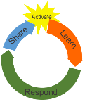 | Teaching and learning activities linked to purpose |  | High level script (key points/questions)
Activate: Activating prior learning, knowledge of contexts and relationships | Connecting with viewers  Linking with the previous episode  Introducing the topic for the session. |  | Kia ora koutou! kei te pewhea koutou?  [Touch base with audience if they’ve sent in texts or emails.]  Now I’ve been wondering - you get to see me, but I don’t get to see you. So, I don’t know whether you’re a regular viewer, or if this is the first science episode you’re watching.  Which also means I don’t know if you saw the last episode, which was on whetū - stars. We talked about how some objects in our night sky look different depending on where you are in the world – you can only see the Southern Cross in the Southern hemisphere, for example. Star clusters and star constellations also have different names and different meanings in different cultures and traditions. For example, Matariki is also known as Pleiades, and It’s called Subaru in Japan – have another look at the Subaru car logo next time you see one!  Today we are going to learn about Te Marama, the moon, and we’re going to talk about the connection between Matariki, Te Marama, and Maramataka, the Māori calendar based on the moon.  Ānei he timatanga. Let’s begin.
Learn: Introducing learning  Reinforce routines, provide multiple exposure to concepts, and strategies. Scaffolding learning | Connecting with Matariki  Introducing the localised nature of Mātauranga Māori.  Celebrations based around astronomical occurrences are international and acknowledged in different ways.  Practicing observing (a skill re-visited regularly through these episodes)  The article gives context to different possible experiences of the Moon. |  | In Aotearoa, Matariki is a really important star cluster as its appearance marks the beginning of the Māori New Year, Te Tau Hou in the traditional Māori Maramataka or calendar.  We had a look at this image in our last episode – it’s the stars of the Matariki star cluster.  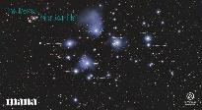  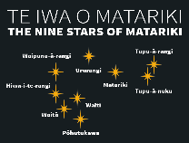  For some iwi, Matariki begins on the first full moon after the star cluster rises; for other iwi it begins with the next new moon. So, you can see, Te Marama has an important role in the timing of Matariki. In fact, the moon’s name is part of the word for calendar, Te Maramataka.  Te Maramataka is a moon-based or lunar calendar rather than a sun-based one like the January to December calendar. A lunar year is 354 days long while the sun-based calendar is 365 ¼ days long. This means that the months don’t align the same way.  Māori star knowledge includes understanding that the rising of different stars at different times of the year is useful to plan for planting, fishing and even navigation across the mighty Moana nui-a-Kiwa or Pacific Ocean.  Other countries also have extensive collections of stories about the moon and stars. For example, Japan also used to have a lunar, or moon-based, calendar. Japanese people have a special moon festival called Otsukimi. お月見。 or Jugoya, when they honour the autumn moon. It literally means moon viewing. The Japanese like to have moon viewing parties in their parks and make decorations from Japanese pampas grass and eat rice dumplings called Tsukimi dango to celebrate the beauty of the moon. In the old days they used to recite poetry at these festivals too. [Image - note the pampas, rice balls, stars, and full moon]  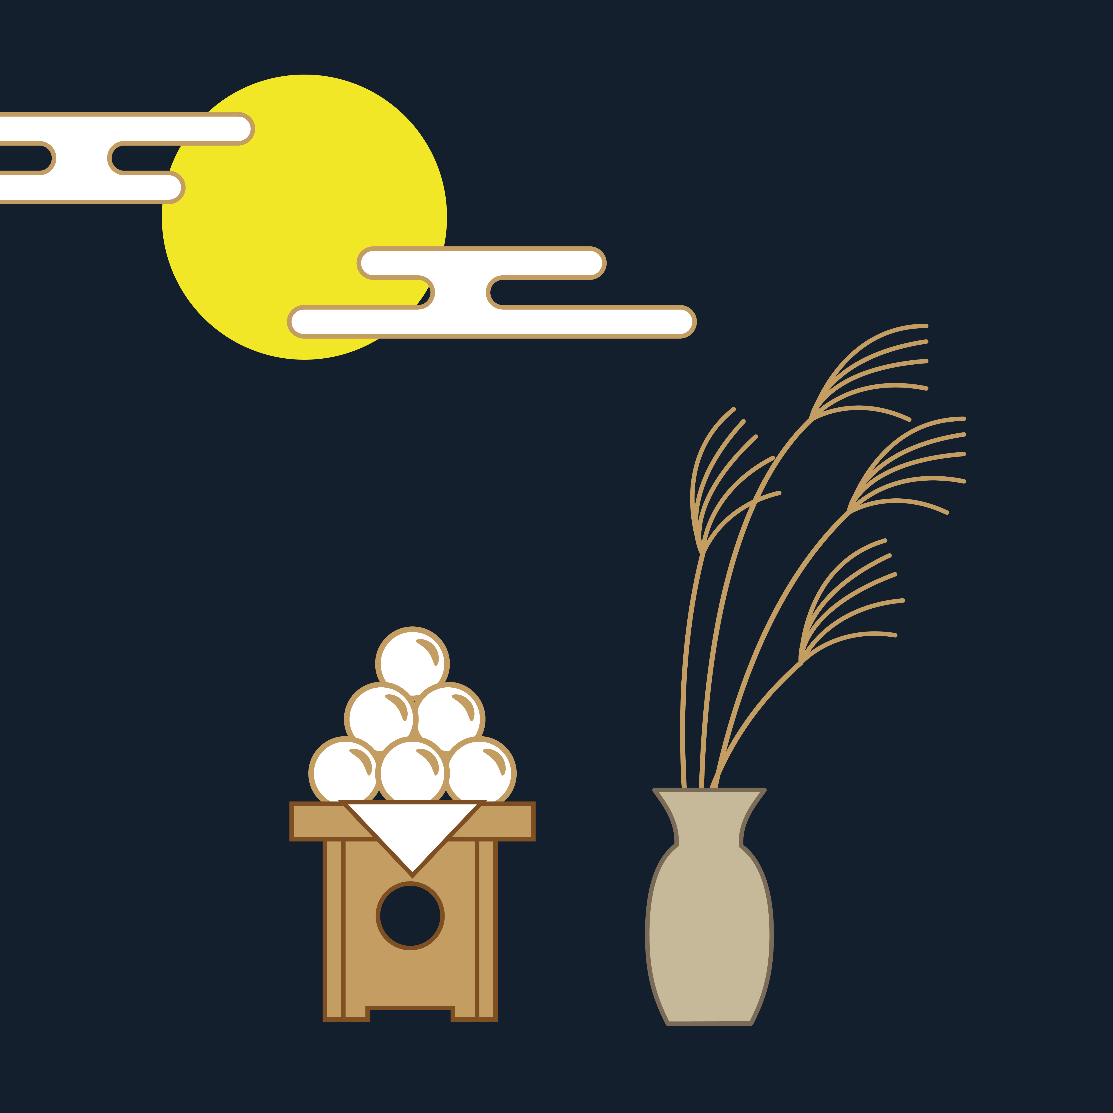  That sounds pretty cool – hanging out and celebrating together while eating special foods under a beautiful full moon!  [Anecdote about observing a full moon / being outside]  Let’s have a look at today’s observation challenge.  FILENAME: Slide 13 Why Is the Moon Upside Down.pptx  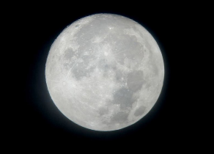  Have you got your paper and pen ready? Let’s make some really accurate observations:  [write on board]  - circular  - areas of light grey and darker grey  - a circular spot on the left hand side with some sort of line pattern radiating out from it  To help us learn more about te marama, the moon, we’re going to be using  a Connected article, “Why is the Moon upside down?” by Trish Puharich.  FILENAME: Slide 1 taken directly from Why Is the Moon Upside Down.pptx  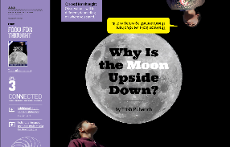  https://docs.google.com/presentation/d/144JsC71SbNDVE3UFhzf53u2EVhY_ZiXWIJ_hxxHCFAA/present?slide=id.p  In our story today, friends Niko and Ani used to like to lie on their deck in their sleeping bags looking up at the moon. They were really good friends, but one day Niko’s Mum was offered a great job in Japan. So, Niko was off, all the way to Japan.  Let’s just check where Japan is relative to New Zealand.  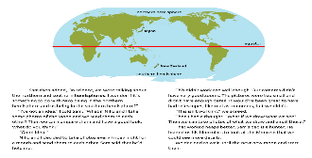  https://docs.google.com/presentation/d/144JsC71SbNDVE3UFhzf53u2EVhY_ZiXWIJ_hxxHCFAA/present?slide=id.g177ca22f5_10  Some of you will be from Japan or have family who live there and so you might know this route well! [Talk through the map – heading north, past Australia, past the Pacific Islands.] It’s a long way from Aotearoa New Zealand, and it’s also in the Northern part of the Earth, north of the Equator (point to the red line) whereas Aotearoa is in the Southern part of the Earth.  After Niko had settled in, he sent Ani an email. He was a bit puzzled. Let’s have a look at what he said,  Filename: EmailFromNiko_WhyIsTheMoonUpsideDown_MOE.jpeg  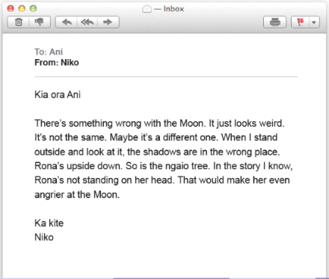  https://docs.google.com/presentation/d/144JsC71SbNDVE3UFhzf53u2EVhY_ZiXWIJ_hxxHCFAA/present?slide=id.g1718dc611_045  Do you know the story of Rona and the Moon? Rona and the Moon is a pūrakau, a legend. It tells the story of the patterning of light and dark on the moon’s surface.  [presenter to read story of Rona and the Moon]  FILENAME: RonaAndTheMoon_MoonUpsideDown_MOE.jpeg  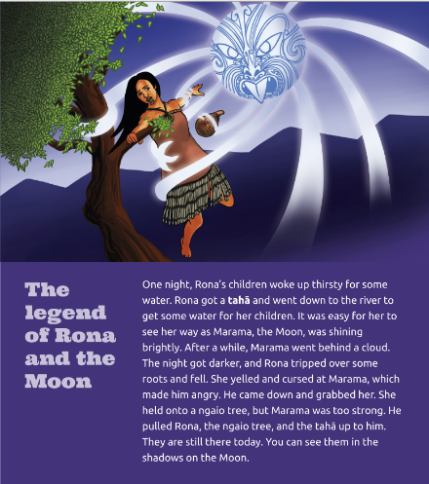  [Read and show slide 3 https://docs.google.com/presentation/d/144JsC71SbNDVE3UFhzf53u2EVhY_ZiXWIJ_hxxHCFAA/present?slide=id.g1718dc611_099 ]  [taha = calabash, container]
Respond: Providing opportunities to use and practice | Continuing to use the story to extend learning by linking in other cultural narratives and then some scientific observation  Making observations; interpreting representations  Critiquing evidence  Engaging with science - researching and collaborating  Interpreting representations  Using a model (shown through video) to understand what causes the phases of the moon.  Learning scientific vocabulary |  | Let’s keep reading about Ani and Niko –  Ani says - When I told my friend Sam about what Niko had said about the Moon being upside down, Sam said that his parents had told him the Sāmoan legend of Sina in the Moon. He said he didn’t think Sina would take too kindly to watching us upside down either. She’d get a headache.  Sam thought for a moment and then he said, “In science, we were talking about the northern and southern hemispheres. I wonder if it’s something to do with Niko being in the northern hemisphere and us being in the southern hemisphere?”  Ani thought that they needed to collect some more data to better understand what was going on. After talking with Sam, they decided to get Niko [who is in Japan] to take photos every Friday night for a month and they would do the same and then send them to each other.  This didn’t work too well though. Their cameras didn’t have very good zooms. The pictures were too small and didn’t have enough detail.  If they had had telescopes like real scientists, that would have been awesome, but they didn't. Ani then had a thought.  “What if we draw what we see? Then we can take photos of what we draw and email those.” That worked heaps better. Sam’s dad [was] a hunter. He loaned [them] his binoculars to look at the Moon so that we could see more details.  Looking at the moon closely like this is what people have done for centuries. In Aotearoa, the changing faces of the moon were used to guide plans for planting, navigating, and fishing. This information is connected to Te Maramataka, the lunar calendar.  Once Ani and Niko exchanged their images, they could see lots of similarities  and some small differences. Let’s have a careful look at their drawings.  FILENAME: WaxingWaningMoon_MoonUpsideDown_MOE.jpeg  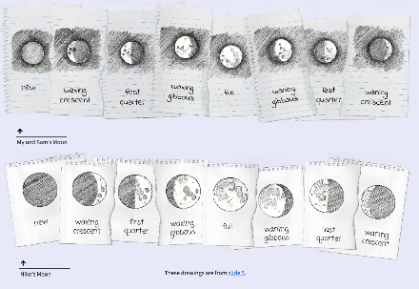  https://docs.google.com/presentation/d/144JsC71SbNDVE3UFhzf53u2EVhY_ZiXWIJ_hxxHCFAA/present?slide=id.g1718dc611_13  What do you observe?  I can see that Ani and Niko drew the moon in different shapes. It looks like they are very good at making scientific observations and then drawing these. They also used some scientific words.  I’m not sure what all those words mean. I think I will see what I can work out if I look at the images. I know that waxing means getting bigger, and I can see that each of the waxing pictures are showing more of the lit side of the moon. I’m not sure what gibbous means. And why do they say that the half moon is the first quarter? It doesn’t look like a quarter to me.  I can see that their labels are in the same order. Niko’s drawings show the shadow really clearly - that line where the dark meets the light is called the terminator.  But I’m looking at the images and I can see a difference. Can you?  Look closely at the image for the waxing crescent- look at the terminator- on Niko’s image that line is on the right but on Ani’s moon it’s on the left making a C shape. And I am looking at the full moon images now- Niko has a small circle with lines coming off it, but Ani’s doesn’t. I can kind of see Rona in Ani’s moon but on Niko’s moon it is different- Ah that’s the upside down bit.  When scientists notice differences, they get curious, and a bit excited! They think about what sorts of things might explain that differences. Maybe Niko is looking more closely – perhaps he was using more powerful binocular? Or maybe Niko is a really good drawer? Or … well, maybe there really is something different about how the moon looks in Japan compared to Aotearoa?  So now if we are thinking like scientists, we need to find out some more. So, Ani took the drawings to Sam and like scientists they collaborated to try and make sense of what they were noticing.  Sam was thinking about his idea about the Northern and Southern hemispheres. Suddenly he said, “I’ve got it! If someone is standing near the top of the Earth, and someone is standing near the bottom, then they seem upside down to each other. “  Ani wasn't sure how that helped explain the different pictures. So, Sam drew a diagram.  FILENAME: ViewsOfTheMoon_MoonIUpsideDown_MOE.jpeg  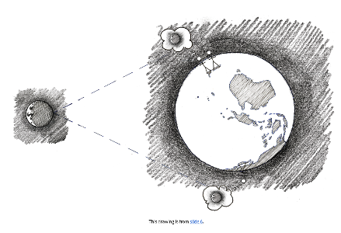  https://docs.google.com/presentation/d/144JsC71SbNDVE3UFhzf53u2EVhY_ZiXWIJ_hxxHCFAA/present?slide=id.g17a176446_80  This diagram helped Ani understand Sam’s idea. Ani looked closely and could see her and Sam on one side of the Earth and Niko on the other side. And of course, they were kind of upside down to each other, so their views of the moon would be opposite for each other.  Ani and Sam spoke online to Niko and explained it. In fact, Sam, Niko, and Ani were just like scientists - excited and keen to find out even more about Te Marama.  Here’s another way of thinking about the way the moon seems to change shape – we call these different shapes the phases of the moon, and it’s to do with how much of the moon is being lit by the sun at any particular time.  [Summarise the video and the use of models to explain scientific ideas.]  Let’s think together about what the names for the different phases of the moon mean.  [Write words on the screen:  waxing – getting bigger  waning – getting smaller  gibbous – humped or convex  crescent – arc-shaped, concave  [Talk about these and provide simple diagrams]
Share: Learner and parent reflection on learning and engagement and what they can do next | Summarising the episode by referring to the phases of Te Marama and inviting students to observe the moon and perhaps keep track of the changing phases over a month.  Some inspirational poetry is also introduced as an alternative direction for ongoing learning. |  | I wonder what phase te marama is in at the moment?  Why don’t you have a look outside later today and see where te marama is. Perhaps you could follow the moon for a month, creating a series of drawings like Ani and Niko?  Or what about writing some lunar poetry? Here’s a beautiful piece.  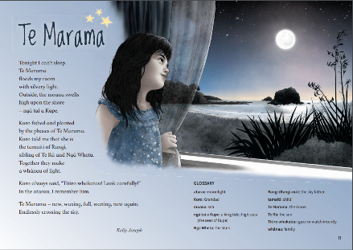  https://instructionalseries.tki.org.nz/content/search?SearchText=te+marama&SearchButton=&CurrentTab=is_homepage&SubTreeArray%5B%5D=22574&ColourWheelLevel=all&CurriculumLevel=all&ReadingYearLevel=all&LearningArea=all  If you live near the beach, you might also want to watch for patterns between the tides and the moon. I think you’ll be impressed with what you can discover by taking note of what you observe.  [Shout out to the Science Learning Hub for support planning this episode]  [Sign off]

