Home Learning TV – Middle Science

Segment lesson planning details
Title for segment: | Ferns - huruwhenua
Year levels (e.g. Yrs1 – 3): | 4-6
NZC learning areas: | Living world - evolution, nature of science
Purpose of lesson:  (What learners will learn) | New Zealanders identify with iconic natural species  Although ferns are part of our ngahere, we are still not certain how they came to be here  The parts of a fern are the rhizome, frond and the reproductive structure - spores
Success Criteria – students will be able to:  (how they will know when they have learnt it) | - talk about why the kiwi and the silver fern are important to New Zealanders  - identify some parts of a fern  - notice ferns in their environment (natural environment, and as icons)
Segment content/context details (as appropriate)
Māori specific content i.e. the learning draws on Mātauranga Māori: | Māori and Pacific content is centered on inclusive language and links to origin stories | Pacific specific content i.e. the learning is focused on Pacific knowledge: | Māori and Pacific content is centered on inclusive language and links to origin stories
Segment production details
Equipment requirements: | White board, screen for showing images and video, fern fronds if possible
Copyright requirements:
Please be specific: Source(Seven Sizzling Sausages by Sam Smith –url link to the source), intended use (to demonstrate alliteration), and length (timings for video clips)
Segment links and attachments (list all links to recordings or attachments, the source and confirm that copyright permissions are granted)
Links to recordings /resources | All images and video detailed in the script: https://www.dropbox.com/home/MOE%20TVNZ%20Science%20Learning%20Hub/MS_03_Ferns%20and%20identity
Attachments
Segment plan content
 | Teaching and learning activities linked to purpose | High level script (key points/questions)
Activate: Activating prior learning, knowledge of contexts and relationships | Connecting with the learners and their experiences. Making observations is a known and ongoing experience for those watching the pūtaiao episodes. | Kia ora - [greeting in multiple languages]  [Touch base with audience if they’ve sent in texts or emails.] While I’m showing you the cool messages I’ve received, check that you’ve got your science journal, or some paper and something to write with.  Remember - if you want to share your ideas or learning with me, text 5811 or email info@hltv.co.nz. The keyword for this episode is ferns or huruwhenua.  [on screen: text 5811 or email info@hltv.co.nz  keyword: ferns or huruwhenua]  [Please check maoridictionary.co.nz for pronunciation support]  As you know, we often start with something to observe to get our brains warmed up for thinking like scientists.  FILENAME: KiwianaCollage.jpeg  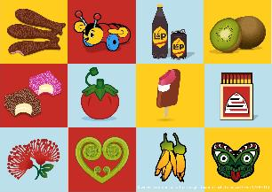  This isn’t like the pictures we normally start with, but it’s still something we can look at closely. What are some of the things you can identify?  [Point out some of them.]  What do you think they all have in common?  [Point out something in common - lots of the pictures relate to food, but not all of them. Hey, I know … they’ve all got something to do with New Zealand!]  [Share an anecdote - perhaps - Now I’m from Canada, but even on my first visit I realised that there were things here in NZ that are uniquely NZ, things that form part of New Zealanders’ national identity.]  Here’s another image  Filename: OneDollarCoin_SLH-UoW.jpeg  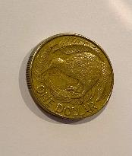  I’m sure you’ll recognise this - it’s a $1 coin. But when last did you have a close look at a $1 coin?  I’ve chosen it, because it’s got two iconic species represented on it - the kiwi, and the silver fern.
Learn: Introducing learning  Reinforce routines, provide multiple exposure to concepts, and strategies. Scaffolding learning | Introducing the theme of identity and how it is closely linked to our unique and iconic natural species.  Origin narratives of the silver fern  Many of Aotearoa’s living things are quite different from living things in the rest of the world.  Science knowledge is tentative - we understand some things but there is still a lot left to learn.  Filename: SporangiaAndSporePrint_SLH_UoW.jpg  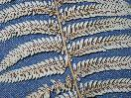  MS_03 sporangia and MS_03_spores_cropped  Ferns are different to flowering plants. They reproduce via spores instead of seeds.  Spores are dispersed by wind and can travel long distances.  Scientists use specialist vocabulary. The images, video and diagram help learners visualise the new terms. Movement is used to reinforce the unfurling of a fern frond. | Let’s think about why the coin has a kiwi and silver ferns on it.  Both the kiwi and the silver fern are iconic species in Aotearoa. Icons are symbols - people associate them with something, and kiwis and the silver fern are associated with Aotearoa.  Your whānau may have originally come from another country and that country also has icons and iconic species. Maybe after this you could ask someone in your family about the unique species found in that country.  The kiwi and silver fern are important to our identity as New Zealanders.  Filename: NorthIslandBrownKiwi_IsseleeEricPhilippe_123RF_33642114.jpg  The kiwi is uniquely ours because it’s endemic to Aotearoa - it naturally lives here and nowhere else in the world. It’s also unique because the kiwi is the only bird in the world with nostrils at the end of its beak. It doesn’t have tail feathers like most birds but it does have whiskers like a cat or a dog.  I think Kiwis - the human variety - like the kiwi as a national symbol because we like to think we are unique too!  The silver fern or kaponga - is also uniquely ours. Like the kiwi bird, it is endemic to Aotearoa - only found here!  Filename: SilverFernGrowing_JohnFowler_CC BY 2.0.jpg  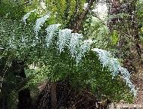  Along with the kiwi, the silver fern is one of Aotearoa’s national symbols. Here it is, on a New Zealand passport.  Filename - NZ_Passport_SLH-UoW.JPG  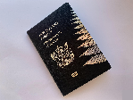  Why don’t you draw a fern symbol in your journal to remind you about today’s topic? You can also write down some of the science terms we will talk about.  Let’s have a look at the whakapapa kōrero of the NZ tree fern, kaponga - the stories of its origin.  One story tells of Tane’s marriage to Punga, and the creation of ferns and other plants and creatures that live in the ngahere, or forest. There’s also a story that Kaponga once lived in the sea, but was convinced to live in the ngahere and act as a guide for Māori hunters and warriors, helping them find their way home. That’s because the silver fern is white or silvery on its underside. The light colour stands out in the darkness of the forest during the day and it stands out on moonlit nights. Check out this photo - someone is using silver fern fronds to help tamariki on a scavenger hunt. Can you see why the silver fern makes such a good marker in the bush?  Filename: MS-03_tracking_SilverFernUnderside_SLH.jpg  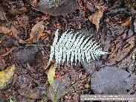  Ferns are an ancient group of plants - fern fossils from about 350 million years have been found. That means ferns have been around a lot longer than dinosaurs!  Aotearoa has around 200 species of native ferns. Have you ever wondered how plants like ferns got to Aotearoa in the first place? It’s not like they could get on an airplane and fly here like I did.  Scientists working at Te Papa Museum in Wellington have been wondering about this too. It’s likely that lots of our fern species blew here - so maybe they did fly like I did!  Well, not quite - this was millions of years ago. Planes haven’t been around for that long. And then there’s biosecurity at the airport - do you remember our last two episodes? I don’t think the biosecurity protection dogs would let me leave the airport with a fern in my suitcase!  Here we can see Te Papa scientists Dr Patrick Brownsey and Dr Leon Perrie in the Te Papa herbarium. A herbarium is a research collection of pressed, dried, and labeled plant specimens.  The-Seuffert-pressed-fern-album_SLH-UoW.jpg  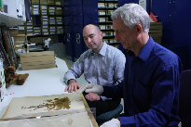  The Te Papa herbarium has over 260,000 plant specimens, including 19,000 fern specimens. Te Papa also holds many early fern collections, like this one that Leon and Patrick are looking at.  Can you see that Patrick is wearing gloves? That’s because he’s working with the Seuffert album, which is nearly 150 years old. At the time, albums of pressed ferns were the coffee table books of the day!  Filename: SeuffertAlbumCollage_SLH-UoW.pdf  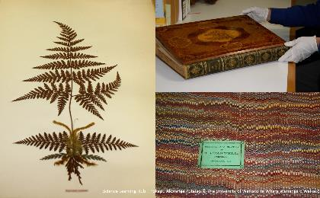  So, these two scientists, Patrick and Leon, believe that many fern species arrived in Aotearoa as spores that had blown across the Pacific Ocean.  Filename: SporangiaAndSporePrint_SLH_UoW.jpg  Let’s look at the silver fern frond on the left. Can you see the little brown dots? They are like little cases that hold the spores. Scientists call them sporangia. When the sporangia - the cases - break open, the spores are released. A spore is a little like a piece of dust. It’s hard to see one spore, but when lots of them are in one place, it kind of looks like piles of dust. This photo on the left is a spore print. I left the fern frond sitting on a piece of paper overnight. The spore cases dried out and broke open and the spores dropped on the paper. When you see the photos side by side, can you see the pattern of the leaves and the pattern of the spores? Now imagine I blew on the spores. Some of them would blow away. If the spores land in a damp, shady place, they might grow into a new silver fern plant. How cool is that!  Now would be a good time to draw dots on your silver fern sketch. Label them spores. [word - spores - pua atua - on screen]  We’ve looked at one part of a fern plant. Let’s look at some of the other parts. Patrick, our fern expert, will tell us about them. While you watch, listen out for the three different parts that he talks about and make notes or drawings in your journal.  [play video - 1:27 minutes]  Filename:SV0542a Parts of a fern RECUT.mov  Vimeo Link: https://vimeo.com/416137822  Did you catch some of those special science terms? The first one is rhizome [on screen - rhizome - piaka].  Patrick told us the rhizome, the underground stem, can climb [point to the fern on the left], or be a trunk like the silver fern [top photo], or be short and tufty [bottom photo].  Filename: Fern-rhizomesSLH_UoW.jpg  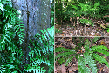  Another term is frond - tētē. [on screen - frond - tētē] A frond is similar to a leaf but scientists use the word frond because it has two functions - it works like the leaves of other plants, using sunlight for photosynthesis. But the fronds also produce the sporangia, which contain the spores we looked at earlier. It’s those spores that will be carried by the wind to new landing spots, and if conditions are right, they’ll germinate and grow.  Fronds can be really big - up to 5 m - like on a mamaku tree.  Mamaku_Cyathea_medullaris_Gerald_CC BY 2.5.jpeg  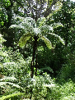  Or as small as 1 cm - like this little filmy fern.  Hymenophyllum_revolutum_OpuaForest_TePapa.jpg  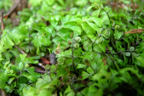  Often, diagrams help us to much more clearly see the different features of something. Here’s a diagram of a fern like the one that Patrick was describing in the video.  [Talk about the key features - rhizome, or underground stem, the frond, where the spores will grow in their sporangia, and we can also see a koru growing.  Filename: Fern-structure-SLH-UoW.jpg  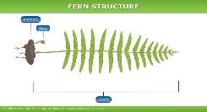  Koru - this is a word I’m sure many of you will know. It’s another New Zealand icon, and it is an integral symbol in Māori art, carving and tā moko, or tattooing, where it symbolises new life, growth, strength and peace.  Filename: Koru_Dicksonia_squarrosa_ManakauTararua_ProtectiveHairsTePapa.jpg  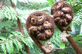  The koru is tightly coiled for protection. The koru can also have hairs or scales, like in this photo.  Draw a koru in your journal. [draw one on the whiteboard and talk about it uncurling as it grows - then act out as below -]  You’ve been sitting for a while. Can you tuck yourself into a koru and slowly unfurl and stretch your fronds in the air? Now pretend you’re a mature frond, with sporangia under each pinnae, or leaflet [wriggle your fingers.] If you give yourself a little shake, do you think spores will come off of you?
`na | Invite students to talk with whānau about identity and traditions, to make observations together and to experiment with fern spores. | The koru is also one of our national symbols. I’m sure you’ll recognise this from the tail wing of an Air NZ Airbus.  FILENAME: Air-New-Zealand-Airbus.jpg  If someone is watching TV with you, I wonder whether you can stand back to back and be a double koru. Can you recreate the Air NZ logo? Have a go and ask someone to take a photo. I’d love to see it!  Ka pai kaipūtaiao. I hope that, like me, you now know a lot more about ferns. But we can’t know everything - not even fern experts know everything about ferns yet!  Here are some things you can talk about with your whānau or classmates:  [Bullet points on screen - kai, art, sports logos  - Ferns - huruwhenua are a traditional food source. Does your whānau eat pikopiko or other ferns? Make sure you talk to your koro, kuia or kaiako about which pikopiko are safe to eat.  - Fern fronds play a part in many artistic and cultural practices. Talk to your whānau and see if they play a part in your culture.  - Our national sports teams wear the silver fern. Find out why - there’s an inspiring whakataukī behind its first use on a rugby jersey in 1888!  [See https://www.nzstory.govt.nz/news/the-history-of-our-national-symbol/ - the Presenter could read a bit if there is time.]  Some other things you could do with your whānau or classmates:  When you are out for a walk:  - Look for rhizomes that climb up trees or form stems.  - Check out frond size - who can find the smallest frond?  - Look at the underside of fronds for spore cases. They have all kinds of different patterns.  Try making a spore print.  - If you find a frond with spores on the underside, put it spore-side down on a piece of white paper. Leave it overnight. If the fern is ready to release its spores, the spore cases will open up and you will have a spore print the following morning. You may need to try a few different types of ferns, as some produce spores at different times of the year.  Whatever you do, I’d love to hear from you. Text 5811 or email info@hltv.co.nz. The keyword for this episode is ferns or huruwhenua.  [on screen: text 5811 or email info@hltv.co.nz  keyword: ferns or huruwhenua]  [Shout out to the Science Learning Hub for support planning this episode]  [Sign off]
Share: Learner and parent reflection on learning and engagement and what they can do next

