Home Learning TV – Middle Literacy

Segment lesson planning details
Title for segment: | Michel Mulipola: Superhero Secrets
Year levels (e.g. Yrs1 – 3): | 4-7
NZC learning areas: | English
Purpose of lesson:  (What learners will learn) | Today we are learning how to tell a story through a cartoon or superhero character
Success Criteria – students will be able to:  (how they will know when they have learnt it) | - Listen, read and use for information in a text  - create a superhero or cartoon character and share with others
Segment content/context details (as appropriate)
Māori specific content i.e. the learning draws on Mātauranga Māori: | UDL planning considerations for learners to use on their own imagination, beliefs, cultural perspectives to tell a story and create a superhero character.. | Pacific specific content i.e. the learning is focused on Pacific knowledge: |  | Michel Mulipola is a Samoan cartoonist living in Auckland. He shares his dreams and techniques as a cartoonist encouraging others to develop their own cartoons.
Segment production details
Equipment requirements: | ‘Superhero’ toy/soft toy  Whiteboard, whiteboard markers, blu-tack  Posters of illustrations from Frogs to be printed in colour A3 for the whiteboard  PowerPoint slides prepared
Copyright requirements:  Please be specific: Source(Seven Sizzling Sausages by Sam Smith –url link to the source), intended use (to demonstrate alliteration), and length (timings for video clips) | N/A - Crown Copyright MOE resources
Segment links and attachments (list all links to recordings or attachments, the source and confirm that copyright permissions are granted)
Links to recordings /resources | http://instructionalseries.tki.org.nz/content/download/38506/430752/file/Michel%20Mulipola%20%E2%80%A2%20Superhero%20Secrets-SJ%20L3%20Aug2016.pdf  http://instructionalseries.tki.org.nz/content/download/38146/427271/file/SJSL_L4_Frogs.pdf
Attachments
Segment plan content
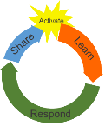 | Teaching and learning activities linked to purpose |  | High level script (key points/questions)
Activate: Activating prior learning, knowledge of contexts and relationships | Presenter greeting  Setting the context  Frogs 1 and 2 A3 colour on whiteboard  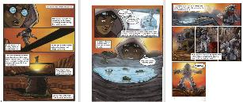  On whiteboard  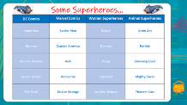  Slide 3 printed to A3 on whiteboard  Motivation to think, notice information in the text and to draw  Learning goals  Defining a superhero  Slide 2 on TV monitor  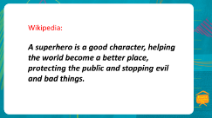  Slide 3 on full screen  Superhero contexts - DC, Marvel, Women, and Animal Superheroes |  | Mōrena, Malo and hello to everyone again.  Kei te pehea koe? How are you today?  I do hope you are well and having a great start to the day.  Today we are going to focus on writers and illustrators. Often the books we read are written by an author and then the pictures or illustrations are created by an artist called an illustrator. Often the writing and artwork are done by two or more separate people.  Think of the books you read at school, some of the picture books or magazines you have at home and even some of the books your whānau read. Most texts we read have illustrations whether they are photographs, drawings, painting, or collage.  Today we are going to be learning about a form of storytelling where the author is also the artist. Its where the stories and adventures that are retold with the art and illustrations with some text.  We are talking about cartoons and graphic novels.  I am sure you have a favourite cartoon character, graphic novel character or even a superhero. So many of these great stories are then made into movies.  Have a look at these two pages.  These are taken from the graphic text Frogs that tells the story of Tane, a boy struggling to survive in a world where drastic environmental changes mean that humans need to protect themselves from the heat of the sun.  Your school has copies of Frogs you might like to read. Ask your teacher.  Frogs is the work of Paul Mason and Michel Mulipola, an Auckland-based Samoan artist.  Notice how the story is shared through vivid illustrations, colour and the information to read is descriptive and short in narrative boxes. The character’s thinking is shown in those thought bubbles.  I am hoping you have some pencils and paper close by as today we are going to learn about techniques and tips on how to create great superheroes and cartoon characters. You might even draw some ideas as we read the information.  Our goals today are to:  - Tell a story through a cartoon or superhero character  - Use some of the tips Michel shared to create a superhero or cartoon character and share with others  I am thinking you might want to draw your own superheroes before the end of today. It could be a famous superhero you have seen before; it could be a totally new superhero or character and it could be fun to morph someone you know in your whānau into a superhero. It might even be you or your pet.  Before we get started let’s define what a superhero is.  Take a few moments to think or tell someone nearby what characteristics make a superhero.  *Pause - think time*  Here is a definition I found on Wikipedia  Let’s look at some of these cartoon superheroes and cartoon characters names.  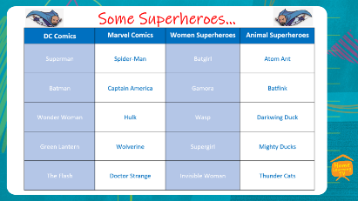  I’m sure you knew a few of those superheroes from comics or movies.  Can you add some more?

Learn: Introducing learning  Reinforce routines, provide multiple exposure to concepts, and strategies. Scaffolding learning | Gets the most out of the resource  Introduction to the text  Prompt for viewing and listening for key information  Slide 4 onscreen  Read text page 26  Slide 4 on screen on TV monitor  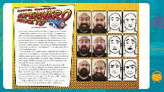  Prompt for viewing and listening for key information  Slide 5 on screen  Read text page 28  Prompt for viewing and listening for key information  Slide 6 on screen  Prompt for viewing and listening for key information  Slide 7 on screen  Read text pages 29-30  slide 8 on TV monitor by Marissa  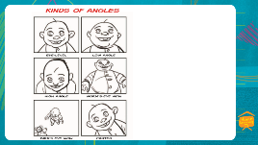  *Marissa has a superhero model or stuffed toy given a fictional superhero name on table to use as a model to show kinds of angles in context for learners*  Slide 9 on TV monitor  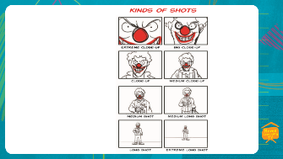  *Marissa has a superhero model or stuffed toy given a fictional superhero name on table to use as a model to show kinds of shots in context for learners*  Slide 10 full screen  Read text pages 30-31  Slide 11 on TV monitor by Marissa  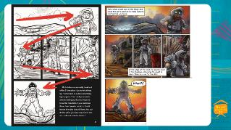 | The title of the article we are reading today is Michel Mulipola Superhero Secrets.  Its written by Hannah Sperber but does not tell us who the illustrator is.  Look for the clues across these pages to see who the illustrator is.  As we read this information, I would like you to be looking and listening for:  - Where you will find Michel most days, and  - What Michel’s dream is  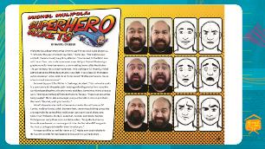  Michel Mulipola Superhero Secrets  By Hannah Sperber  Michel Mulipola discovered comics when he was five years old: a pile of 2000 AD. “I remember the exact moment I saw them,” Michel says. “The bright colours and bold characters really caught my attention.” Mesmerised, Michel fell in love with the art form. He’s made comics ever since. He’s just finished illustrating a graphic novel for American readers, a pro-wrestling drama called Headlocked: The Last Territory. Fans already want more. (He’s working on it.) Recently, Michel got to meet some of those fans at Comic-Con. Held in San Diego, it’s the biggest comic convention in the world. Or as Michel puts it: “It’s the international mecca of comic-book awesomeness.”  But most days you’ll find Michel in Onehunga, Auckland. This is where he works in a comic store. It’s the perfect job – reading and selling comics from round the world and spending time with other comic-book fans. Sometimes, Michel draws at work. “It brings something different to the store,” he says. “People can see comics being created.” Michel also encourages young cartoonists to come in and share their work. “We chat, and I give them tips.”  Michel’s dream is to be the first Samoan to draw for Marvel Comics or DC Comics. He doesn’t mind which. Between them, these two publishing companies are responsible for some of the world’s most iconic comic-book characters: Spider-Man, Wolverine, the Hulk, Superman, Batman, and Wonder Woman. Michel grew up loving these comics and characters. “Being able to draw my favourite superheroes is a massive goal of mine. But Marvel and DC are giants. You have to be hugely talented for them to notice you.”  Perhaps you’d like to work for Marvel or DC? Maybe even beat Michel to it! He has some secrets for making good comics, and he’s willing to share  Have you decided who the illustrator for this article is?  I think it could be Michel.  The clues for me were the six photos of Michel pulling different facial expressions and with six cartoon sketches that look like the photos. The final clue was a cartoon superhero with cape under the heading Michel Mulipola Superhero Secrets who, again, looks like the 6 photos of Michel.  When reading graphic novels and cartoons you need to look across illustrations for clues to make meaning because sometimes there is not a lot of writing to tell you.  Now, we had two things to read and listen for. I am confident you will know.  - Where you will find Michel most days?  and  - What is Michel’s dream?  Pause. - Think Time  Ae, ka pai.  Michel can be found working in a comic store selling comics in Onehunga, Auckland and he draws at work. He encourages young cartoonists to come in and share their work. He even gives them tips!  Tumeke!  I also learnt that Michel’s dream is to be the first Samoan to draw for Marvel Comics or DC Comics.  Michel said he would give us some tips for developing our own cartoon.  I hope you have plenty of paper and pencils close by.  Here’s a challenge - can you make 4 or 6 different facial expressions?  Why not take some photos of yourself, or look in the mirror and sketch yourself as a cartoon character of your photos?  You might like to do that after we have finished reading.  Here’s Michel’s first Secret.  As we read, take special note of two things Michel tells us about planning and characters.  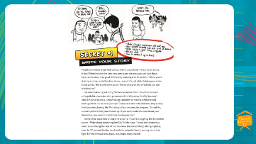  Secret #1  Write your story  People sometimes forget that comics aren’t just pictures – they’re stories too. In fact Michel reckons the very best comics are the ones you can’t put down because the story is so good. This is why planning is so important. “When you’re starting a comic, write the story down – even if it’s just a bit of dialogue or a few bullet points. This is called the script. The script is a bit like directions you can refer back to.”  So what makes a great story? Michel can answer this. “Good stories need unforgettable characters who go on some kind of journey. And by ‘journey’, I don’t mean a road trip. I mean facing a problem or making a mistake and dealing with it. It’s an inner journey.” Characters who make mistakes stop a story from becoming boring. But Michel says they have another purpose. “In real life, no one’s perfect. Everyone messes up. If you want readers to care about your characters, you need to show them messing up, too.”  Sometimes, ideas take a long time to come. If you’re struggling, there’s another option. “Write about something familiar,” Michel says. “I once did a humorous comic about the lighter side of life. You know the kind of thing: siblings fighting over the TV remote; Sunday lunch with the extended family turning into a food fight. For me it was an easy topic, but people really liked it.”  What did Michel tell us about planning?  Michel said the best cartoons are the ones you can’t put down because the story is so good. The story must be planned. It can be dialogue, what is said, or a few bullet points.  This is the script. The script is like the directions.  What did Michel tell us about characters?  Ae, characters in good stories are not perfect and they make mistakes and deal with it.  Let’s look closely at the cartoon as I read.  Can you see:  - 5 pieces of the plan?  - the dialogue in speech bubbles?  - the difference in Joe’s facial expression?  - Think about how Joe might be feeling, look at his face and the way he is standing  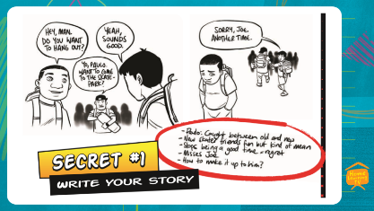  “Hey man do you want to hang out?”  “Yo, Paulo. Want to come to the skate-park?”  “Yeah, sounds good.”  “Sorry, Joe. Another time.”  Did you notice how different Joe was in the two pictures of him?  The first one he was smiling and talking. In the second he looked sad, looking down and was alone.  The cartoonist has shown different emotions by drawing rather than writing them. The facial expressions show how Joe feels.  Here is the second tip from Michel to help you with your cartoon drawings. He compares comic writing to another form of art. An art form that involves a lot of people.  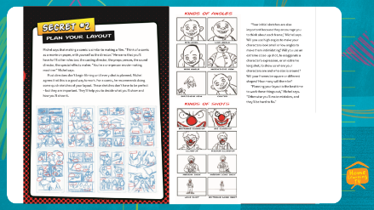  Secret #2  Plan your Layout  Michel says that making a comic is similar to making a film. “Think of a comic as a movie on paper, with yourself as the director.” He warns that you’ll have to fill other roles too: the casting director, the props person, the sound director, the special-effects maker. “You’re a one-person movie-making machine!” Michel says.  Most directors don’t begin filming until every shot is planned. Michel agrees that this is a good way to work. For a comic, he recommends doing some quick sketches of your layout. These sketches don’t have to be perfect – but they are important. They’ll help you to decide what you’ll show and how you’ll show it.  “Your initial sketches are also important because they encourage you to think about each frame,” Michel says. Will you use high angles to make your characters look small or low angles to make them intim idating? Will you use an extreme close-up shot, to exaggerate a character’s expression, or an extreme long shot, to show us where your characters are and who else is around? Will your frames be square or different shapes? How many will there be? “Planning your layout is the best time to work these things out,” Michel says. “Otherwise you’ll make mistakes, and they’ll be hard to fix.  Wow, a comic is like a film on paper.  People often think comics are simple but as you can see the illustrator needs to think of everything.  Planning your layout is important so you think about how you draw characters in each frame.  Michel has shown different ‘Kinds of Angles’ to view the same object. These are important techniques to add to the cartoon or film.  Eye-level is drawing or looking straight at our character  Low angle is looking up at the character  High angle is above the character and looking down on them  Worms-eye view is really low, looking up from the ground.  Bird’s-eye view is from above, imagining what a bird flying in the sky would see looking down  And,  Canted is at eye level but on an angle.  See how that can make your character look so different and create impact?  Have a look at the TV monitor again and think about how you might draw your cartoon character or superhero using some of these techniques. That way the character will do not look the same in each frame.  Pause  Here’s another cartoonist’s technique.  Michel also gave us tips on techniques called ‘Kinds of Shots’ that are used in movies, cartoons and graphic novels. They add impact and can be used to show how close or distant your character is.  Pause  Extreme close-up is very close with only a few features visible.  Mid close-up is still close, but you can see more of the character’s face.  Close up is like a passport photo with the whole head in the frame.  Then, do you see as the shot is further away from the character you see more of them and they appear smaller?  Medium close-up, medium shot, medium long shot, long shot, and finally extreme long shot where the character looks small in the distance.  Think how you might use one or two of those shots in a cartoon panel. The same character can look so different depending on the kind of angle or the kind of shot.  The third secret from Michel is about layout.  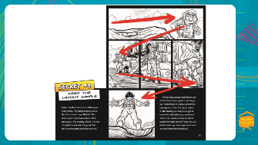  Secret #3  Keep the layout simple  Make sure that readers can follow your story easily. “Try using a layout called the Z formation,” says Michel. “This means your story travels from left to right, much like reading a book. It is very straightforward, which is good. You don’t want readers working too hard.”  Michel does occasionally break out of the Z formation – just to mix things up. “Sometimes in a story something big happens. Then the layout needs a little shaking up. But you have got to know the rules before you can break them. I can tweak a comic so that it breaks the rules but still flows. You can do this when you have experience and are confident with the basics.”  Did you know about the Z formation? I did not know until I just read that in the text. The Z formation is inmportant for overall design and layout.  Because there is lots of action in cartoons and graphic novels your eye can wander anywhere and not go to the left margin like a story that is printed text.  Think of the Z formation of the layout and then look how different the same cartoon can look in colour.  The Z formation helps the reader look at all the panels and read the text an not miss any of the story or detail in the story.
Respond: Providing opportunities to use and practice | Directly relevant to learning intention  Involves student participation – with options about how it can be done  Slide 12 on TV monitor  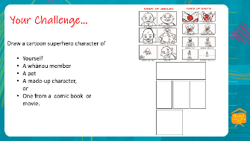 | So, let’s look at our goals for today and see if we have achieved them  Our goals were to  - Tell a story through a cartoon or superhero character  - Use some of the tips Michel shared to create a superhero or cartoon character and share with others  We have gained lots of ideas about how to plan a story the reader doesn’t want to put down, create a character who is not perfect but does good and use different techniques using angles, shots and the Z formation to make my comic have impact  Remember : ‘A superhero is a good character, helping the world become a better place, protecting the public and stopping evil and bad things.  I think Michel is a super hero.  What I’d like you to do at home, on your own or with a whānau member is do be a cartoon illustrator. Here are some of the tips from Michel.  You might want to draw a cartoon super hero character of  - Yourself  - A whānau member  - A pet  - A made up character or  - One from a comic book or movie.,  After that if you could plan a short story with 4 or 5 panels of a cartoon.  Its exciting.  As Michel said. You are not only the cartoonist, its like making a film. You are in charge of everything.  See if you can include different kinds of angles and types of shot.
Share: Learner and parent reflection on learning and engagement and what they can do next | Debrief prompts student’s reflection on learning outcomes and progress  Includes opportunity to share learning or learn together with whānau , HLTV or others  - Reiterates the task if done outside of the lesson  - Introduces ‘independent learning’ through a provocation  Guide whānau | I do hope you enjoyed today and hope that you are inspired to plan and create your cartoon. The possibilities are endless.  To quote Buzz Lightyear from Toy Story. “To Infinity and Beyond”  We would love to see your character, superhero, or cartoon. Your whānau, friends and teachers at school would too.  You could text or email them into me at info@hltv.co.nz or text to 5811.  Ka kite. Until next time, have a great day.

