Home Learning TV

Segment lesson planning details
Title for segment: | Construction: Saving a sea wall
Year levels (e.g. Yrs1 – 3): | Years 4-7
NZC learning areas: | English
Purpose of lesson:  (What learners will learn) | The purpose of the lesson is to:  Build vocabulary linked to the movement of waves  Read an article which is set at St Clair Beach in Dunedin and describes 3 constructions used to protect the sea wall from erosion.  Read for meaning and synthesise the key ideas.
Success Criteria – students will be able to:  (how they will know when they have learnt it) | Students will:  Discuss the effects of wave actions on a sea wall and beach  Identify some constructions used to protect a sea wall from erosion  Summarise and synthesis the main ideas
Segment content/context details (as appropriate)
Māori specific content i.e. the learning draws on Mātauranga Māori: | It’s not explicit in text, but will make links to protecting the environment –to Kaitiaki (guardianship) and kaitiakitanga - protecting and looking after the environment. |  | Pacific specific content i.e. the learning is focused on Pacific knowledge: | Not in this lesson
Segment production details
Equipment requirements: | Whiteboard, PowerPoint, sentence strips, Large chart or poster with the structure of the text – as in the instructions
Copyright requirements:  Please be specific: Source: (Seven Sizzling Sausages by Sam Smith –url link to the source), intended use (to demonstrate alliteration), Length (timings for video clips) | None:  Min of Ed - Connected 2006 The Sands of St Clair  I have attached photos of the 3 pages for the presenter in case there’s no access to the Connected journal.
Segment links and attachments (list all links to recordings or attachments, the source and confirm that copyright permissions are granted)
Links to recordings /resources
Attachments | Lesson plan, powerpoint, photos of the text for presenter’s reference
Segment plan content
 | Teaching and learning activities linked to purpose | High level script (key points/questions)
Activate: Activating prior learning, knowledge of contexts and relationships  (5 mins) | Welcome  Setting the connection to the topic  Setting the specific context – constructions to protect a sea wall  Front-loading vocabulary  Making meaning and making connections  Highlighting the problem  Locating the setting | **presenter**  Welcome etc.. adlib  This week we are thinking about construction. This is about the way that people are able to design, make or build objects that we need. Constructions may be made of materials such as paper, wood... or the natural materials around us.(adlib to match consistency of message across the 4 lessons)  Today we are thinking about and reading about some constructions that have been built at a beach. We are going to read an article about different types of constructions that have been put in place to make a beach much safer. But more about that soon.  Our goals for today are to  - discuss the effects of wave actions on a sea wall and beach  - identify some constructions used to protect a sea wall from erosion  - summarise and synthesis the main ideas  In Aotearoa, we are an island, so we are surrounded by the sea. Did you know that there is nowhere further than 120 kilomentres away from the sea. How far away are you? Do you like going down to the beach?  I do. I like to walk along the sand and watch all of the people and the waves.(adlib)  It’s always different every time I go. I like the fact that some days the sea is gentle and quiet. But on other days it is rough and very loud.  **Powerpoint slide 2**  Have a look at these two photographs. They are both photos of the sea. What is the difference between them?  What words could we use to describe the sea in these photos? (pause)  Did you notice that in the photo on the left, the sea is calm with hardly any waves... and in the photo on the right the sea is rough and the waves are high and dramatic...  ** presenter**  (**Note to presenter** Have the phrases on strips of card to blutak to the whiteboard**)  Sometimes writers like to use words and phrases that create a picture in our minds.  Here’s some phrases which describe the sea, in particular the action of the waves. These phrases are in our article, so you will recognise them and know what they mean when we read. Let’s have a look. You might like to read along with me..  **Presenter Read the list and place the strips with each phrase onto whiteboard:  water rushes out, tugging at your legs  the sand is dragged into the sea  the ocean is calm  waves rush up and crash down  waves lap at the beach  its great for surfers  Which phrases could describe a calm, gentle sea and which ones describe a rough sea? (pause) I’m going to sort them. See if you agree with me.  ** presenter** sorts into 4 ‘rough’ phrases and 2 ‘calm’ phrases  Emphasise the wave action linked to tugging, dragged (rough) and lap (gentle) as these words may not be known (adlib)  When the actions of the waves are rough or strong, they can create problems for the beach and buildings nearby. The article we are going to read today is set at St Clair beach in Dunedin. Here they had a problem because the old sea wall was being washed away by the rough sea and the action of the waves.  The council have needed to do a lot of construction to save the beach and the sea wall. We’re going to read about this construction today. It’s important that we are kaitiaki of our beautiful land and work to protect it. It’s good if kaitiaki work together in teams to find ways to solve problems. That’s what we’ll learn about in the article.  **Powerpoint slide 3**  Here’s a map of Aotearoa. It’s showing our 3 main islands. Notice the long, narrow shape of our islands and the length of our coastline or beaches. Remember I mentioned that no place is far away from the beach.  Can you see where Dunedin and St Clair beach is? (pause) It is on the east coast of the South Island. Perhaps you’re watching and have been to this amazing place.
Learn: Introducing learning  Reinforce routines, provide multiple exposure to concepts, and strategies. Scaffolding learning  (12 mins) | Introducing the text  Reiterating previous skills (non-fiction text features  Reading closely – diagram  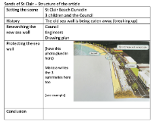  Prediction and questions to activate meaning  Making connections between text and visuals  Making connections back to the front-loading of vocab.  Prediction and listening for specific information  Use of a graphic organiser to make sense of the text  Use of specific non-fiction features; sub-headings, diagrams etc | **Presenter**  Today I’m reading an article called the Sands of St Clair and it is written by Bill O’Brien. It’s mainly a non-fiction text, an article, so you will notice, photographs, diagrams and sub-headings to help with the organisation of the ideas.We’ve learnt about these things before.  We will summarise the main ideas in some of the article as we read. That will help us make sure we have understood the overall meaning.  Like most articles, the one we are reading today has a structure that helps us.  **Refer to wb**You can see this in my chart/poster. I’ll be talking about it as we read. At the start of the article; we will set the scene, cover some history and find out about ways to protect the sea wall.  **Have on a large piece of paper (poster/chart) on Whiteboard looking like this:**  I’m going to read the article to you now.  **Powerpoint slide 4** Read aloud the text:  The Sands of St Clair by Bill O’Brien  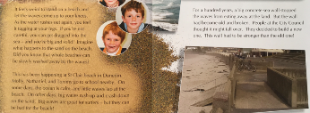  Now let’s look closer at the diagram. It has got an explanation to help us understand clearly.  It says: Waves bring sand from the sea and dump it on the beach..  And, waves also take sand away from the beach as the water flows back to the sea.  The arrows show the direction of the sand coming in to the beach, and then the sand rushing back. Unfortunately, its these waves that can damage the beach and land near by.  ** presenter**  Did you see the words and phrases we talked about at the start today. I hope you were able to . **point to them on the whiteboard** Great work.  Let’s see what Molly, Nathaniel and Tommy do next. Listen for a question the children want to know and what they decided to do about it.  Read aloud the text:  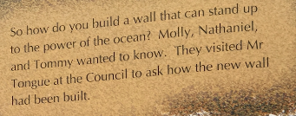  So the children want to know if the sea wall will stand up to the power of the waves. That was a good question for the Council. Let’s see what Mr Tongue tells them.  **Powerpoint slide 5** Read aloud the text:  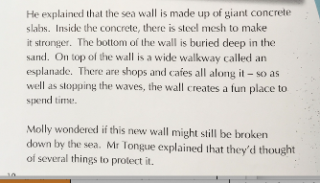  **Powerpoint slide 6**  Presenter script/say aloud  We know from the article that the Council have some ideas to protect the new sea wall.  In the article there is an engineer’s drawing plan that shows what the sea wall and esplanade will look like. This drawing plan is helpful for us as we read, so that we can make connections to exactly what Mr Tongue at the Council is talking to the children about.  Look closely at the label for the esplanade. We can see the wide walkway, and the shops and cafes along it. Look closely at the label for the sea wall. Perhaps you can tell it is made of giant concrete slabs, even though we can’t see the steel mesh to make it stronger.  Can you see the pull out arrow on the plan? (pause) It shows a more detailed drawing (a close up) of the steps to the beach and the sea wall . You can’t quite see it in the drawing plan, but right at the far end of the beach at the top left of the plan, there is a swimming pool. This pool is a bit different because it’s filled up with sea water for people to swim in.  **Presenter**  Do you have a picture in your mind now? Do you have a clearer idea about the esplanade and sea wall at St Clair?  (pointing to relevant parts of the chart)  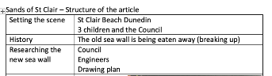  Let’s check in on our chart/poster that shows the structure of the article so we can check in with what we already know.  So far we have ‘set the scene’ we know… .. read aloud the top 3 boxes (adlib)  The last thing we read in the article was that the Council had some constructions in mind to protect the wall and esplanade. I wonder what these will be? Let’s find out.  **Powerpoint slide 7**  Can you see the sub-heading – It says ‘Bolted rocks’ This is the first type of construction. Let’s read what bolted rocks are and how they will protect the beach. You could read along with me and see how you get on understanding.  Read aloud the text:  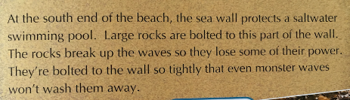  Look closely at the photo. Can you see the huge white bolts going down through the top of the rocks into the wall. How do these help? (pause)  Can you find the sentence that tells us (pause)  Read: It says…The rocks break up the waves so they lose some of their power.  Let’s read a bit more to find out what other constructions have been used.  **Powerpoint slide8**  Can you see the sub-heading – It says ‘Rip rap” This is the second type of construction. Let’s read what riprap is and how it will be used to protect the beach. You could read along with me and see how you get on understanding.  Read aloud the text:  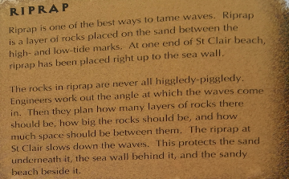  Did you understand how rip rap works? There is a diagram with labels to help us make a connection to the words in the article.  I was surprised to learn that the rocks are placed so carefully because of the engineer’s knowledge of wave angles. What did you think? (pause)  Let’s read a bit more to find out what the final construction to protect the beach is.  **Powerpoint slide 9**  Can you see the sub-heading – It says Sand sausages. That’s an interesting sub heading!  Let’s read what sand sausages are and how they will be used to protect the beach. You could read along with me and see how you get on understanding.  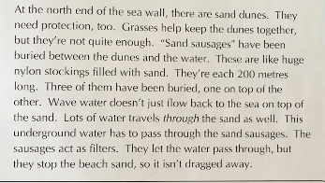  Read aloud the text:  I can see from the diagram that the large rolls of sand really do look like sausages. Did you know that water flowed down the beach through the sand as well as on top of it? (pause). Those sand sausages act as a filter to stop the sand falling back into the sea. That is a very clever construction.
Respond: Providing opportunities to use and practice  (3 mins) | Directly relevant to learning intention  Involves student participation – with options about how it can be done  Constructing a summary  Listening to a conclusion | **Presenter**  What a lot we have learned about constructions at the beach. Did you notice how the sentences gave us the information we needed. Some sentences were very important for us. Let’s check that we understood the information about the 3 ways the council are saving the beach and esplanade.  **Go to whiteboard/poster/chart**  Can you see on the poster that I have a diagram from the article showing the plan of St Clair beach. Let’s check that we understood each of the constructions by writing a summary.  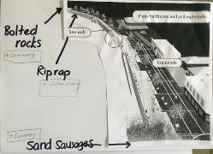  Draw arrows or a sketch onto the map of the beach (adlib) while writing the summaries.  Here’s where the bolted rocks are. In the article it told us that (speak and write) ‘Bolted rocks are large rocks bolted to the wall to break up the power in the waves’.  I’ve been able to write a summary about this in just one sentence. Did you think of something similar? (pause)  What about the riprap?(pause) We don’t always use the exact sentences in a summary, just recreate the main idea. I think I’ll write..  Rip rap are layer of rocks that have been placed at exactly the right angles to slow down the waves. What did you think of?  Let’s summarise the way the sand sausages work. What would you say here? (pause)  I’m going to use my knowledge from the words and the diagram to help me.  I’ll write.. Sand sausages are rolls of sand over 200 metres long that are buried beneath the beach to stop sand being dragged back out to sea.  I’m happy with my summaries of the three different constructions protecting the sea wall and beach at St Clair. Poster/chart with the structure of the article has really helped me to think about the main ideas. Articles don’t always have a conclusion at the end. This one does though and I think it helps make it sound finished off.  I’ll read it to you.. Read aloud the conclusion ..Now st Clair has a beautiful esplanade to stroll along and a beach with plenty of sand. That’s great for the kids. A beach without sand wouldn’t be much fun!
Share: Learner and parent reflection on learning and engagement and what they can do next  (1 min 30 sec) | Debrief prompts student’s reflection on learning outcomes and process  Guide whānau  Includes opportunity to share learning or learn together with whanau, HLTV or others  - Reiterates the task if done outside of the lesson  - Introduces ‘independent learning’ through a provocation | Do you remember our goals for today?  That is right we were going to  - discuss the effects of wave actions on a sea wall and beach  - identify some constructions used to protect a sea wall from erosion  - summarise and synthesis the main ideas  How did you go, did you achieve the goals today?  We’ve learned a lot about being kaitiaki and protecting the beach today.  Did you notice the features of non-fiction text that helped us to read and understand; the diagrams, the paragraphs, the sub-headings and the photographs all help us.  Perhaps you live near a beach. Is there a sea wall or shops or an esplanade along the beach? Can you see any ways that the beach is being protected from rough waves?  Find out by doing some research: What is done to protect the beach so the sand can stay in place? (for example; planting tussock or creating walkways)  Perhaps your council has planted tussock or created walkways so that the sand can safely stay in place.  Ask someone in your whānau if your beach is calm or rough. Tell them about some of the phrases you learnt today. Do they know how the beach near you is kept safe?  If you liked the sounds of some of the words today you could write some more phrases about calm sea and rough sea. You could write a poem.

