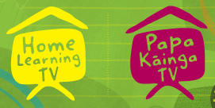
Home Learning TV – Lesson Plan – 20 September

Title for segment: | Matariki - The Stolen Stars of Matariki
Year levels (e.g., Yrs1 – 3): | Junior Years 1-4
NZC learning areas: | English (Reading Level 2)  - show some understanding of ideas within, across and beyond texts (making meaning through identifying main ideas in a story map)  - show some understanding of text structure (order and organisation or words and images contribute to text meaning)  English (Writing Level 2)  - organises and sequences ideas and information with some confidence (using a story map to structure and plan writing)  Social Science (Level 2)  - Understand how cultural practices reflect and express people’s customs, traditions, and values.
Purpose of lesson:  (What learners will learn) | Learners will:  - learn how to make connections between reading and writing through story mapping to identify main events  - understand how the characters and settings in a story help to structure the main events  - make connections between their planning and writing of the text
Success Criteria – students will be able to:  (how they will know when they have learnt it) | Learners will be able to:  - unpack the main events in a story to understand how the author planned for writing  - plan for their own writing by mapping out their story including characters, setting and main events.
Māori specific content i.e., the learning draws on Mātauranga Māori: | Matariki | Pacific specific content  i.e., the learning is focused on Pacific knowledge:
Equipment requirements: | TV screen for PowerPoint images, whiteboard for writing, printouts of (setting, character, event) cards, large, printed story  mountain (in slides), blu-tack
Copyright requirements:  Please be specific: Source: (Seven Sizzling Sausages by Sam Smith –URL link to the source), intended use (to demonstrate alliteration),  Length (timings for video clips) | https://www.tvnz.co.nz/shows/goodnight-kiwi/episodes/s1-e4 - Goodnight Kiwi (TVNZ) reading of the story by Stacey Morrison http://clipart-library.com/ - Free Clipart Library
Links to recordings /resources | https://www.tvnz.co.nz/shows/goodnight-kiwi/episodes/s1-e4 - Goodnight Kiwi (TVNZ) reading of the story by Stacey Morrison
Attachments | Printable Slideshow for whiteboard
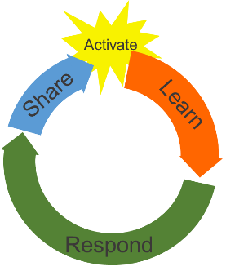 | Teaching and learning activities linked to purpose |  | High level script (key points/questions)
Activate: Activating prior learning, knowledge of contexts and relationships | Please read through the whole lesson to understand the sequence of the learning steps and teaching points.  Learners will;  - learn how to make connections between reading and writing through story mapping to identify main events  - understand how the characters and settings in a story help to structure the main events  SLIDE 2  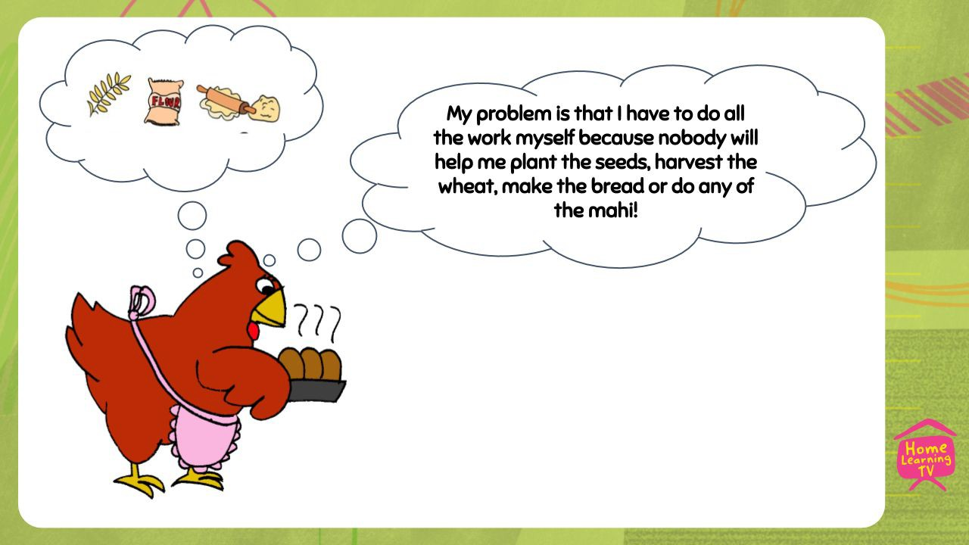 |  | (***ON CAMERA***) Kia ora, talofa, malo e lelei, hello. It's great to see you - welcome to our learning time.  Today we are going to continue our learning about Matariki and hear another story that teaches us about the importance of the Matariki stars. Do you know that reading and writing are linked? Sometimes we are the reader of the story, which somebody else has written for us to enjoy.  Other times we are the writer of the story where we create a story for somebody else to read and enjoy.  In reading we listen out for main events which tell us what is happening. Often the author will start by setting the scene, telling us where the story takes place. This is important to help us build a picture in our mind as if we were watching a tv programme or a movie. We also meet different characters along the way. Why do you think characters are important in a story? I think they are the ones who tell the story through their actions and words. Characters often come across a problem which they have to solve. Let’s look at some characters we might know from traditional stories and think about the problems they face.  (***POWERPOINT OS***) SLIDE 2 [presenter to read out thought bubble] The Little Red Hen, hmmm she didn’t have anybody to help her make the bread. Her problem was that she had to do all the mahi by herself. SLIDE 3 [presenter to read out thought bubble] What about the Three Little Pigs? They had a problem too...I’ll give you a clue! Their

 | SLIDE 3 | problem huffed and puffed and blew their houses in. That’s right. The
 | 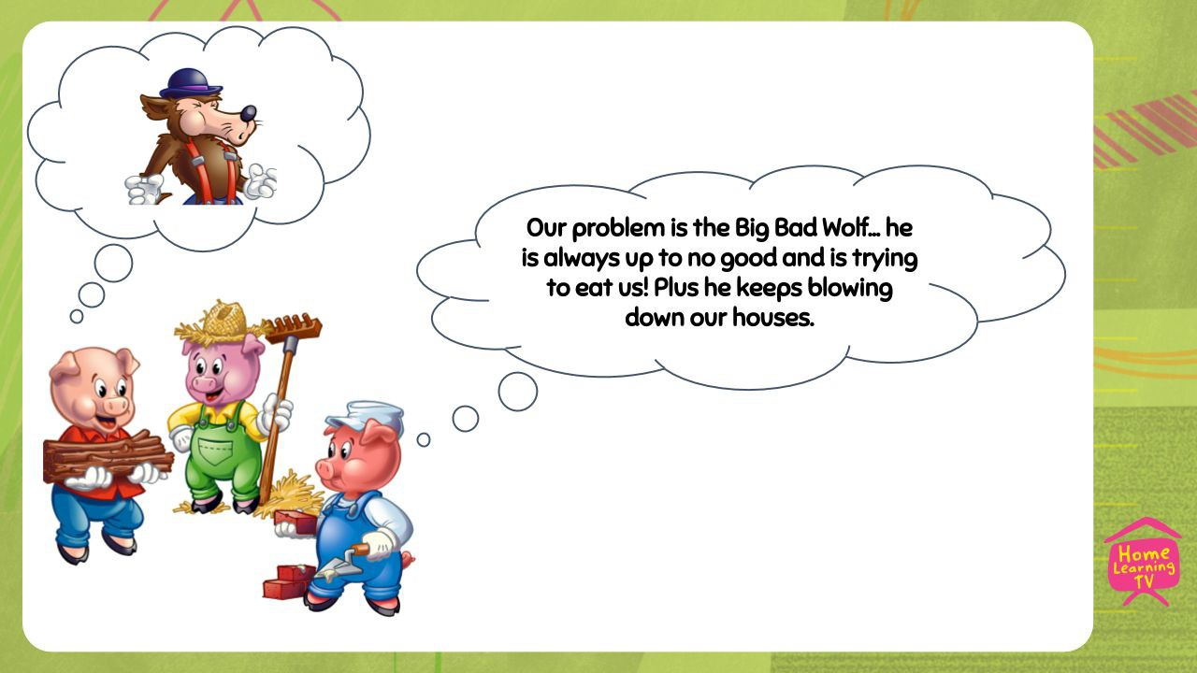 | Big Bad Wolf was their problem and he wanted to blow down their  houses and eat them up.  (***ON CAMERA***) When the author is creating a story they will be thinking about the events and problems that might happen for the characters. This makes the story exciting for the reader and helps us to understand it.
 | SLIDE 4  Presenter to point to the words on the screen, beginning  middle end  characters/setting events problem/resolution  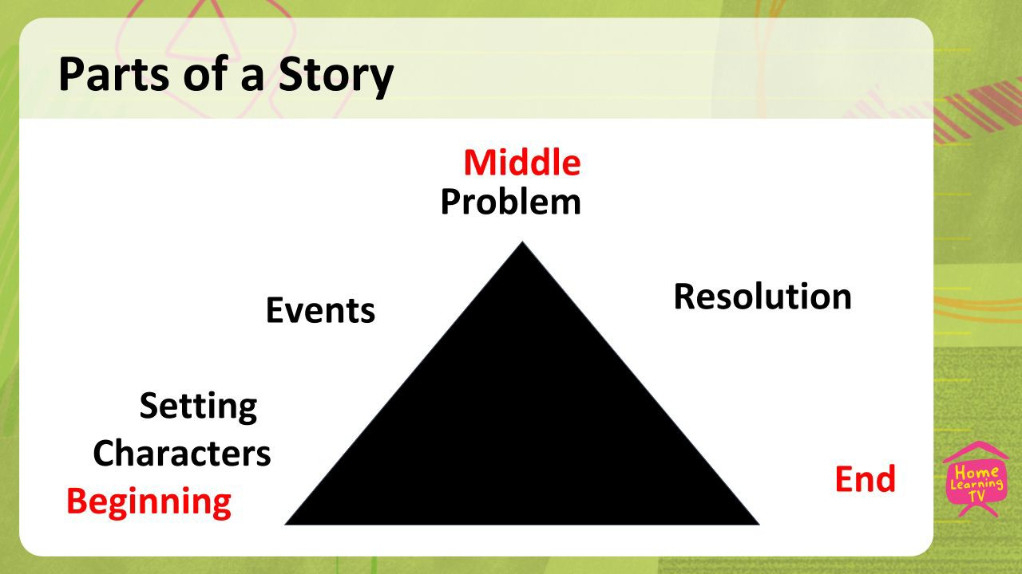 | (***POWERPOINT OS***) When we write stories, we might use a story  map to plan out our ideas before we start writing. SLIDE 4 We know that stories have a beginning, middle and an end. During each part of the story, some other things need to happen. This will give our writing structure. At the beginning, the characters are introduced, and the author describes the setting. This helps us to begin and understand what’s happening. Next, lots of events will happen which continue the story and tell us what the characters are doing. At least one of these events will be a problem or something that adds excitement or drama - this happens near the middle. Then towards the end of the story the problem will get resolved and the ending will happen. Story maps help us to make connections between the characters and the events that happen to them. When I write a story, I always do a plan first because it makes the writing process easier. All my hard-thinking work has been done and that gives me a plan of where I am heading when I’m writing.
 |  | (***ON CAMERA***) Ka Pai - great learning everyone. [complex idea,
 |  | presenter needs to speak slowly with pauses] Remember when we think
 |  | about stories we have to wear two hats; One is our reader’s hat...this is
 | Learners will;  - learn how to make connections between  reading and writing through story mapping to | when we enjoy reading a story that somebody else has written. We have  to work out what they are saying and the main points of the story. Our other hat is our writer's hat… this is where we use what we noticed when
 | identify main ideas. | we were reading and apply it to our own writing. This ensures that our  story has all the right parts and flows nicely for our audience. This will
 |  | help when planning our own writing later.
 |  | In our story today, we are going to meet Te Rerehua and Sam who often
 |  | stay with the Grandma and Pōua at a special place called Te Mata
 |  | Hāpuku. The problem is that some cheeky patupaiarehe steal something
 |  | that is important. Te Rerehua and Sam set about making things right.
 |  | As we listen to the story, see if you can hear the characters and where
 |  | the story is set. Try to remember what the problem is and how it is
 |  | solved.
Learn: Introducing learning | Watch Goodnight Kiwi S1E4 | TVNZ OnDemand | (***ON CAMERA***) Let’s get ready to listen and read along with the story. (***POWERPOINT FF***) (***ROLL VT***) TVNZ Goodnight Kiwi Reading - 8 Mins  (***ON CAMERA***) Birdlings Flat, what an amazing setting for the story. I would love to go there to find agate, wouldn’t you? Te Rerehua and Sam are very lucky to get to visit Te Mata Hāpuku and have such fun holidays. Do you have a special place that you and your whanau like to visit? Perhaps it is a place where you go on adventures which you can then write stories about? (***ADLIB***) presenter to talk about a special place to her. Hmmm... how many characters can you remember from the story? Try and list them using your fingers to count. (***POWERPOINT OS***) SLIDE 5 Let’s see… did you remember Sam? Te Rerehua? Grandma and Pōua? And there were some other characters who came into the story when the problem occured? That’s right! The patupaiarehe who were stealing the Matariki stars.  (***ON CAMERA***) So far, we have noticed the setting and the characters - two important parts of any story. Now we need to think about what happened during the story. We call these the events. Some of them will lead to the problem and some will lead to the resolution.  In our story did you hear the problem that Te Rerehua and Sam faced? Remember when Grandma looked up into the night sky and counted the stars? She told her mokopuna that there were two stars that were missing. Why was this such a big deal? Grandma explained to Te Rerehua and Sam that “without those two stars it will be hard to know when to stop eeling and rest for winter”. Sam and Te Rerehua knew they had to get the stars back. Let’s look at the events together and try to think about which order they happened in the story. To help us retell the story, we can use a story map.  (***WHITEBOARD***) [large story mountain attached and cards ready to order] This is my story maunga or map. As the story gets more exciting, we go further up the mountain. Then we get to the top where the problem happens. First, we need to think about where each label goes.  These ones in whero, say beginning, middle and end. I think we know where they would go so, we could put them in place on the maunga. Now it gets a little bit trickier as we have to look at the pictures and see if we can figure out which ones are the characters, the setting, the events, the problem, and the resolution.  [after speaking about each picture, presenter will blu-tack picture in appropriate place on mountain]  What can you see in this picture [presenter picks up the character picture]. This is Grandma, Te Rerehua, Sam and Pōua. They are the characters. Can you remember when these characters are introduced in the story? Point to the place on our story maunga where you think the characters might go. That is right! At the beginning. The other thing that needs to be introduced near the beginning of a story, is the setting. [presenter picks up setting picture]. Why do you think this might be? Well
Reinforce routines, provide | https://www.tvnz.co.nz › TVNZ OnDemand ›
multiple exposure to concepts, and | Goodnight Kiwi
strategies. Scaffolding learning | 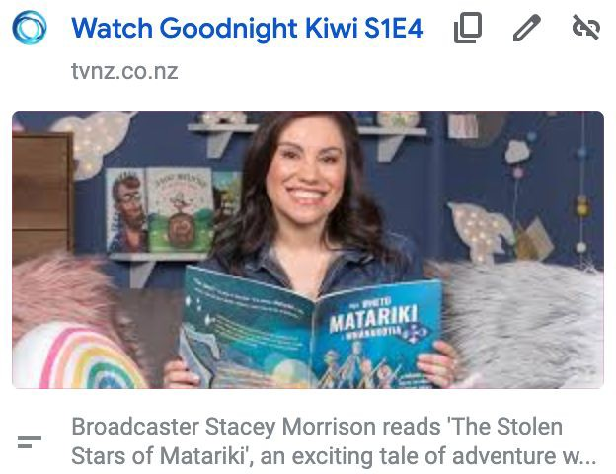
 | SLIDE 5
 | 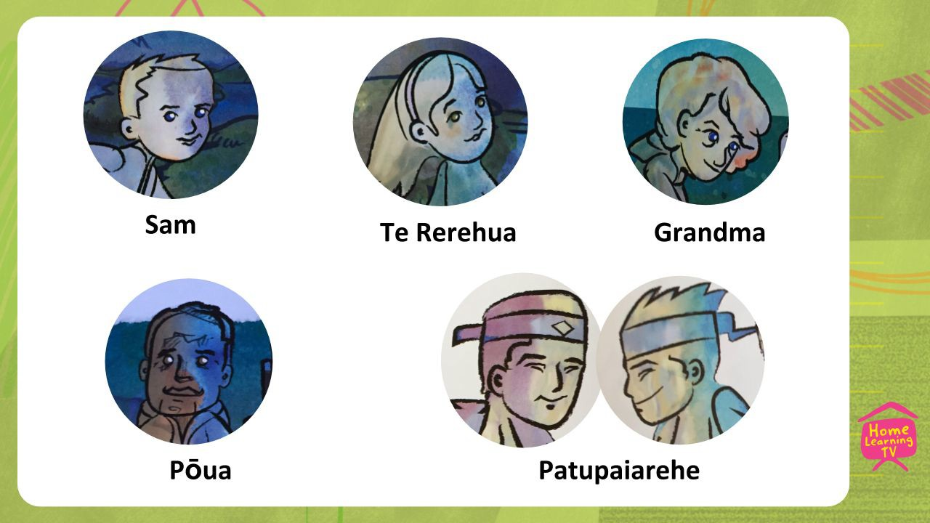
 | Learners will;
 | - understand how the characters
 | and settings in a story help to
 | structure the main events
 | - learn how to make
 | connections between
 | reading and writing through
 | story mapping to identify
 | main ideas.
 | Presenter to move pictures and labels to the correct place on
 | the story mountain. Do this while thinking aloud about the
 | order of the story mountain.
 | ON PRINTABLE SLIDES FOR WHITEBOARD
 | 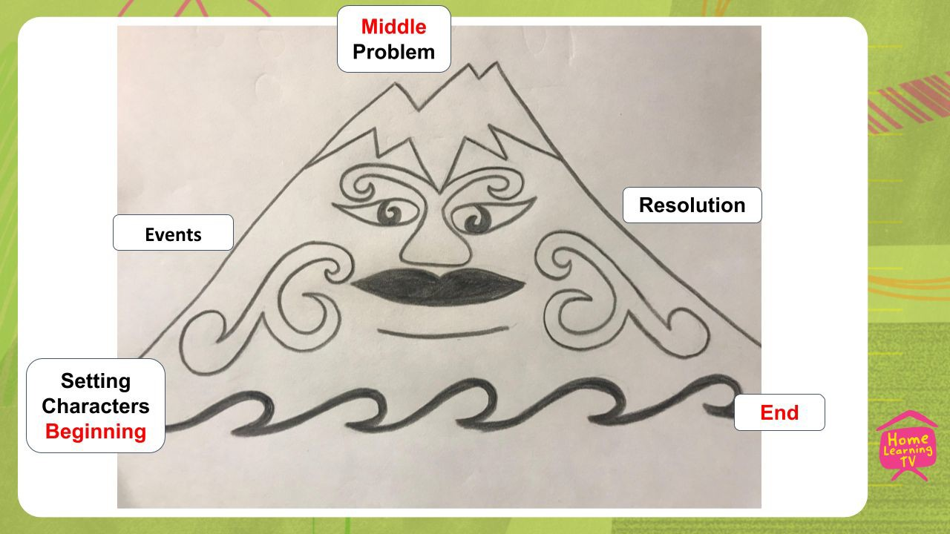
 | Characters
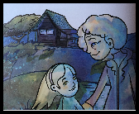

 | 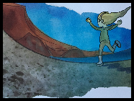Setting 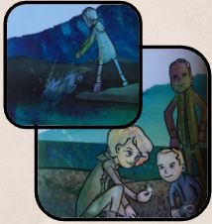Events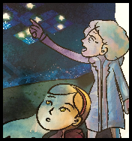 Problem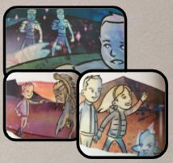 Resolution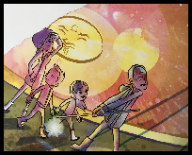 End  What final maunga should look like on the whiteboard.  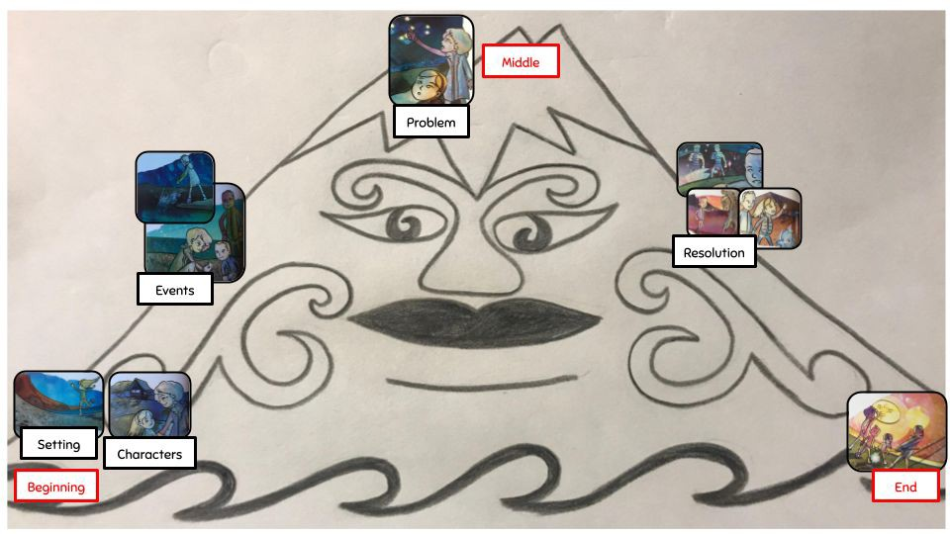 | if we didn't have a setting then the reader would not know where the story was taking place.  [presented picks up the event picture] Now these pictures show some different things that happened in the story, like Grandma and Sam finding agate and Pōua catching eels. These events are important in our story because they tell us what is happening and what the characters are doing. Without them the story would be pretty boring. Point to the place on our mountain where you think these events will go. Yup, I agree so I will put them up here. Can you remember the big problem that Te Rerehua and Sam faced? [presenter picks up problem card] Their Grandma counted the stars and told them that two were missing. Where should we put the problem? Well done - the problem happened at the top of the mountain. Writers sometimes call this the climax or the peak of the story, this is where the story gets very exciting. Because the problem is introduced in the middle of the story, it gives the author time to write about how the characters solved the problem. Hmmm, now what is next? We have these two pictures left. Let’s look at this one first. [presenter picks up resolution picture] This shows the patupaiarehe dancing about and Te Rerehua and Sam distracting them while the sun rose. Why did they do that? [pause] It was their solution to the problem. They needed a way of getting the stolen stars back from the fairies and they knew that the patupaiarehe did not like sunlight. Problem solved… they tricked the fairies to stay around until the sun came up and when it did the fairies ran away leaving the stars behind them. This is called the resolution. It is a tricky word but if you look carefully you might see a smaller word… solution. A solution is an answer to the problem, so we know that this needs to go on our mountain after the problem but before the end of the story. Speaking of the end of the story we have one picture left. Before I show you what it is, can you think back to what happened on the last page of the story, after Te Rerehua and Sam had rescued the stolen stars? They needed to be put back in the sky with the other stars of Matariki. [presenter picks up the end picture]. The stars needed to join their family back up in the sky. It was lucky that Pōua was able to fling the stars back to where they belonged.  [presenter interacting with/pointing to the completed story maunga on whiteboard] How do you think it looks? Is our story maunga complete? Well, we have a beginning, middle and end - ka pai! We also have characters and a setting - tu meke! Then we have some events which led to the problem. Finally, we have the resolution which means the story can end.  (***ON CAMERA***) I know that we made this story maunga after reading the story, but do you think the author, Miriama Kamo might have made a similar map when she was planning this story? I do because it makes writing easier when you have a plan.
Respond: Providing opportunities to use and practice | Learners will;  - plan for their own writing by mapping out their story including characters, setting and main events.  SLIDE 6  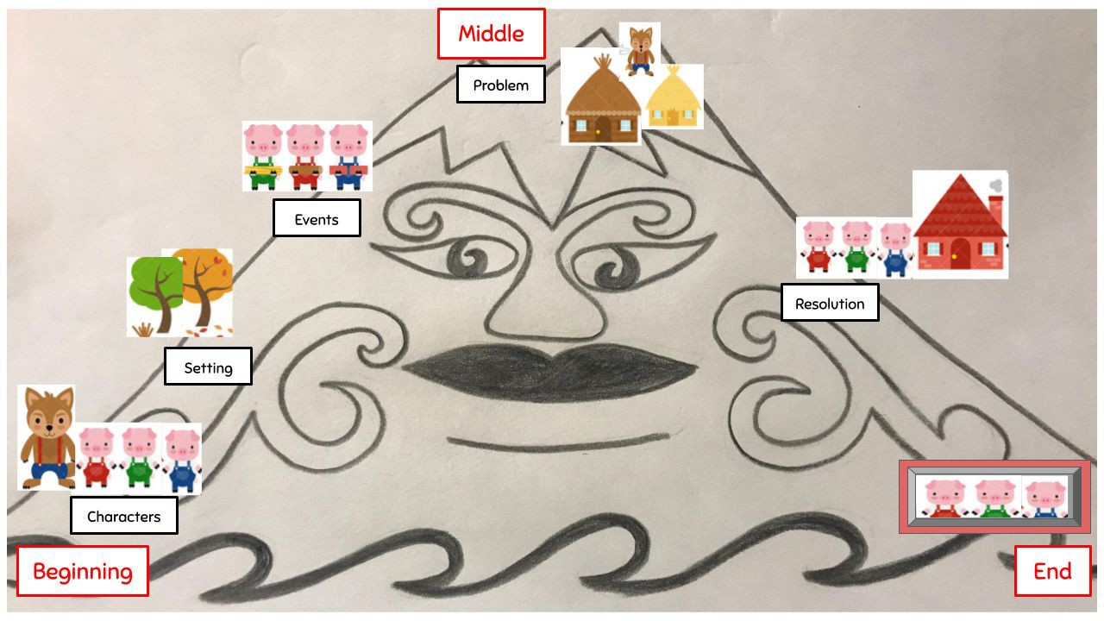  Once upon a time there were Three Little Pigs and a Big Bad Wolf.  They lived in a field which was close to a forest. They each built a house using straw, sticks or bricks.  The Big Bad Wolf huffed and puffed on each house to try and blow it down to catch the pigs.  The pigs ran to the brick house to get away from the Big Bad Wolf.  The Wolf gave up trying to blow down the bricks and the pigs lived happily and safely ever after. | So now that we have seen how we place characters, settings, and events from a story onto a story mountain, we are ready to use this map in our own writing. Let’s use a fairytale that most of us will already know - The Three Little Pigs. I have found some pictures and placed them on our story maunga. Let’s have a look.  (***POWERPOINT OS***) SLIDE 6 [presenter points to each part of the maunga as she follows the script] Here are some characters...who can you see? The Three Little Pigs and the Big Bad Wolf. Let’s look at the setting. There are some trees, I think it could be a forest. Can you look at the map to see what comes next? Did you say that the Three Little Pigs each built a house? What are the pigs holding? Can you remember from the story what the houses were made of? Straw, Sticks and Bricks. The problem comes next and then it gets solved. The last picture shows the Three Little Pigs living happily in the brick house. Hang on! There are no words, can you help me write them to make our story? We need to keep looking back at our story maunga to keep on track. (***WHITEBOARD***)  [presenter to look at the story map] First we need to introduce the  characters. [write on board] Once upon a time there were Three Little Pigs and a Big Bad Wolf.  [presenter to look at the next picture on the story map] Next it looks like we need to write a sentence about the setting. [write on board] They lived in a field which was close to a forest.  [presenter to look at the next picture on the story map] Hmmm… so this is where some events happen to move the story along. What did the pigs do next? [write on board] They each built a house using straw, sticks or bricks.  [presenter to look at the next picture on the story map] Now it looks like we are at the top of the mountain, so we need to write a sentence about the problem the little pigs faced. [write on board] The Big Bad Wolf huffed and puffed on each house to try and blow it down to catch the pigs.  [presenter to look at the next picture on the story map] What happened next? Let’s check our story mountain. So, the pigs ran to safety, let’s write that into our story. [write on board] The pigs ran to the brick house to get away from the Big Bad Wolf.  [presenter to look at the next picture on the story map] Now we just need an ending. What shall we write? [write on board] The Wolf gave up trying to blow down the bricks and the pigs lived happily and safely ever after. (***ON CAMERA***) I think we did it! We have used our story mountain to plan a story using pictures. We have written about each picture to

 |  | form a story with characters, a setting, a problem, a resolution, and an ending.
Share: Learner and parent reflection on learning and engagement and what they can do next | Learners should have;  - unpack the main ideas in a story to understand how the author planned for writing  - plan for their own writing by mapping out their story including characters, setting and main events.  SLIDE 7  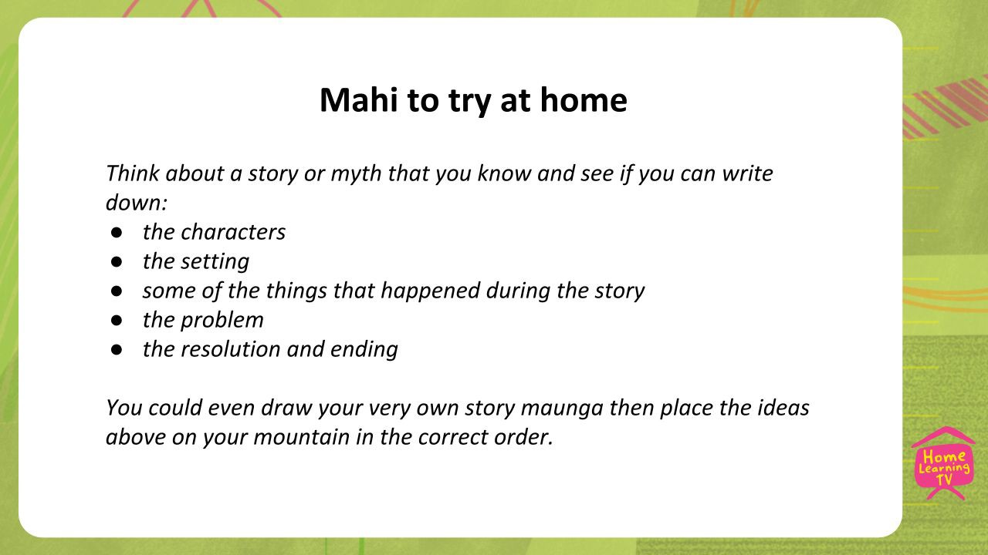 | Today we have learnt how to unpack the main events from a story using a story map to order the events correctly. We have also learnt how to plan for our writing including characters, setting, problem and resolution. All of these things are really important when writing a story. (***POWERPOINT FF**) SLIDE 7: Now it is your turn to do some writing mahi on your own. Think about a story or myth that you know and see if you can write down the characters and the setting. Then you might be able to list some of the things that happen during the story and identify the problem. Remember every story needs an ending so make sure this is the very last thing on your list. You might like to draw your very own story maunga which could then be used to order the events from any story you want to write.  (***ON CAMERA***) Did you learn something new today? Give yourself a thumbs up, thumb to the side or thumbs down to show how much you learnt.  Also, make sure you share your writing with your whanau, I’m sure they will love learning about the story maunga too.  Have a good day. Mā te wā

