Home Learning TV – Lesson Plan – 17 September

Segment lesson planning details
Title for segment: | Listening to the Land  Maramataka: The Māori Calendar
Year levels (e.g. Yrs1 – 3): | 4-7 Science
NZC learning areas: | English
Purpose of lesson:  (What learners will learn) | Student will understand the significance of Maramataka the Māori Calendar.
Success Criteria – students will be able to:  (how they will know when they have learnt it) | Understand how Māori looked after and used Papatūānuku, the earth mother, during different seasons  Listen, read and scan for information in a text to identify key points.  Design a diagram of ‘Maramataka at our whare’ - the seasons at your house noticing nature around your house and special things you do with your whānau.
Segment content/context details (as appropriate)
Māori specific content i.e. the learning draws on Mātauranga Māori: | Matariki, Mātauranga Māori, Maramataka the Māori calendar and the significance of the seasons in nature for Maori. | Pacific specific content i.e. the learning is focused on Pacific knowledge: |  | Cross cultural UDL opportunities – based around seasons and each students whare.
Segment production details
Equipment requirements: | Whiteboard, whiteboard markers  Pre written stickies/post its  A3 posters on whiteboard  PowerPoint slides made up with text when teacher reads - if the images cannot be placed on tv screen full sized  Resource used Connected 2018 Level 3 Cracking the Code
Copyright requirements:  Please be specific: Source (Seven Sizzling Sausages by Sam Smith –URL link to the source), intended use (to demonstrate alliteration), and length (timings for video clips) | Crown Copyright resource  All material sourced from Resource used Connected 2018 Level 3 Cracking the Code
Segment links and attachments (list all links to recordings or attachments, the source and confirm that copyright permissions are granted)
Links to recordings /resources
Attachments | Attached:  Google Slides link  PowerPoint with text and images for monitor and to be shown full screen also  Maramataka at my whare - template for whiteboard and teacher and on screen for students.  Seasons vocabulary chart
Segment plan content
 | Teaching and learning activities linked to purpose |  | High level script (key points/questions)
Activate: Activating prior learning, knowledge of contexts and relationships  (2 min 40 sec) | Presenter greeting  Setting the context  Stars and whakatauki on tv monitor  Slide 2  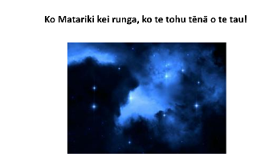  LO written on whiteboard  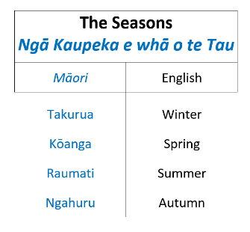  Print to A3 and on whiteboard |  | Mōrena tātou, and hello to everyone again.  Kei te pehea koe? How are you today?  I am really excited at this time of the year as here in Aotearoa/New Zealand we celebrate Matariki. I am sure will you know a number of things about Matariki.  Matariki signals the Māori New Year. It is a time of renewal and celebration in Aotearoa New Zealand that begins the rising of the Matariki star cluster of 7 stars.  The Greeks called this cluster of stars Pleiades.  The Japanese, Subaru [pronounced Soo-baar-oo]  and the Chinese, Mao.  The physical appearance of Matariki in the sky was traditionally used by a tohunga (a priest or expert) as a forecast of the year ahead. Clear and bright stars signalled warm and productive seasons, and hazy or shimmering clusters meant a cold winter was coming and ground for crops was prepared accordingly.  Today Matariki is seen as an important time to celebrate the earth and show respect for the land. It is also a time to acknowledge those who have passed away and to plan for the year ahead.  Today are going to learn about Maramataka: The Māori calendar  We will learn about:  - the lunar calendar, and how Māori looked after and used Papatūānuku, during different seasons  and,  - we will make notes to help design a diagram of the seasons around your whare and special things you do with your whānau.  *chart*  Before we start today let’s remind ourselves of the seasons.  You will see they are written in te reo Māori and in English. You may also know the name of these seasons in a language you use at home.  *Pause and look T says the seasons Reo first then English*  The Seasons  Ngā Kaupeka e whā o te Tau  Takurua - Winter  Kōanga - Spring  Raumati - Summer  Ngahuru - Autumn  Have you noticed the order of the seasons in English?  Do they appear in a different order than you would normally say?  There was a clue earlier when we talked about Matariki.  We will come back to that later.  We will need a pencil or pen and some paper today as we make notes about the seasons.

Learn: Introducing learning  Reinforce routines, provide multiple exposure to concepts, and strategies. Scaffolding learning  (15 mins 30 sec) | Gets the most out of the resource  Introduction to the text  Prompt for viewing and listening for key information  Slide 3  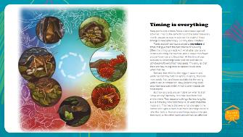  Slide 4  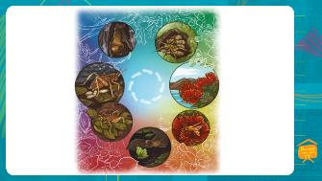  slide 5  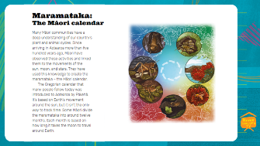  Slide 6  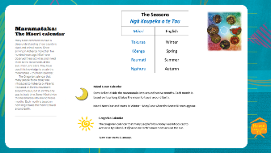  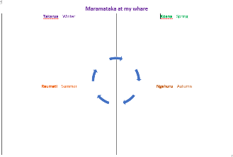  Slide 7  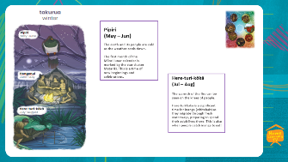  On white board  Takurua Stickies pre-  written.. cold nights, Matariki stars (drawn with caption), whānau dinners on Friday  Slide 8  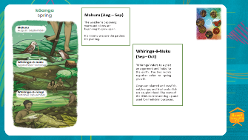  On whiteboard  Kōanga Pre written stickies 1. Drawing of a bee of a bee 2 stickie with word vegetables to go on whiteboard model.  Slide 9  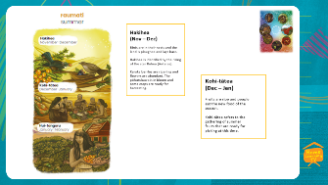  On whiteboard  Raumati pre written stickies 1. Fresh fruit (with sketch- strawberry?), warm weather (sun) BBQs with whānau to go on whiteboard model.  Slide 10  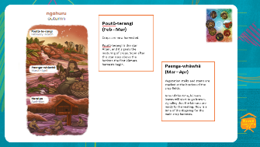  Whiteboard - looking something like this with notes  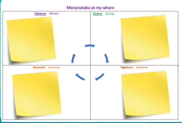  Ngahuru pre written stickies 1. Orange leaves. 2. darker earlier at night  Whiteboard A3s doc - images from book and A3 notes page on white board  Slide 11 on TV panel.  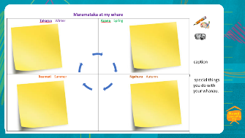  Whiteboard | We will read an extract from an article called Listening to the Land by Laura Goodall. Your school has this book and you might like to read the entire article at another time. Ask your teacher.  As we read note the information important to you. Do not write everything. Write a key word, a brief sentence or draw a quick sketch.  As we start to look at the seasons remember this has been shared through kōrero over time. Kōrero means to talk, to have a conversation. Think of the kōrero you have with your whānau, with your friends and how you share your knowledge.  As I read the text look closely at the diagram with the illustrations.  If you look at the centre of the diagram you will see arrows in a circle. These show us that we are going to be looking at something that goes in a cycle continuously.  1:00  **slide 3 on screen and teacher reads*  Timing is everything  Many plants and animals follow a continuous cycle of activities. They do the same things at the same time every month, season, or year. In science, the study of these timings is called phenology. But why does it matter?  Plants and animals have evolved to reproduce at times that give them the best chance of surviving. Often this timing connects with what other plants and animals are doing. For example, pōhutukawa trees flower around November and December. At this time of year, bees are out collecting nectar and can pollinate the pōhutukawa flowers that make seeds. This ensures that there are new young trees to replace the old ones when they die.  Similarly, tree wētā lay their eggs in autumn and winter so that they hatch in spring. In spring, there are more seeds, fruit, and leaves available for the young wētā to eat. In comparison, New Zealand long-tailed bats hibernate over winter, which is when insects are most scarce.  But how do plants and animals know when to start a new activity? Normally, they take cues from their environment. They respond to things like how long the sun is in the sky, how cold the air is, or what phase the moon is in. This means that even small changes in the climate can signal a plant or animal to do things earlier or later than before. And once one living creature changes their cycle, all the other plants and animals are affected.  Let’s use the information we have read and look at the diagram closely. See if you can answer these questions.  3.50  *slide 4 on screen*  Look for the Pohutukawa flower. The Pōhutukawa flowers around November - what season is that? Does the orange colour in the background give you a clue? If orange is a warm colour it might be… Āe – Summer.  If we follow the direction of the arrows from the pōhutukawa we see images of the wētā.  What seasons do the tree wētā lay their eggs?  Correct, the wētā lays its eggs in Autumn and Winter.  The long-tailed bats hibernate (go to sleep) during a season when there are very little insects around to be eaten. When is that?  Ka pai. The long-tailed bats sleep in winter.  Follow the arrows from the bat to the images with the green background what season do you think that that is?  *pause*  Ka pai. The green background and the clues from the other seasons tell us this season is Spring.  What season do the baby wētā hatch in and what do they eat?  Āe the wētā hatch in spring when there are more seeds, fruits and leaves to eat.  Ka pai tamariki. This diagram shows us the cyclic nature of the four seasons and how living things in nature live and grow through cycles  5.25  We know there are four seasons a year. Let’s read about Maramataka: The Māori calendar  **slide 5 on screen and teacher reads to students**  Maramataka: The Māori calendar  Many Māori communities have a deep understanding of our country’s plant and animal cycles. Since arriving in Aotearoa more than five hundred years ago, Māori have observed these activities and linked them to the movements of the sun, moon, and stars. They have used this knowledge to create the maramataka – the Māori calendar.  The Gregorian calendar that many people follow today was introduced to Aotearoa by Pākehā. It’s based on Earth’s movement around the sun, but it isn’t the only way to track time. Some Māori divide the maramataka into around twelve months. Each month is based on how long it takes the moon to travel around Earth.  The maramataka has long been used by Māori communities as a guide for when to hunt, fish, plant, and harvest. Different iwi have their own versions of the maramataka. Some iwi would see Matariki rise in the sky and know that it was the right time to hunt animals like the kererū, which would be plump enough for eating. Others know that certain phases of the moon are good for catching pātiki because that is when the fish come closest to the shore  As well as the positions of the moon and stars, Māori also observed changes in the environment that affected different animals’ behaviour. Some iwi know that when pōhutukawa trees flower, the kina (sea urchin) have roe (eggs) that are fat and creamy.  *Pause*  7:20  **slide 6 on screen*  Did you notice there are two types of calendar commonly used in Aotearoa?  I learnt that Maramataka the Māori calendar is a lunar calendar and Matariki, Māori New Year starts in winter.  The order of seasons from Matariki is Winter, Spring, Summer, Autumn.  When we use the Gregorian calendar January to December, New Year is on 1 January and people usually say the seasons go Summer, Autumn, Winter, Spring.  8.00  Our challenge today is to note what the seasons are like where you live.  You will need to have a pencil and a piece of paper to note ideas. You might write key words or draw a quick sketch.  **A3 on Maramataka at my whare on whiteboard **  Let’s start with Takurua - Winter  *slide 7 on screen and T to read.*  I will read you the information - follow with your eyes. Remember look at the illustration to see how some of that information is shown. The illustrations may give you clues about the seasons and help you think what it is like at your whare.  Takurua -Winter  Pipiri  The earth and its people are cold as the weather cools down.  The first month of the Māori lunar calendar is marked by the star cluster Matariki. This is a time of new beginnings and celebrations.  Here-turi-kōkā  The warmth of the fire can be seen on the knees of people.  Here-turi-kōkā is a significant time for inanga (whitebait) as they migrate through fresh waterways, preparing to spend their adult lives there. This is also when people catch inanga to eat!  I learnt that takurua is the coldest time of the year.  People gathered together to keep warm. They probably told stories.  The Matariki stars appear in the sky.  Let’s take a few moments to write down key words or a quick sketch of:  What do you notice in nature around your house in winter?  Do you notice anything different with plants or wildlife in the garden?  What do you and your whānau do over takurua at your house?  30secs pause – leave image on screen  These are my ideas about winter at my whare  Cold nights  Matariki stars  Whānau dinners on Friday  *T puts prewritten stickies on A3 on whiteboard*  I hope you have at least one or two ideas for Takurua at your place. I will ask you the same thinking questions for each season.  10.20  *slide 8 on screen and T to read.*  Now to Kōanga - Spring  I will read you the information – also look at the illustration. What is spring like at your place?  Mahuru  The weather is becoming warm and plants are beginning to grow again.  It’s time to prepare the gardens for planting.  Whiringa-ā-Nuku  ‘Whiringa’ refers to a plait on a garment and ‘nuku’ to the earth. The two words together refer to spring growth.  Crops are planted and crayfish, eel, inanga, and freshwater fish are caught inland. The roots of the tī kōuka tree are dug up and used for medicinal purposes.  A lot of things happen in kōanga/. On another part of your piece of paper let’s take a few moments to write down key words or a quick sketch.  What do you notice in nature around your house?  Do you notice anything different with plants in the garden or wildlife?  What do you and your whānau do over kōanga at your house?  30secs leave image on screen  I learnt that as the weather gets warmer plants begin to grow. I see bees in my garden in spring and I plant my favourite vegetables.  *T puts prewritten stickie with a drawing of a bee on A3 poster and a stickie with the word vegetables*  I know you will have noticed different things between winter and spring and I hope you have a chance to share with someone at home. *  12.05  *slide 9 on screen and T to read.*  Let’s now read about Raumati - Summer  Raumati will be very different to what the weather is like now. I love summer. There is lots of fresh fruit to eat. It’s warm and I have barbeques with my whānau.  Hakihea  Birds are in their nests and the land is ploughed and lays bare.  Hakihea is identified by the rising of the star Rehua (Antares). Karaka berries are ripening and flowers are abundant. The pōhutukawa is in bloom and some crops are ready for harvesting.  Kohi-tātea  Fruits are ripe and people eat the new food of the season.  Kohi-tātea refers to the gathering of summer fruits that are ready for picking at this time.  On a new part of your piece of paper let’s take a few moments to write down key words or a quick sketch of what happens at your whare in Raumati/Summer.  What do you notice in nature around your house?  Do you notice anything different with plants in the garden or wildlife?  What do you and your whānau do over summer at your house?  30 seconds leave image on screen  * Teacher puts stickies on whiteboard and reads aloud*  Here are my notes  Fresh fruit  Warm weather  BBQs with my whānau  13:40  *slide 10 on screen and T to read.*  And now the last season. Ngahuru – Autumn  What do you notice in the illustrations?  Poutū-terangi  Crops are now harvested.  Poutūterangi is the star Altair, and it signals the maturing of crops. Soon after this star rises above the horizon the first kūmara harvests begin.  Paenga-whāwhā  Vegetation stalks and stems are stacked at the borders of the crop fields.  Around this time, kūmara leaves will start to go brown, signalling that the kūmara are ready for harvesting. Now is a time of thanksgiving for the main crop harvests.  On the last blank space on your piece of paper let’s take a few moments to write down key words or a quick sketch of what happens at your whare in Ngahuru. As we have just had Autumn you will have plenty of ideas I know.  What do you notice in nature around your house?  Do you notice anything different with plants in the garden or wildlife?  What do you and your whānau do over autumn at your house?  30 seconds leave image on screen  I love the colour of the leaves that fall to the ground and notice it gets darker earlier at night  15:25  Looking at whiteboard model.  I know you will have selected a number of experiences and pieces of information that are important for you in each season of the year. My collection of ideas has grown too. Each season something special happens in nature, with plants and animals and for me.  *points to A3 pan on whiteboard*  17:00
Respond: Providing opportunities to use and practice  (1min) | Directly relevant to learning intention  Involves student participation – with options about how it can be done  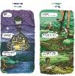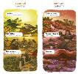 | Taken from the text (corresponding coloured asterisk in the transcript above – timings included above)  I know you will have noticed different things between winter and spring and I hope you have a chance to share with someone at home.  What I would like you to do is use your notes and to design a diagram (it could be on paper or on a device) of Maramataka at your whare. Consider how you will include the important things in nature and your whānaua around your whare in each season.  You may wish to do your information similar to the style in the book.  *T points to A3 illustrations examples on whiteboard slide 12 on TV as noted in left column*  You could draw, paint or take photos of something important at your whare, caption it, and don’t forget to include something special you do each season with your whānau. Use your notes to help you design your Maramataka
Share: Learner and parent reflection on learning and engagement and what they can do next  (1 min total time 20 min 30 sec) | Debrief prompts student’s reflection on learning outcomes and progress  Includes opportunity to share learning or learn together with whānau , HLTV or others  - Reiterates the task if done outside of the lesson  - Introduces ‘independent learning’ through a provocation  Guide whānau | So, today our goals were to learn about Maramataka :  - and how Māori looked after and used Papatūānuku, during different seasons  and,  - we made notes to help design a diagram of the seasons showing special things you do with your whānau.  We have made notes about what we notice in nature , gardens/living things around our home and special times with whānau, each season.  We would love to see your maramataka. Your whānau, friends and teachers at school would too.  Ka kite. Until next time, have a great day.  18:00

