Home Learning TV – Lesson Plan – 14 September

Segment lesson planning details
Title for segment: | Matariki - a time for celebration
Year levels | Years 1-4
NZC learning areas: | Social Sciences Level 2  - Understand how cultural practices reflect and express people’s customs, traditions, and values.  Science Level 2  - Share ideas and observations about the Sun and the Moon and their physical effects on the heat and light available to Earth.  English (Reading) Level 2  - Ideas: Show some understanding of ideas within, across, and beyond texts.
Purpose of lesson:  (What learners will learn) | Students will:  - learn to read for a purpose - explain the timing of Matariki celebrations in relation to the stars and the moon  - make connections between sections of the text and to their own knowledge and experiences  - use visualising to make sense of text
Success Criteria – students will be able to:  (how they will know when they have learnt it) | Students will be able to:  - make connections between sections of the text and to their own knowledge and experiences  - use visualising to assist making sense of text  - explain the timing of Matariki celebrations in relation to the stars and the moon
Segment content/context details (as appropriate)
Māori specific content i.e. the learning draws on Mātauranga Māori: | Matariki  Mātauranga Māori | Pacific specific content i.e. the learning is focused on Pacific knowledge:
Segment production details
Equipment requirements: | TV screen
Copyright requirements:  Please be specific: Source: (Seven Sizzling Sausages by Sam Smith – url link to the source), intended use (to demonstrate alliteration), Length (timings for video clips) | Information https://www.twoa.ac.nz/pages/te-iwa-o-matariki?sc_lang=en  phases of the moon images https://www.moongiant.com/moonphases/june/2020/  slide image from Matariki Breakfast http://instructionalseries.tki.org.nz/Instructional-Series/Ready-to-Read/Matariki-Breakfast  Just one wheel SJ L2, May 2015 http://instructionalseries.tki.org.nz/Instructional-Series/School-Journal/School-Journal-Level-2-May-2015/Just-One-Wheel  Olly’s new bike, JJ 38  Stars of Matariki and New Moon movie by Anton PIters, using image from ‘Matariki’ by Waitangi Teepa  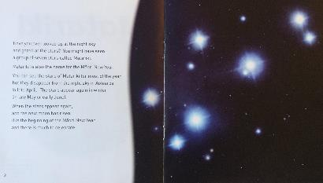  This was the original page, however the dates were incorrect for 2020. We rewrote this page to now look like this:  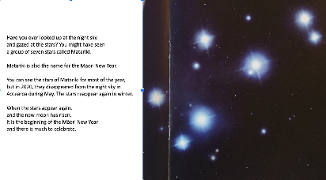
Segment links and attachments (list all links to recordings or attachments, the source and confirm that copyright permissions are granted)
Attachments | PowerPoint with mini movie
Segment plan content
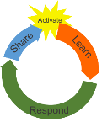 | Teaching and learning activities linked to purpose |  | High level script (key points/questions)
Activate: Activating prior learning, knowledge of contexts and relationships  2 mins | Students will be able to:  - make connections between sections of the text and to their own knowledge and experiences  - use visualising to make sense of text  - explain the timing of Matariki celebrations in relation to the stars and the moon |  | (***ON CAMERA***) Kia ora, talofa, malo e lelei, hello.  It's great to see you - welcome to our learning time. I’m looking forward to sharing some new learning with you today!  You may already know quite a lot about Matariki and what you can do as part of Matariki celebrations. What do you already know about Matariki? WOW that's great - already knowing about something is called prior knowledge. Using your prior knowledge about something is really useful when you read. Remember to bring that prior knowledge about Matariki to your new learning today! There are two main things we are going to learn today:  - The first one is reading for a purpose. Good readers always have a purpose or a reason for reading. Our purpose when we read may be to find out who did something, how to make something or why something happens. Today, our purpose is to understand when we celebrate Matariki.  - The second thing we are going to learn today is how to visualise! Whenever we are reading, we think about what the text says and what we already know (remember our prior knowledge), and then we make pictures in our head. This is what we call visualising. It helps us to understand what we have read.  So today we are going to revisit a book we’ve read before called Matariki. However, when we read it again, we are going to focus on reading this book for a very different purpose - this time we are reading to understand about when we celebrate Matariki. That's our purpose for reading this text!  Let’s get ready to read, and see what new information you can learn about Matariki.
Learn: Introducing learning  Reinforce routines, provide multiple exposure to concepts, and strategies. Scaffolding learning  14 mins | Students will be able to:  - make connections between sections of the text and to their own knowledge and experiences  - use visualising to make sense of text  - explain the timing of Matariki celebrations in relation to the stars and the moon  SLIDE 7 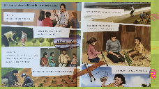  SLIDE 8 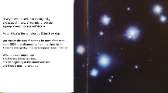  SLIDE 9 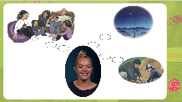  SLIDE 10  SLIDE 11 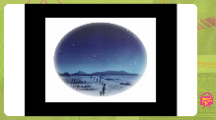 |  | (***POWERPOINT FF***) SLIDES 2-6 Monique to read, please. Reading the text takes approximately 4:30 minutes  (***ON CAMERA***) It’s great to re-read a familiar book like this, and be reminded of so much interesting learning about Matariki. It is a time to celebrate new life, to remember those who’ve passed, share stories and a time to plan for the future.  Hey - How did you get on with visualising - making pictures in your head? What pictures did those words we read help you create in your head? What did you visualise?  Some parts of the book were really easy to visualise. Let's go back into the text and start with them.  Remember we are learning that good readers have a purpose when they read. Our purpose for reading this page is to find out ‘What are some of the ways we can celebrate Matariki?’  Read these pages with me and let's see if we can find an answer to that question.  (***POWERPOINT OS***) SLIDE 7 (Presenter to read and then do this think-aloud) As I was reading these pages I was trying to find out the answer to that question also. Hmmmm ‘What are some of the ways we can celebrate Matariki?’ Aaah, here’s one way we can celebrate Matariki – (presenter to point to planting trees and winter crops picture) ‘It is a time to plant trees and winter crops.’ Let me think! The pictures helped me to connect to things I already knew and reminded me of when I have done something similar. The picture added more detail and helped me to make better sense of what I was reading. I was thinking that maybe this child is being taught about the names of different crops such as potatoes, kumara, and pumpkin - and where they like to grow. The child may also be learning about the importance of plants as food, or how to care for particular crops.  That's one of the ways people celebrate Matariki. Did you find lots of  other ways that people can celebrate Matariki on these pages also – what ones did you already know something about? What new ones did you find? Did you bring your memories and prior knowledge to help you understand the information and then make pictures or visualise in your head? Great! Tino pai!  Now let’s bring this new learning along with us as we read the next page.  Remember :  - We read for a purpose or a reason  - We connect what we read to what we know and then visualise or make a picture about this in our head.  We are now going to go back to Page Two of the text and use these great reading strategies.  (***POWERPOINT FF***) SLIDE 8 On page two, the only picture is the stars of Matariki. Let’s read together:  Have you ever looked up at the night sky?  and gazed at the stars? You might have seen  a group of seven stars called Matariki.  Matariki is also the name for the Maori New Year.  Ah, so Matariki means two things - it is the Māori name for a cluster of stars, and also the name of the Māori new year. So, I am visualising the stars of Matariki - just like in the picture, and I am thinking about Matariki as the Māori New Year. I know that we celebrate Matariki by sharing stories and planting vegetables. Let me show you what the picture in my head looks like. SLIDE 9 The pictures in my head helped me think about what I was reading. Did you visualise Matariki like that when we read? Did it help you understand the information?  (***ON CAMERA***) Well done! You are connecting the information with what you already know and have read, and making a picture in your head to help you!  Now, when I read the next part on this page, I found it a bit tricky. Read it with me to find information about when we celebrate Matariki.  (***POWERPOINT FF***) SLIDE 10 (same as SLIDE 8)  You can see the stars of Matariki for most of the year,  but in 2020, they disappeared from the night sky in Aotearoa during May. The stars reappear again in winter.  Hmm. What are you visualising to help you understand this information? At first, I was a bit confused because I thought the Matariki stars only appeared for a short time each year. But that was not right.  Look at what it says here:  You can see the stars of Matariki for most of the year.  Hmm! I thought, ‘most of the year’ - so the stars of Matariki are visible most of the time, but disappear for a short time during the year and we cannot see them. I started to visualise the stars being in the sky then gradually I couldn't see them anymore - they were disappearing.  Here's the next part of the sentence ….  but in 2020, they disappeared from the night sky in Aotearoa in May.  I’ll give you a moment to point to this sentence on screen. I am realising that just like the sun rises and sets, so do the stars of Matariki. That means sometimes we can’t see them - so it seems like they disappear! This time I was visualising the sky with no stars of Matariki. Let’s keep reading.  The next line reads that the stars reappear again in winter.  Here I visualised the stars of Matariki rising up into the sky again. The next sentence When the stars appear again, and the new moon has risen, it is the beginning of the Māori New Year and there is much to celebrate. (***ON CAMERA***) What were you wondering and visualising as you read that sentence? Do you know what the new moon looks like? I had to pause there and think. I knew what the full moon looked like, and then I remembered that the new moon is barely visible - it looks like there is no moon. So, I held those two pieces of information in my head by visualising the stars of Matariki disappearing and then reappearing. Let me show you what I was visualising.  SLIDE 11 (video) (***POWERPOINT FF***) (***ROLL VT***) (***ADLIB****)  Is that the picture you were making in your head? Is it helping you to understand the information? Tino pai!  (***ON CAMERA***) Remember - until the new moon starts to appear, it is not officially Matariki.  We were reading for a very specific purpose today - to understand when we celebrate Matariki. We made connections to what we already knew, with what it said in the text, and used visualising to help us make pictures in our head. That certainly was a lot of visualising we needed to do to understand how we know it's time for Matariki to begin!  By the way - did you realise that there is no exact date for Matariki each year? Your birthday is on the exact same date each year. Christmas Day is on the exact same date each year and Waitangi Day is on the exact same date each year. However... celebrations like Easter and Matariki do not happen on the exact same date each year. The date for them depends on the moon and stars and where they are in the sky.  This year, the stars of Matariki disappeared around the middle of May, but don't worry - they will reappear soon, around the middle of July. That is when we will begin our Matariki celebrations - just before the new moon.
Respond: Providing opportunities to use and practice  3 mins | Students are invited to visualise two scenes as Monique reads/shares them, and evaluate the accuracy of their visualisation.  Students will be able to:  - make connections between sections of the text and to their own knowledge and experiences  - use visualising to make sense of text  SLIDE 13 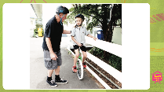  SLIDE 15 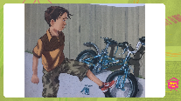 |  | Let's now have a go at practising our visualising together. Let’s read this sentence and visualise as we read.  (***POWERPOINT FF***) SLIDE 12 Mr Rob patted Katie on the back as she held onto the fence and tried to balance her unicycle.  Have you visualised what that might look like? What pictures did you make in your head? Did it look something like this?  SLIDE 13 (***ADLIB***) Ka pai! You’re really good at visualising! You got a great picture in your head by reading the details carefully.  Are you ready for another one?  Let’s read this sentence and visualise as we read.  SLIDE 14 Olly was annoyed. He didn't want the old bike. Olly kicked the bike, fighting back tears. The bike crashed against the fence, and a pedal fell off.  Have you visualised what that might look like? Did it look something like this?  SLIDE 15 (***ADLIB***) Ka pai, again. Look at how visualising helped you to have a better understanding of what you read.
Share: Learner and parent reflection on learning and engagement and what they can do next  2 mins | Students will be able to:  - use visualising to make sense of text  - explain the timing of Matariki celebrations in relation to the stars and the moon  SLIDE 16 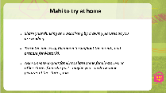 |  | (***ON CAMERA***) Today we used our reading to find what time of the year Matariki celebrations happen. We learned some new reading strategies to help us do this.  The first one was to read with a purpose. This helped us to focus on what was important to look for in the text, to answer the questions we are wondering about. Do you feel confident that you understand the importance of having a purpose or reason for reading? Give yourself a thumbs up, thumb to the side or down to show how much you learnt. Ka pai!  We also learnt to connect what we have read with our prior knowledge and then visualise this in our head, to help understand the information in the text. Give yourself a thumbs up, thumb to the side or down to show how much you learnt. Ka pai!  You might like to try this mahi at home.  SLIDE 16 (***ADLIB***)  - Practise visualising by drawing pictures as you are reading.  - Track the phases of the moon throughout the month, and prepare for Matariki.  - Ask someone in your family to share some family stories, or other stories from the past - maybe you can draw some pictures of those stories, too  Also, make sure you share your writing with your whanau, I’m sure they will love learning about visualising, too.  Enjoy your Matariki celebrations … Have a great day!  Mā te wā

