Home Learning TV: Junior Science – Day 17
Segment lesson planning details
Title for segment: | Pepeketua - frogs
Year levels (e.g. Yrs1 – 3): | 1-3
NZC learning areas: | Living world - ecology and evolution  Nature of science - communicating in science/interpreting representations
Purpose of lesson:  (What learners will learn) | We need to know about species before we can act as kaitiaki  Our native frogs are unique because of their long isolation  Our native frogs are under threat due to habitat loss and predators; they need and deserve our protection
Success Criteria – students will be able to:  (how they will know when they have learnt it) | Success criteria:  - explain that Aotearoa has native and introduced frogs  - give two examples of how our native frogs differ from other types of frogs  - give an example of how we can act as kaitiaki for frogs
Segment content/context details (as appropriate)
Māori specific content i.e. the learning draws on Mātauranga Māori: | Our responsibility as kaitiaki of Papatūānuku and the plants and animals that live on her. | Pacific specific content i.e. the learning is focused on Pacific knowledge:
Segment production details
Equipment requirements: | a plastic frog and some vegetation
Copyright requirements:
Segment links and attachments (list all links to recordings or attachments, the source and confirm that copyright permissions are granted)
Links to recordings /resources | Provided in the lesson plan below
Attachments
Segment plan content
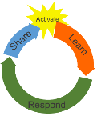 | Teaching and learning activities linked to purpose |  | High level script (key points/questions)
Activate: Activating prior learning, knowledge of contexts and relationships  4 minutes | Connecting with the audience and linking with the previous episode.  Revisiting the idea of species bias and preferential conservation treatment.  [This links to the theme of social justice for all endangered species.]  Drawing on learners’ experience of frogs - perhaps from books or cartoons.  On the screen/board is written  Pepeketua Poraka  We can’t act as kaitiaki if we don’t know the species exist. |  | Kia ora! Talofa!  [Touch base with the audience. Chat about texts and emails.]  Last time we were together, we talked about conservation and how we tend to look after the native animals we either really like or know something about.  We talked about wētā and the role they play in the ecosystem. Hopefully, by getting to know them a little better, we are more likely to look after them and give them help when they need it.  Do you remember the word we used when we talked about protecting or watching over something? It is kaitiakitanga. We are kaitiaki when we protect Papatūānuku and the plants and animals that live on her.  [Frog sounds in background. This will need to be looped so it plays for longer.  https://www.doc.govt.nz/contentassets/2275c4aae6c84439886be1a12060719d/aurea.wav  (from https://www.doc.govt.nz/nature/native-animals/reptiles-and-frogs/frogs-pepeketua/identifying-introduced-frog-species/)]  Today we are going to talk about some wee creatures that really need us to be kaitiaki.  Can you hear me over that noise? I said - today we are going to talk about some wee creatures that really need us to be kaitiaki.  [If you have the gear, please ‘find’ a toy frog sitting on leaves or other vegetation.]  Oh - so it’s you making all of that noise. The creatures we are going to talk about today are frogs. Real frogs.  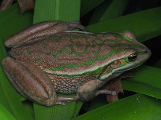  https://inaturalist.nz/photos/72255254  The frog we’ve just been listening to is the green and golden bell frog. It is one of three introduced species of frogs that live here in Aotearoa.  An introduced species is one that was brought here by people. Sometimes this was done on purpose because people thought Aotearoa needed more animals. Sometimes it was because the frogs hitched a ride when no one was looking.  Introduced frogs are called poraka. Our native frogs - those that naturally live in Aotearoa - are called pepeketua. I like all frogs, but our pepeketua are really special.  [Have these words on the screen?]  [Please see https://maoridictionary.co.nz/ for pronunciation support.]  Most people don’t know about our pepeketua, our native frogs. We need to get the word out, so people learn about them and get involved in looking after them and keeping them safe. Let’s hop to it!
Learn: Introducing learning  Reinforce routines, provide multiple exposure to concepts, and strategies. Scaffolding learning  10 minutes for this section  Running time 14 minutes | Scientists have special fields of knowledge. Herpetologists study frogs.  New Zealand’s long isolation means we have some very unusual plants and animals.  Making observations via photos. (science capability - ‘gather and interpret data’)  Presenter records in blank table as she points out the differences  Pepeketua Poraka  Open their mouths and lunge Shoots tongue out really quickly  Round eyes Slit eyes  Toes Webbed feet  Don’t hear well  Make chirping sounds but use smell to communicate Croak  Making comparisons between a well known lifecycle and the rare native frog life cycle.  Reading and interpreting a diagram. (Science capability - interpret representations.)  Cycles follow a pattern and continue, rather than having a beginning or end.  Pepeketua Poraka  Open their mouths and lunge Shoots tongue out really quickly  Round eyes Slit eyes  Toes Webbed feet  Don’t hear well  Make chirping sounds but use smell to communicate Croak  froglets Tadpoles  ¾ live and breed on dry land Live near water |  | Today we are going to learn about why we need to become kaitiaki of our pepeketua and how we might do that.  Our pepeketua have lived here for a long time. And when I say a long time, I mean a very, very long time. The scientists who know lots about frogs - herpetologists - believe that the ancestors of our native frogs go as far back as 80 million years ago! Our frogs have changed so little in all this time, they are known as living fossils. This makes them unique and different from most other frogs around the world.  I’d like you to meet one of my friends, Professor Phil Bishop. Phil is a herpetologist who works at the University of Otago. He’s going to tell us that - yes - our pepeketua are special!  https://vimeo.com/418757228 [0:34 seconds]  One part of a frog’s body that I’ve always thought was cool is its tongue. Have you seen videos or cartoons of frogs catching insects with their tongues? It’s really fast. Like this - do it with me! [Mimic the action a few times.] The frog in this photo has a long tongue and it’s attached to the front of its mouth. The frog shoots its tongue out really quickly and wraps it around the insect. Most frogs have sticky saliva that helps trap the insect during the attack, but it turns watery again when the insect is inside its mouth.  Sticky saliva, insects in my mouth - I’m glad I’m a human!  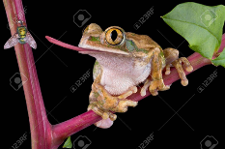  https://www.123rf.com/stock-photo/frog_tongue.html?start=440&sti=n588yhwxgt09dis8jw|&mediapopup=8537840  But our native frogs are different. They can only stick their tongues out a little bit. Let’s see what Phil has to say:  https://vimeo.com/418757327 [0:23 minutes]  Hmm - native frogs open their mouths and lunge - what do you think that looks like? Shall we try this together! [Mimic action]. Kind of like me with a hot dog! Allright - the tongue is one part of their heads. What about other features on their heads? Look at this cutie - this is a Maud Island frog. Yep - this frog is named after the island it lives on.  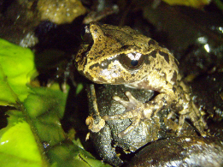  https://www.sciencelearn.org.nz/images/1685-maud-island-frog  Our native pepeketua have round eyes instead of slits. Did you know that frogs have bulging eyes so they can see all around them? Their eyes are always open - even when they sleep!  Hey - check out the feet on this little pepeketua. Our native frogs don’t have webbed feet. Those are pretty cute little toes grasping the stone!  So there are differences in the tongue, the eyes, the feet - now to the ears. Let’s look closely at this frog - it’s an Archey’s frog. Can you see its ears? Ears - what ears? Where are they?  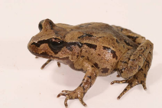  https://www.sciencelearn.org.nz/images/3366-frogs-s-ears  Aotearoa’s native frogs don’t have an external eardrum and middle ear so they don’t hear much. Although they can make chirping sounds, they don’t croak. Herpetologists like Phil think they use smells to communicate instead of sounds.  [Sniffing actions…]  Using smells to talk to each other - can our frogs get any stranger? Of course they can - this is Aotearoa - our animals rule the world in being different!  Let’s talk about baby frogs.  Have you ever seen these before? That’s right, they’re tadpoles. They’re the frog babies before they become four-legged frogs. Well, they are for introduced frog species…  IMAGE  Now is a good time to stand up and get active while we talk about lifecycles - hurihanga ora.  [For example, hold up fists for eggs and embryos. Tadpoles, one hand on top of the other, swimming through the water. Extend thumbs for 2 legs. A jump or two for an adult frog. Hold up fists again to demonstrate this is a cycle without a beginning or end.]  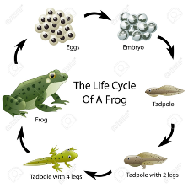  https://www.123rf.com/stock-photo/frog_life_cycle.html?sti=nloo7wgbw5n1tw6y37|&mediapopup=64560820  Something tells me that Kiwi frogs do things differently. Let’s listen to Phil tell us about the native frog life cycle.  https://vimeo.com/418757282  Wow! Our pepeketua really are unique!  So - no tadpoles. Just froglets that get piggyback rides for a couple of months. It’s a good thing they only lay a few eggs. Can you imagine this poor dad with thousands of froglets on his back? He looks pretty full up with just a few of these little guys!  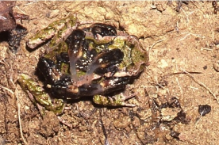  https://www.sciencelearn.org.nz/images/1686-archey-s-froglets-on-father-s-back  So we’ve got a lot of differences already  - their tongues  - their eyes  - their ears  - their feet  - their lifecycle ….  A final difference is where our native frogs live. We usually associate frogs with water but three of our 4 native species live and breed on dry land. This is Hochstetter’s frog.  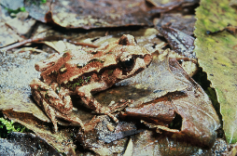  https://www.sciencelearn.org.nz/images/3365-land-lovers  It’s the only species that lives near the water. This species of frog spends its days under stones or logs near the edges of creeks and streams. Though they prefer damp areas, Hochstetter’s frogs can also survive on farmland and in non-native forests. Hochstetter’s frogs live in the northern half of Te Ika a Maui - the North Island. They’re pretty tricky to spot, though. Look at how well this one blends in with its environment.  Do you remember the name for this type of protection? Yep - it’s called camouflage.  Here’s another photo of a well-camouflaged frog. Can you spot the Archey’s frog?  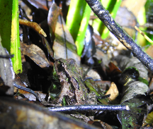  Sara Smerdon https://inaturalist.nz/observations/6246145  Archey’s frogs only live naturally in two places in Aotearoa - in the Coromandel Peninsula and in one ngahere - forest - west of Te Kuiti. That means that they’re pretty vulnerable should either of these areas be developed!  Here’s a photo of Hamilton’s frog.  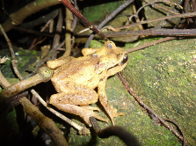  https://inaturalist.nz/observations/950157 (Mark Anderson CC BY_SA 4.0)  Hamilton’s frog is one of the rarest frogs in the entire world. Experts reckon there are less than 300 of these frogs. Hamilton’s frogs and Maud Island frogs live in really remote places - on small islands in the Cook Strait, at the top of Te Wai Pounamu. [Point out the purple dots that indicate the locations of Stephen’s Island to the north and Maud Island to the south.]  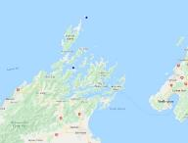  JS_08_Maud Island
Respond: Providing opportunities to use and practice  4 minutes this section  Running time 18 minutes | Pepeketua are under threat of extinction. We all need to be kaitiaki to protect them.  Native frogs are unable to change/adapt to cope with habitat loss and predation |  | Aotearoa once had seven species of native pepeketua, but three are now extinct.  We say that an animal or plant is extinct when it has died out - there are no longer any more of that animal or plant, at all.  The four native frogs species that we have left are under threat of extinction. Isn’t it sad to think that we might lose these critters that have been around for millions of years and that are so different to most other frogs in the world?  Why are our frogs under threat? I wonder what Phil thinks?  https://vimeo.com/418757383 [1:06 min]  Phil uses the words mammalian predators. A predator - konihi - is an animal that hunts and kills another animal. Rats and stoats are konihi - the same predators that are killing our native birds.  Phil mentioned a second threat - cutting down the ngahere - the native forests. We’ve taken away a lot of the special places where frogs liked to live.  So, how can we be kaitiaki? How can we protect our little pepeketua? Organisations like the Department of Conservation and Auckland Zoo are learning lots about frogs - with the help of herpetologists like Phil.  They are finding new homes for frogs. This is called translocation. The new homes are on small islands that are free from predators like rats and stoats. The frogs are also finding new homes in eco sanctuaries that are surrounded by special fences - like this one around ZELANDIA in Wellington. It’s protecting Maud Island frogs as well as lots of native birds and reptiles.  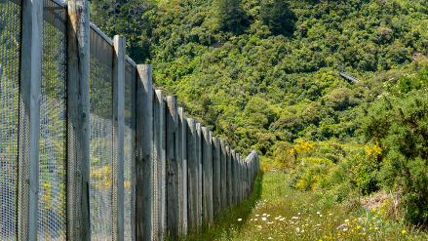  https://www.sciencelearn.org.nz/images/3677-zealandia-s-fence  I don’t know about you, but I’m feeling rather captivated by our pepeketua. We’ve learned that they are small, secretive and that they live in really remote locations, so ecosanctuaries and zoos are the only places most of us will see them. ? Are you more keen to take a moment and look for them in the zoo?  We’ve also learned that they’re really different to other frogs - they’ve got different tongues, eyes, ears, feet, lifecycles and habitats or places where they live.  More importantly we know now how we might be kaitiaki for thee pepeketua given the predators and the loss of the ngahere.
Share: Learner and parent reflection on learning and engagement and what they can do next  2 minutes this section  Running time 20 minutes | Summary/reflecting on knowledge of pepeketua and whether it has influenced personal ideas regarding kaitiaki.  Suggestions for active learning with the whānau.  Suggestions for taking action and becoming kaitiaki of pepeketua and poraka. |  | Maybe now you could explain the pepeketua lifecycle to your whānau. Remember the differences? Native frogs lay just a few big eggs and dad looks after them. They hatch as froglets and ride on dad’s back for a few weeks before they hop away. I bet you can turn it into a fun game with your pāpā or you could be the dad and carry your little brother or sister around.  Remember way back at the beginning of this episode, we also talked about poraka - introduced frogs. Believe it or not, the poraka that live in Aotearoa are widespread here, but are endangered in Australia.  We can give them a hand, too. Did you know that you can turn your garden into a frog friendly habitat and frogs might come for a visit? Poraka enjoy plants with wide leaves, like harakeke. They also need water and they like to rest on rocks. That’s their habitat sorted. What’s the other thing you need? Protection from predators like rats and even your pet cat.  I’d love to see a photo of your habitat or of you pretending to be a pepeketua.  Text 5811 or email info@hltv.co.nz, or visit me on my FB page  The keyword for this episode is Suzy.  [Sign off]

