Flower images created by writer using free images from wikimedia commons.

https://commons.wikimedia.org/wiki/File:Flower_Plumeria_rubra.gif

https://commons.wikimedia.org/wiki/File:Flower_Hibiscus_rosa-sinensis.gif

Image 1:

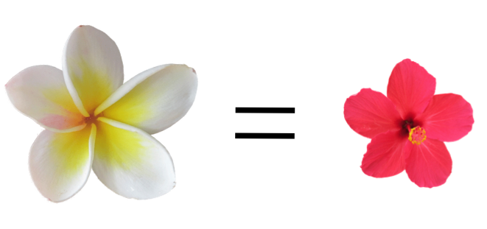

Image 2:
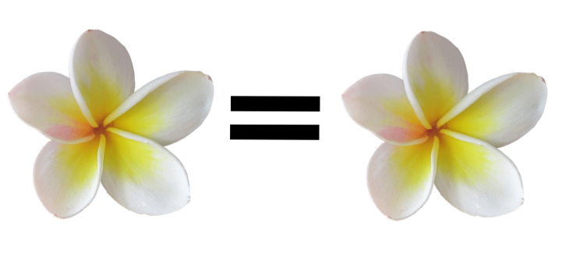

Image 3:
Images created by writer

Image 4:

Image created by writer

