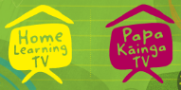
Home Learning TV – Middle Literacy
-Day 13

Segment lesson planning details
Title for segment: | Te Papa Detective
Year levels (e.g. Yrs1 – 3): | 4-7
NZC learning areas: | English
Purpose of lesson:  (What learners will learn) | English - listening, reading, viewing  - integrates sources of information and prior knowledge with developing confidence to make sense of increasingly varied and complex texts  - selects and uses a range of processing and comprehension strategies with growing understanding and confidence  - uses their personal experience and world and literacy knowledge confidently to make meaning from texts  Social Sciences  - Understand how cultural practices reflect and express people’s customs, traditions, and values.
Success Criteria – students will be able to:  (how they will know when they have learnt it) | Listen as they hear the text and  - Make connections with what they already know  - Visualise/ make a picture of what they hear in their head  - Self-question as they listen to clarify and understand  - understand we all have our own identity and with that identity we have traditions, articles and taonga that are unique and valuable to us.
Segment content/context details (as appropriate)
Māori specific content i.e. the learning draws on Mātauranga Māori: | The article is about the curator of Mātauranga Māori at Te Papa Museum and the care of the 35,000 taonga stored there. | Pacific specific content i.e. the learning is focused on Pacific knowledge: |  | Families slide has Pacific focus
Segment production details
Equipment requirements: | whiteboard
Copyright requirements:  Please be specific: Source(Seven Sizzling Sausages by Sam Smith –url link to the source), intended use (to demonstrate alliteration), and length (timings for video clips) | Images of Kiwiana from the web
Segment links and attachments (list all links to recordings or attachments, the source and confirm that copyright permissions are granted)
Links to recordings /resources | http://instructionalseries.tki.org.nz/content/download/38772/434458/file/Puawai%20Cairns-SJ%20L3%20Nov2016.pdf  Puawai Cairns Te Papa Detective, School Journal Level 3 November 2016
Attachments
Segment plan content
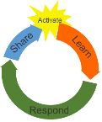 | Teaching and learning activities linked to purpose |  | High level script (key points/questions)
Activate: Activating prior learning, knowledge of contexts and relationships | Setting the Scene  Building interest – drawing the students in  Introducing the idea of Identity  Introducing the lesson  Developing idea of identity through  Your identity  Your family identity  A national identity  Presenter tells about herself and what she loves to connect to students  Developing the idea of identity in a family  Developing the idea of identity as a country  Asking the students to look around their home and think of what they value  Connecting with the audience – presenter |  | (***POWERPOINT OS***) Title Page  Kia ora everyone Today we are going to meet a real NZ detective. Interested? Puawai the detective is someone who looks after and investigates some of our important taonga that are protected and cared for in Te Papa our national museum in Wellington. You can be a detective as well so stayed tuned.  What is your identity? Who are you? What is your history? Your family? Your friends, your school,  your community and your country?  What things make you who you are and what is important to you.  This lesson is going to investigate how we as families and individuals and a country have our own identities and with this identity comes things we value, both internally, and as symbols and items.  NZ is made up of many different cultures and people, who, speak different languages, enjoy different pastimes, value different things who all have their own identity.  You have an identity as an individual  You are different from your brothers and sisters so you have an identity within your family. You like certain TV shows, have favourite foods, favourite clothes, and friends. You are unique.  (***ADLIB***)  Teacher tells about herself – with images or ad lib  Your family has a unique identity – who your family is made up of, the size of your family, who lives at your house, what you eat, what church you go to, your traditions and things you value.  (***POWERPOINT FF**)  Here is a family from New Zealand. They have their own identity and enjoy different things – one family is out kicking the ball and the other has been at a festival.  And as a country we have a National identity – New Zealand Aotearoa has characteristics and behaviours that distinguish us from other nations. We have much history.  Even though we are seen as a young country – our Māori history has been here for centuries. Plus we have grown as a country to right now where we are a team of 5,000,000 who are identifying as a country fighting the Covid virus. Part of our identity and who we are is shown by items, images or pictures that represent and express our identity.  You may recognise these images from Aotearoa  (***POWERPOINT FF**)  When we see these we know that they represent NZ and our identity as a nation.  Taonga or treasures are important to us. Those are national images but you will have some of your own – take a look around- can you see any from where you are sitting or can you picture something in your head? (thinking time)  Did you think of some?  I was thinking…… (***ADLIB***) or of a special book my mum gave me which I love and think is a taonga  (3 mins)
Learn: Introducing learning  Reinforce routines, provide multiple exposure to concepts, and strategies. Scaffolding learning | Introducing Text  Setting Learning Objectives  I want the students to use these simple strategies to help with their comprehension -  Frontloading Vocab  Setting a question for students to consider as they listen and reinforcing LI’s  Read Text:  Discuss text/ teacher thinking aloud as she processes the text and clarifies – modelling to students  Referring to Learning Goals  Wondering / meta cognition  Introduce Text  Discussion on text/ think alouds / wondering  Introduce next part of text  Remember Learning Goals  Text  Discussion |  | Powerpoint page 4  Today we are going to learn about a treasure detective in this non-fiction article  Our goal for the lesson is to:  - understand we all have our own identity and with that identity we have traditions, articles and taonga that are unique and valuable to us.  And to understand the text more clearly by  - Using our prior knowledge and what we already know to make connections  - self-questioning to clarify and check – that’s questioning inside your head  - Using visualisation to make pictures and images in our heads  Remember last month we looked at how to visualise while reading a fiction text, our goal was to notice the words that created pictures in our head and think about how they made us feel. We can practice this more today as we explore a non-fiction text.  Let’s look at an article in this journal about Puawai Cairns who has a very important job investigating and protecting some of our Taonga at our National Museum Te Papa in Wellington.  Perhaps you’ve been there?  (***WHITEBOARD***) refer to white board  Some of the words you may need to know are:  - Curator which means the carer or keeper of a museum  And when it tells us contempory Curator it means the person who is the curator now  - Taonga is a treasure  - Kākahu is a Māori garment and in this article includes a Māori cloak called a korowai  - And a kete is a bag;  As we read bring your prior knowledge (what you already know) to the text because you may know something about detectives and Te Papa.  Puawai isn’t like the detective you might be thinking of. She is a detective in history. Listen to what her job is and let’s see what the article tells us…….  Try to visualise what the story is saying and think about what you see in your head.  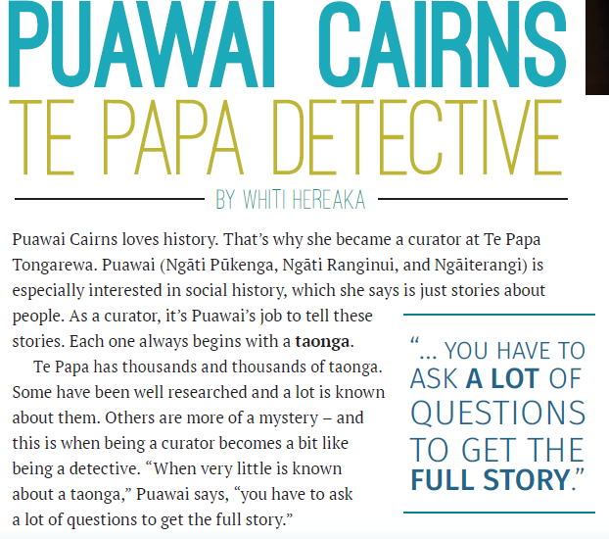  So how did you go?  I liked that we had talked about the word curator because I didn’t know what a curator was until now. (***WHITEBOARD***)  When you heard the text did you think – this bit makes me think of….. Or I can see this.  When I read I thought.. I have been to Te Papa and a picture of Te Papa was in my head.  I also liked it when she said social history is just stories about people.  That makes it easier for me to understand about history (***ADLIB***) or and I was thinking about my dad who is 91 years old. He must have some interesting stories to tell. In fact maybe there are so many people in my family that could have an interesting story.  I also wondered about everything beginning with a taonga –  I visualised a big chest of gold but then I asked myself could that be true?  And then I realised that the Taonga Puawai is talking about will not be gold and jewels but probably things that are valuable, just not the treasure I was thinking of.  That was an example of bringing my prior knowledge to the text and then visualising and questioning which helped me work out the meaning.  So let’s see what Puawai does next:  We can tell it’s a new section of the text because it has the heading called Mātauranga Māori  You may need to remember the vocab especially the word kākahu which means a garment or cloak ( you can make a picture in your head and visualise what that might look like. and see if you are right…….. but here’s a clue……this is a NZ Museum so it may be a cloak that belongs to someone from NZ)  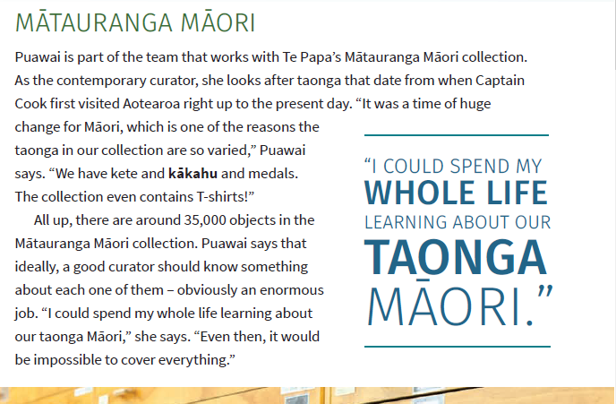  So do you think you were right with your visualisation….what sort of kākahu did you have?  Did it look like this one? (***POWERPOINT FF**)  Kākahu or korowai are true taonga of Mäori.  In historical times they were made out natural products including harakeke flax, tree parts and feathers from our native birds.  They took a very long time to make, often told a family story and had a lot a mana (Honour) attached to them.  And I heard 35, 0000 objects – that is a lot! And some of them are T shirts!  Think of your favourite T shirt or piece of clothing you own – is it a taonga to you right now?  Do you think you should keep it forever so people in the future can see it?  It may seem funny but some of the things that we see as normal right now may become taonga in the future.  And that is what Puawai is thinking about in the next section of text we are going to read.  As you listen, remember our goals and  - bring what you know to the text,  - make a picture in your head  - ask yourself questions to help understand  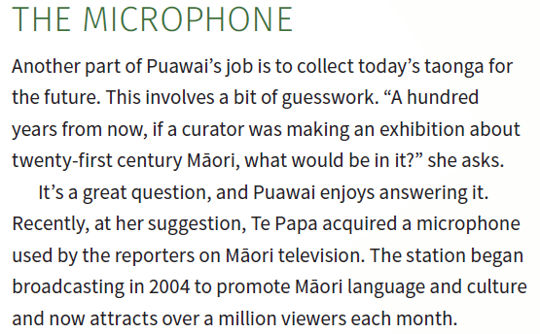  A microphone- taonga?  Did you ask yourself – is this treasure?  Did you make a picture of it in your head?  It must be difficult to decide what is going to be a treasure in the future.
Respond: Providing opportunities to use and practice | Thinking  Non Fiction Texts  Questions How big is the collection? What happens to the things that are not display? What sort atmosphere? Does that mean temperature? How long is the pole? Why is it a treasure?  I already know… I know that Te Papa is a very big building because I have visited there. Because I have visited museums in the past I know that many items are stored in drawers. I have seen a flag pole at school, so I know how long a flag pole is. |  | Here is the question I want you to consider:  A 100 years from now if a curator was making an exhibition about kids and their life in 2020 what would be in it?  What are your treasures…..what do you have that is precious – will it be precious in a year…… a 100 years?  Let’s have a look at an example of a taonga that Puawai talks about in this article. As I read the text I am going to be aware of what questions I have and if I can make a connection to things I already know.  I am going to use a simple table to record my answers and help me order my thoughts.  Presenter records her answers on the table as she reads through the article.  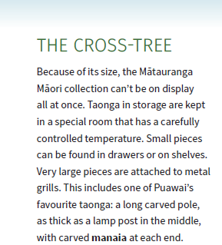  Because of its size, the Mātauranga Māori collection can’t be on display  all at once.  So I have a question straight away- how big is the collection? I picture a big room in my head full of lots of different things, so many things that you can barely walk through them. Items piled high to the ceiling!  What do you see? Did you ask the same question as me?  Taonga in storage are kept in a special room that has a carefully controlled temperature.  I wonder if that means air conditioning? I know my house and my classroom has an air conditioner to control heating and cooling, I wonder if this is what the article means.  So, I have a made connection between what I am reading and something that I already know!  What do you think this means? Did you make any connections to what you already know?  Small pieces can be found in drawers or on shelves. Very large pieces are attached to metal grills.  Hmm what is a grill? I remember the metal part of our BBQ that sits over the heat and know it is sometimes called a grill, now I have an image in my mind and can see items attached to the grill in the museum.  This includes one of Puawai’s favourite taonga: a long carved pole, as thick as a lamp post in the middle, with carved manaia at each end.  I wonder why this is one of Puawai’s favourite taonga? I also wonder what the pole is?  I visualise in my mind an image of the pole, I have seen lamp posts on the street so I know how thick they are, I wonder how long the pole is?  I can also add to my image, I know what a manaia is because my pounamu necklace has a carved manaia, my one has the head of a bird and the tail of a fish. I know this image is often found in Māori carving.  So, do you see how I am making connections with what I already know and asking myself questions as I read the text.  What sort of questions did you ask yourself? What were the connections you made as you listened to the section of text?  So, let’s think about what our goal was for to day, do you remember?  Yes that’s right Our goal for the lesson was to:  - understand we all have our own identity and with that identity we have traditions, articles and taonga that are unique and valuable to us.  And to understand the text more clearly by  - Using our prior knowledge and what we already know to make connections  - self-questioning to clarify and check – that’s questioning inside your head  - Using visualisation to make pictures and images in our heads  How did you go, do you think you achieved our goals today?  Here are some ideas for you to try. Perhaps one of your whānau will help.  (15 mins)
Share: Learner and parent reflection on learning and engagement and what they can do next | Debrief prompts student’s reflection on learning outcomes and progress  Includes opportunity to share learning or learn together with whanau, HLTV or others  - Reiterates the task if done outside of the lesson  - Introduces ‘independent learning’ through a provocation  Guide whānau |  | 1. You could be a curator of your own treasures – you may like to photograph and label the treasure describing what it looks like and why it is a treasure to you.  2. You could ask an older member of your family what they think are the taonga in your family – you could write a set of 3 or 4 questions to ask them so it helps them think about their taonga  3. You could get your favourite T shirt and either photograph or draw a sketch or picture about it and either record or write telling us what it looks like and why it is your taonga,  4. You could go onto the Te Papa website and look at some of their taonga – there is a sad story about a little girl who died in the 1919 flu epidemic and her family gave the man who looked after her a splendid kākahu korowai which now lives in Te Papa Here is the link to that  https://collections.tepapa.govt.nz/topic/3663?fbclid=IwAR2-CJvoxyMOiRYQALHbBovBXNxZxC197koPiliZz4KWUOIIWkuFhzQCtxk  Remember you can send us your ideas and questions by texting to 5811 or emailing info@hltv.co.nz.  (1 min)

