Home Learning TV – Middle Literacy
– Wednesday 27 May

Segment lesson planning details
Title for segment: | My Identity is an important part of Me
Year levels (e.g. Yrs1 – 3): | 4-7 English, Social Studies, The Arts
NZC learning areas: | English
Purpose of lesson:  (What learners will learn) | Learners will understand identify that their identity is unique and part of it is made up from cultural practices shared/lived in family/ whānau and community
Success Criteria – students will be able to:  (how they will know when they have learnt it) | Gained and understanding of a cultural practice important to several students’ identity and then reflect on and explore their own  Identify text features of a sequence
Segment production details
Equipment requirements: | Whiteboard, whiteboard markers  Powerpoint slides made up - if the images cannot be placed on tv screen full sized  Print large photo of dancers for whiteboard  I noticed idea strips with noticing’s on them ready to attach to whiteboard
Copyright requirements:  Please be specific: Source(Seven Sizzling Sausages by Sam Smith –url link to the source), intended use (to demonstrate alliteration), and length (timings for video clips) | https://www.facebook.com/LitiaMaiava/videos/1591800050915425/?v=1591800050915425  http://instructionalseries.tki.org.nz/content/download/41484/462251/file/Tafoe%20O-SJ%20L2%20November%202018.pdf  http://instructionalseries.tki.org.nz/content/download/41502/462305/file/Tafoe%20O-SJ%20L2%20November%202018.mp3
Segment links and attachments (list all links to recordings or attachments, the source and confirm that copyright permissions are granted)
Links to recordings /resources | See above
Attachments | Attached:  Vocabulary bank  I notice: – idea strips  Image from Tafoe video for whiteboard  Mp3 with audio of text to be played for Marissa
Segment plan content
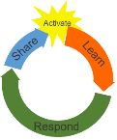 | Teaching and learning activities linked to purpose | High level script (key points/questions)
Activate: Activating prior learning, knowledge of contexts and relationships | Presenter greeting  Images on the whiteboard  Setting the context  ***Written on whiteboard  Taonga = treasure***  Learning Intention (oral)  Today we are going to learn about special events, songs, dances and stories that are significant to us and our families/whanau and are an important part of our identity.  Locating Tokelau  Noticing  Response to images and modelling noticings in complete sentences  I noticed that (written above the image)  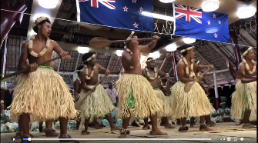  Blu-Tack the following strips using the think aloud/read aloud strategy around the image/screen shot that is on the whiteboard  I noticed that:  The dancers are in rows  The dancers wore a grass skirt over what looked like a lavalava  The dancers each had an oar  The building the dancers were in had grass mats and  There were New Zealand flags from the ceiling | Mōrena, Kia orana, Bula Vanaka, Malo, Ni Hao, Talofa and hello to everyone again.  Kei te pehea koe? How are you today?  I do hope you are well and having a great start to the day.  Lately I have been thinking a lot about all the people who live in New Zealand and what makes us such a special country. Part of what makes New Zealand special is that we are a multicultural country with people from all over the world who call New Zealand home.  We each have our own cultural identity as well as being called a New Zealander or kiwi. There are so many languages and cultures in our country. Do you know people who speak a language other than English at home, in your family, at your school or in your community? Can you speak more than one language?  (pause imagining some chatter at home or them saying yes and a couple of words)  Often part of our identity is something we have learned or practised as a family or community group that is special to us and we share with others. It might be through music, sports, drama, writing, food or dance. These special treasures or taonga are often something passed down from generation to generation in families and whānau over time.  Can you think of any very special treasures or taonga that you know, have seen or can do in your family, with grandparents, cousins, uncles and aunts or community?  (pause) I am sure you will have several taonga that are very special for you and your family / whānau  Today we are going to learn about special events, songs, dances and stories that are significant to us and our families/whānau and are an important part of our identity.  Our goals for today are to:  - gain an understanding of a cultural practice important to our identity and then  - reflect on and explore our own cultural practices and identity  - Identify text features of a sequence  I thought we could look at and read a story about some children learning a dance that is an important part of Tokelauan culture and part of their identity.  We all love to dance right? Can you think of dances or songs that are important to you, your family/whānau or people in your community?  First let’s see where Tokelau is. I have had a look using Google Maps to find Tokelau it is very small and a long way from New Zealand.  ***Use 4 google maps on powerpoint. Show each one from close up and moving out ***  Slide one on screen  In this slide we can see where Tokelau is in relation to Samoa, as we go further out…  Slide 2 on screen  Now we can see at the bottom edge of our map some more of our pacific neighbours- can you see Fiji and Niue. Let’s pull out in even further and see what other countries we can spot…  Slide 3 on screen  Wow I can see a lot of countries in this picture, new ones I can see are Tonga, Cook Islands, New Caledonia, Vanuatu, the Solomon Islands and Tuvalu. I wonder where Aotearoa/New Zealand is?  Slide 4 on the screen  Ahh there we are and the red flag is on Tokelau. Goodness it is a long way away isn’t it.  Tokelau is a remote group of atolls with a total land area of 12km² in the South Pacific Ocean, halfway between Hawaii and New Zealand. Tokelau is usually accessed by boat from Samoa, and trip that can take around 24 hours. The population is 1500 people. 45% of the population were born overseas in Samoa or New Zealand.  We have communities of gagana Tokelau, living and born here who call New Zealand home.  Let’s take a moment to look at this photo of a dance called Tafoe (pronounced tahoe).  As you look at the picture see if you can find 3 or more ‘things you noticed’ that are special and unique for these dancers. I will give you 30 seconds to look at it.  ***photo 5 on powerpoint on screen for 30 seconds)  What did you notice? (pause 10 sec)  *** teacher at whiteboard and starts thinking aloud/reading aloud her noticing’s and places then on the whiteboard around still image captured from vision***  I noticed that:  The dancers are in rows  The dancers wore a grass skirt over what looked like a lava lava  The dancers each had an oar  The building the dancers were in had grass mats and  There were New Zealand flags from the ceiling  Did you notice more than 3 things? I am sure you did.  So with that information we have gained let’s read the article.  (6 min 15 sec)

Learn: Introducing learning  Reinforce routines, provide multiple exposure to concepts, and strategies. Scaffolding learning | Gets the most out of the resource  Tafoe O!  Vocabulary bank  Tokelau English Maori My language  aganuku culture  fakatuatua sense of belonging whanaungatanga  fakatuatua faith whakapono  kaulotu church group  tafoe traditional dance kanikani  foe paddles hoe  talatalai carving whakairo whakairoiro  toki tool used for carving  Tokelau language pronunciation  Vocabulary building in relation to text context  Tokelau -English – Reo -Other  *writes on whiteboard*  ‘f’ sounds like ‘hw’  *On whiteboard *  Reo sourced from Maori Dictionary.co.nz  Applying Tokelau, Reo home language to vocabulary associated with the text  ‘First, the group has to learn the song’  ‘Then they go over the tune.’  ‘After that, it’s time to learn the actions.’  http://instructionalseries.tki.org.nz/content/download/41502/462305/file/Tafoe%20O-SJ%20L2%20November%202018.mp3  Locate three pieces of information in the text  Locate the meaning of the song  Modelling recording ideas to give clues for colloquial words and phrases  teacher writes ‘stand his ground = not retreat or move back when pressured by opposition’ on whiteboard  Select a waiata or dance that is a taonga, practice, share  Teacher uses think out loud to Model the identification of sequencing words, | In this article we are going to read today we will learn about the Tafoe dance, how three children Kewa, Ros and Mouankai learn this special dance and why it is a treasure/taonga.  There are going to be specific words written in gagana Tokelau that we may not have come across before. They will have the English meaning next to them in brackets. In today’s article there are words associated with dancing, canoes and community.  I also learnt that in gagana Tokelau the letter ‘f’ is said and sounds like ’hw’  ***T writes ‘f’ sounds like ‘hw’ on the whiteboard***  *** powerpoint to vocab on screen***  The words here in the first column are gagana Tokelau words and we will come across them in the article.  This next column (*second column*) are the words in English.  You will see there are some words in Māori that I know here that have the same meaning.  If you speak another language at home and with family and friends, maybe Cook Island Māori, Tongan, Samoan, Punjabi, Thai, Nepali, French or Spanish … there are so many languages from all around the world here in NZ …. You could say the words in your language.  Let’s take a moment to see if you can select three or four words from the column in English and say them in your choice of languages.  Say the words to someone in your house: your cat, the goldfish, your sister, your Mother, Nanny, the TV or yourself!  (Pause 10 sec)  ***page 18/19 on screen***  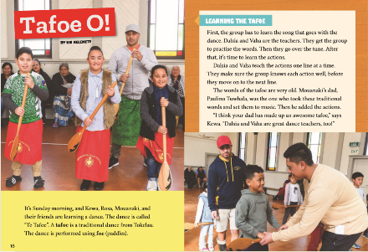  Here are the first two pages of the article.  What do you think the children are doing?  (Pause)  Yes, that is right they are Learning the Tafoe.  Let’s listen to the first part of the article  ***play Mp3 0:00- 1:48 with p18/19 on screen***  ***Teacher voice as page stays on screen***  So, what did we find out about Kewa, Rosa, Mouankai and their friends?  Pause  Correct, Kewa, Rosa, Mouankai were learning a dance called Te Tafoe and they were doing it on Sunday morning.  Ka pai  There was a sequence of three steps to learning the song and dance .  Let’s look at the text again and see if you can find them.  (pause)  When I count in gagana Tokelau tell me what you found  Tahi ….  Lua …  Tolu ….  Kapai.  Yes,  Tahi/first: the students learn the words  Lua/second: they learn the tune, and then;  Tolu/third they learn the actions.  Did you notice any words in the text that help us determine a sequence?  Hmm, I can see in this sentence  ‘First, the group has to learn the song’ (presenter reads sentence and writes on whiteboard)  The use of the word First, (presenter underlines first) this gives me a place to start.  In the second sentence another ordering word is use can you spot it?  Here is the sentence (presenter writes sentence on whiteboard)  Then they go over the tune.’  Yes you are correct it is the word ‘then’, the use of then in this sentence implies that what is being said follows the first statement. (presenter underlines then)  So, so far we have first….then…. I wonder what comes next?  Let’s see if we can see another ordering word in this sentence  ‘After that, it’s time to learn the actions.’ (Presenter writes sentence on board)  I think they are getting easier to spot, do you think so too? What word or words do you see that make us place things in order?  Ka wani kē koe, you are awesome! Yes it is the words ‘after that…’ (presenter underlines after that)  So our ordering words are first…..then….after that. As we listen to the rest of the recording lets see if we can find any more ordering words that help us sequence.  *** continue to show page 19 on screen again***  I also learnt that the words for the tafoe are very old, they are special traditional taonga and that Kewa enjoyed the tafoe.  Can you find the sentence with the word that Kewa used to say how much he like the tafoe?  (pause)  Kapai, awesome.  “I think your Dad made up an awesome tafoes,” says Kewa.  An important part of the Tafoe is the words to the song/waiata. The words have an importance and are part of the taonga that has been passed down over time. Lets have a look at the words and then the meaning of the song. The words in Tokelau look and sound similar to some in Maori.  In the blue box we will see what the words mean.  ***play mp3 1:46 -2:43 and p20 on screen for students to read***  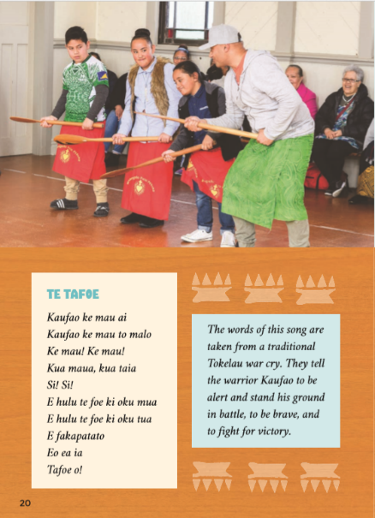  Did you find out what meaning for this song was?  (pause)  Āe, a traditional war cry where the warrior Kaufao was brave, stood his ground in battle and fought for victory.  ‘stand his ground’ or ‘stood his ground’ is a phrase  What could stood his ground mean?  (Pause )  Stood his ground, or to stand your ground means to not retreat or move back when pressured by opposition or people attacking.  Maybe you can think of some times when you or your family/whānau members may have had to ‘stand your ground’  The majority of cultures all around the world have, over time, told stories through songs or song and dance.  Can you think of traditional songs and dances from within your own family/whānau that are important to you?  You may also know some Māori waiata.  You might like to select one or two of your favourite songs that have a special meaning to your family/whānau.  (Think time)  *** Marissa you could share the name of a personal favourite ***  You might like to sing it to a family member or record it and send to someone special. You could send it to us.  Think- why is this song special to me and my family/ whānau?  Can you sing or perform your dance to someone else today or maybe even record it?  Shortly when we read the next page (**21**) we will find out about Tokelau Culture and a master carver who makes Foe.  As we read these pieces of information think about the importance of people at the kaulotu who Paulino learnt a lot of his carving skills from.  Also remember to look for those words that help to sequence ideas.  *** camera cut to page 21 on screen and play mp3 audio 2:42-4:38***  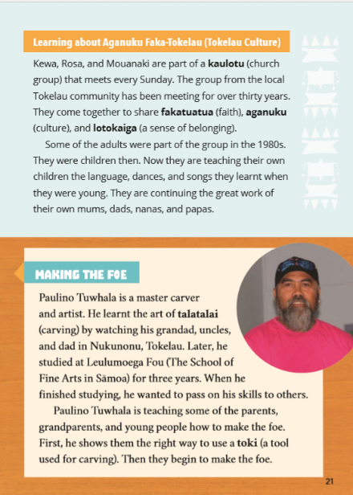  ***camera back to teacher standing by vocab chart at whiteboard***  We read about the kaulotu: the church group, fakatuatua, faith; aganuku,  culture: lotokaiga, sense of belonging and Paulino learning the art of Talatalai , carving.  How important were people in the family and community?  (Pause – give children think time)  I will confidently stand my ground and say that if we were in the same learning space together you would have awesome answers and ideas. You would tell us all, that it is people you spend time with, people in your whānau/ family and those older than you, that share their learning and help you create your identity that makes you the one of a kind, unique, person that you are.  (Pause)  Were you think about ordering words as you listened to that passage, did you see any words that helped to sequence ideas?  Let’s have a closer look at one section of the text we listened to. (Presenter to have this text ready on the whiteboard)  ‘They were children then. Now they are teaching their own  children the language, dances, and songs they learnt when  they were young. They are continuing the great work of  their own mums, dads, nanas, and papas’  Can you see the words that help us with sequencing?  Yes, we can see in the first sentence  They were children then  The use of were and then together allow us to place this in the past, it is our first part of the sequence. (presenter underlines were and then)  Next we are told  Now they are teaching their own children the language, dances, and songs they learnt when they were young.  Can you see the movement in time that has happened, which words help us to understand that?  Āe, you are correct it is the use of Now at the beginning of the sentence, we as readers know that we have moved from the past to the present time. (presenter underlines now as she talks)  Now, let’s look at the last part of the paragraph.  They are continuing the great work of their own mums, dads, nanas, and papas’  What word or words help us to see a further movement in time from past to present to future?  Well done! You spotted that correctly – it is the use of continuing. So now in our time sequence we have  Were children then….past  Now they are…. Present  Continuing the…. Future  Now it is your turn, as you listen to the rest of the text think about how you would sequence if you were the writer, what sort of words would you use?  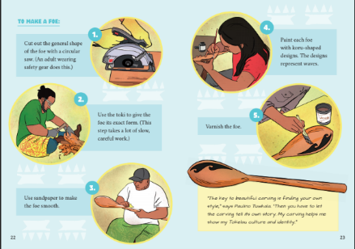  *** page 22 on screen and play Mp3 4:40-5:47 then page 24 on the screen as audio plays from 5.47 to end***  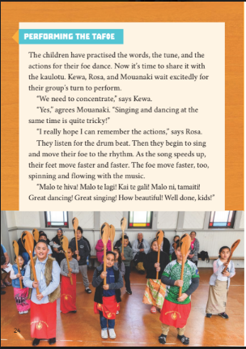  (15 mins 30 sec)
Respond: Providing opportunities to use and practice | Directly relevant to learning intention  Involves student participation – with options about how it can be done | You might like to sing your favourite waiata to a family member or record it and send to someone special. You could send it to us.  Then you might like to make, draw or photograph this taonga or one of your own taonga and write how to make the item in 5 steps.  Remember, short precise statements under the drawing photo  We’d love to see what is important to you. We will have the details of where to send the information at the end of our lesson.  (30 sec)
Share: Learner and parent reflection on learning and engagement and what they can do next | Debrief prompts student’s reflection on learning outcomes and progress  Includes opportunity to share learning or learn together with whānau, HLTV or others  - Reiterates the task if done outside of the lesson  - Introduces ‘independent learning’ through a provocation  Guide whānau | So let’s look at our goals for today and see if we have achieved them  Our goals for today were to  - gain an understanding of a cultural practice important to our identity and then  - reflect on and explore our own cultural practices and identity  - Identify text features of a sequence  So today we’ve learnt about the importance of Tafoe O! for Tokelauan people. We have considered the people and explored family/whānau taonga shared across age groups are an important part of our identity.  We also learned to identify words that help us to sequence ideas.  I do hope you talk with whānau about special stories or dances and art that are important. Find out who they learnt their songs, stories and dances from and why they are important.  We would love to hear from you if you have made or recorded an important item, written and illustrations a 5 step process or if you have drawn/taken pictures of symbols and shapes that are an important part of your identity.  You could text or email them into me at info@hltv.co.nz or text to 5811.  Ka kite. Until next time, have a great day.  (1min 06 sec)

