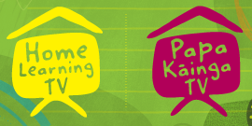
Home Learning TV – Senior Literacy – Monday 25 May

Segment lesson planning details
Title for segment: | Where do I belong - sense of belonging
Year levels (e.g. Yrs1 – 3): | 7-10
NZC learning areas: | English
Purpose of lesson:  (What learners will learn) | Students will read a graphic novel (short text) that tells of the experiences of fitting in and belonging and think critically about  The vocabulary and ideas relating to a personal sense of belonging in text and visuals.
Success Criteria – students will be able to:  (how they will know when they have learnt it) | Students will be able to  Extend vocabulary and think about ideas related to the concept of belonging.  Use language interpretation and prediction skills to understand ideas about belonging in text and visuals.
Segment production details
Equipment requirements: | School journal Level 4 June 2018
Copyright requirements:  Please be specific: Source: (Seven Sizzling Sausages by Sam Smith –url link to the source), intended use (to demonstrate alliteration), Length (timings for video clips) | Youtube clip  https://youtu.be/ygehUaxRC6s  Visual text (School Journal, Level 4, June 2018 - Something Alive by Jem Yoshioka)  http://instructionalseries.tki.org.nz/Instructional-Series/School-Journal/School-Journal-Level-4-June-2018/Something-Alive  https://youtu.be/S7-BJfH5weU - timer  https://sites.google.com/site/hscbelongingstandard/concepts-of-belonging/belonging-emerges-from-connections
Segment links and attachments (list all links to recordings or attachments, the source and confirm that copyright permissions are granted)
Links to recordings /resources | See above – copyright links
Attachments | Slides as appropriate – see accompanying powerpoint
Segment plan content
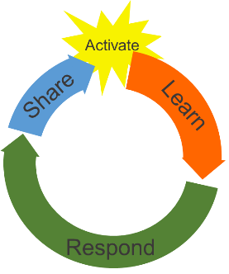 | Teaching and learning activities linked to purpose | High level script (key points/questions)  Consider how personal experiences impact on our feelings of belonging
Activate: Activating prior learning, about the concept of belonging  6 mins | Introduce key term and concept  Do a vocab activity focusing on the concept of belonging – see accompanying slides to develop student understanding of belonging  Show mindmap on screen. Teacher models completing mindmap after giving students time to think. Teacher explains vocab  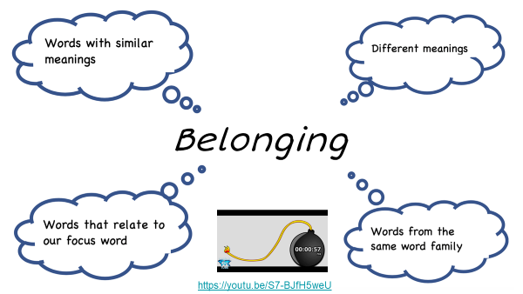  Teacher provides video – where do I belong? For students to view  https://youtu.be/ygehUaxRC6s  Teacher poses questions prior to the video and suggests possible responses to the video afterwards. [Show questions on screen/whiteboard]  Teacher adds further relevant ideas to mindmap based on video. Discuss ideas about belonging in relation to people and place. | Greeting in te reo and Pasifika languages  Ask- What does it mean to Belong? Where do we Belong? Who do we belong with? What do we belong to? What words do your whānau use to describe belonging? Eg. Whakapapa/ auai [Samoan word for belonging]  These are all questions that we will ask ourselves at some stage. Today we will explore the concept of belonging.  Vocab activity – concept of belonging – see accompanying slides  Introduce vocab - Like any unit of work you start, it’s a good idea to gather your prior knowledge around your topic.  So let’s start with the term Belonging. Take a minute and quickly jot down your ideas around the four stems (explain mindmap) and any other ideas you may have. You might like to talk with other family/whanau. What does belonging look like for your family?  In this short video clip we will look at the way belonging is described. While you watch you might like to think about:  What does belonging mean to the person in this video?  What images of belonging does this video surface? (note: video focuses on place)  Ask – what did the girl mean when she said ‘I may never fit in a box perfectly somehow I still belong’  Ask - What does ‘belonging’ look like within your culture?  Does this change your ideas about belonging? Can we add other ideas to our mindmap?
Learn: Introducing learning  Reinforce routines, provide multiple exposure to concepts, and strategies. Scaffolding learning  12-15 mins | Introduce the text – Something Alive –  http://instructionalseries.tki.org.nz/Instructional-Series/School-Journal/School-Journal-Level-4-June-2018/Something-Alive  Discuss text structure – graphic novel – and prediction – what it is and how it helps us.  Teacher gives students time to make a prediction about content and purpose. Teacher shares her ideas (use headings prediction and reason why). Record on whiteboard to revisit.  Introduce the first section of text – refer slide – technically I am only from one place (Refer to attached powerpoint for relevant sections of text) Slide 14 onwards contains text.  Teacher discusses her prediction and her reasons for making it.  Teacher explains figurative language – reasons writers use this. Explore examples from the text.  View key phrases from text – see slide – the language features, figurative language identified in these slides can be used when discussing the text.  Teacher reads the text – models interpreting figurative language. Then give students time to practise interpreting figurative language. Teacher shares her thinking. Record on a table for reference after each example:  Example of figurative language and visuals Meaning  Teacher revisits a couple of images from the text that suggest ideas about belonging. Describe and record in table above. | Introduce the title of the text we are going to explore today – ‘Something Alive’  This is a graphic novel (show quick example of text features) – note accompanying slide has lists of features.  Explain that a prediction is a BEST guess based on the information/ideas provided. Predictions become clearer as you read on and encounter more information. The writer leaves us hints to help us with prediction. That’s part of the enjoyment of reading … doing a bit of detective work … searching for ideas and clues about what might happen further on in the text.  Based on this title – what ideas about belonging do you think this text might explore? What is your prediction and why?  Technically, I am from one place.  Let’s have a think about this statement. What might the writer mean here?  Yes, we may all be from one place …. New Zealand …. We reside here currently, we all live in New Zealand but what are our connections with our country. What is our sense of belonging to this place? The use of the word technically implies that may be there is more to this text than meets the eye.  Can you belong to more than one place? Do you have connections with another country?  Back to the text …  What aspects of belonging do you predict this text might investigate?  Let’s look at these examples of figurative language from the text. How does this use of language effect the readers ideas about the key message of belonging?  “Accent blends smoothly with the current of voices”  “my heritage is a living part of me ... something moving and alive ... a thing to pursue”  “I feel like a badly translated haiku that doesn’t mean the same in English”  “I often feel like I’m not enough ... as if the dilution of my blood makes me less somehow”  New Zealand opened its arms to me and accepted me as one of its own  After reading – ask question – what are we learning about belonging? [Could add further ideas about belonging to the mindmap from lesson beginning.]  In this text the images also convey ideas. Are there any images that suggest ideas about belonging?
Respond: Providing opportunities to use and practice  8 mins | Directly relevant to learning intention  Involves student participation – with options about how it can be done  Amend graphic from first part of lesson: use concept of ‘my sense of belonging’ in centre.  Teacher completes a personal belonging map at same time.  Teacher revisits figurative language as used in previous text. Choose one or two features eg. Simile or metaphor and explains plus provide an example of a personal belonging statement  Modelling and guiding  Teacher constructs a personal belonging statement using figurative language. Explains language use. | So far we have thought about words to express ideas about belonging, viewed a video clip and read a text about belonging.  Now let’s think about making a personal map of belonging. You can use the graphic provided (at beginning of lesson) or make up your own. Perhaps you might borrow some of the words we have already used.  Alternatively, you might prefer to draw an image that represents what belonging means to you.  Let’s do this together. I’ll share my ideas about belonging at the same time.  Now you have a map of your ideas about belonging and what belonging means to you!  Let’s see if we use those ideas to construct a sentence or two about personal belonging.  Think about using a language feature as well to really make it personal! Here’s one I prepared earlier …  I’ll write another one at the same time.  Feelings about belonging are personal, unique to individuals.
Share: Learner and parent reflection on learning and engagement and what they can do next | Debrief prompts student’s reflection on learning outcomes and process  Includes opportunity to share learning or learn together with whānau, HLTV or others  - Reiterates the task if done outside of the lesson  - Introduces ‘independent learning’ through a provocation | Reflect on our learning goals – how have we gone today?  What have we learned about belonging today? It’s not something we usually write down. Do you feel like you know more about your feelings of belonging?  Perhaps you could find out if other members of your whanau have similar ideas about belonging. I wonder what your whānau/family belonging map might look like.

