Home Learning TV: Middle Science, Tuesday 12th May
Segment lesson planning details
Title for segment: | Science in Antarctica
Year levels (e.g. Yrs1 – 3): | 4-6
NZC learning areas/ KCs: | Living world - adaptation  NoS - scientists provide evidence to support their ideas  KCs - Thinking
Purpose of lesson:  (What learners will learn based on the above) | - Share a sense of science as adventure  - Consider some of the challenges of doing science in Antarctica  - Identify some adaptations of living organisms living in Antarctica
Success Criteria – students will be able to:  (how they will know when they have learnt it) | - Explain some of the challenges of doing science in Antarctica  - Identify some adaptations of living organisms living in Antarctica
Segment plan content
Stage | Teaching strategies linked to purpose | Learning tasks and activities | High level script (key points/questions for presenter)
Beginning of lesson:  Activating prior learning and relationships | Connecting with the audience, introducing the context for the episode | Thinking about everyday experiences - changing seasons and temperatures  Locating Antarctica  Map  Filename: AntarcticaMap_Annotated.jpeg  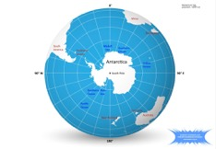 | Have you noticed it’s been getting cooler while we’ve been in lockdown? What are some of the other signs of Autumn? [Props of leaves, photos from a daily walk.]  [Maybe an anecdote from the presenter about living in Canada, some memories of Autumn there?]  I’ve been wondering what Autumn might feel and look like in different parts of Aotearoa - and I know that the further south we go, the cooler it gets.  Do any of you live in Te Wai Pounamu – The South Island? Maybe we have some viewers who live in Bluff – our southernmost town?  So what happens when we go all the way South - all the way to Antarctica?  Have you heard of Antarctica? I wonder what you know about it already? Maybe you have never heard of it?  I am learning new things about places all the time - [perhaps a personal anecdote from the presenter]  Like you do with any big journey, you might start with a map.  [Show map and orient audience to Antarctica and NZ’s proximity to it.]
 |  | Practising observing  Filename: Dry-Valley_MeganBalks.jpg  https://www.sciencelearn.org.nz/images/1049-dry-valley  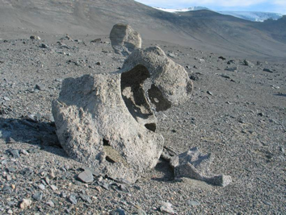  Filename: Deschampsia-antarctica_WithChinStrapPenguins_Mark_CC BY 2.0.jpg  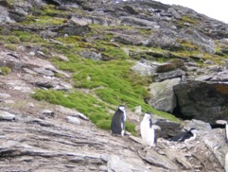 | Like we usually do in these sessions, we’re going to start by practising our observation skills. Remember, observation is a very important scientific skill. When you look closely at something, and ask questions about what you observe, you're thinking and behaving like a scientist.  Here’s today’s image.  What things can you see?  Dry sand, gravel and rocks, the rock in front has a beautiful shape - I can infer that it’s been eroded by water or wind.  I mentioned Antarctica earlier - and this image was taken in one of Antarctica’s Dry Valleys. Did you know that Antarctica had dry, desert-like places like this, where there’s no snow or ice?  Or what about this image - the green stuff is actually a type of grass - and it grows in parts of Antarctica that don’t get quite so cold!
art of lesson (a) :  Introducing learning  Reinforce routines, provide multiple exposure to concepts, and strategies. Scaffolding learning | Aotearoa has a close connection with Antarctica.  A big challenge when working is Antarctica is coping with the cold  Research in Antarctica in addressing important issues like climate change | Map image  Using images to connect with the context  Filenames:  ErnestShackAndFrankHurley_FHurley.jpeg  ErnestShackletonFrankWild_FrankHurley.jpeg  WreckWithDogs_FrankHurley.jpeg  Robert_Falcon_Scott_by_Herbert_Ponting_PublicDomain.jpg  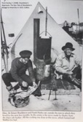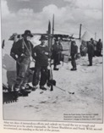  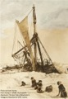  Image - Scott Base  Filename: Scott-Base_DrMeganBalks.jpg  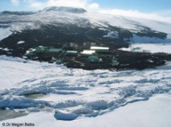  ScottBase-7408.JPG  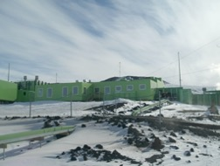  Linking to everyday experiences - dressing for cold  Filename: SV0061a Staying warm in Antarctica RECUT.mov  Getting dressed -  Filename: SV0039a Getting dressed for the antarcticRECUT.mov  Linking to everyday experiences - accommodation as protection from cold  Image of early tents  Filename: At_the_South_Pole,_December_1911_PublicDomain.jpg  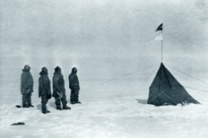  Filename: ErnestShackletonFrankWild_FrankHurley.jpeg  Filename: SV0023a A tent in antarctica RECUT.mov (1:06)  Linking with everyday experiences - what about going to the loo?  Going to the loo - SV0024a Antarctic field toilet RECUT.mov  Questions to focus on when watching the video  Video - researching on sea ice  SV0056a Researching on sea ice RECUT.mov | In Aotearoa, our connection with Antarctica is a really special part of our identity.  Hui Te Rangiora, a Polynesian chief, may have been the first person to see Antarctica, over 1,350 years ago (650 AD).  Tamarereti is another tupuna who travelled south in a waka and found white land. His canoe - Te Waka Tamarereti - is located in the tail of the Scorpio constellation.  In more modern history, Tuati was probably the first New Zealander to view the Coast of Antarctica. Tuati was the son of a whaler and sealer Captain William Stewart (after whom Stewart Island is named), and his Ngapuhi wife.  As we saw earlier [Show map], Aotearoa is one of the countries that is closest to Antarctica, and we were involved in lots of significant Antarctic firsts – including the first landing on the continent and the first overland crossing. [A variety of images are provided for the presenter to select from.]  Scott Base is our permanent research station, and 86 people can stay there at any one time in the Summer.  What we all probably know about Antarctica is that it can get really, really cold. Like, way colder than we are right now!  So when people spend time in Antarctica - and mostly they’re scientists - the freezing cold is something that they need to think about and plan for.  What are some of the ways we manage when we’re cold - makariri - here in Aotearoa?  That’s right, we can put on more clothes. [Perhaps have some props of several layers?]  Or we use fires or heaters. We can eat warm kai. And we can stick close together, sharing the body heat of others.  But how many layers of clothes might you need in Antarctica?  Let’s watch Scientists Megan Balks talk about it as Leah Adlam shows us what getting dressed can look like. While you’re watching, try to see how many layers Leah ends up putting on.  [Play video]  What do you think of that? How many layers did you count?  Let’s watch Leah layering up again.  [Play second video] - Leah layering up - Presenter to voice-over the number of items that she’s putting on.  So, lots and lots of layers.  [This next section about accommodation is optional, for the presenter to make a decision about in relation to the length of the episode and aspects he wants to focus on.]  What else might you do?  Well, accommodation is really important - but what about if you’re out in the field?  Here are some of the very early tents that explorers used.  Let’s find out a bit about what tenting is like in more modern times. While you’re watching the video, I want you to notice what Megan says about how heat is generated.  Show video  So what did you notice Megan talked about in terms of heat?  There is no specific heating, but  - Heat comes from cooking  - Heat from having two people  - Protection from the wind  - Layers of clothing  - Cosy sleeping bags  That doesn’t sound too bad - as long as you’re happy to wear lots of layers, and be in very close quarters with your colleagues! No social distancing going on in those videos!  But what about toilets? Everyone always wants to know about toilets, right?  Not only … well, how you go … but what happens to the waste.  Let’s find out -  [Show video]  Now, I don’t mean to be gross - but I’ve still got some questions. I’m picking they’re not appropriate for national TV though …  What we can safely focus on is what people do to help them survive when they’re faced with the extreme cold of one of the coldest places on earth - lots of clothes, and having the right food and gear.  [This section on equipment is also optional – we leave the presenter to decide which ‘optional’ segments to include.]  But what about equipment? What sorts of things are needed to make sure that the scientific equipment that they’re using will work in the extreme conditions?  I’ve got another video here, where scientist Dr Mike Williams talks through some of the challenges that he and his team face when collecting water samples.  Watch carefully to see what the problem is, and how they get around it.  [Show video]  That video of Mike was shot more than 10 years ago - he’s now a Director of an important National Science Challenge called Deep South. This is a large research project that will help New Zealanders to adapt, manage risk and thrive in a changing climate - which sounds like really important work to me!
Main part of lesson (b) | Living organisms have evolved specific adaptations that enable them to survive in the harsh Antarctic climate; these adaptations can be physiological or behavioural. | 3.30 minutes  Link to prior knowledge  Talk/write about adaptations - use images as a reference  Images:  Filename: PenguinChick_KatjaRiedel.jpg  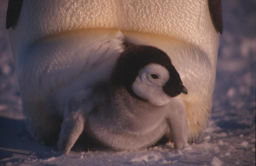  Filename: SLH_NEWS16_emperor_penguin_huddle.jpg  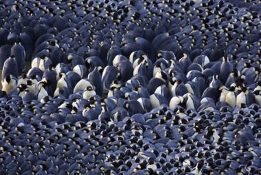  Weddell seal - Filename: WeddellSeal_OliverDoddCC BY 2.0.jpg  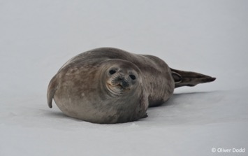  Linking to earlier learning  Filename: Deschampsia-antarctica_WithChinStrapPenguins_Mark_CC BY 2.0.jpg  Filename: SV0025a Antarctic icefish.mov  Image - Tangaroa  Filename: Tangaroa_NIWA_DSC00034.jpg  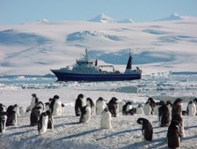  Tangaroa_smallerResearchsurveytender_NIWA_DSC00608.jpg  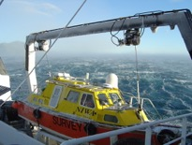  Tangoroa_Cape Hallot_NIWA.jpg  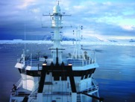  Filename: AndrewStewart_TePapaShirt.jpeg  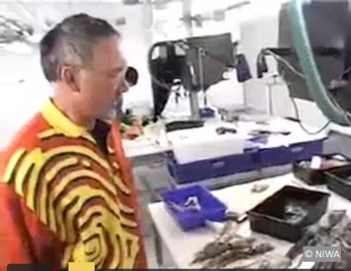  Icefish_C._aceratus_CCBY-SA4.0.jpg  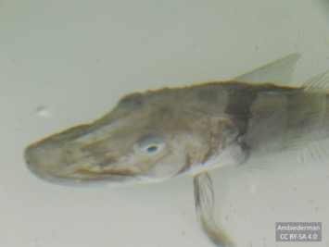  Icefish_ClearBlood_NorthwesterUni.jpg  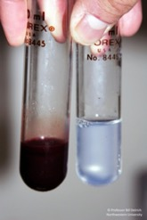 | So we’ve met some scientists who collect some of their research data in Antarctica, and we’ve talked a little bit about what it’s like for them when they work down there.  But what’s it like for the animals, plants and other organisms that live in this harsh, cold climate?  Let’s have a look at this video of 17 year old A’aifou Potemani from Sir Edmund Hillary College in South Auckland recently got to kayak amongst wildlife in Antarctica when he was selected for the Antarctic Heritage Trust’s Inspiring Explorers' Expedition. But as New Zealand went into lockdown because of Covid-19, A'aifou and his group had to find other ways of getting home.  [Presenter to comment on the video and link to the next section on adaptation.]  Well, all the organisms that live there have developed specific features that help them to survive. We call these adaptations.  [On screen: Adaptations allow organisms to survive in their environments]  I’m going to show you some images, and I want you to think about what features they have that help them to survive. Maybe you can write them down, or talk about it if you’re watching this with someone else.  [Emperor Penguins]  This chick of an Emperor penguin is pretty cute, right? What do you observe?  Well, it’s tucked into its Mum’s pouch. You can also see the feathers - Emperor penguins have four layers of overlapping feathers. These feather layers trap air close to the penguin’s body, preventing the penguin’s body heat from escaping. These feathers also stop wind from getting in, and a greasy layer provides waterproofing, and the dark feathers on their backs absorb heat from the sun when it’s shining. On land, Emperor penguins rest their entire weight on their heels and tail, reducing contact of their feet with the icy surface. They can also tuck their flippers in close to their bodies and shiver to generate additional heat.  Look at this image.  What can you see? It’s Emperor Penguins, alright - hundreds of them, all huddling together for warmth. They even take turns being on the outside and inside - this a behavioural adaptation.  [Weddell seal]  Isn't this Weddell seal gorgeous? What do you know about seals and how they’re adapted to living in the cold?  Well, they’ve got a thick coat of fur for insulation, as well as a thick layer of blubber, or fat.  They’re streamlined and strong, so they can move easily through the water.  They can also store more oxygen in their blood and muscles than we can, so they can go for really long dives.  Remember this picture that we saw earlier, of Antarctic hair grass? They only have a short growing period during Summer, and can survive the freezing temperatures of Winter. They also have a deep root system, which keeps them well anchored in the face of strong winds and disturbance by penguins and seals and allows them to absorb the water and nutrients they need from their rocky homes.  [Optional content, depending on the Presenter’s time spent telling anecdotes and on the earlier segment re. accommodation in Antarctica]  What about all the organisms that live in the sea? Of course, they’ve got adaptations too.  Let’s listen as Andrew Stewart talks about some of the adaptations of one of the fish that is common in Antarctic waters - the Antarctic ice fish.  [Show video]  This video was beamed to the Science Learning Hub directly from the Tangaroa, New Zealand’s only deep water research vessel that has ice strengthening.  Did you notice Andrew’s t-shirt? Did any of you recognise it?  It’s the fingerprint logo of Te Papa Tongarewa, our national museum in Wellington - and that’s where Andrew works.  So what was interesting about the icefish he was telling us about?  Do you remember that their internal organs were white, where the internal organs of other fish (and us) are red? That’s because they don’t have something called haemoglobin in their blood. Haemoglobin is what makes the blood of fish - and us! - look red. It’s important, because it carries oxygen.  Now the icefish - like us - need oxygen. But these fish have evolved to be able to get enough oxygen directly from the water because - did you hear Andrew say this? - colder waters contain more dissolved oxygen.  What I want you to notice is that white blood is a unique feature of icefish.  We need haemoglobin in our blood so that different parts of our body get enough oxygen. When it comes to keeping warm, our bodies can direct blood away from our skin when we’re cold. Shivering is also a natural way of keeping us warm. It’s a reflex - we do it without thinking about it. The movement of the muscles creates heat.
End of lesson:  Learner and parent reflection on learning and engagement and what they can do next | Summary of the lesson | Students are invited to continue to wonder about what scientists do in Antarctica. | It feels like it’s getting time to wrap this segment up [putting on a jacket]. Did you get that? I’m wrapping up, by putting on my jacket, but I’m also wrapping up by bringing this episode to a close.  During this time together, we’ve met Megan, Leah, Mike and Andrew. They told us a little bit about what it’s like to do research in Antarctica - and the special things they need to keep them and their equipment warm and functioning.  We also met some beautiful penguins and seals, and the unusual icefish, and talked about some of the ways that they are adapted to living in Antarctica’s extreme conditions.  I’ve still got a lot of questions, and I bet you might too.  If you were to meet a scientist who has spent time in Antarctica, I wonder what you might ask them about?

